Facilitator’s Guide for Exploring PsA and Reproductive Health

Case by Case

ACKNOWLEDGEMENTS

These educational materials were supported by a medical education grant from Pfizer, Inc. to address Psoriatic Arthritis and Reproductive Health education to support patients, educators, and clinical teams.
Its contents are solely the responsibility of the authors and do not necessarily reflect the official views of Pfizer, Inc.
© 2021 American College of Rheumatology. All rights reserved.

AUTHORS
Mehret Birru Talabi, MD
Linda Grinnell-Merrick, NP
Sonam Kiwalkar, MD
Arthur Kavanaugh, MD
Vagishwari Murugesan, MD

Notes:

Getting Started
Exploring PsA and Reproductive Health, Case by Case is a program designed to educate prescribing providers and their healthcare teams on how to manage and treat Psoriatic Arthritis (PsA) in patients of reproductive age. Utilizing the 2020 American College of Rheumatology (ACR) Guidelines for Reproductive Health in Rheumatic Disease as the foundation, this program will explore the importance of shared decision making with patients, medications compatible with pregnancy and lactation, as well as how to educate patients on how to prepare for the best pregnancy outcomes given their disease status. Using multiple case studies with women and men, this program will walk providers through the appropriate considerations, lab tests, and conversations that non-rheumatology and rheumatology providers should be aware of to provide the best care for their patients and their growing families.
Objectives of This Presentation:
At the end of this presentation, learners will be able to:
- Discuss effects of Psoriatic Arthritis (PsA) on pregnancy
- Explain potential adverse pregnancy outcomes associated with PsA
- List the impact of drugs used in the treatment of PsA during pregnancy and lactation
- Recognize that women with PsA have a risk of flare post-partum
- Demonstrate successful use and integration of the ACR Reproductive Health in Rheumatic Diseases guidelines into patient care
Length of the Activity:
The presentation and discussion should last between 60-75 minutes.
What You Need:
- Computer and audio/visual equipment for projection of the PowerPoint presentation to the audience
- Guide for Exploring PsA and Reproductive Health, Case by Case, PowerPoint presentation
- Facilitator’s Guide/Presentation script
- PsA Handouts (4)
Importance of Evaluation: the Pre & Post Test
To continue to improve this education for others, it is important that we get feedback on:
- What are the participants learning from this session?
- How can this session be improved?
- What additional information would be helpful?
Please be sure to encourage your learners to take the pre-test prior to the session, and the post-test at the completion of the session. If you have questions, please speak with your organization’s point of contact.
Slide 4: Learning Objectives
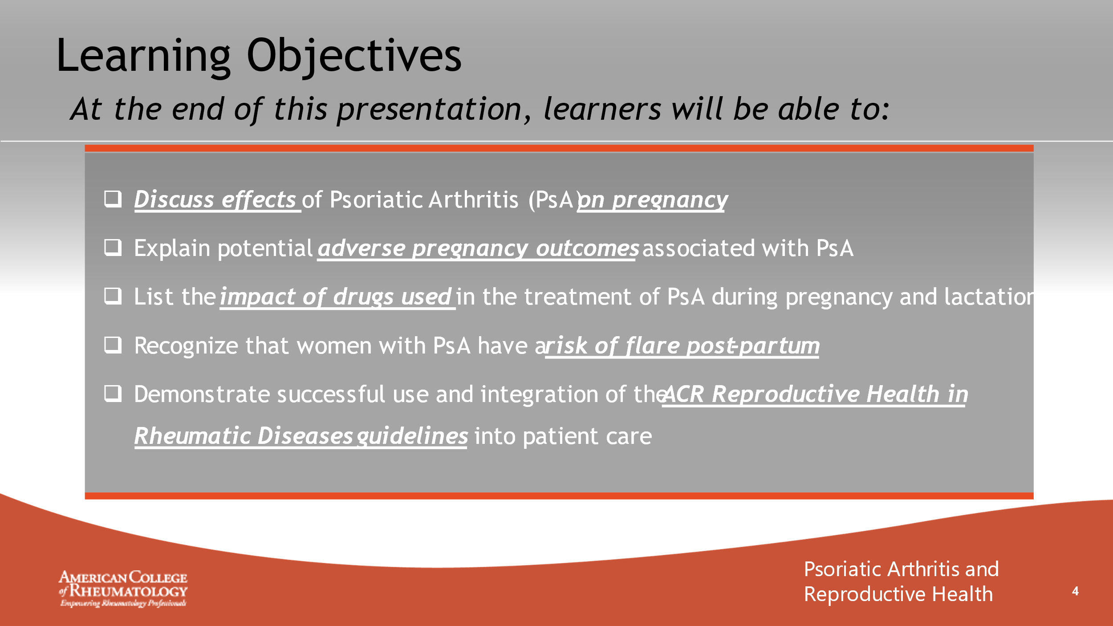

- _______________________________________________________
- _______________________________________________________
- _______________________________________________________
- _______________________________________________________
- _______________________________________________________
- _______________________________________________________
- _______________________________________________________
- _______________________________________________________

Slide 5: Disease Overview
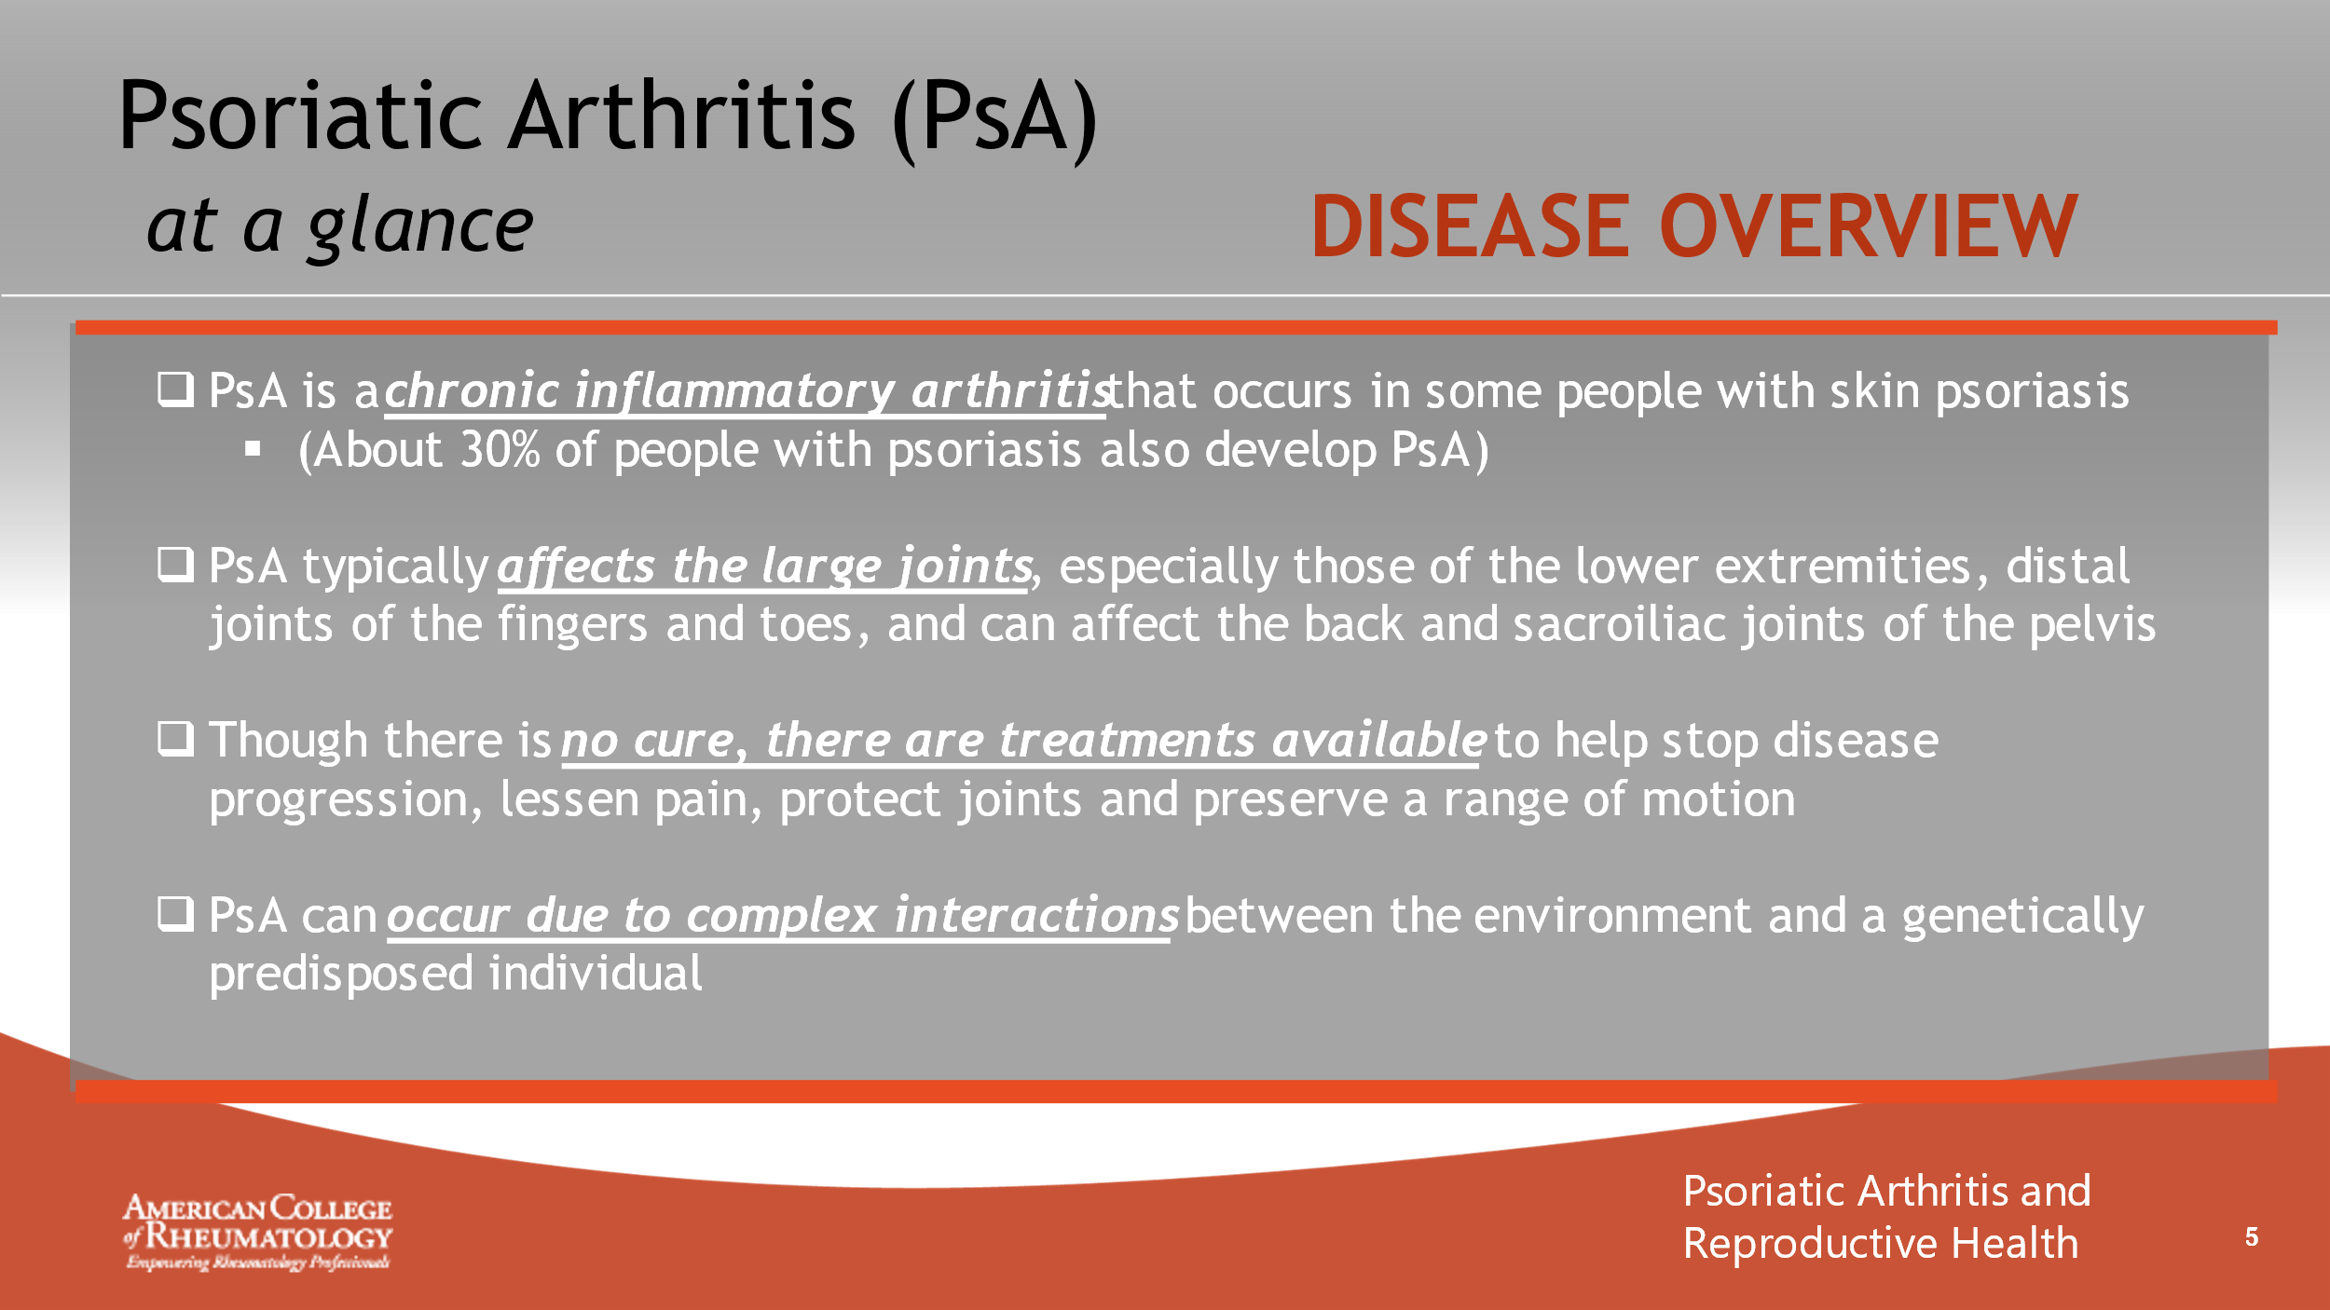

- _______________________________________________________
- _______________________________________________________
- _______________________________________________________
- _______________________________________________________
- _______________________________________________________
- _______________________________________________________
- _______________________________________________________
- _______________________________________________________

Slide 6: Common Symptoms
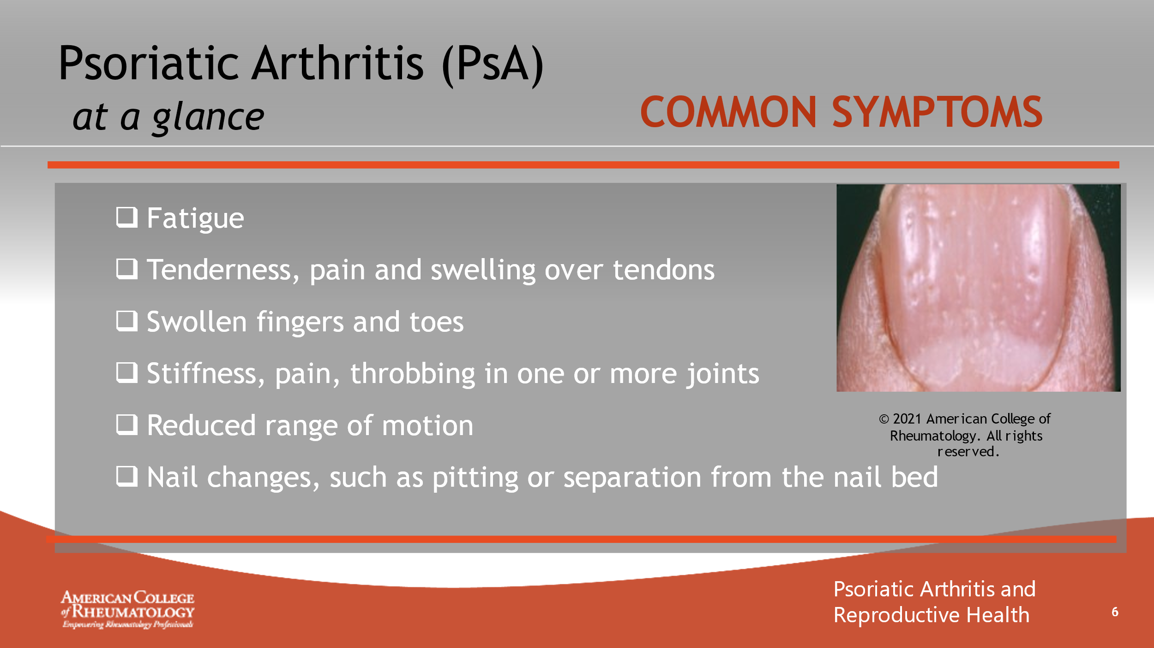

- _______________________________________________________
- _______________________________________________________
- _______________________________________________________
- _______________________________________________________
- _______________________________________________________
- _______________________________________________________
- _______________________________________________________
- _______________________________________________________

Slide 7: Demographics
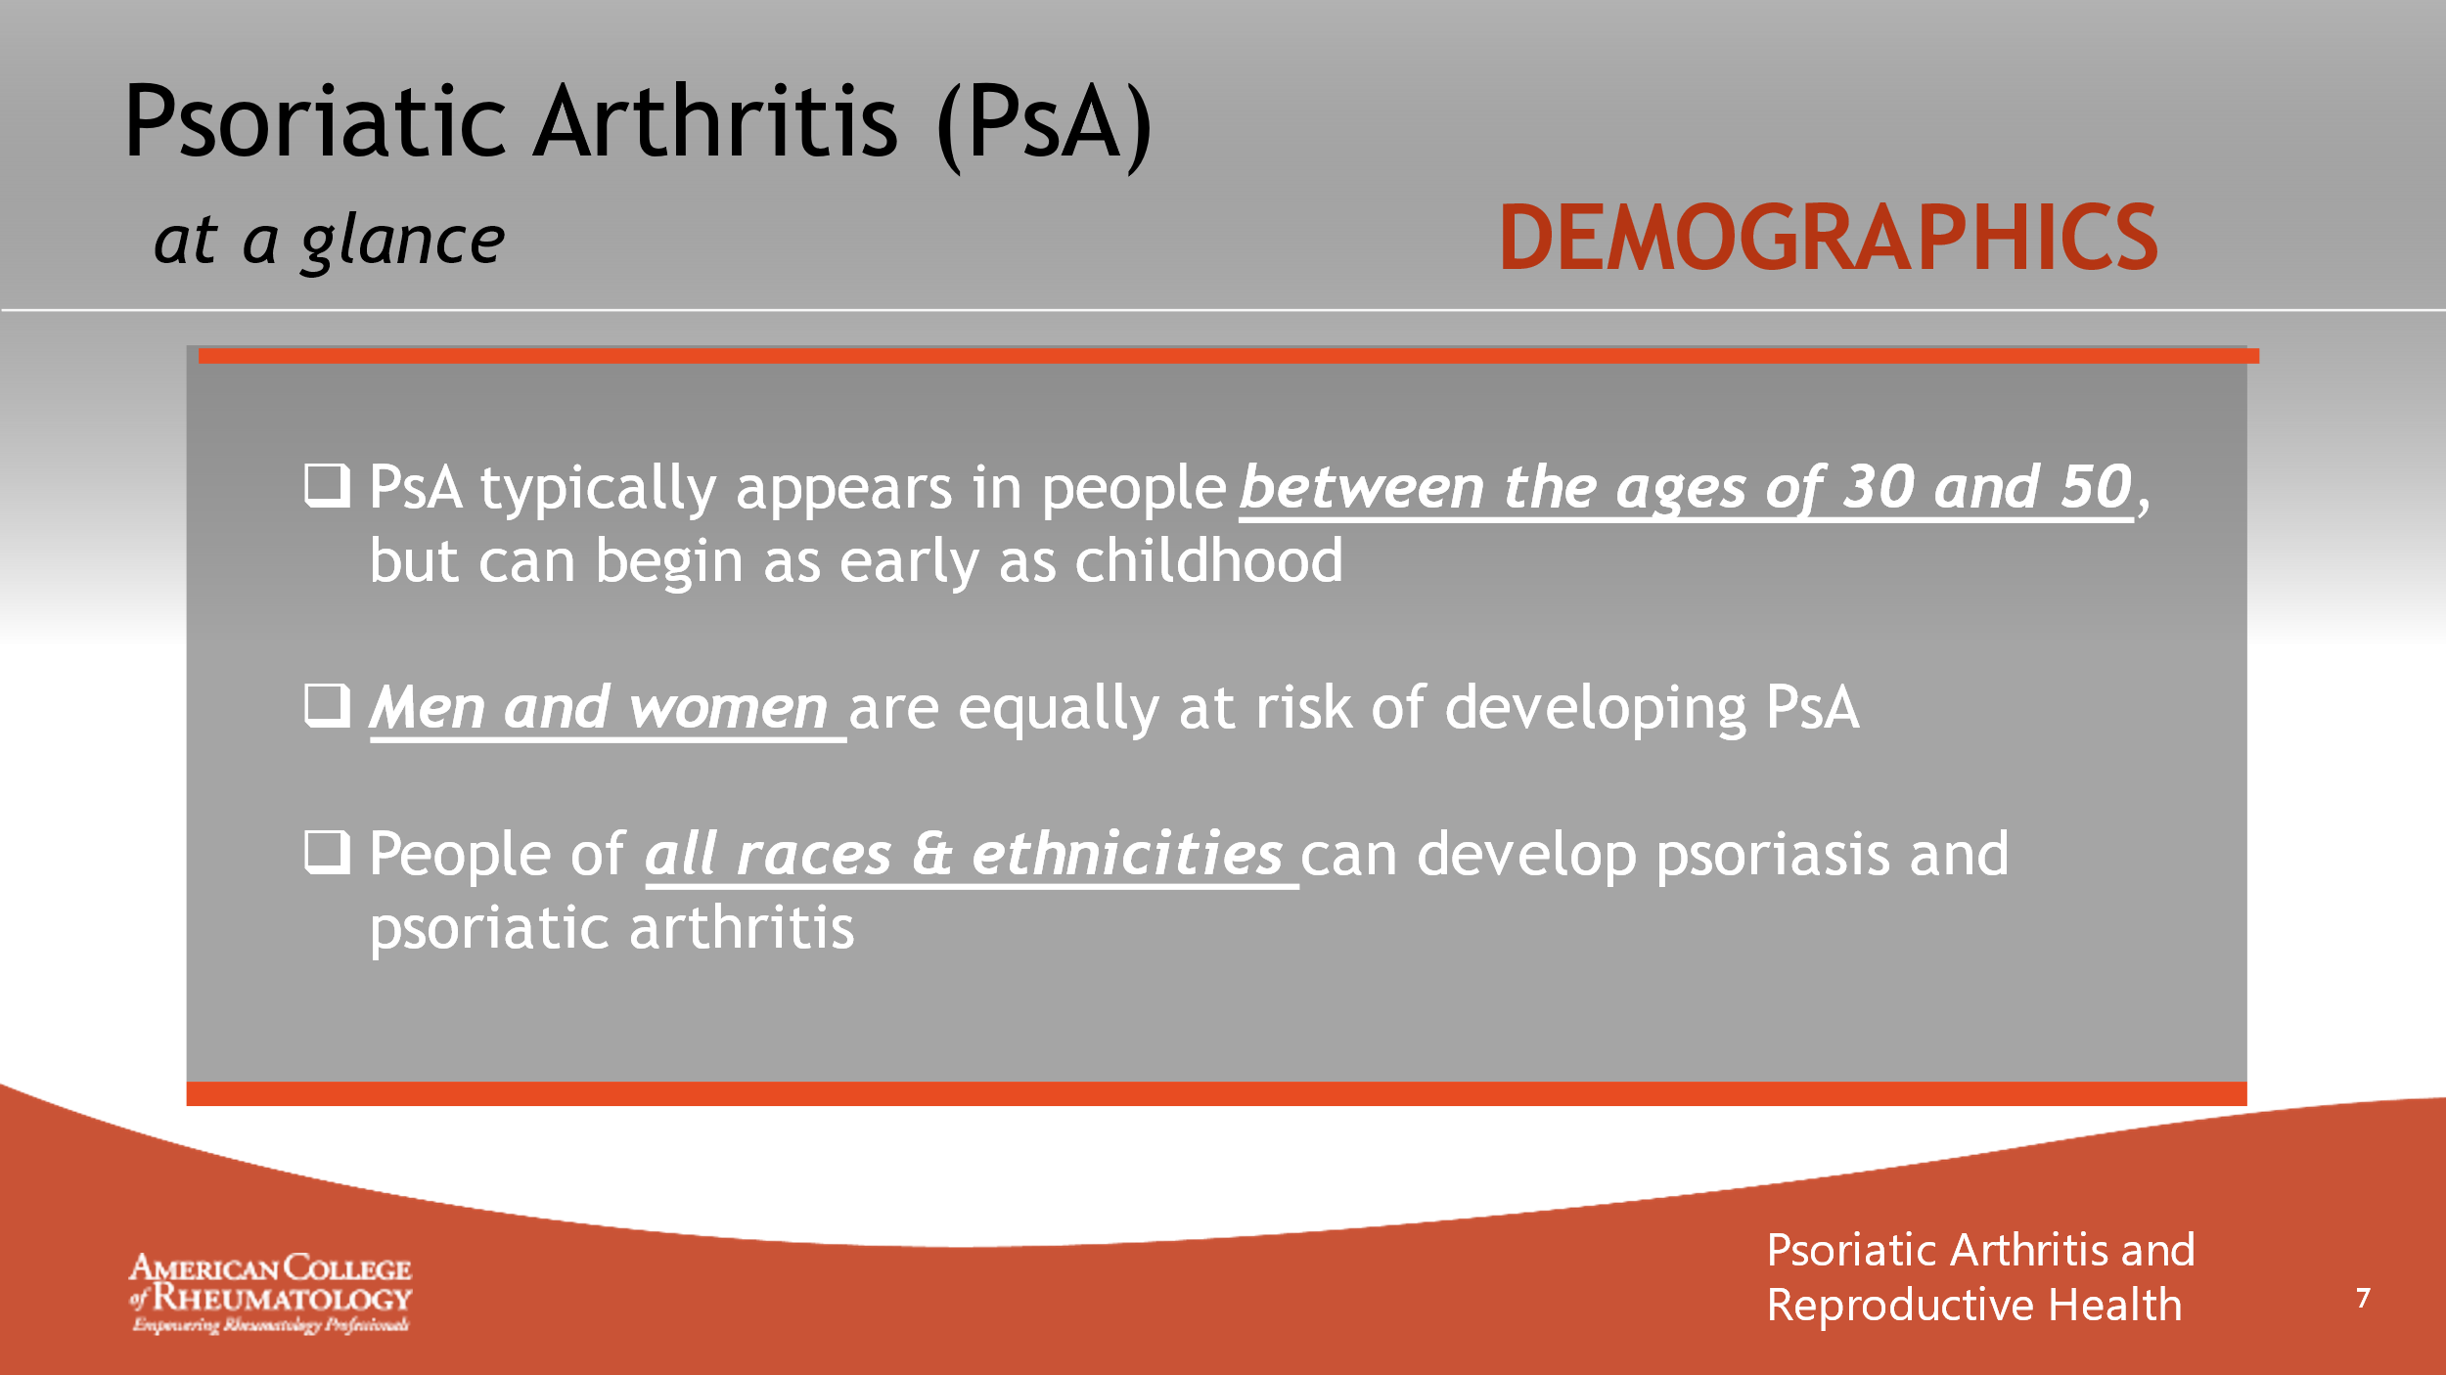

- _______________________________________________________
- _______________________________________________________
- _______________________________________________________
- _______________________________________________________
- _______________________________________________________
- _______________________________________________________
- _______________________________________________________
- _______________________________________________________

Slide 8: CASE 1 - TAMMY

- _______________________________________________________
- _______________________________________________________
- _______________________________________________________
- _______________________________________________________
- _______________________________________________________
- _______________________________________________________
- _______________________________________________________
- _______________________________________________________

Slide 9: MEET TAMMY
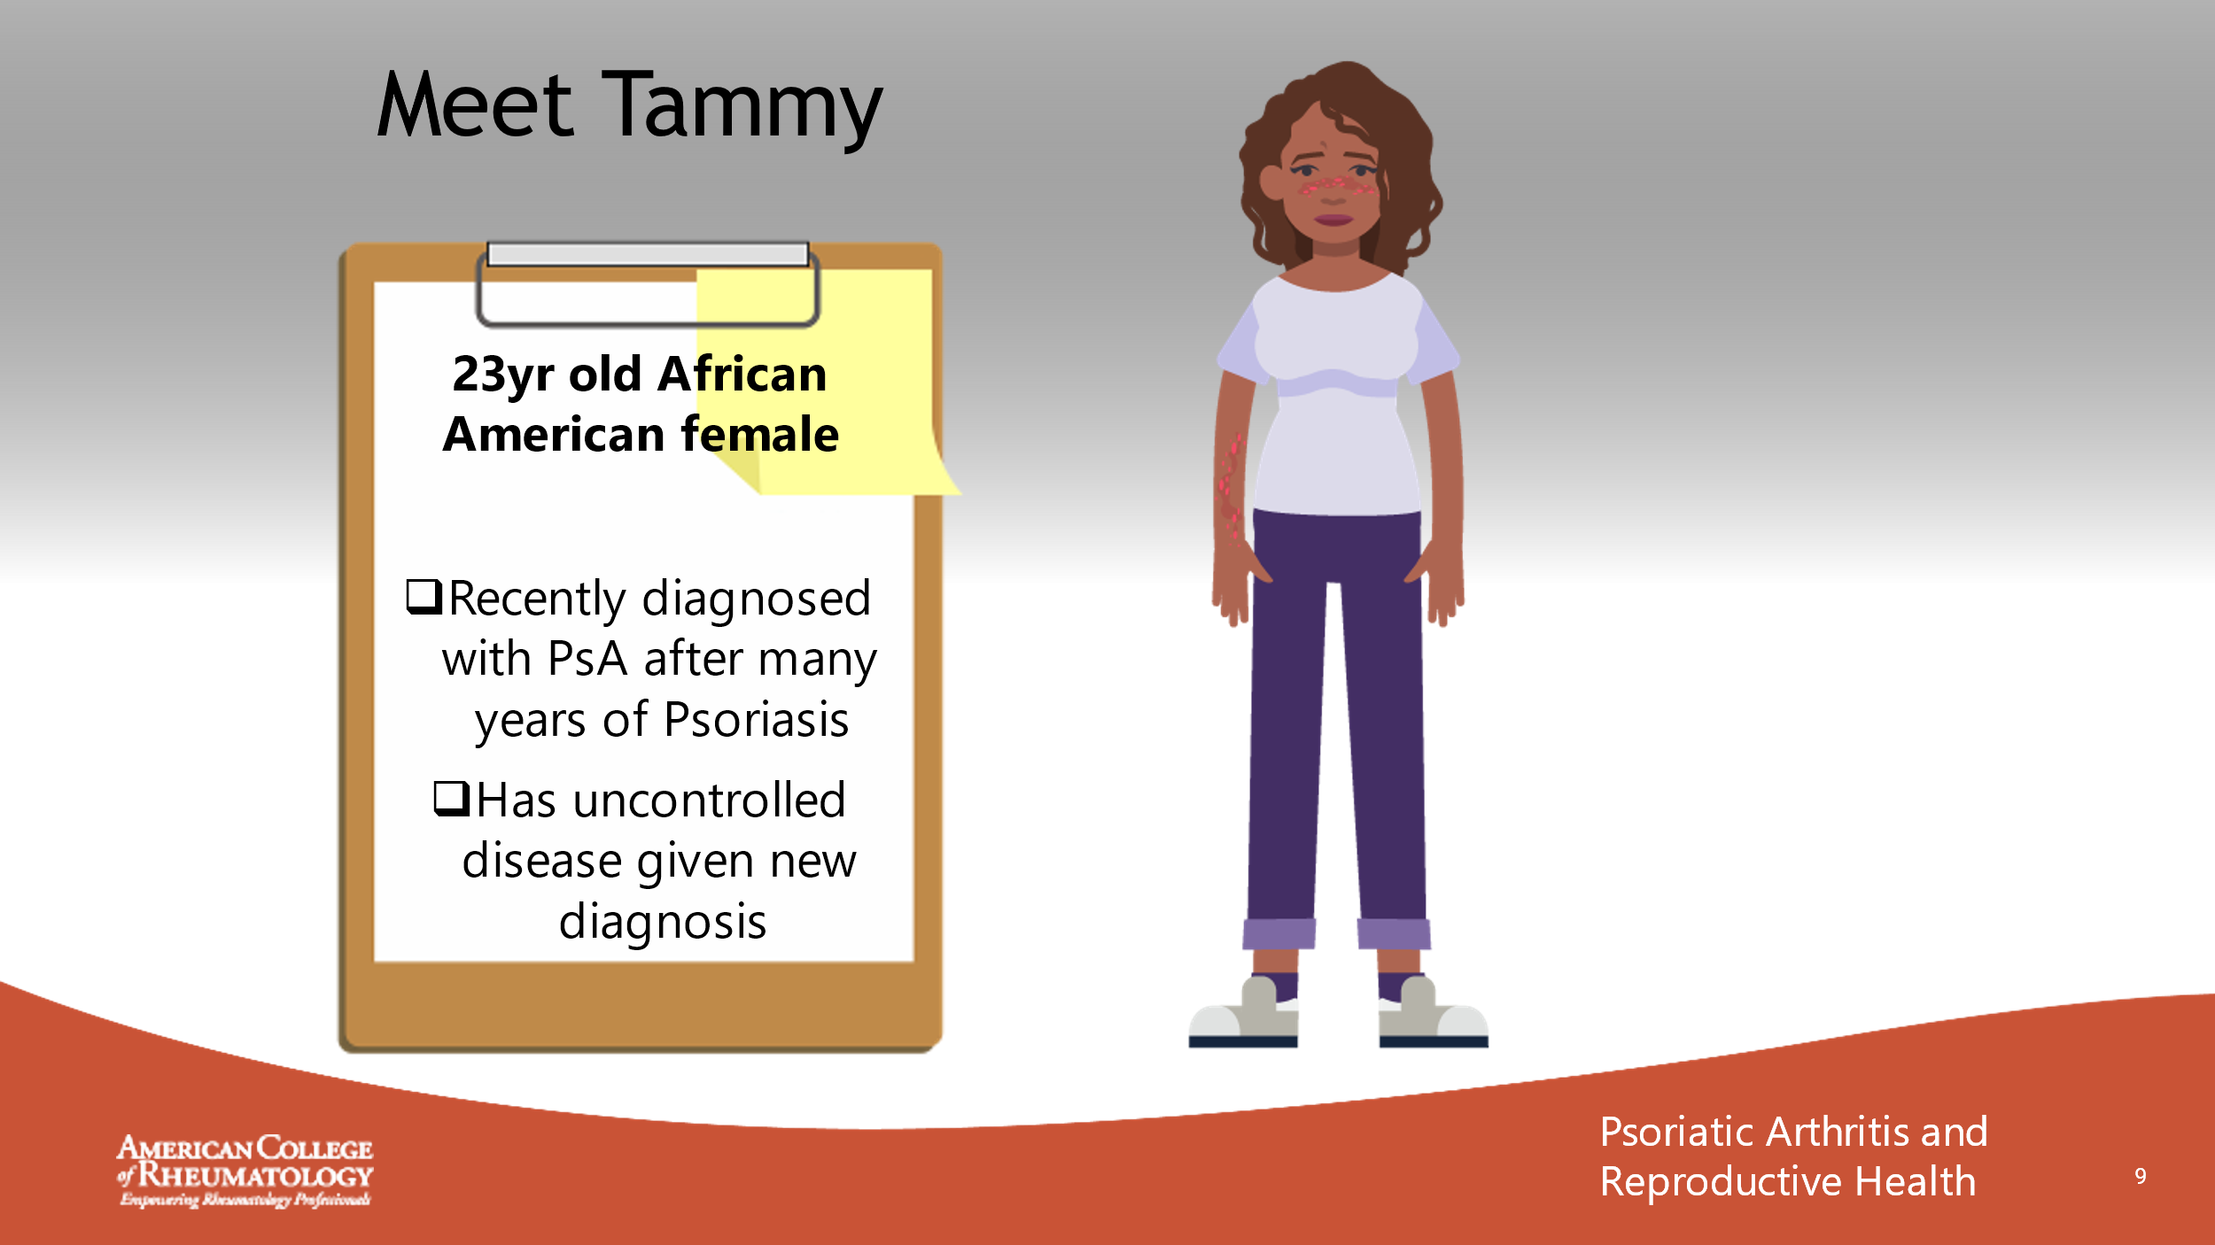

- _______________________________________________________
- _______________________________________________________
- _______________________________________________________
- _______________________________________________________
- _______________________________________________________
- _______________________________________________________
- _______________________________________________________
- _______________________________________________________

Slide 10: CONVERSATION
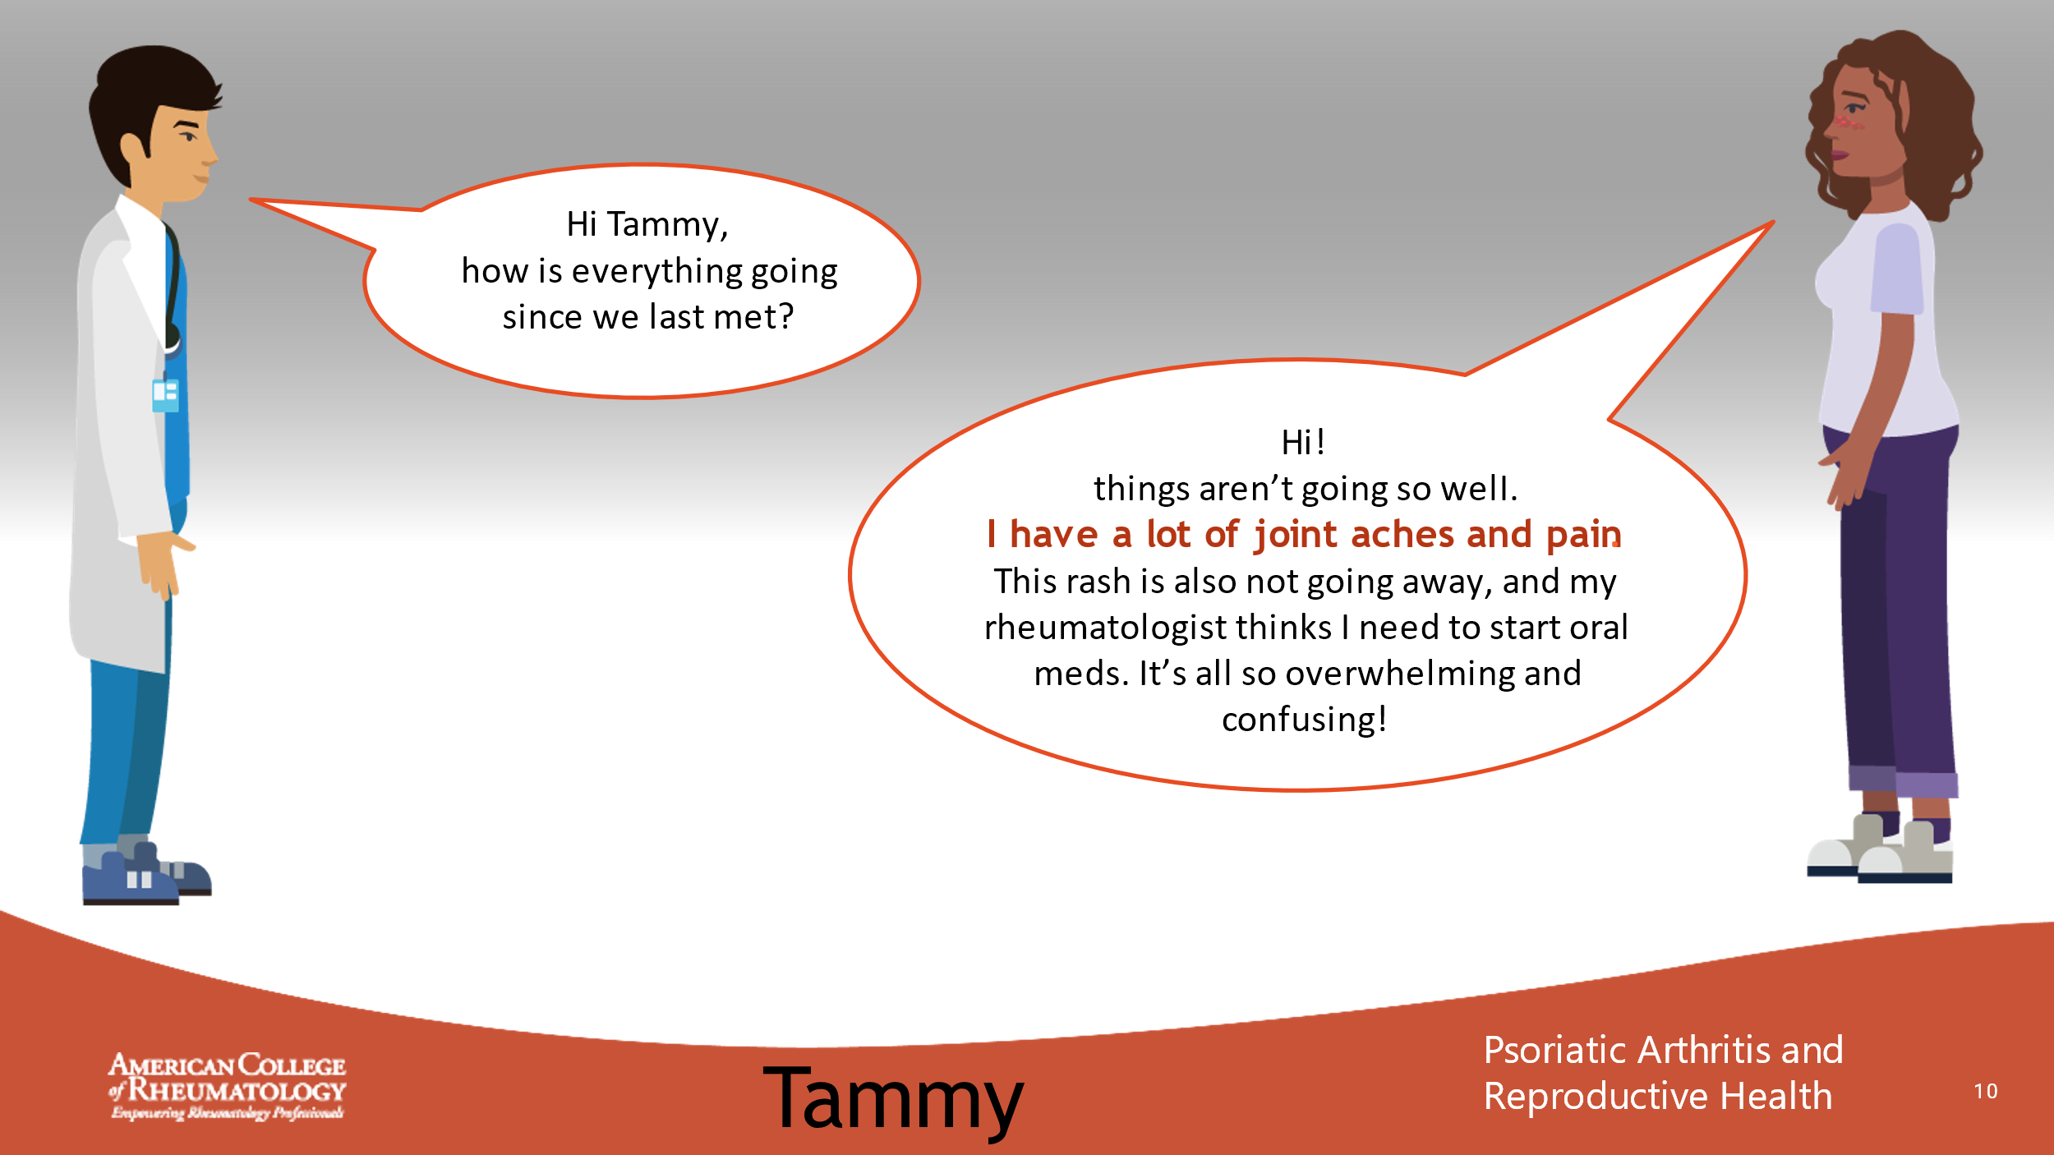

- _______________________________________________________
- _______________________________________________________
- _______________________________________________________
- _______________________________________________________
- _______________________________________________________
- _______________________________________________________
- _______________________________________________________
- _______________________________________________________

Slide 11: CONVERSATION
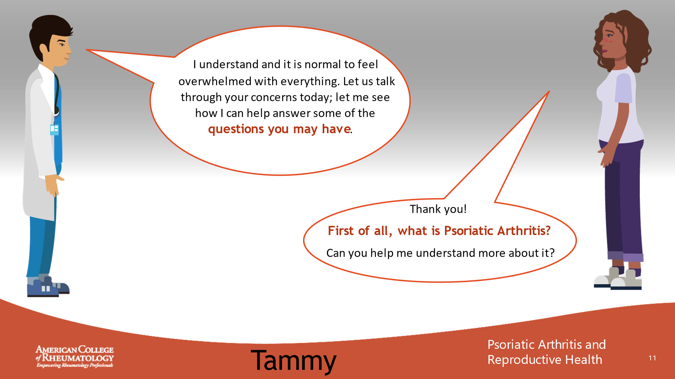

- _______________________________________________________
- _______________________________________________________
- _______________________________________________________
- _______________________________________________________
- _______________________________________________________
- _______________________________________________________
- _______________________________________________________
- _______________________________________________________

Slide 12: CONVERSATION
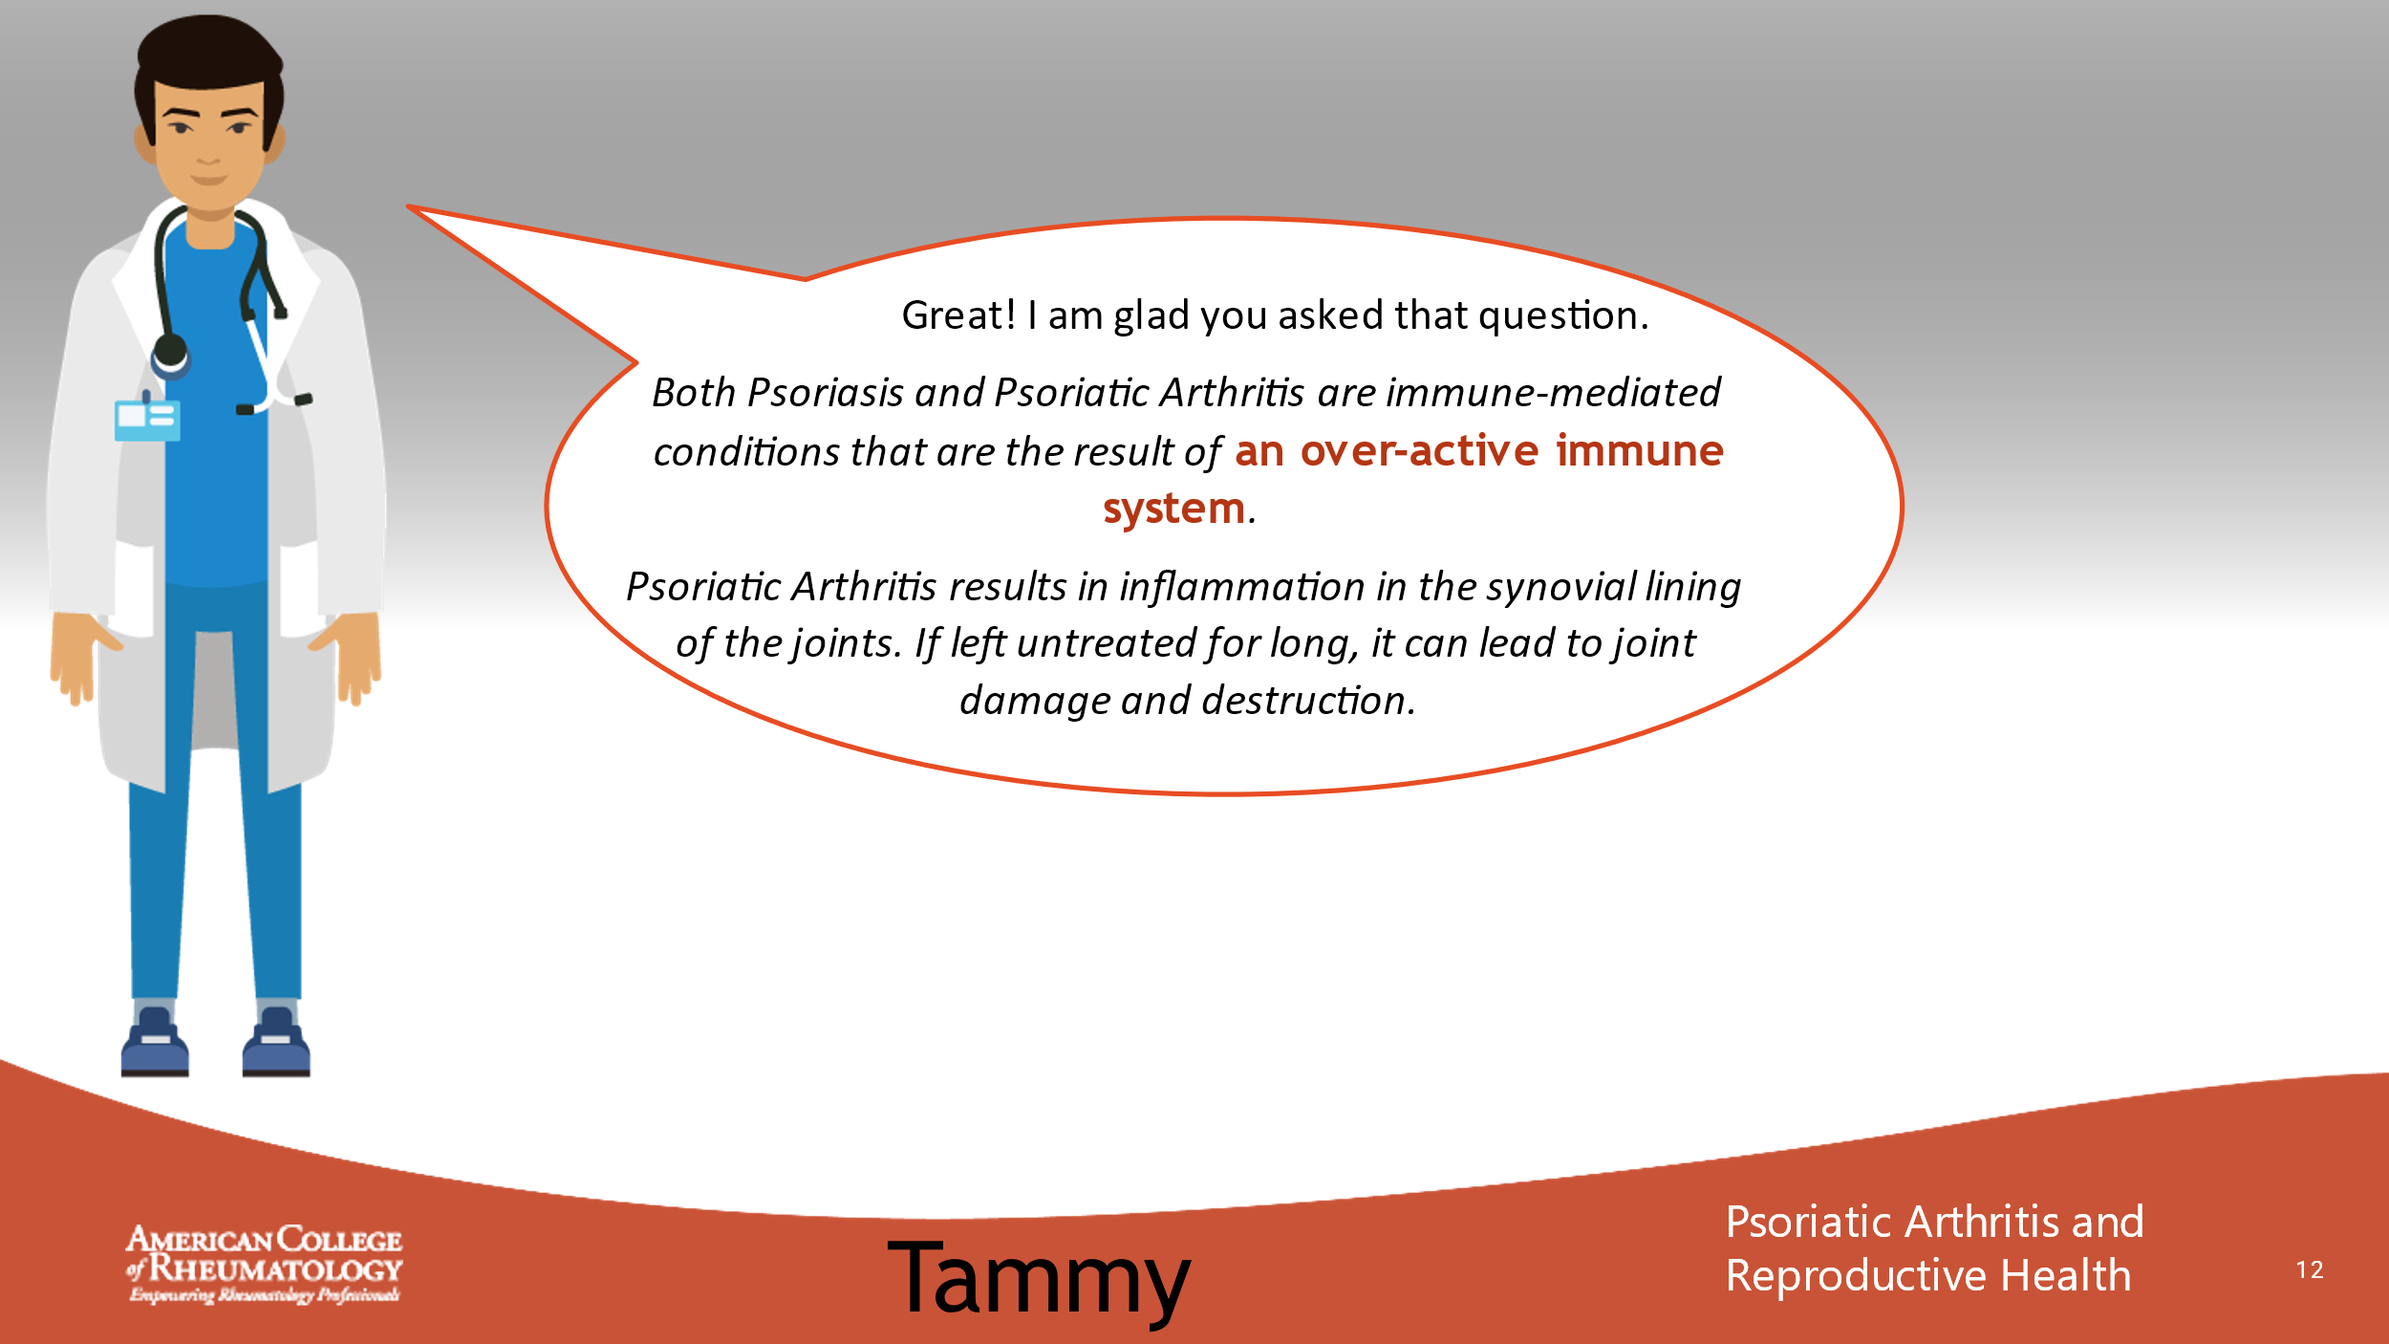

- _______________________________________________________
- _______________________________________________________
- _______________________________________________________
- _______________________________________________________
- _______________________________________________________
- _______________________________________________________
- _______________________________________________________
- _______________________________________________________

Slide 13: CONVERSATION
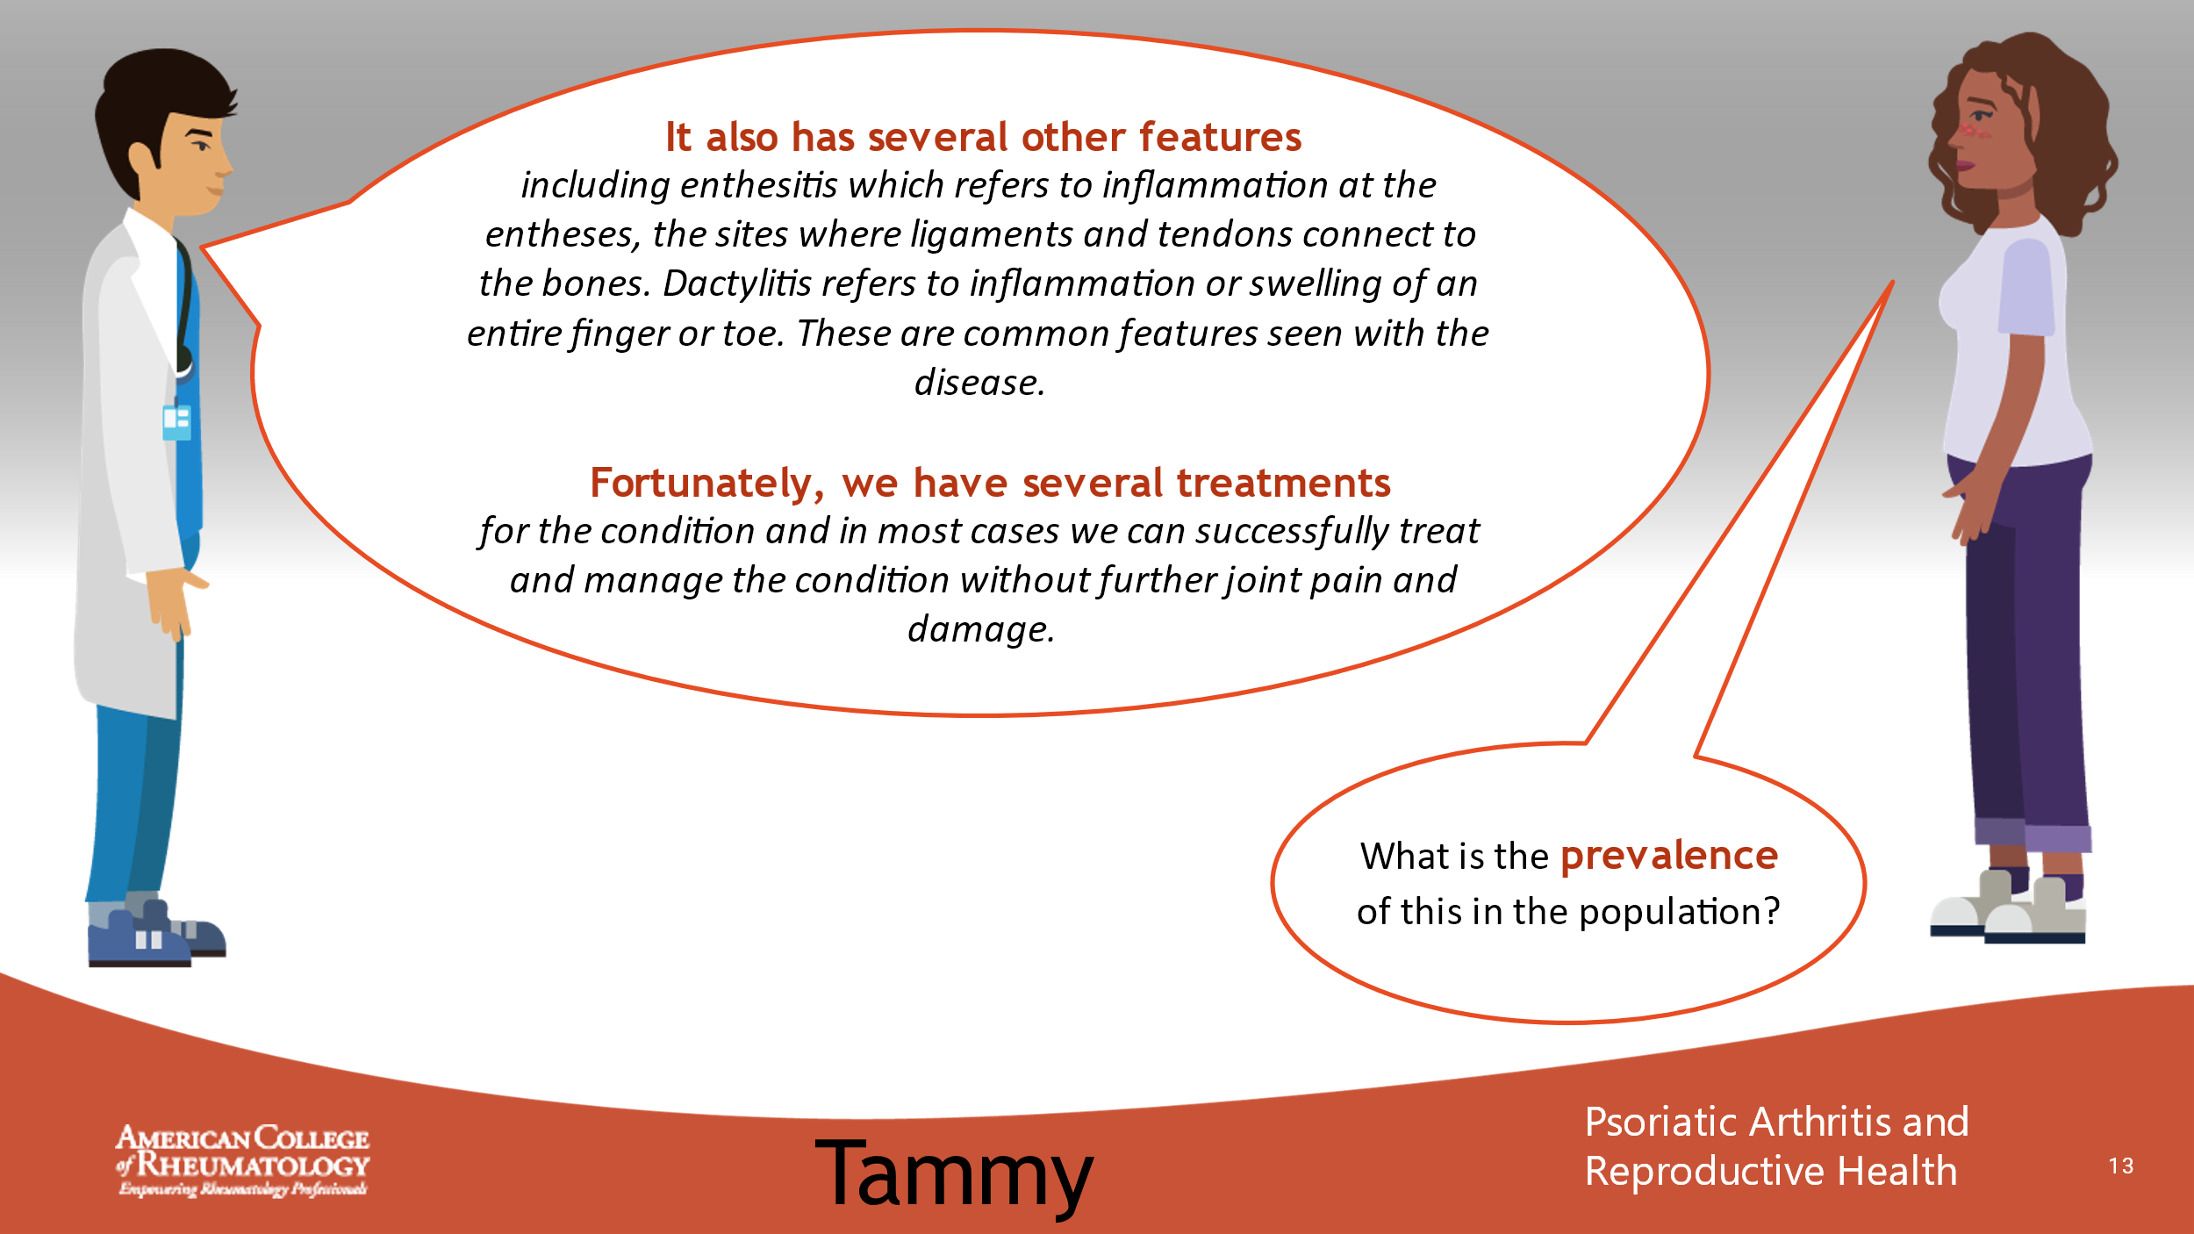

- _______________________________________________________
- _______________________________________________________
- _______________________________________________________
- _______________________________________________________
- _______________________________________________________
- _______________________________________________________
- _______________________________________________________
- _______________________________________________________

Slide 14: CONVERSATION
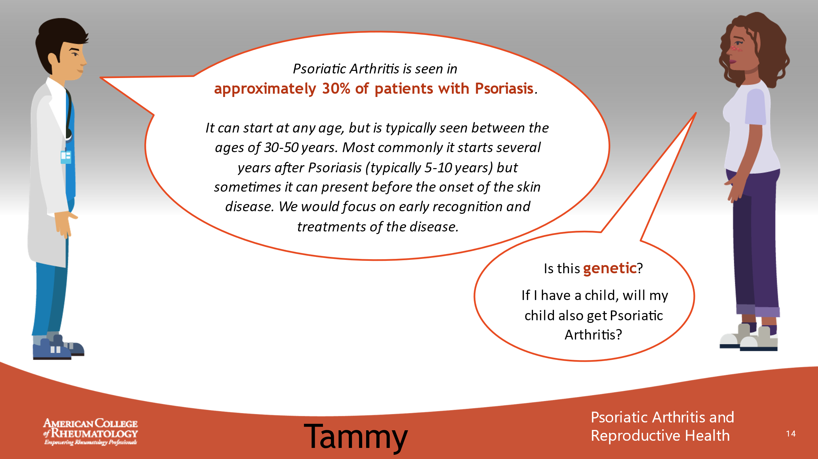

- _______________________________________________________
- _______________________________________________________
- _______________________________________________________
- _______________________________________________________
- _______________________________________________________
- _______________________________________________________
- _______________________________________________________
- _______________________________________________________

Slide 15: CONVERSATION
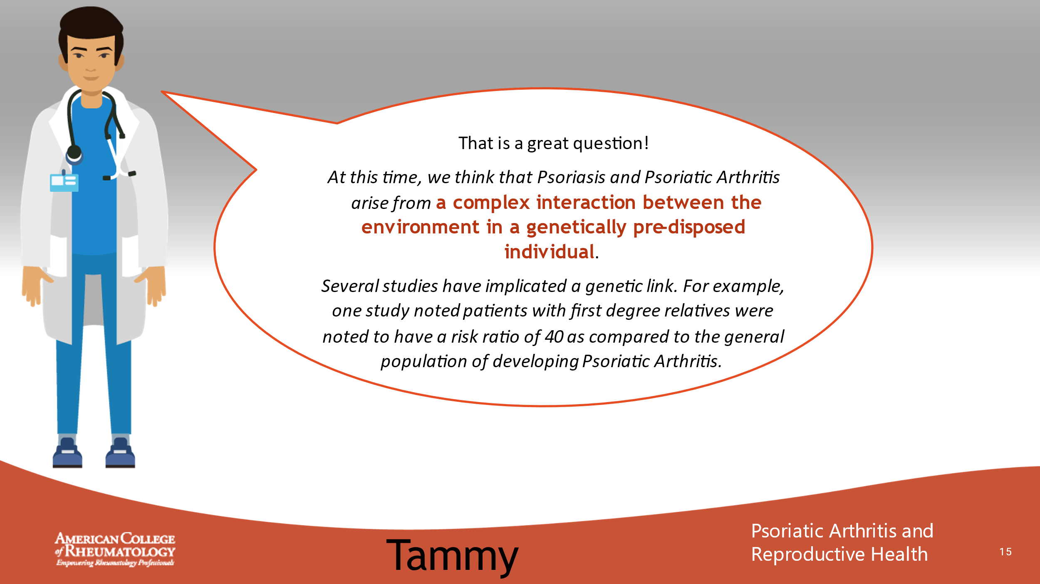

- _______________________________________________________
- _______________________________________________________
- _______________________________________________________
- _______________________________________________________
- _______________________________________________________
- _______________________________________________________
- _______________________________________________________
- _______________________________________________________

Slide 16: CONVERSATION
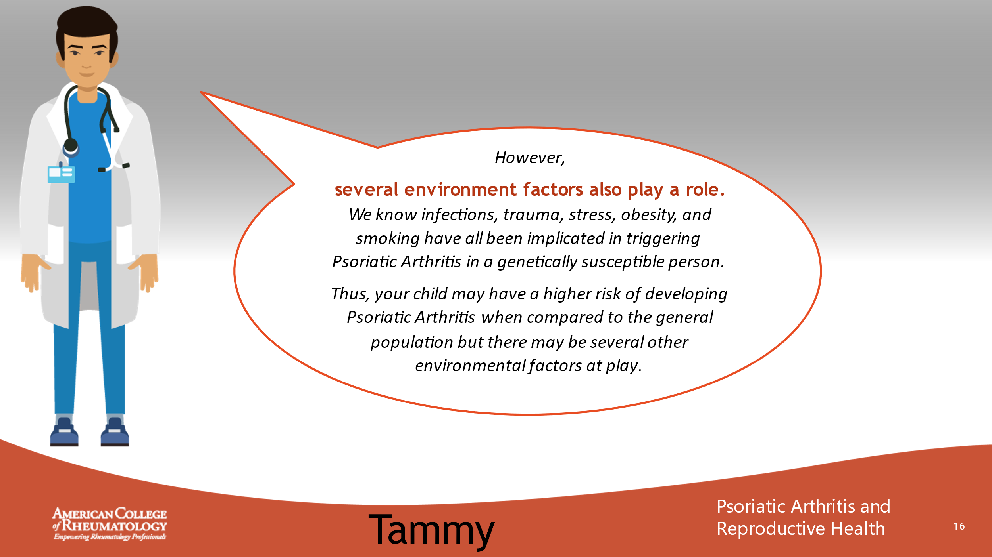

- _______________________________________________________
- _______________________________________________________
- _______________________________________________________
- _______________________________________________________
- _______________________________________________________
- _______________________________________________________
- _______________________________________________________
- _______________________________________________________

Slide 17: CONVERSATION
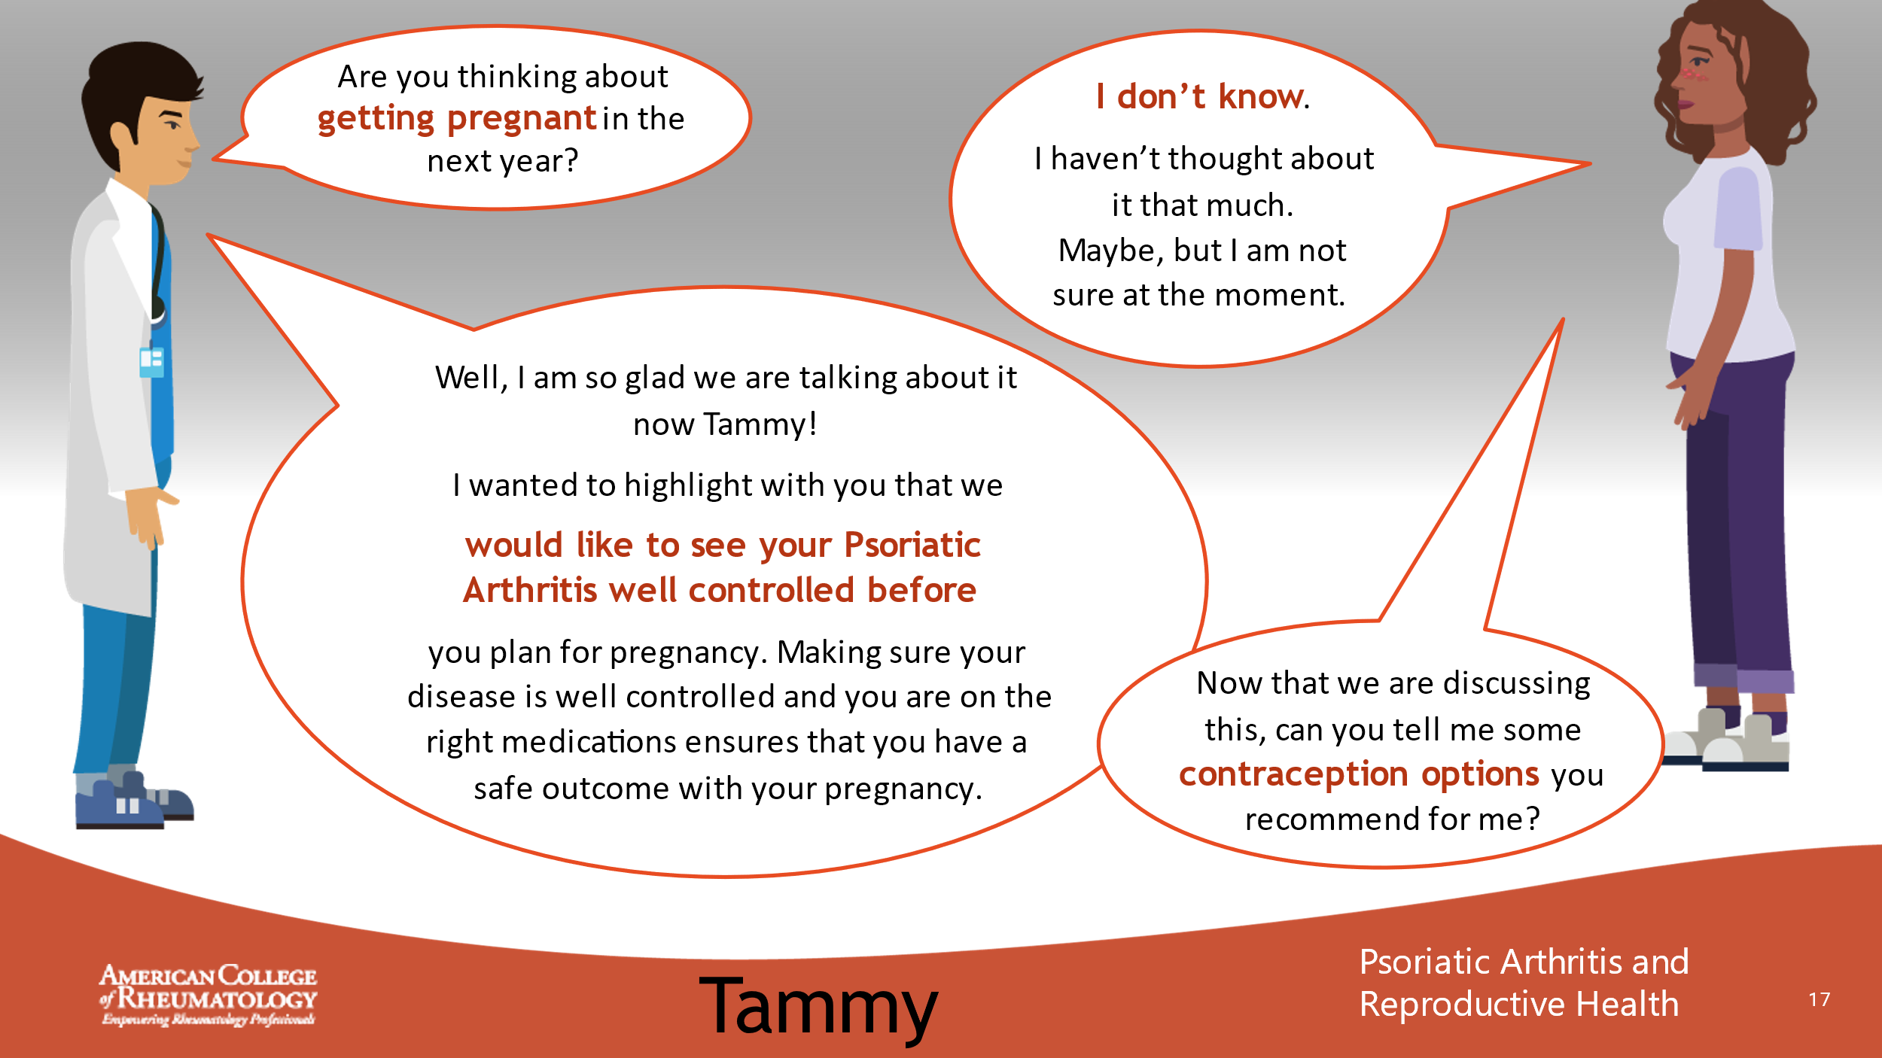

- _______________________________________________________
- _______________________________________________________
- _______________________________________________________
- _______________________________________________________
- _______________________________________________________
- _______________________________________________________
- _______________________________________________________
- _______________________________________________________

Slide 18: CONVERSATION
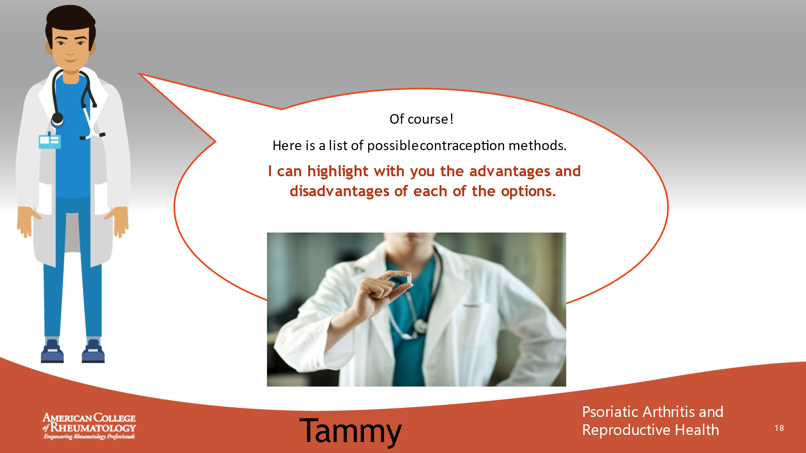

- _______________________________________________________
- _______________________________________________________
- _______________________________________________________
- _______________________________________________________
- _______________________________________________________
- _______________________________________________________
- _______________________________________________________
- _______________________________________________________

Slide 19: BIRTH CONTROL CHART
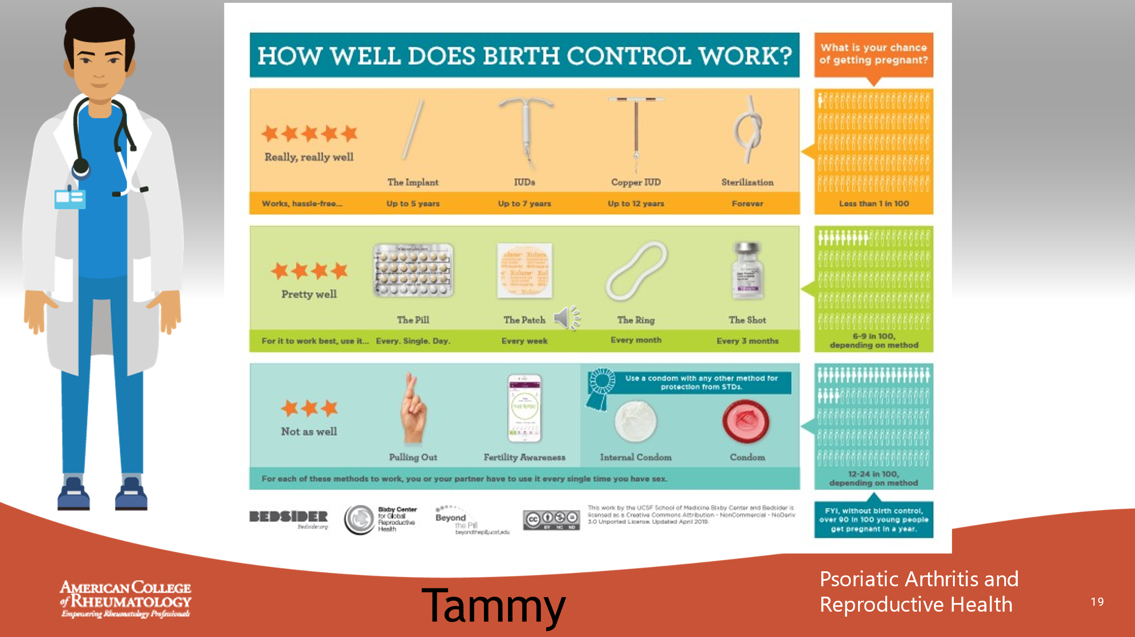
VOICEOVER TEXT

Provider: Okay here is a chart we can look at together. Let’s start at the bottom and work through the top. Overall, without any form of birth control, 90 out of 100 women would become pregnant in a year.
When it comes to contraception, we have lots of options to work with based on your comfort level. Effectiveness of the contraceptive is one way to look at it but there are also several other considerations. These include convenience, affordability, reversibility, side effect profile, method of use, partner preference, duration of time needed as well as unique benefits of one contraceptive over the other, such as lighter menstrual periods, protection against sexually transmitted infections, as well as reduction in the risks of certain types of cancers. Additionally, we want your decision to be compatible with your religious beliefs and cultural practices. That is why this is a shared decision-making process, so I want you to ask me lots of questions and feel comfortable with whichever method you choose!
Our least effective options include pulling out and fertility awareness. Condoms are moderately effective, but they have an additional benefit of preventing STDs. In all 12-24 out of every hundred women may get pregnant if only using these methods.
In the second tier of contraceptive options are pills, patch, the ring and shot. These methods work well and are effective. About 6-9 out of every 100 women still have a chance of pregnancy using these methods. For them to be effective, they must be taken, every day, every week or every month depending on the method.
On the third tier and all the way at the top are methods that work well. These include implants, IUD which are effective for several years at a time. A more permanent option is of course sterilization. Less than 1 in 100 women would become pregnant in this option. What questions do you have for me?
Tammy: Thank you. This is very helpful.
Slide 20: CASE 1 LEARNING POINTS
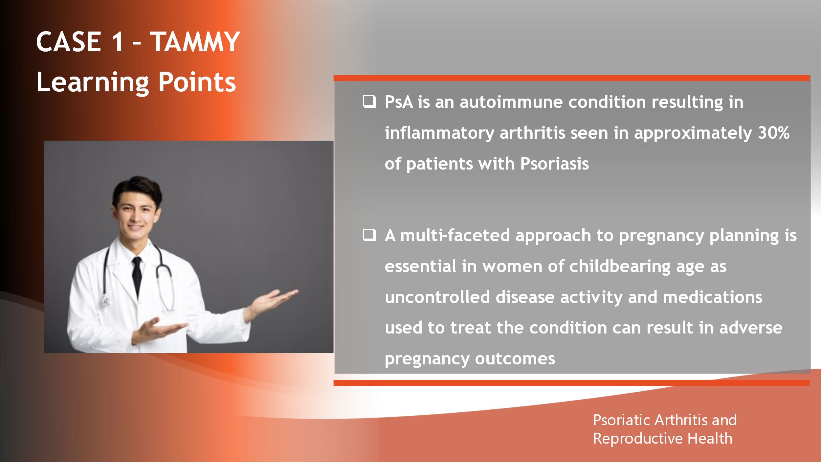

- _______________________________________________________
- _______________________________________________________
- _______________________________________________________
- _______________________________________________________
- _______________________________________________________
- _______________________________________________________
- _______________________________________________________
- _______________________________________________________

Slide 21: CASE 2 - LACEE

- _______________________________________________________
- _______________________________________________________
- _______________________________________________________
- _______________________________________________________
- _______________________________________________________
- _______________________________________________________
- _______________________________________________________
- _______________________________________________________

Slide 22: MEET LACEE
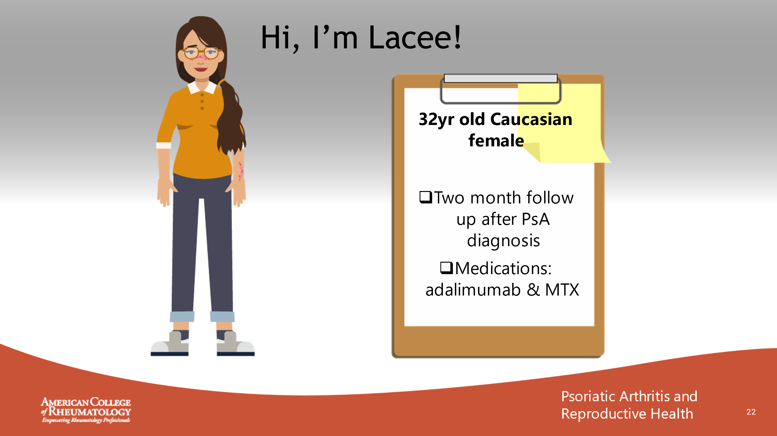

- _______________________________________________________
- _______________________________________________________
- _______________________________________________________
- _______________________________________________________
- _______________________________________________________
- _______________________________________________________
- _______________________________________________________
- _______________________________________________________

Slide 23: CONVERSATION
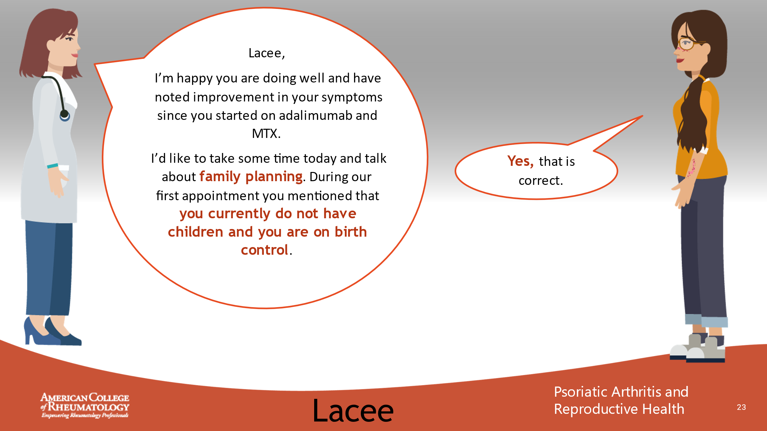

- _______________________________________________________
- _______________________________________________________
- _______________________________________________________
- _______________________________________________________
- _______________________________________________________
- _______________________________________________________
- _______________________________________________________
- _______________________________________________________

Slide 24: CONVERSATION
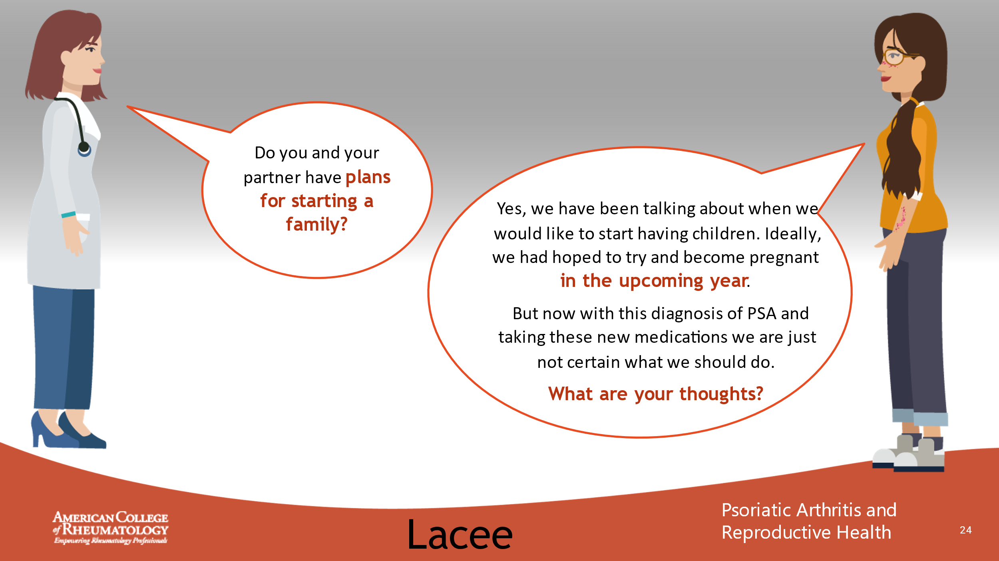

- _______________________________________________________
- _______________________________________________________
- _______________________________________________________
- _______________________________________________________
- _______________________________________________________
- _______________________________________________________
- _______________________________________________________
- _______________________________________________________

Slide 25: CONVERSATION
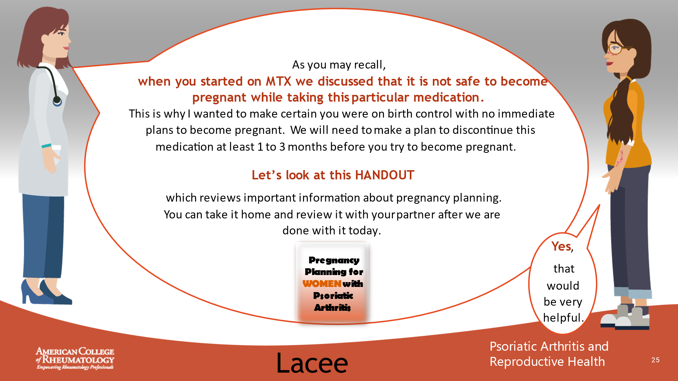

- _______________________________________________________
- _______________________________________________________
- _______________________________________________________
- _______________________________________________________
- _______________________________________________________
- _______________________________________________________
- _______________________________________________________
- _______________________________________________________

Slide 26: PREGNANCY PLANNING – 4 STEPS (HANDOUT)
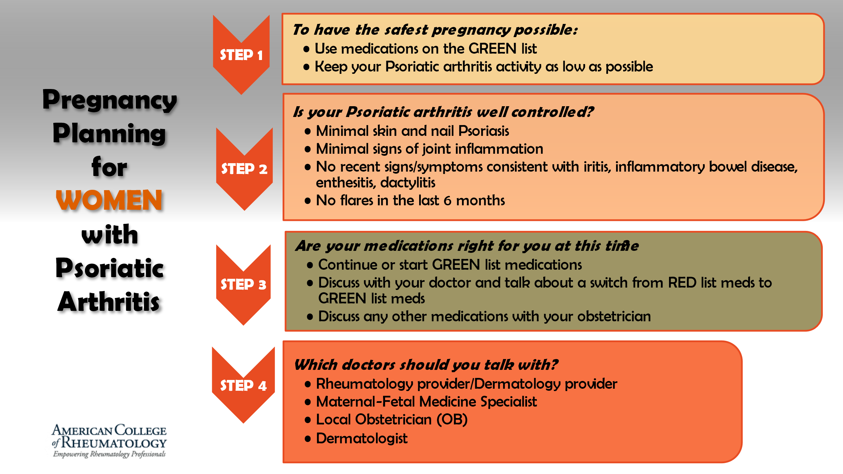

- _______________________________________________________
- _______________________________________________________
- _______________________________________________________
- _______________________________________________________
- _______________________________________________________
- _______________________________________________________
- _______________________________________________________
- _______________________________________________________

Slide 27: PREGNANCY PLANNING – STEP 1
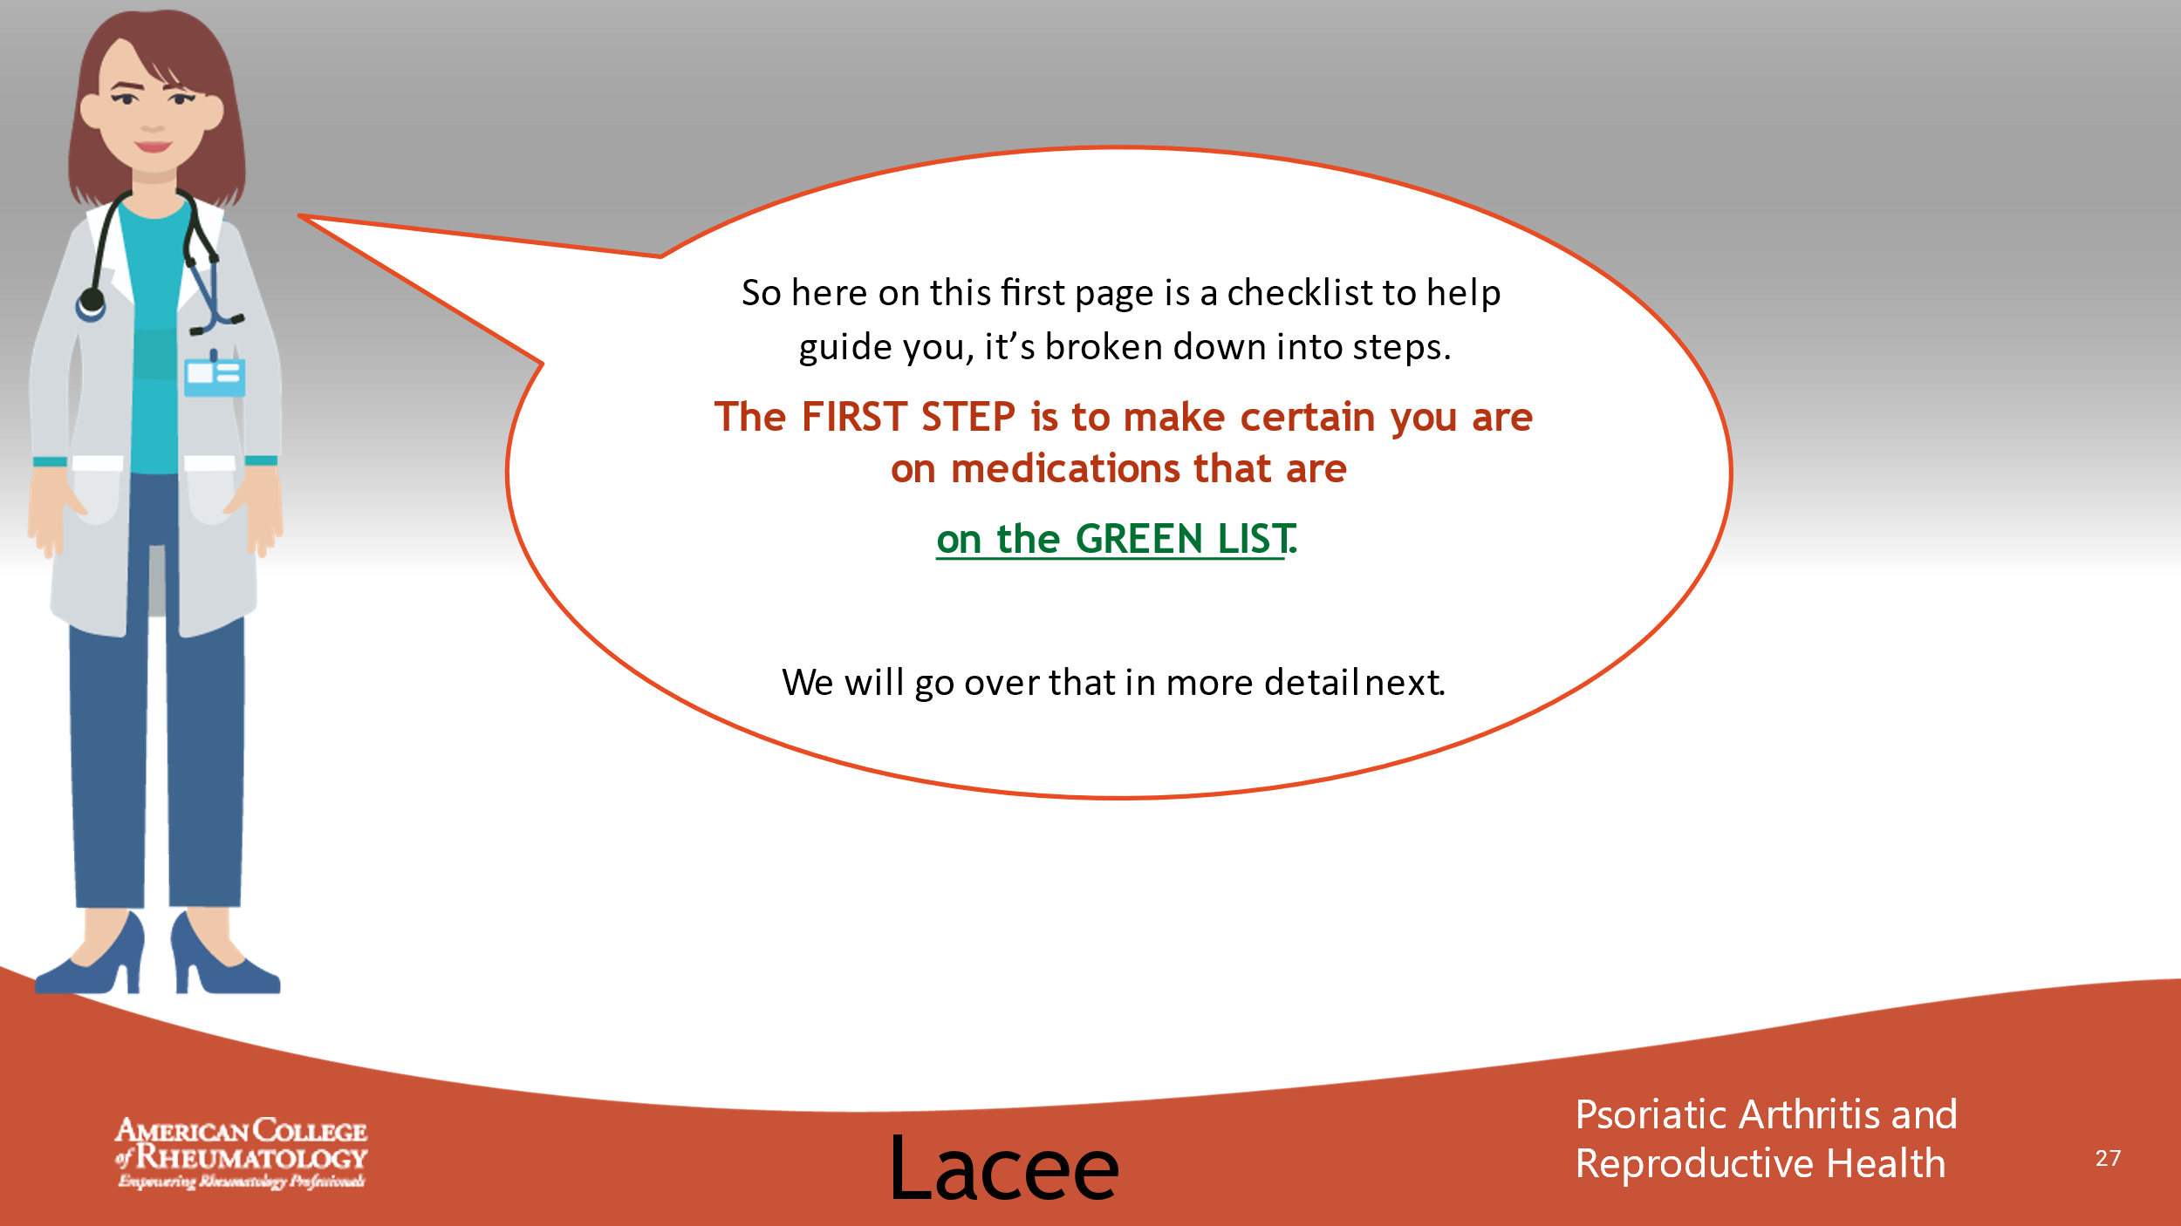

- _______________________________________________________
- _______________________________________________________
- _______________________________________________________
- _______________________________________________________
- _______________________________________________________
- _______________________________________________________
- _______________________________________________________
- _______________________________________________________

Slide 28: MEDICATION LIST (HANDOUT)
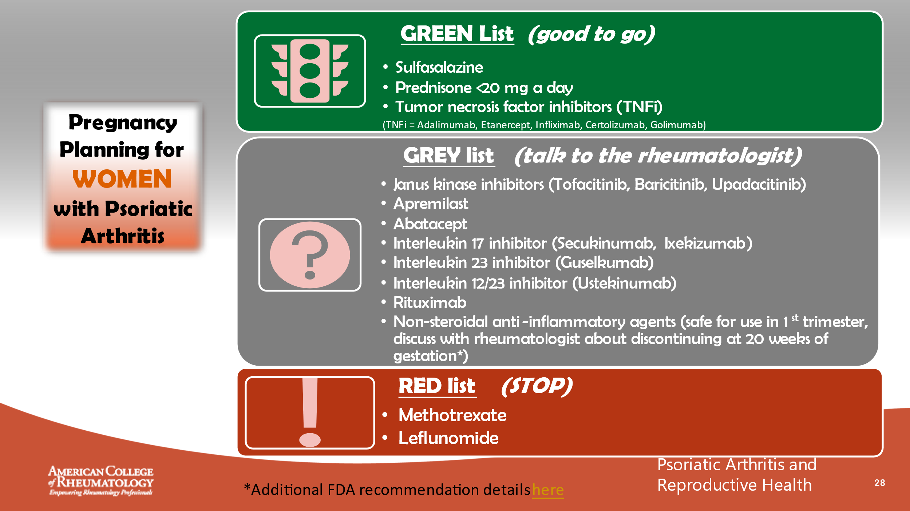

- _______________________________________________________
- _______________________________________________________
- _______________________________________________________
- _______________________________________________________
- _______________________________________________________
- _______________________________________________________
- _______________________________________________________
- _______________________________________________________

Slide 29: PREGNANCY PLANNING – STEP 2 & 3
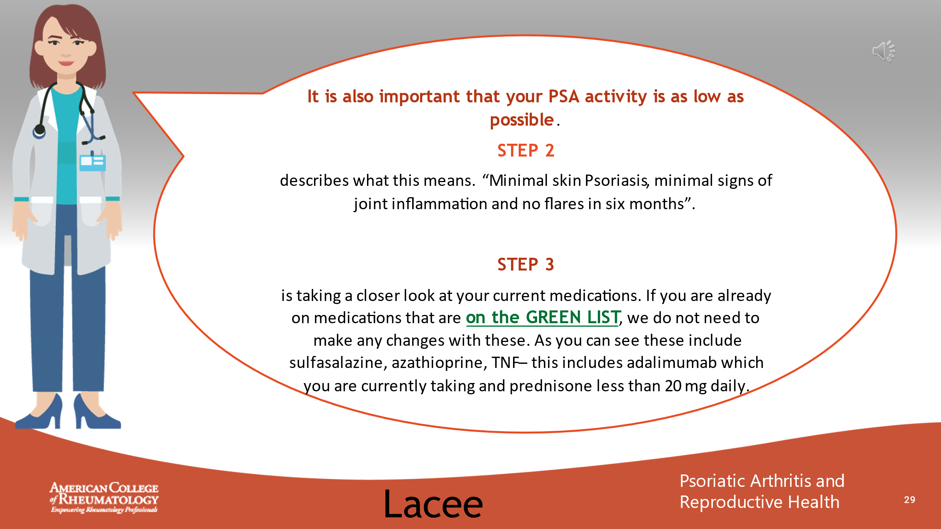

- _______________________________________________________
- _______________________________________________________
- _______________________________________________________
- _______________________________________________________
- _______________________________________________________
- _______________________________________________________
- _______________________________________________________
- _______________________________________________________

Slide 30: PREGNANCY PLANNING – STEP 2 & 3
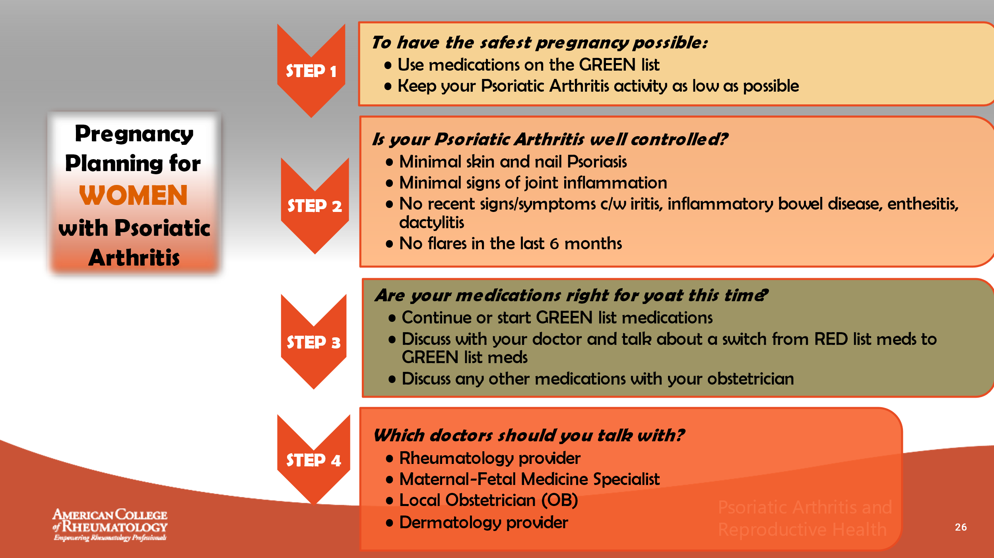

- _______________________________________________________
- _______________________________________________________
- _______________________________________________________
- _______________________________________________________
- _______________________________________________________
- _______________________________________________________
- _______________________________________________________
- _______________________________________________________

Slide 31: PREGNANCY PLANNING – MEDICATIONS
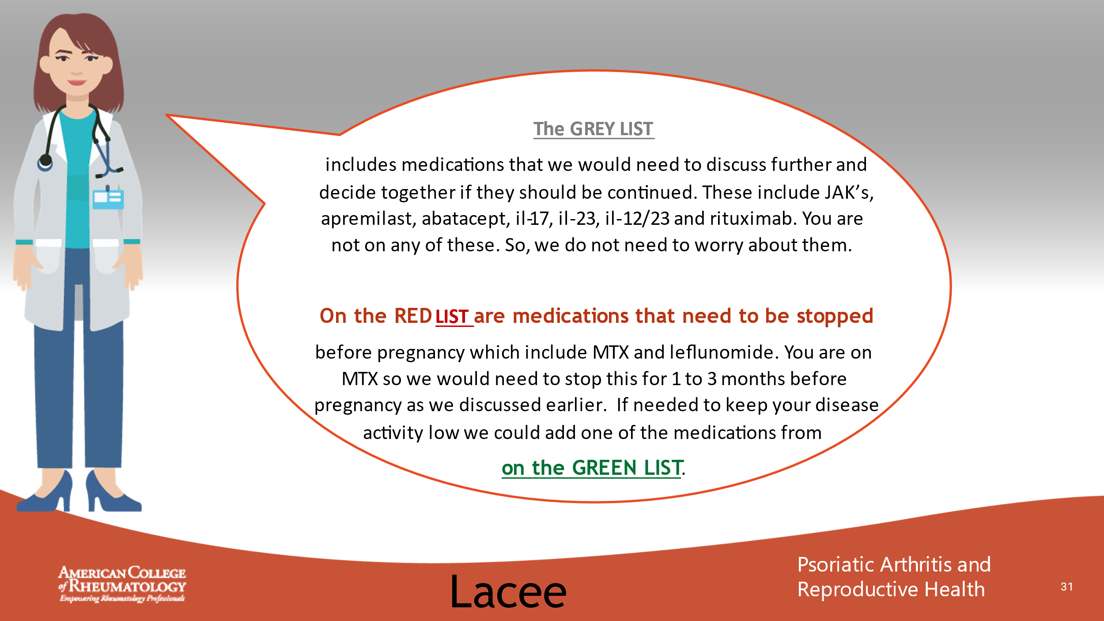

- _______________________________________________________
- _______________________________________________________
- _______________________________________________________
- _______________________________________________________
- _______________________________________________________
- _______________________________________________________
- _______________________________________________________
- _______________________________________________________

Slide 32: MEDICATION LIST (HANDOUT)
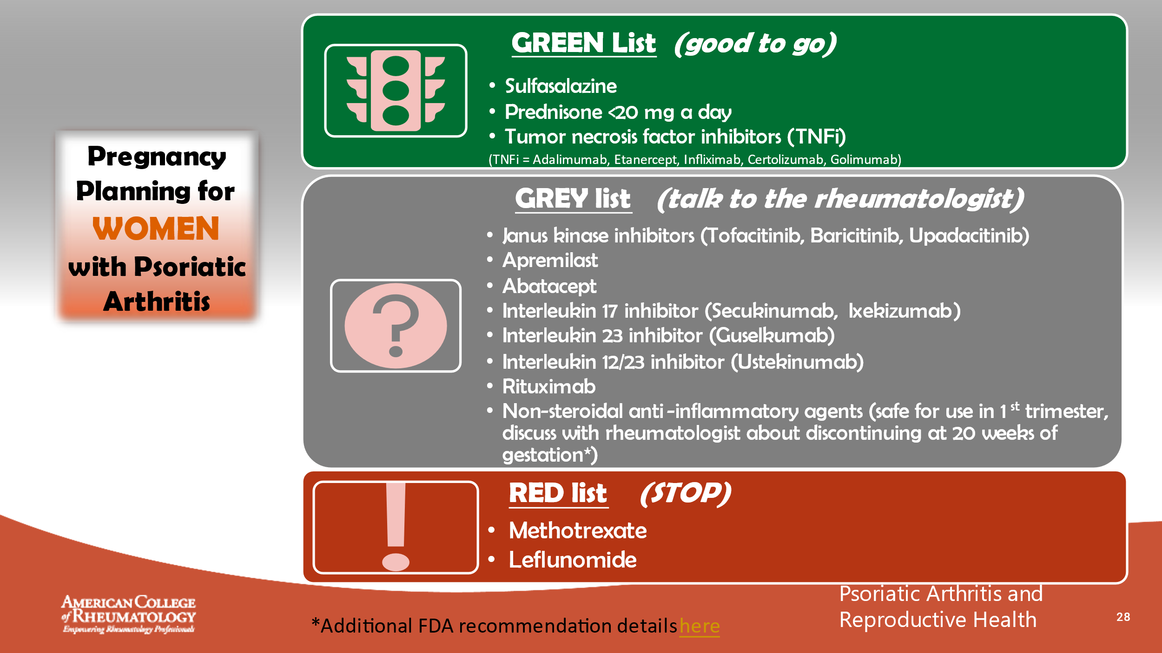

- _______________________________________________________
- _______________________________________________________
- _______________________________________________________
- _______________________________________________________
- _______________________________________________________
- _______________________________________________________
- _______________________________________________________
- _______________________________________________________

Slide 33: PREGNANCY PLANNING – STEP 3 & 4
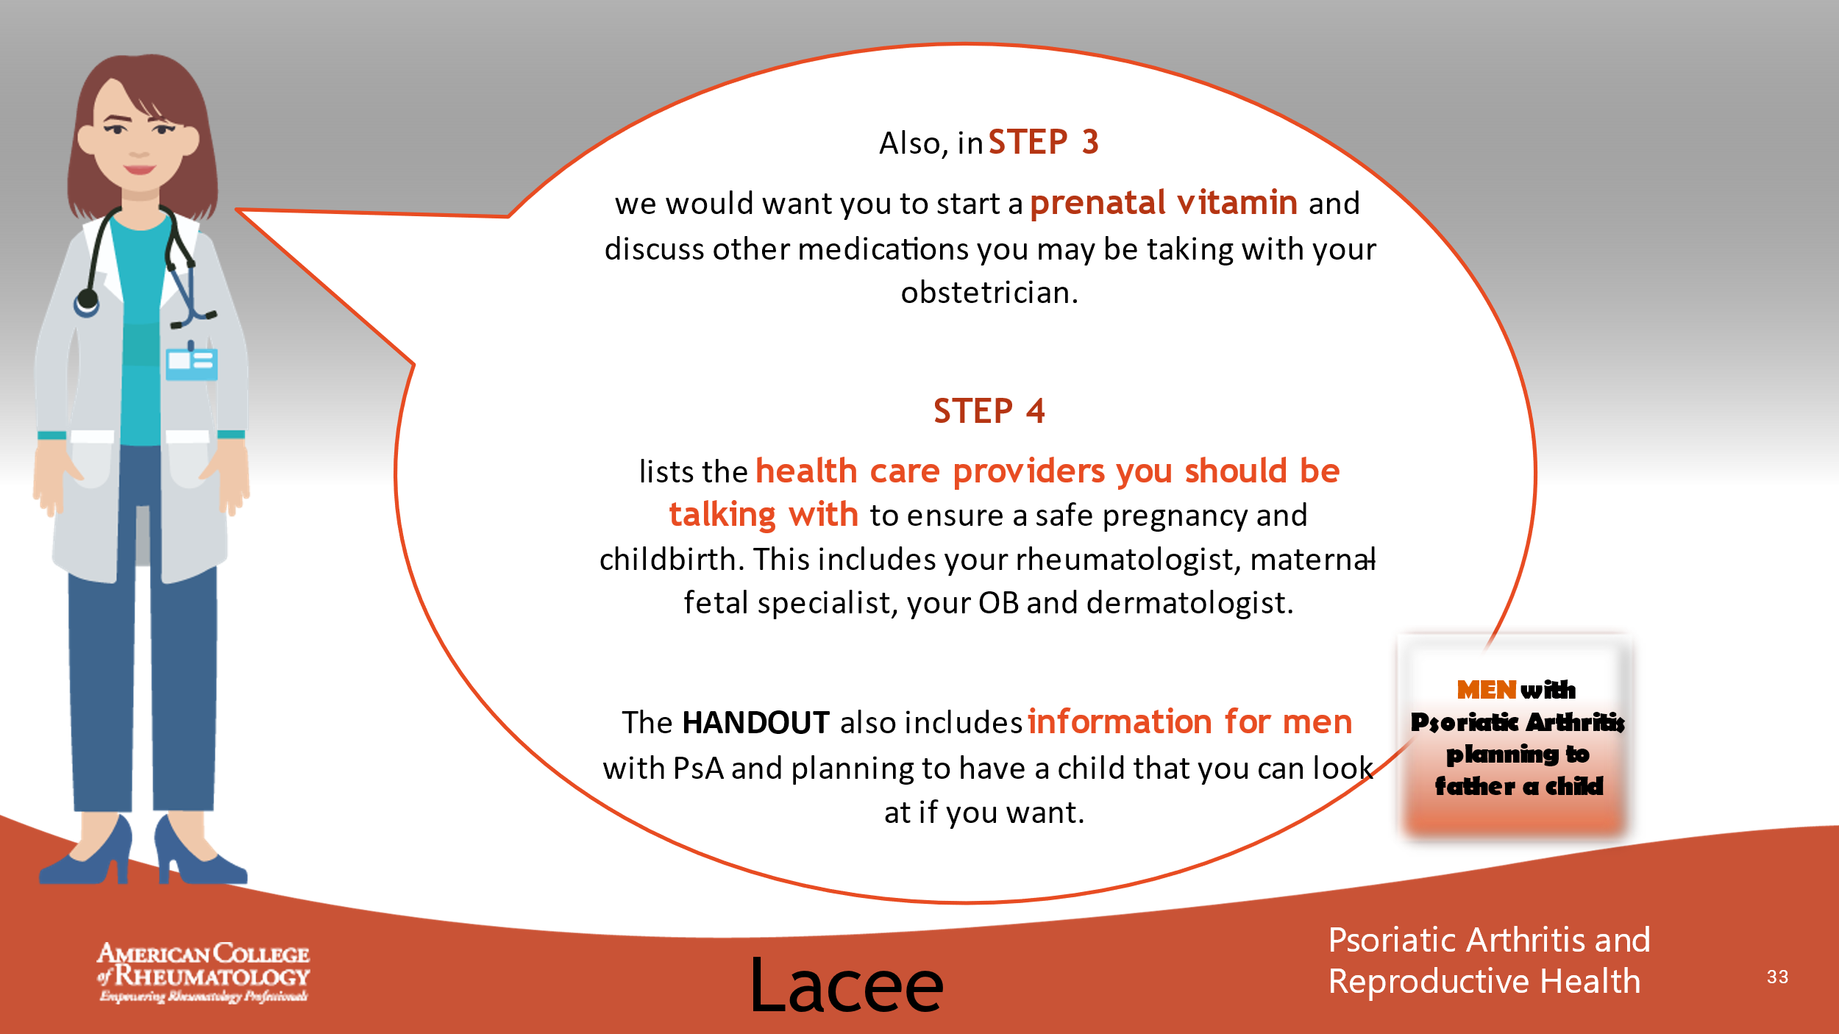

- _______________________________________________________
- _______________________________________________________
- _______________________________________________________
- _______________________________________________________
- _______________________________________________________
- _______________________________________________________
- _______________________________________________________
- _______________________________________________________

Slide 34: PREGNANCY PLANNING – STEP 3 & 4
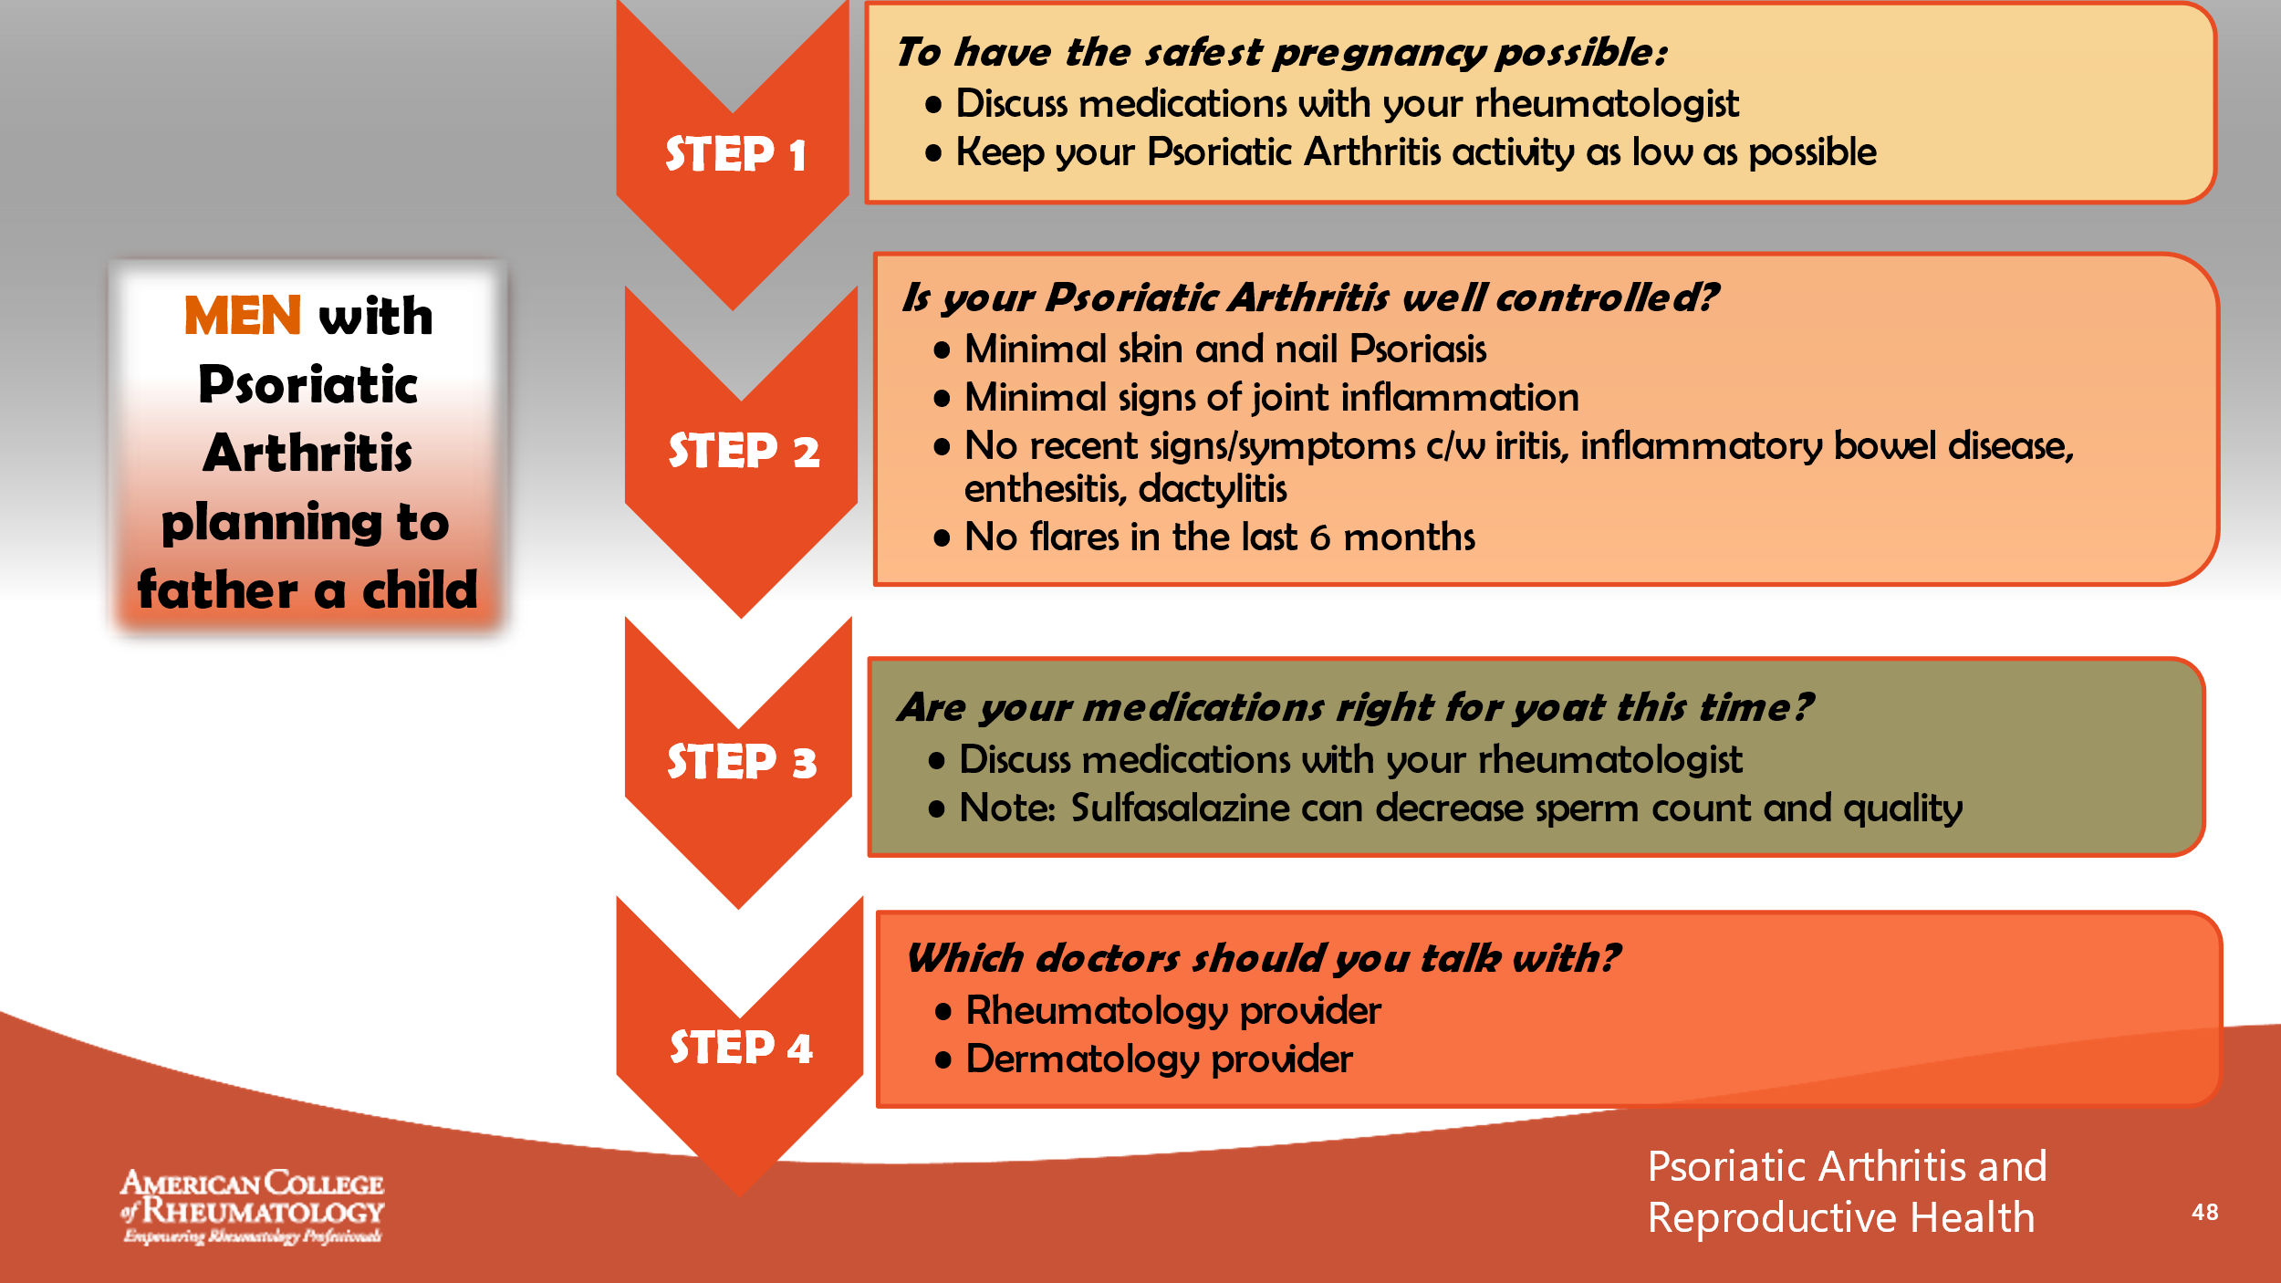

- _______________________________________________________
- _______________________________________________________
- _______________________________________________________
- _______________________________________________________
- _______________________________________________________
- _______________________________________________________
- _______________________________________________________
- _______________________________________________________

Slide 35: CONVERSATION
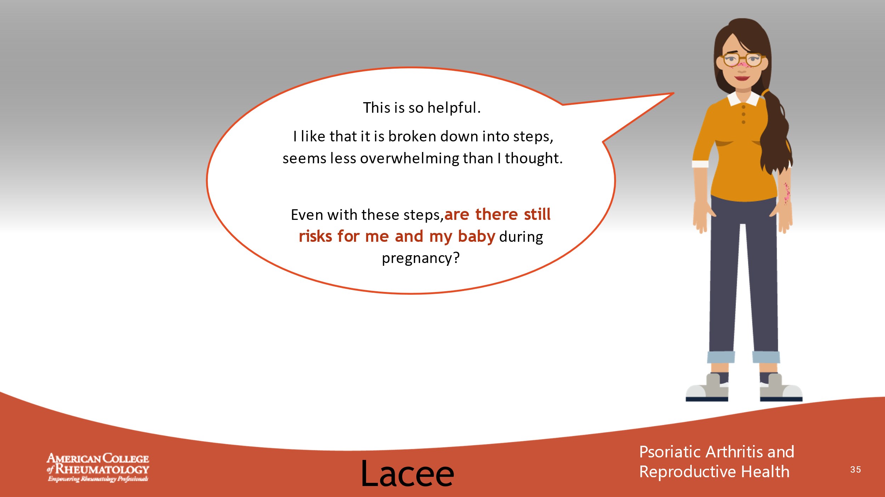

- _______________________________________________________
- _______________________________________________________
- _______________________________________________________
- _______________________________________________________
- _______________________________________________________
- _______________________________________________________
- _______________________________________________________
- _______________________________________________________

Slide 36: CONVERSATION
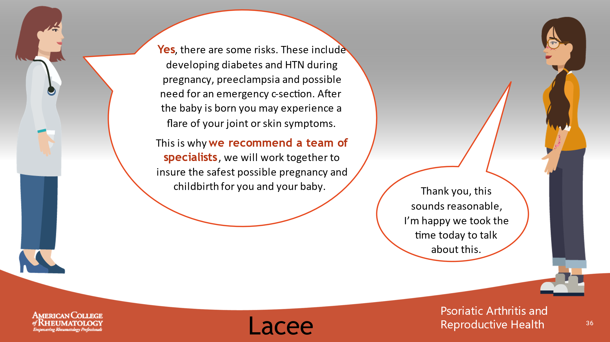

- _______________________________________________________
- _______________________________________________________
- _______________________________________________________
- _______________________________________________________
- _______________________________________________________
- _______________________________________________________
- _______________________________________________________
- _______________________________________________________

Slide 37: CONVERSATION
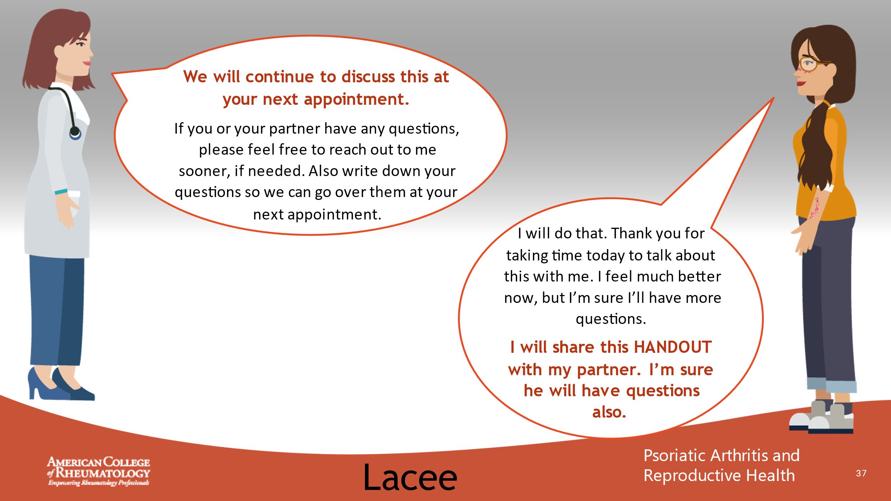

- _______________________________________________________
- _______________________________________________________
- _______________________________________________________
- _______________________________________________________
- _______________________________________________________
- _______________________________________________________
- _______________________________________________________
- _______________________________________________________

Slide 38: CASE 2 LEARNING POINTS
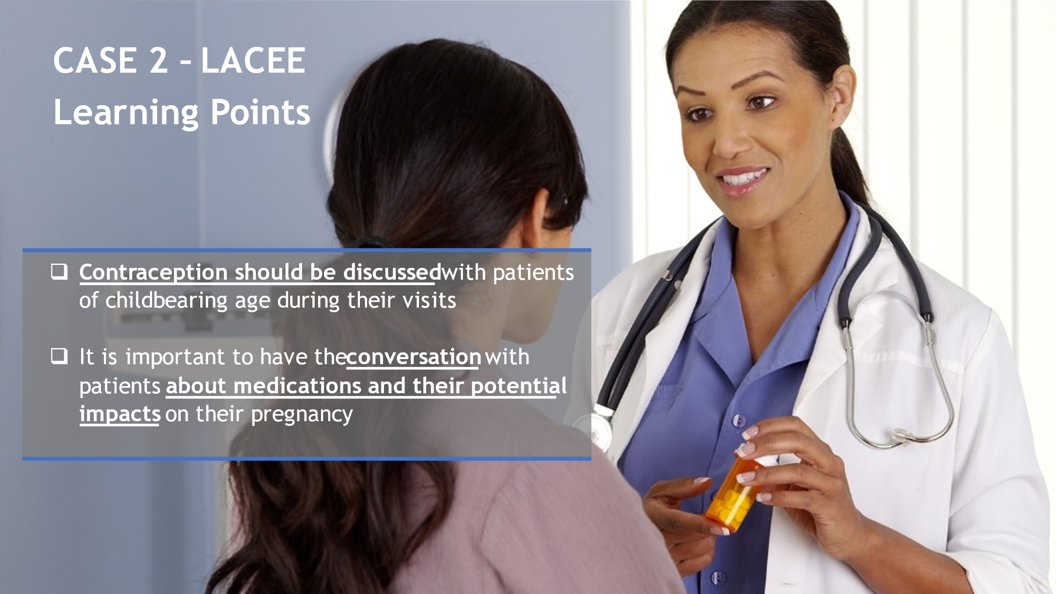

- _______________________________________________________
- _______________________________________________________
- _______________________________________________________
- _______________________________________________________
- _______________________________________________________
- _______________________________________________________
- _______________________________________________________
- _______________________________________________________

Slide 39: CASE 3 - JACK

- _______________________________________________________
- _______________________________________________________
- _______________________________________________________
- _______________________________________________________
- _______________________________________________________
- _______________________________________________________
- _______________________________________________________
- _______________________________________________________

Slide 40: MEET JACK
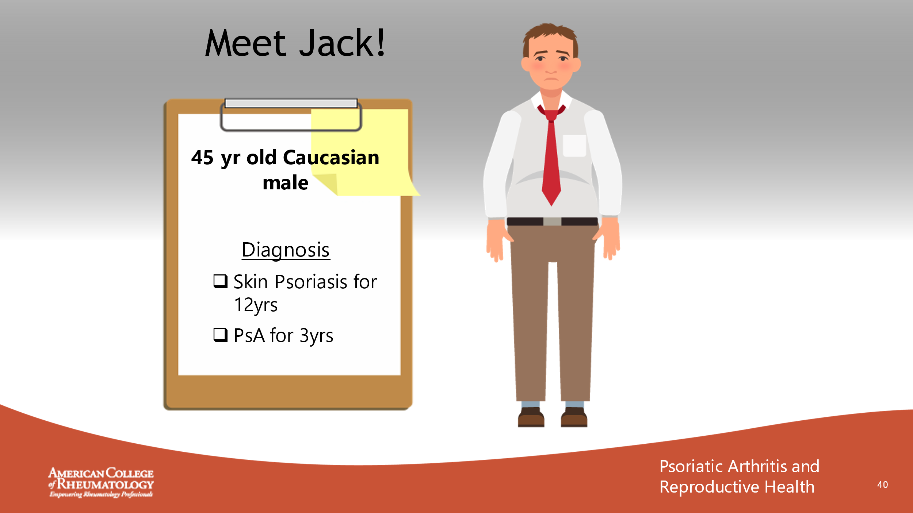

- _______________________________________________________
- _______________________________________________________
- _______________________________________________________
- _______________________________________________________
- _______________________________________________________
- _______________________________________________________
- _______________________________________________________
- _______________________________________________________

Slide 41: JACK’S FILE
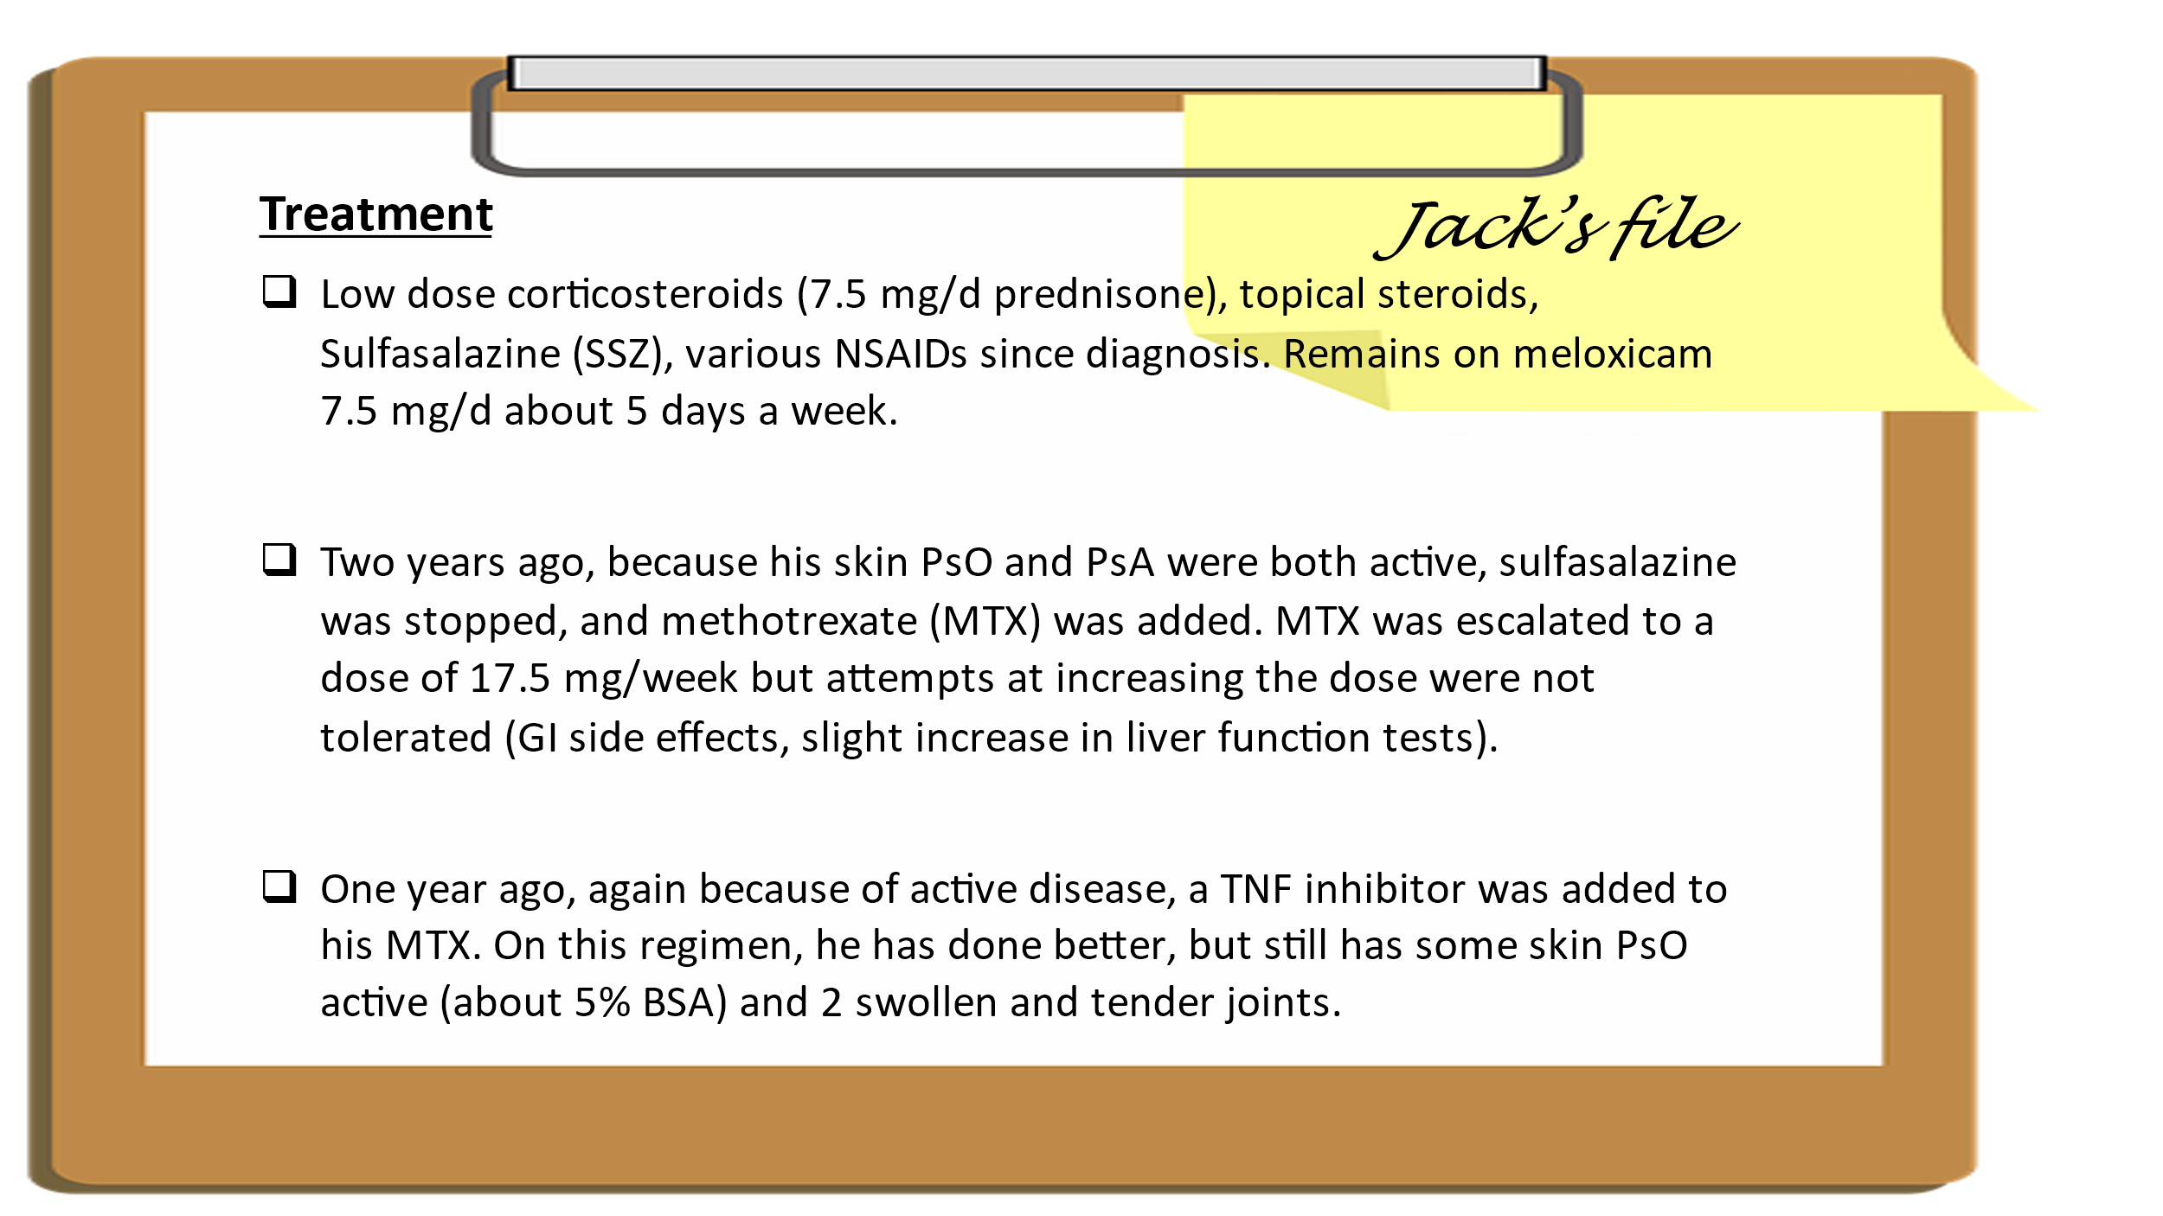

- _______________________________________________________
- _______________________________________________________
- _______________________________________________________
- _______________________________________________________
- _______________________________________________________
- _______________________________________________________
- _______________________________________________________
- _______________________________________________________

Slide 42: JACK’S VISIT
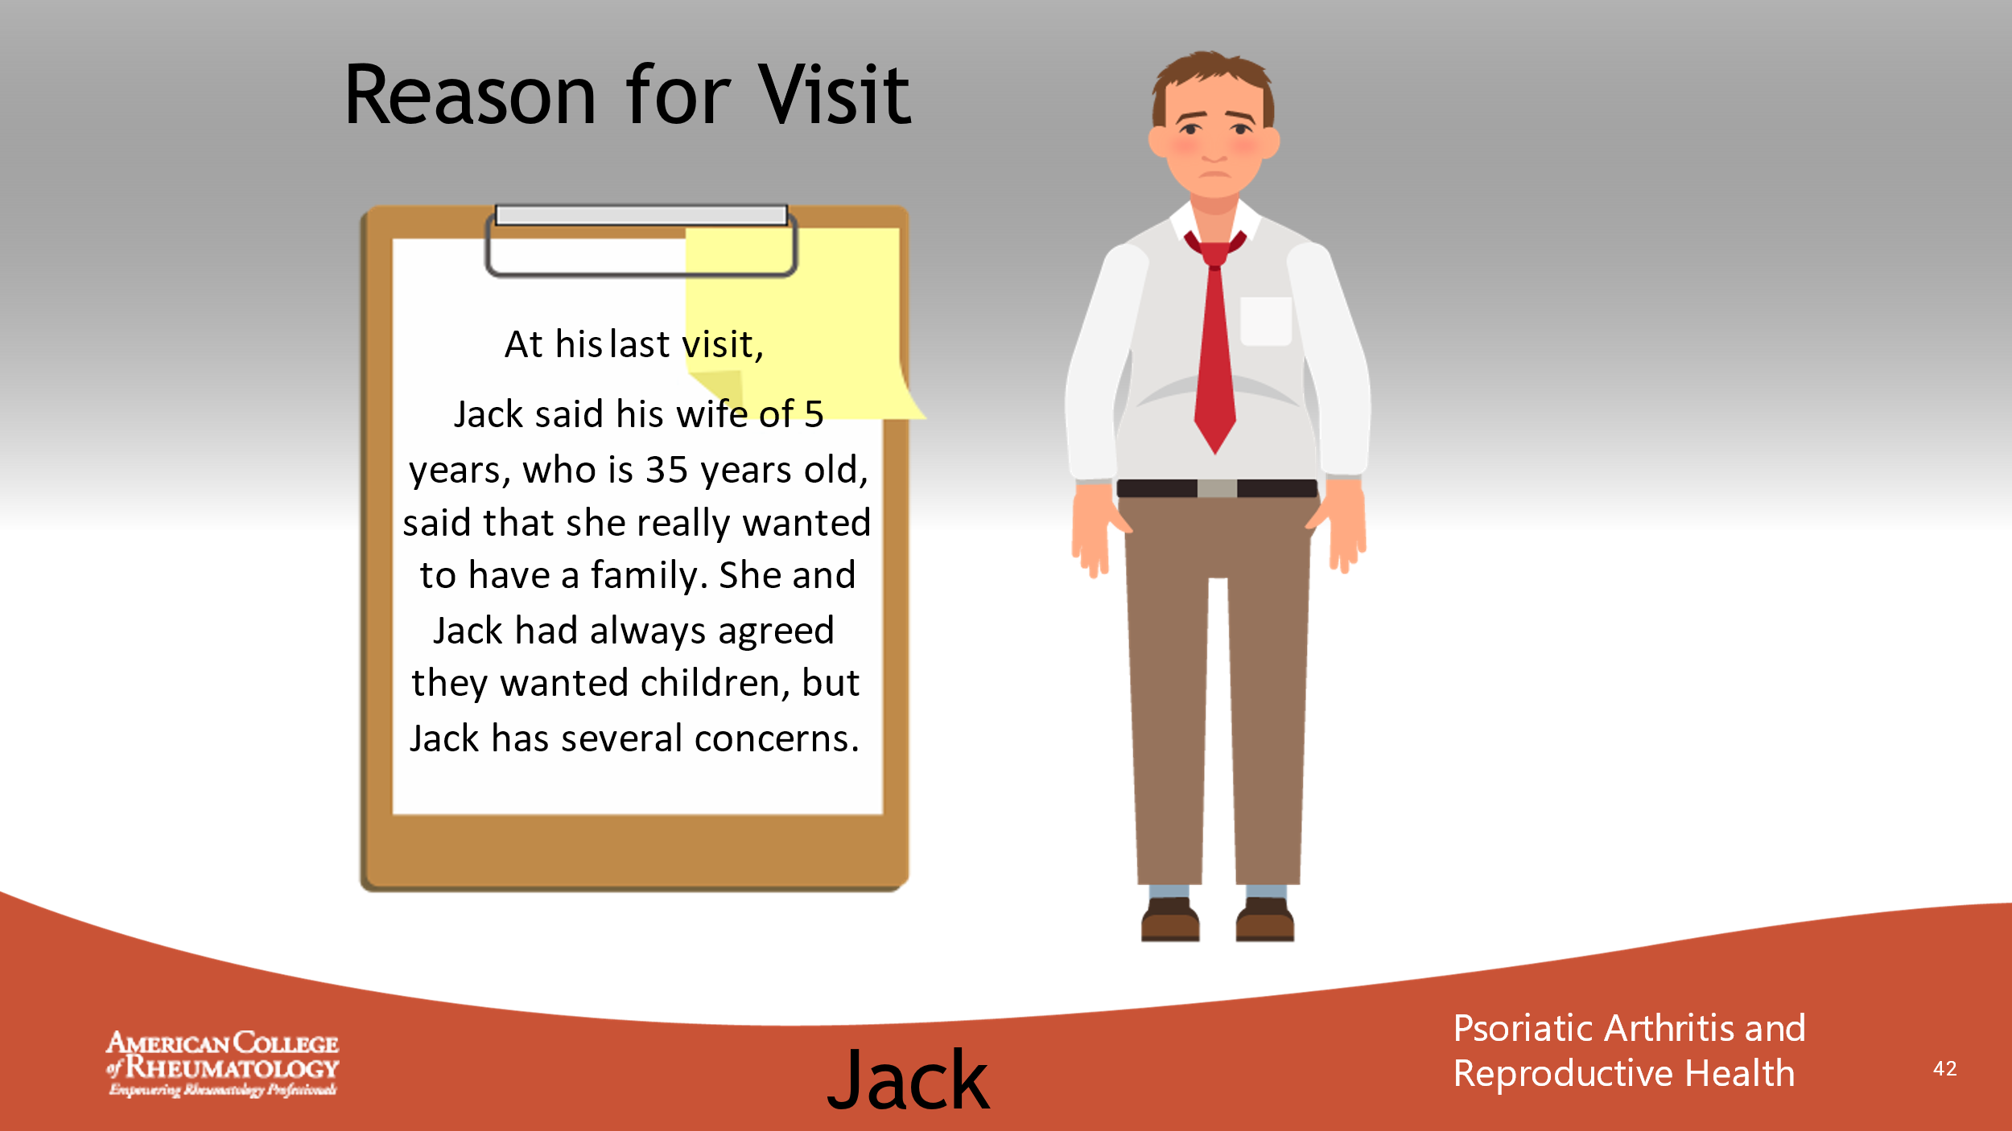

- _______________________________________________________
- _______________________________________________________
- _______________________________________________________
- _______________________________________________________
- _______________________________________________________
- _______________________________________________________
- _______________________________________________________
- _______________________________________________________

Slide 43: CONVERSATION
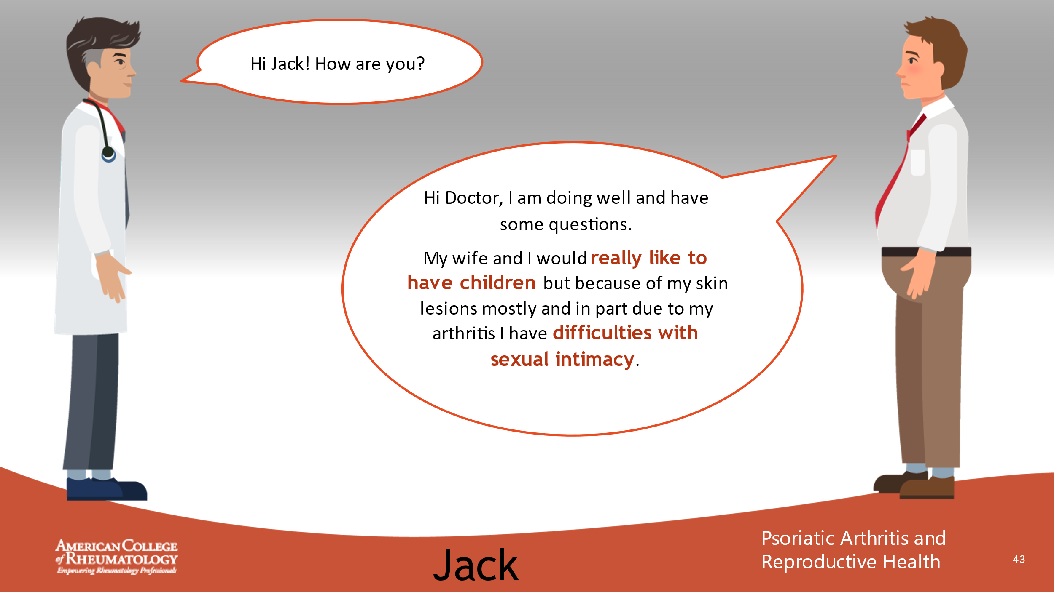

- _______________________________________________________
- _______________________________________________________
- _______________________________________________________
- _______________________________________________________
- _______________________________________________________
- _______________________________________________________
- _______________________________________________________
- _______________________________________________________

Slide 44: CONVERSATION
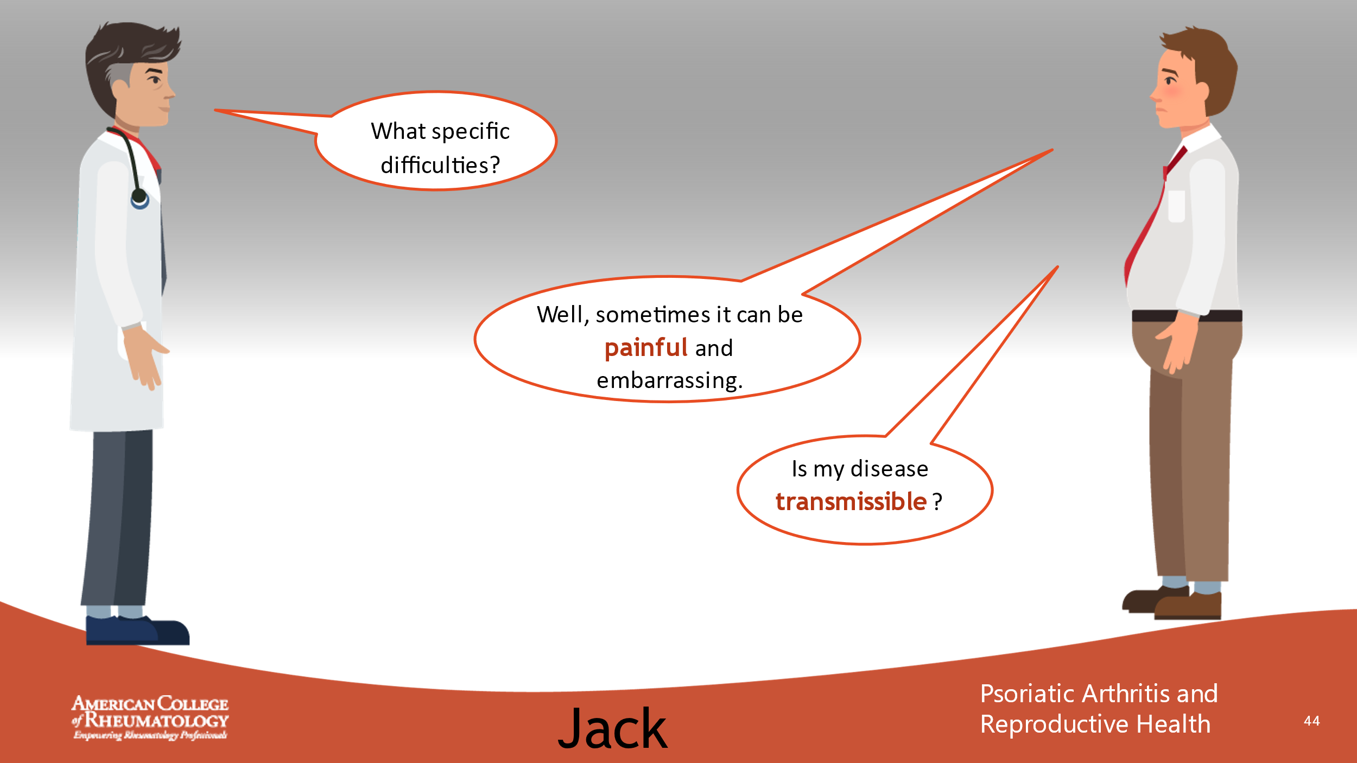

- _______________________________________________________
- _______________________________________________________
- _______________________________________________________
- _______________________________________________________
- _______________________________________________________
- _______________________________________________________
- _______________________________________________________
- _______________________________________________________

Slide 45: CONVERSATION
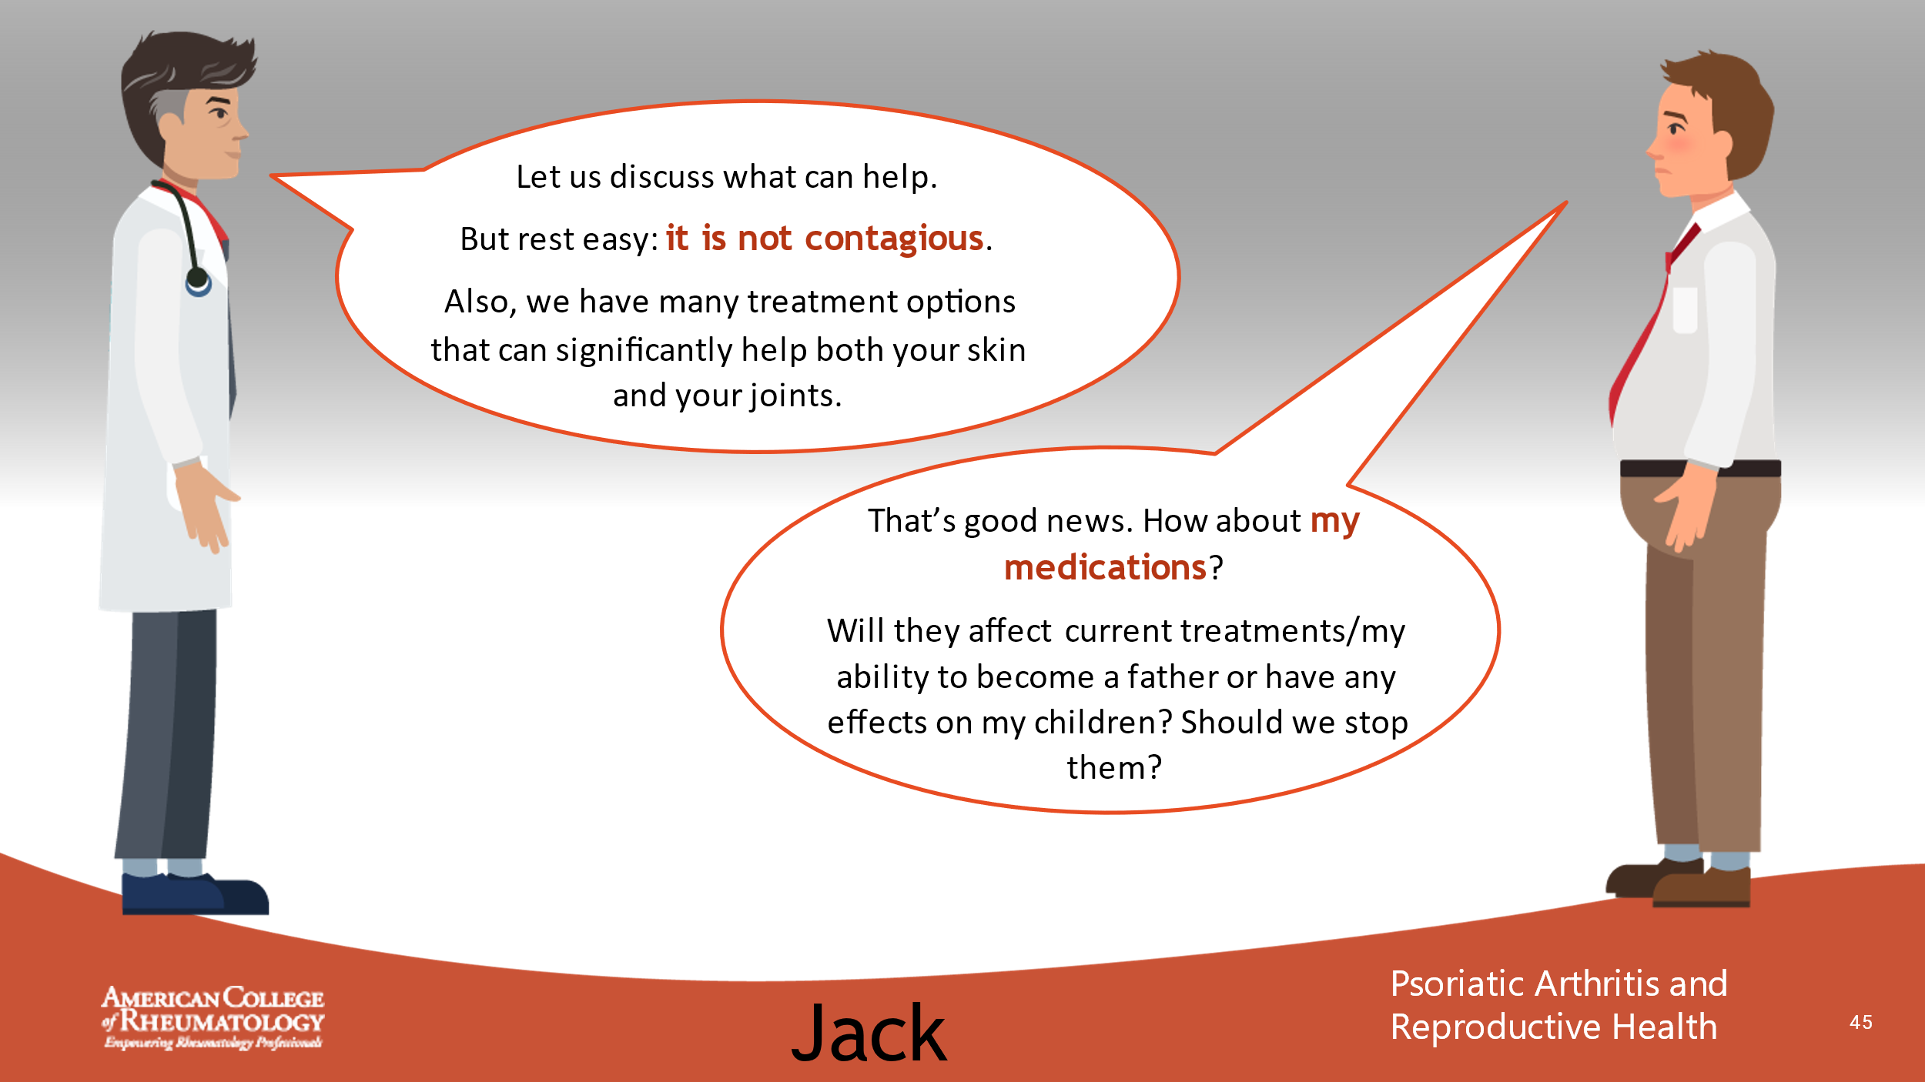

- _______________________________________________________
- _______________________________________________________
- _______________________________________________________
- _______________________________________________________
- _______________________________________________________
- _______________________________________________________
- _______________________________________________________
- _______________________________________________________

Slide 46: CONVERSATION
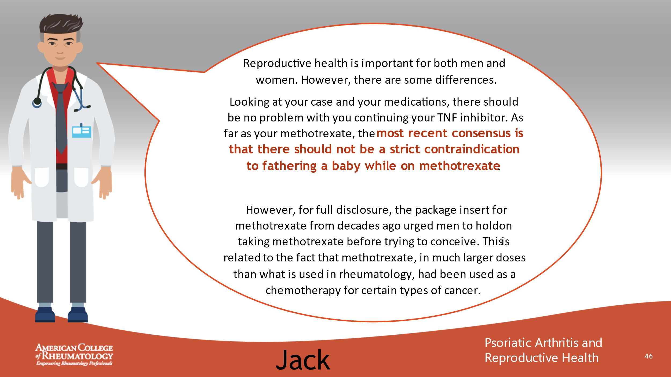

- _______________________________________________________
- _______________________________________________________
- _______________________________________________________
- _______________________________________________________
- _______________________________________________________
- _______________________________________________________
- _______________________________________________________
- _______________________________________________________

Slide 47: CONVERSATION
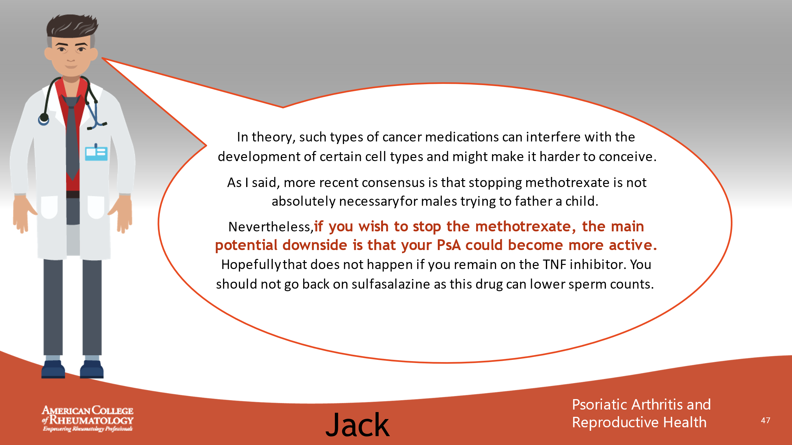

- _______________________________________________________
- _______________________________________________________
- _______________________________________________________
- _______________________________________________________
- _______________________________________________________
- _______________________________________________________
- _______________________________________________________
- _______________________________________________________

Slide 48: PREGNANCY PLANNING – 4 STEPS

- _______________________________________________________
- _______________________________________________________
- _______________________________________________________
- _______________________________________________________
- _______________________________________________________
- _______________________________________________________
- _______________________________________________________
- _______________________________________________________

Slide 49: MEDICATION LIST
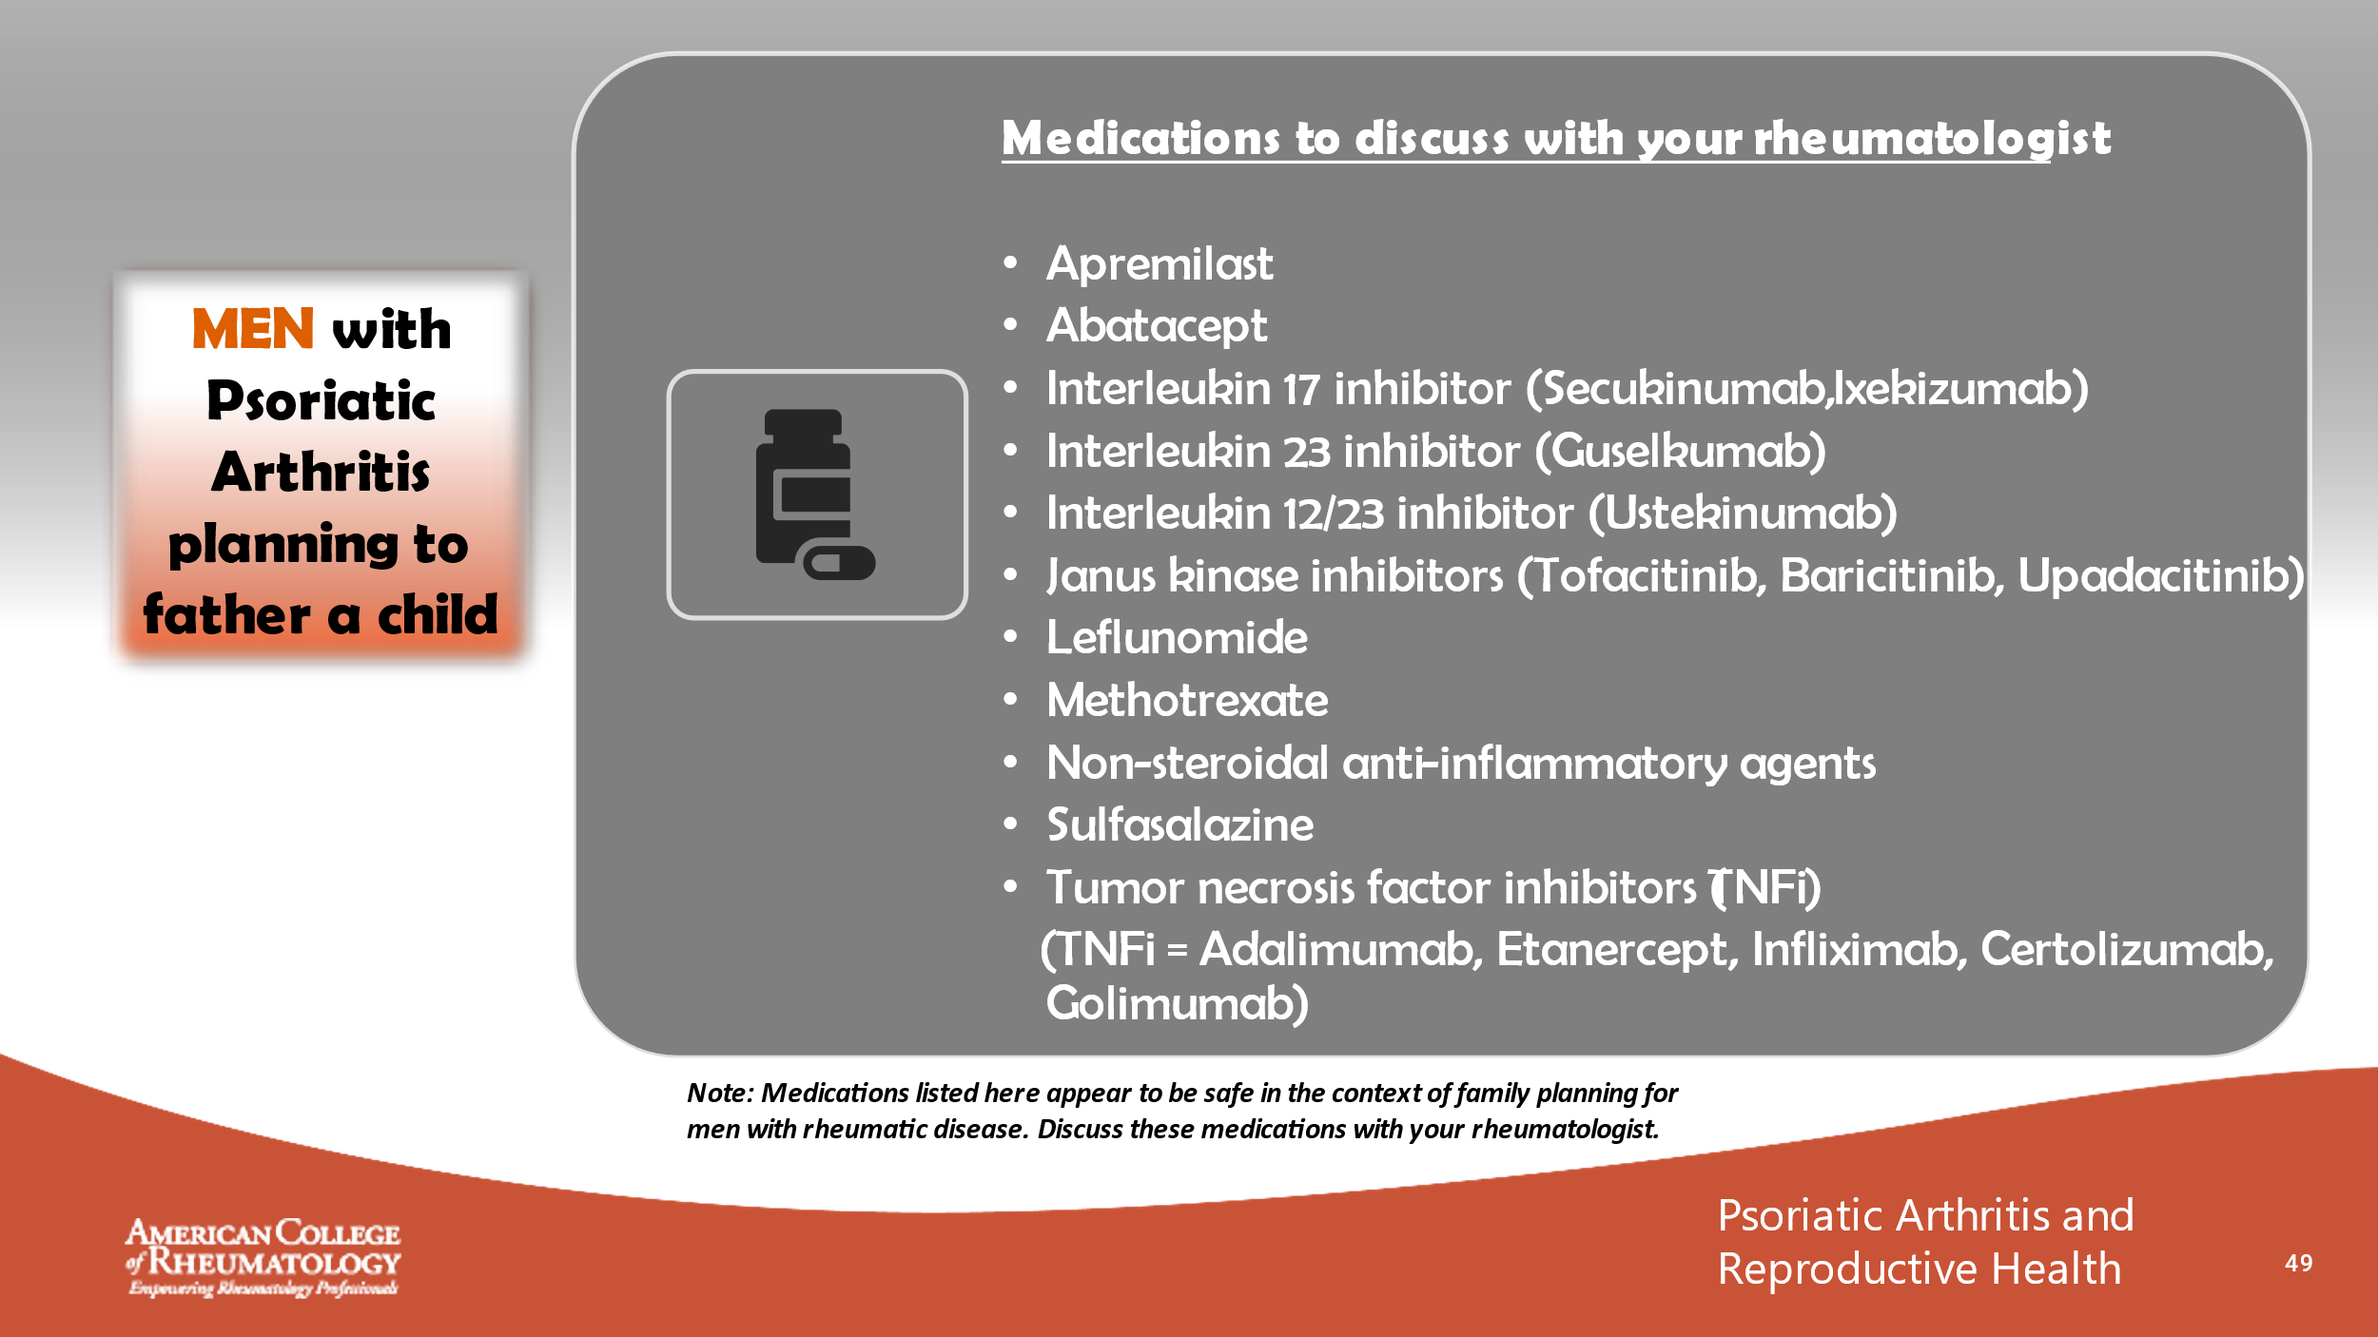

- _______________________________________________________
- _______________________________________________________
- _______________________________________________________
- _______________________________________________________
- _______________________________________________________
- _______________________________________________________
- _______________________________________________________
- _______________________________________________________

Slide 50: CASE 3 LEARNING POINTS

- _______________________________________________________
- _______________________________________________________
- _______________________________________________________
- _______________________________________________________
- _______________________________________________________
- _______________________________________________________
- _______________________________________________________
- _______________________________________________________

Slide 51: CASE 4 - TERRI

- _______________________________________________________
- _______________________________________________________
- _______________________________________________________
- _______________________________________________________
- _______________________________________________________
- _______________________________________________________
- _______________________________________________________
- _______________________________________________________

Slide 52: MEET TERRI
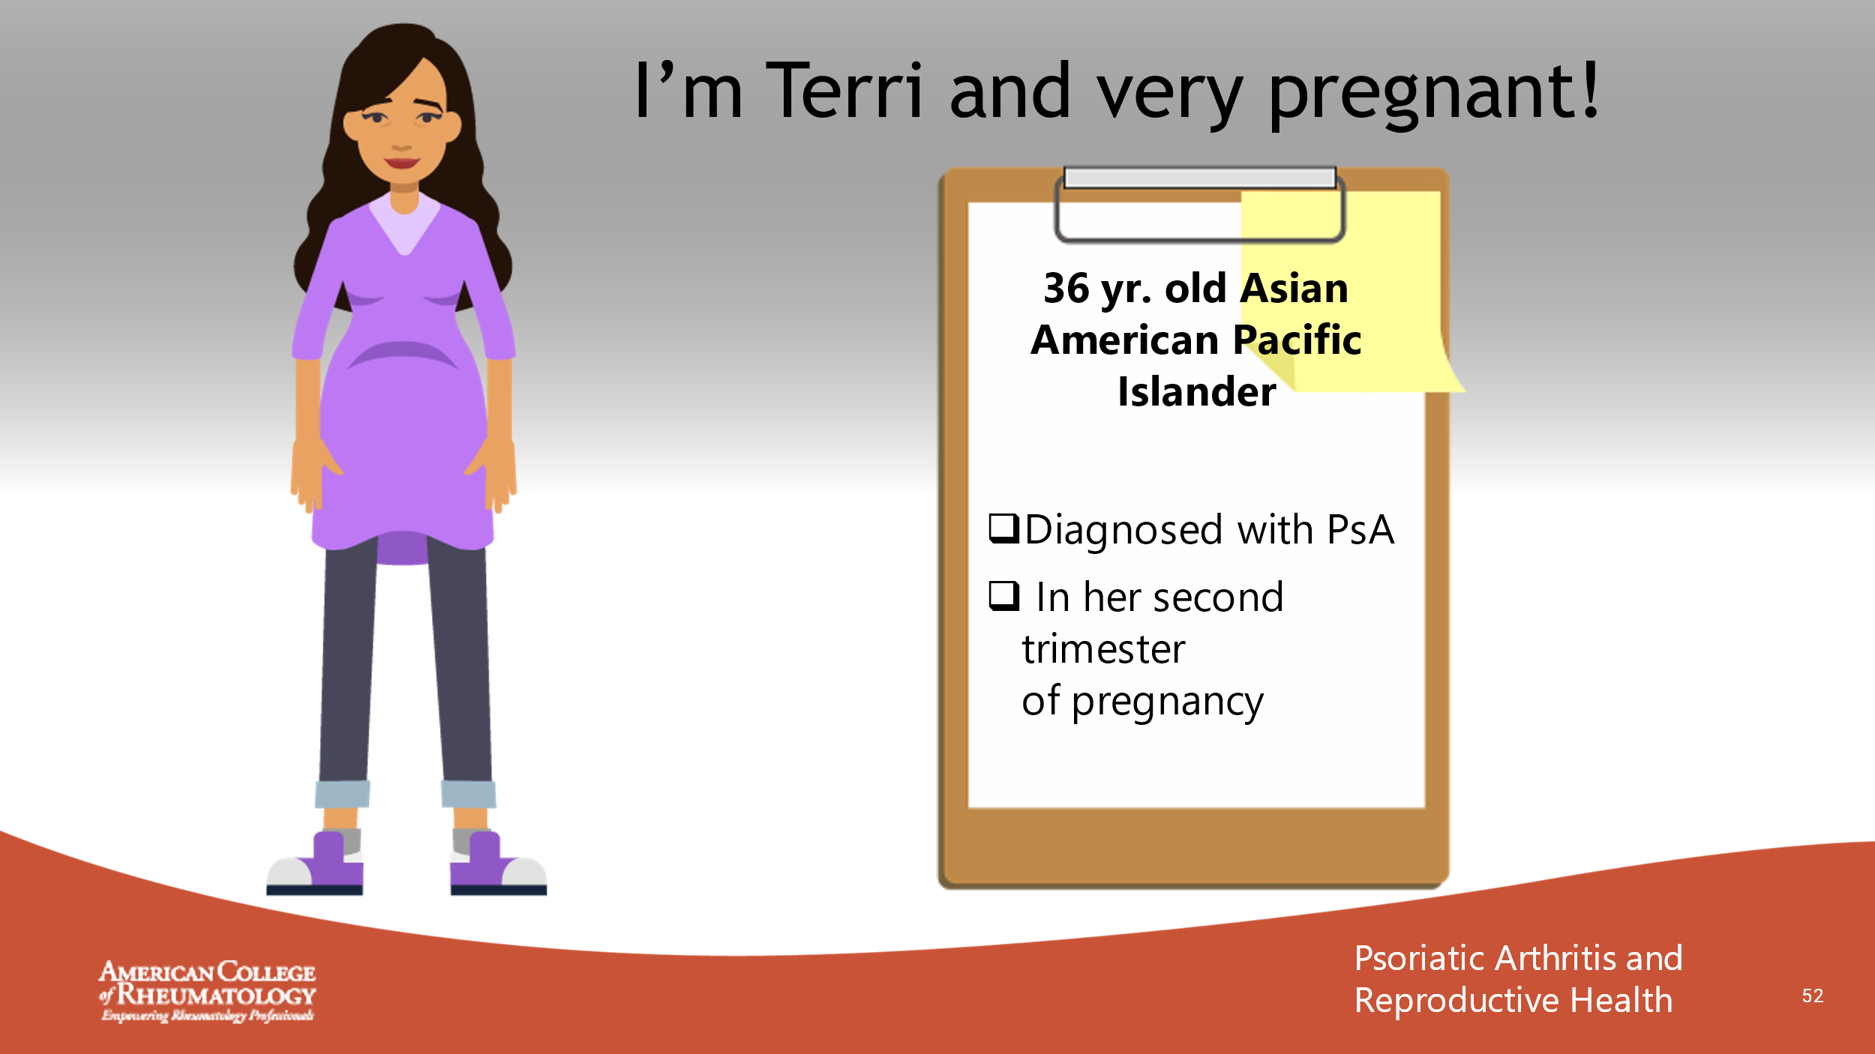

- _______________________________________________________
- _______________________________________________________
- _______________________________________________________
- _______________________________________________________
- _______________________________________________________
- _______________________________________________________
- _______________________________________________________
- _______________________________________________________

Slide 53: TERRI’S FILE
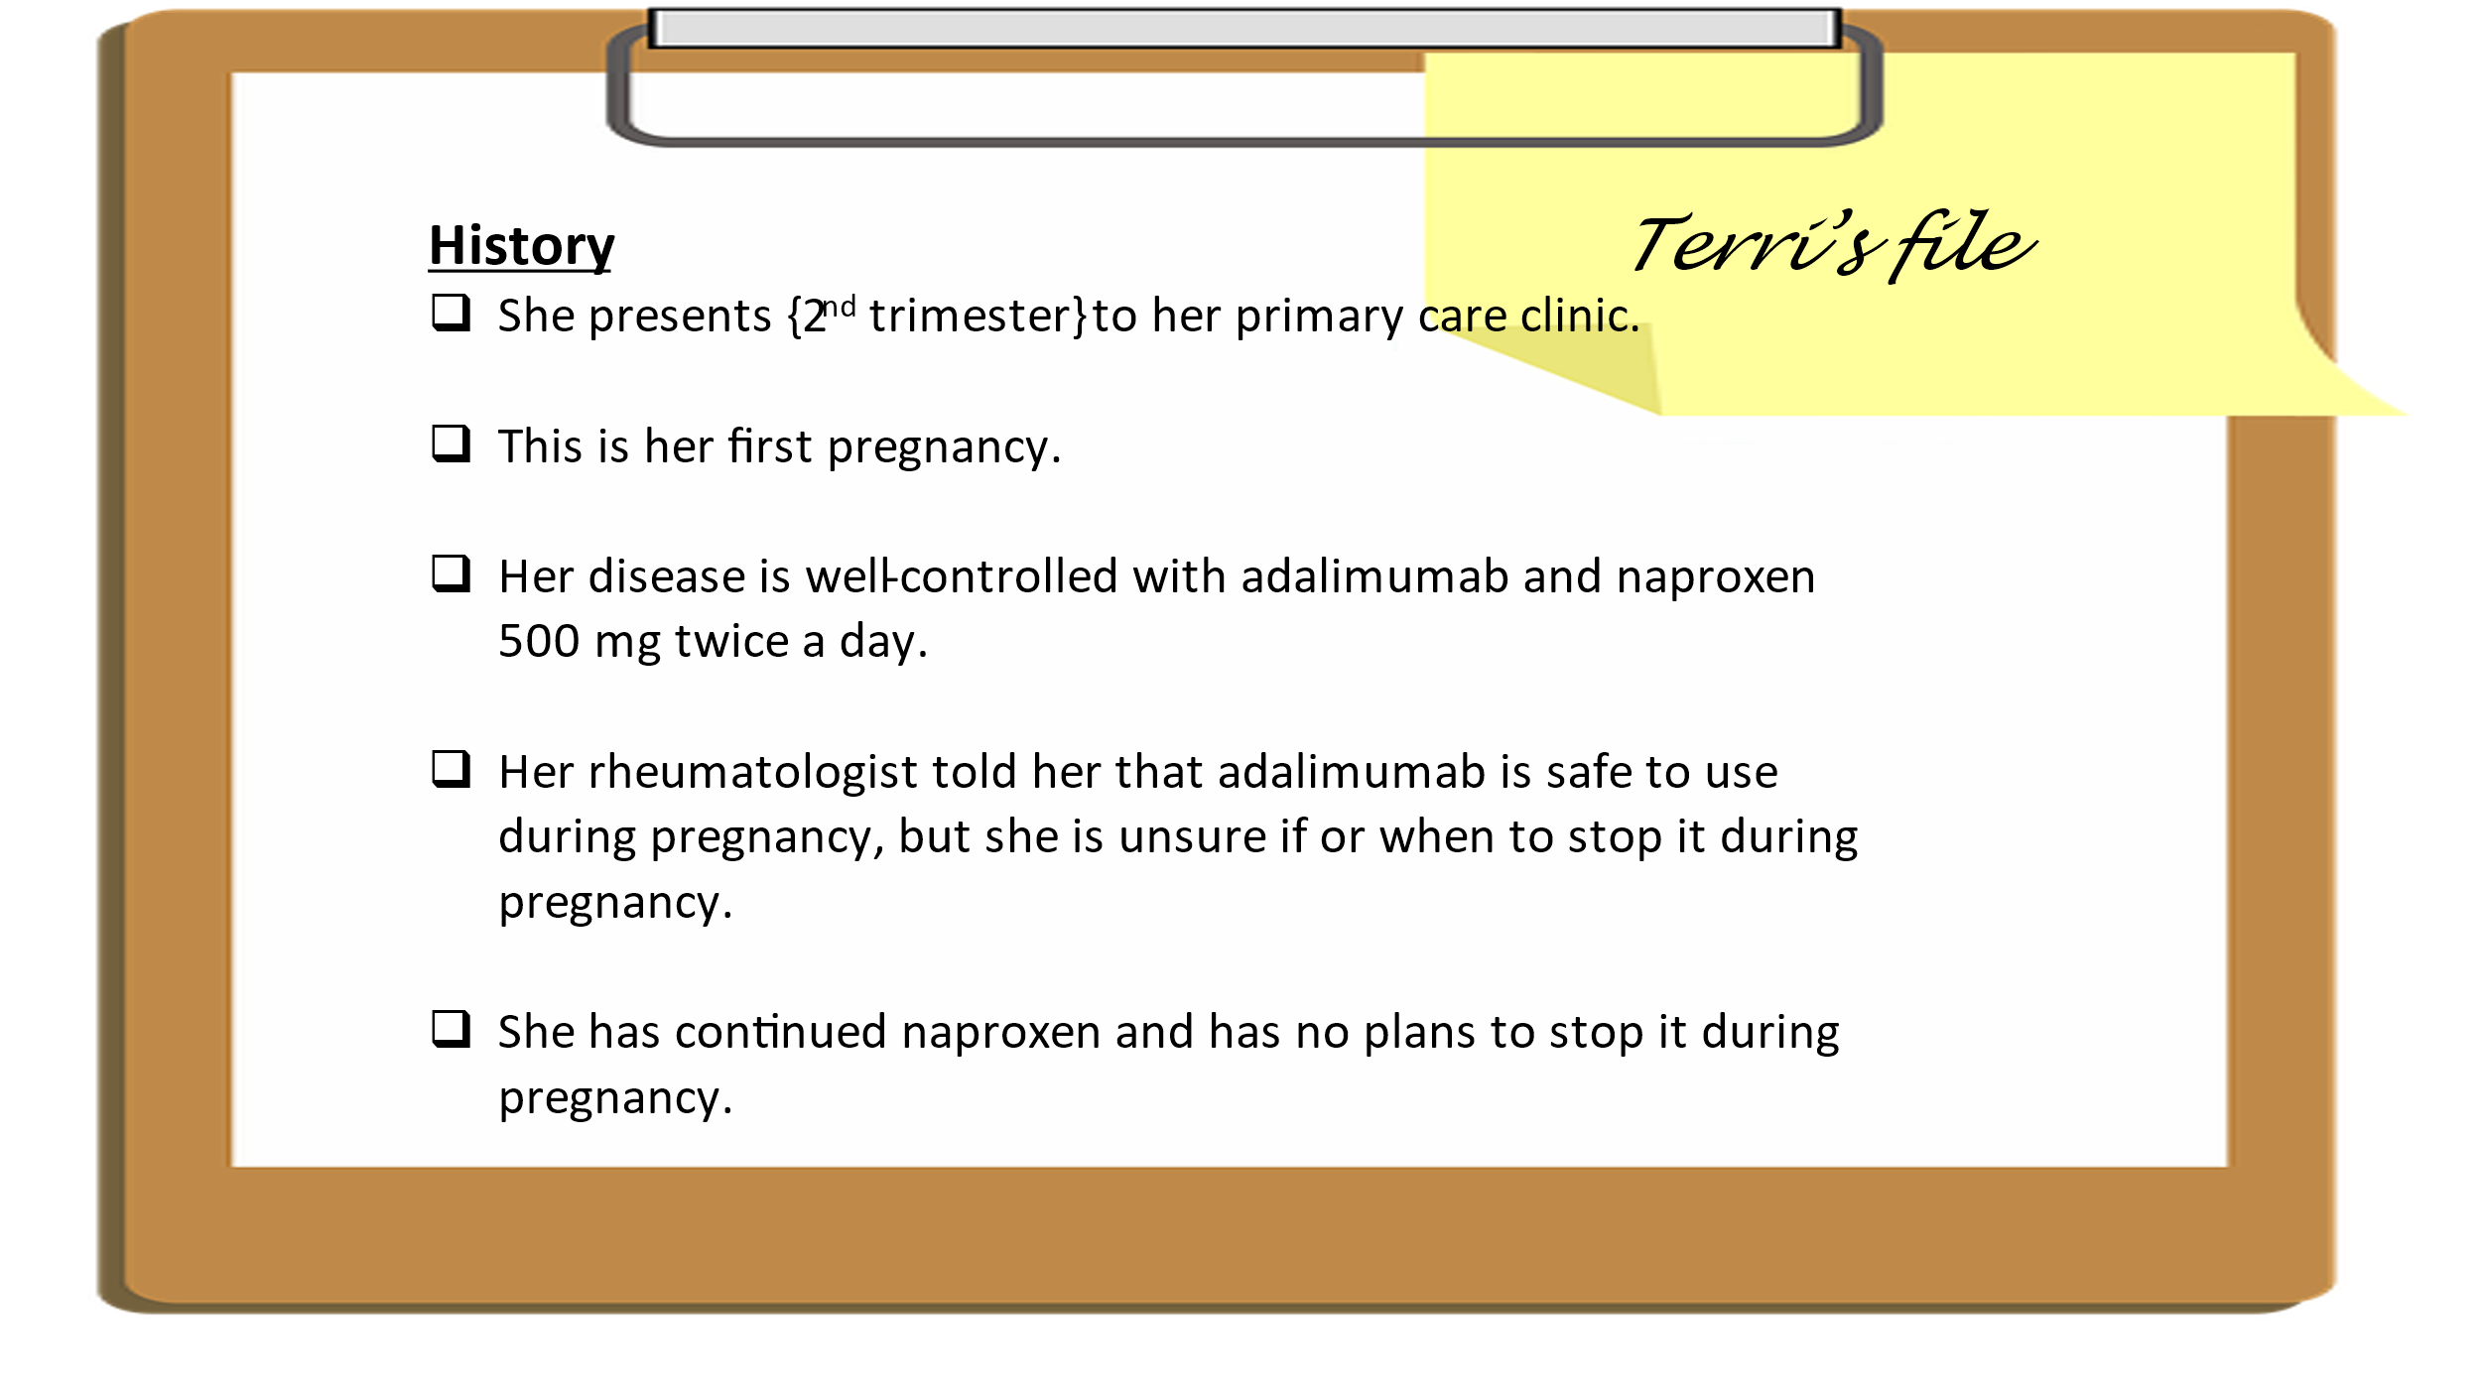

- _______________________________________________________
- _______________________________________________________
- _______________________________________________________
- _______________________________________________________
- _______________________________________________________
- _______________________________________________________
- _______________________________________________________
- _______________________________________________________

Slide 54: TERRI’S VISIT
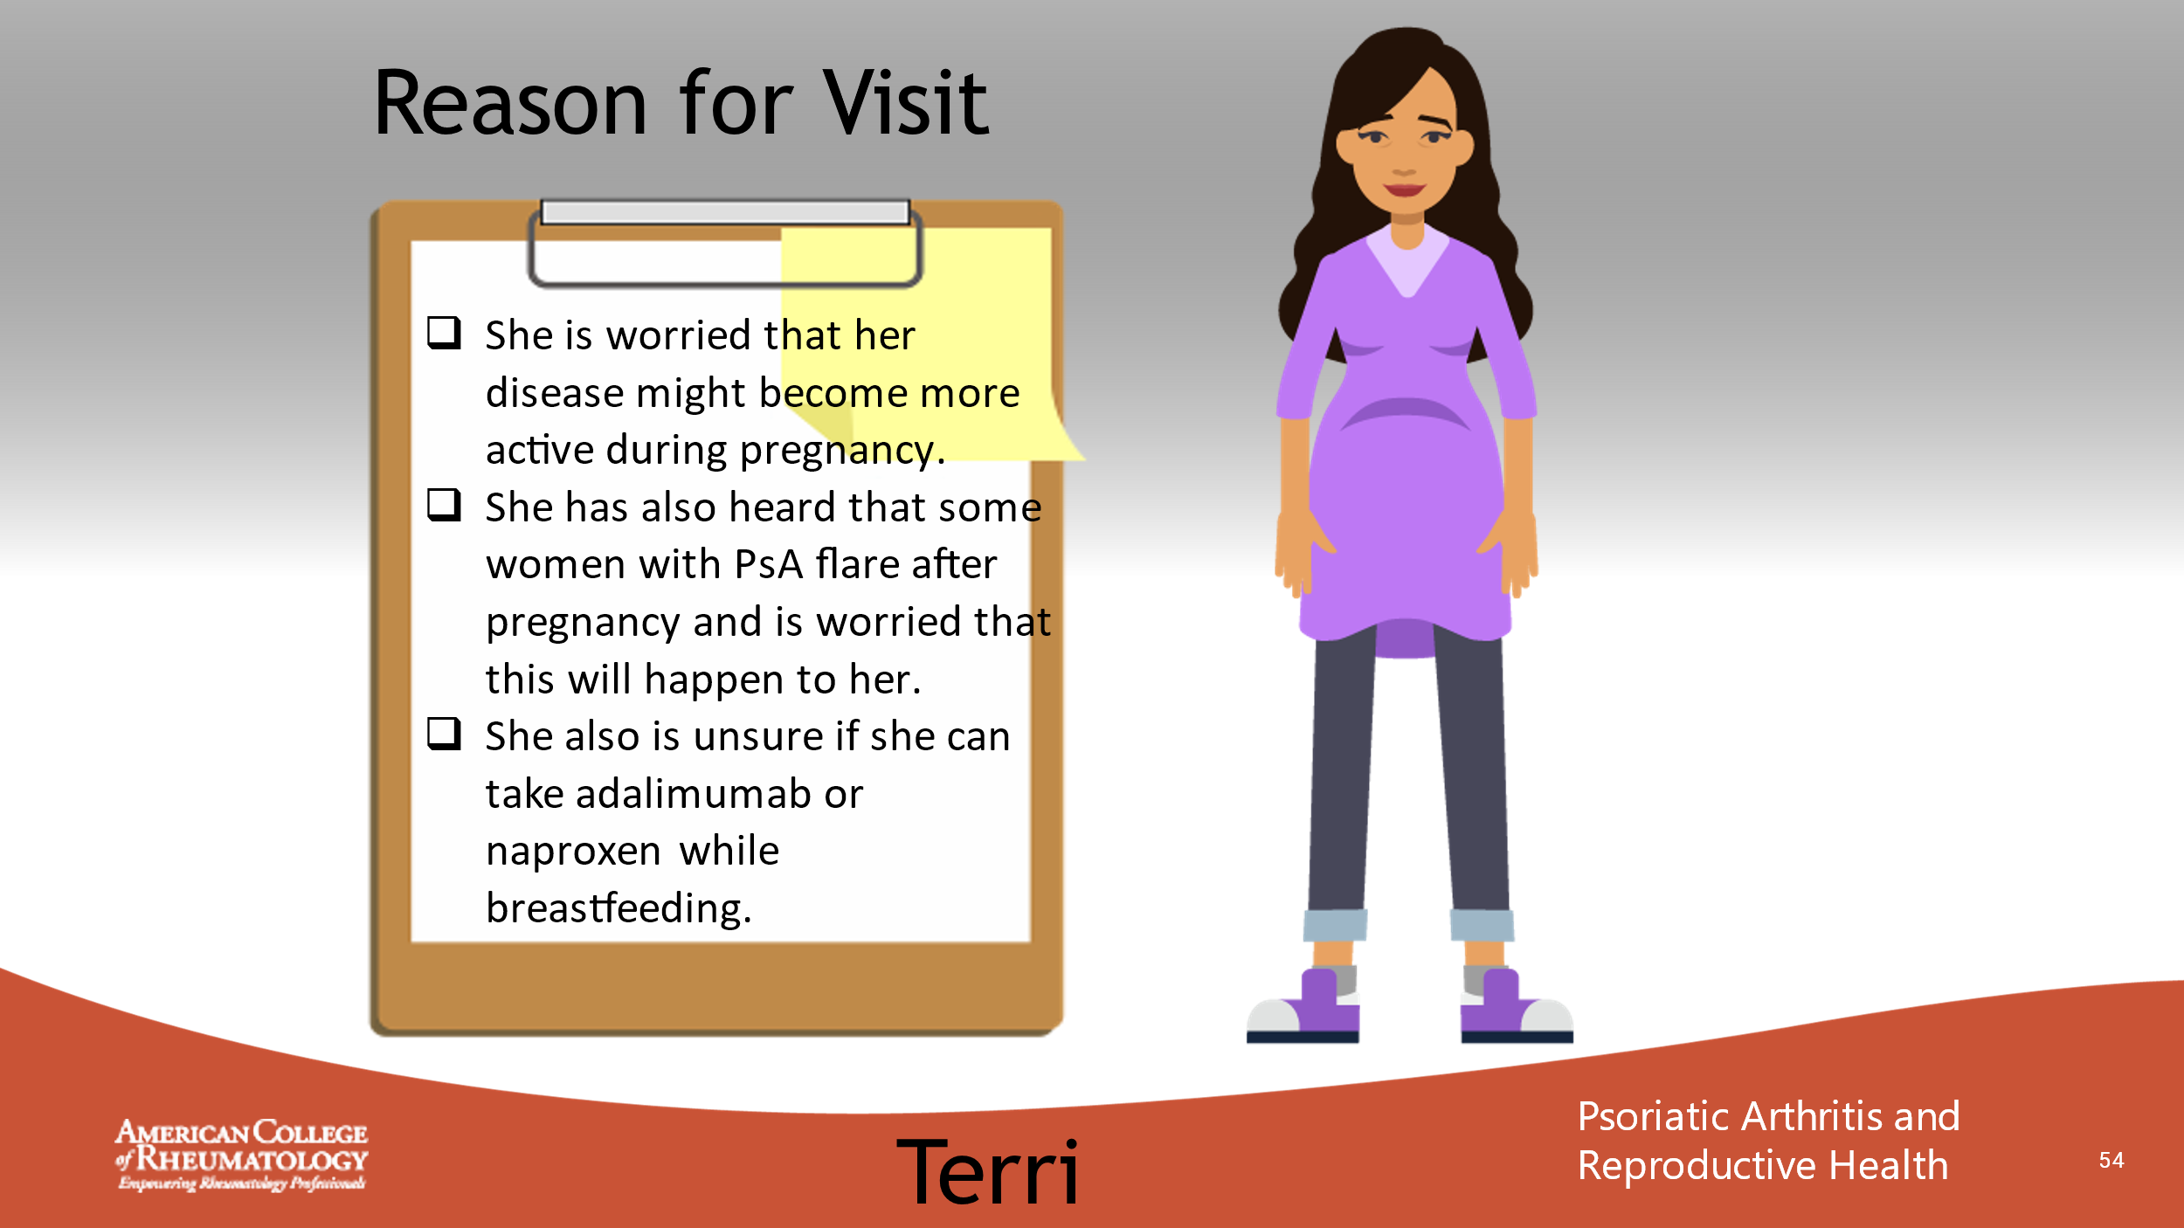

- _______________________________________________________
- _______________________________________________________
- _______________________________________________________
- _______________________________________________________
- _______________________________________________________
- _______________________________________________________
- _______________________________________________________
- _______________________________________________________

Slide 55: CONVERSATION
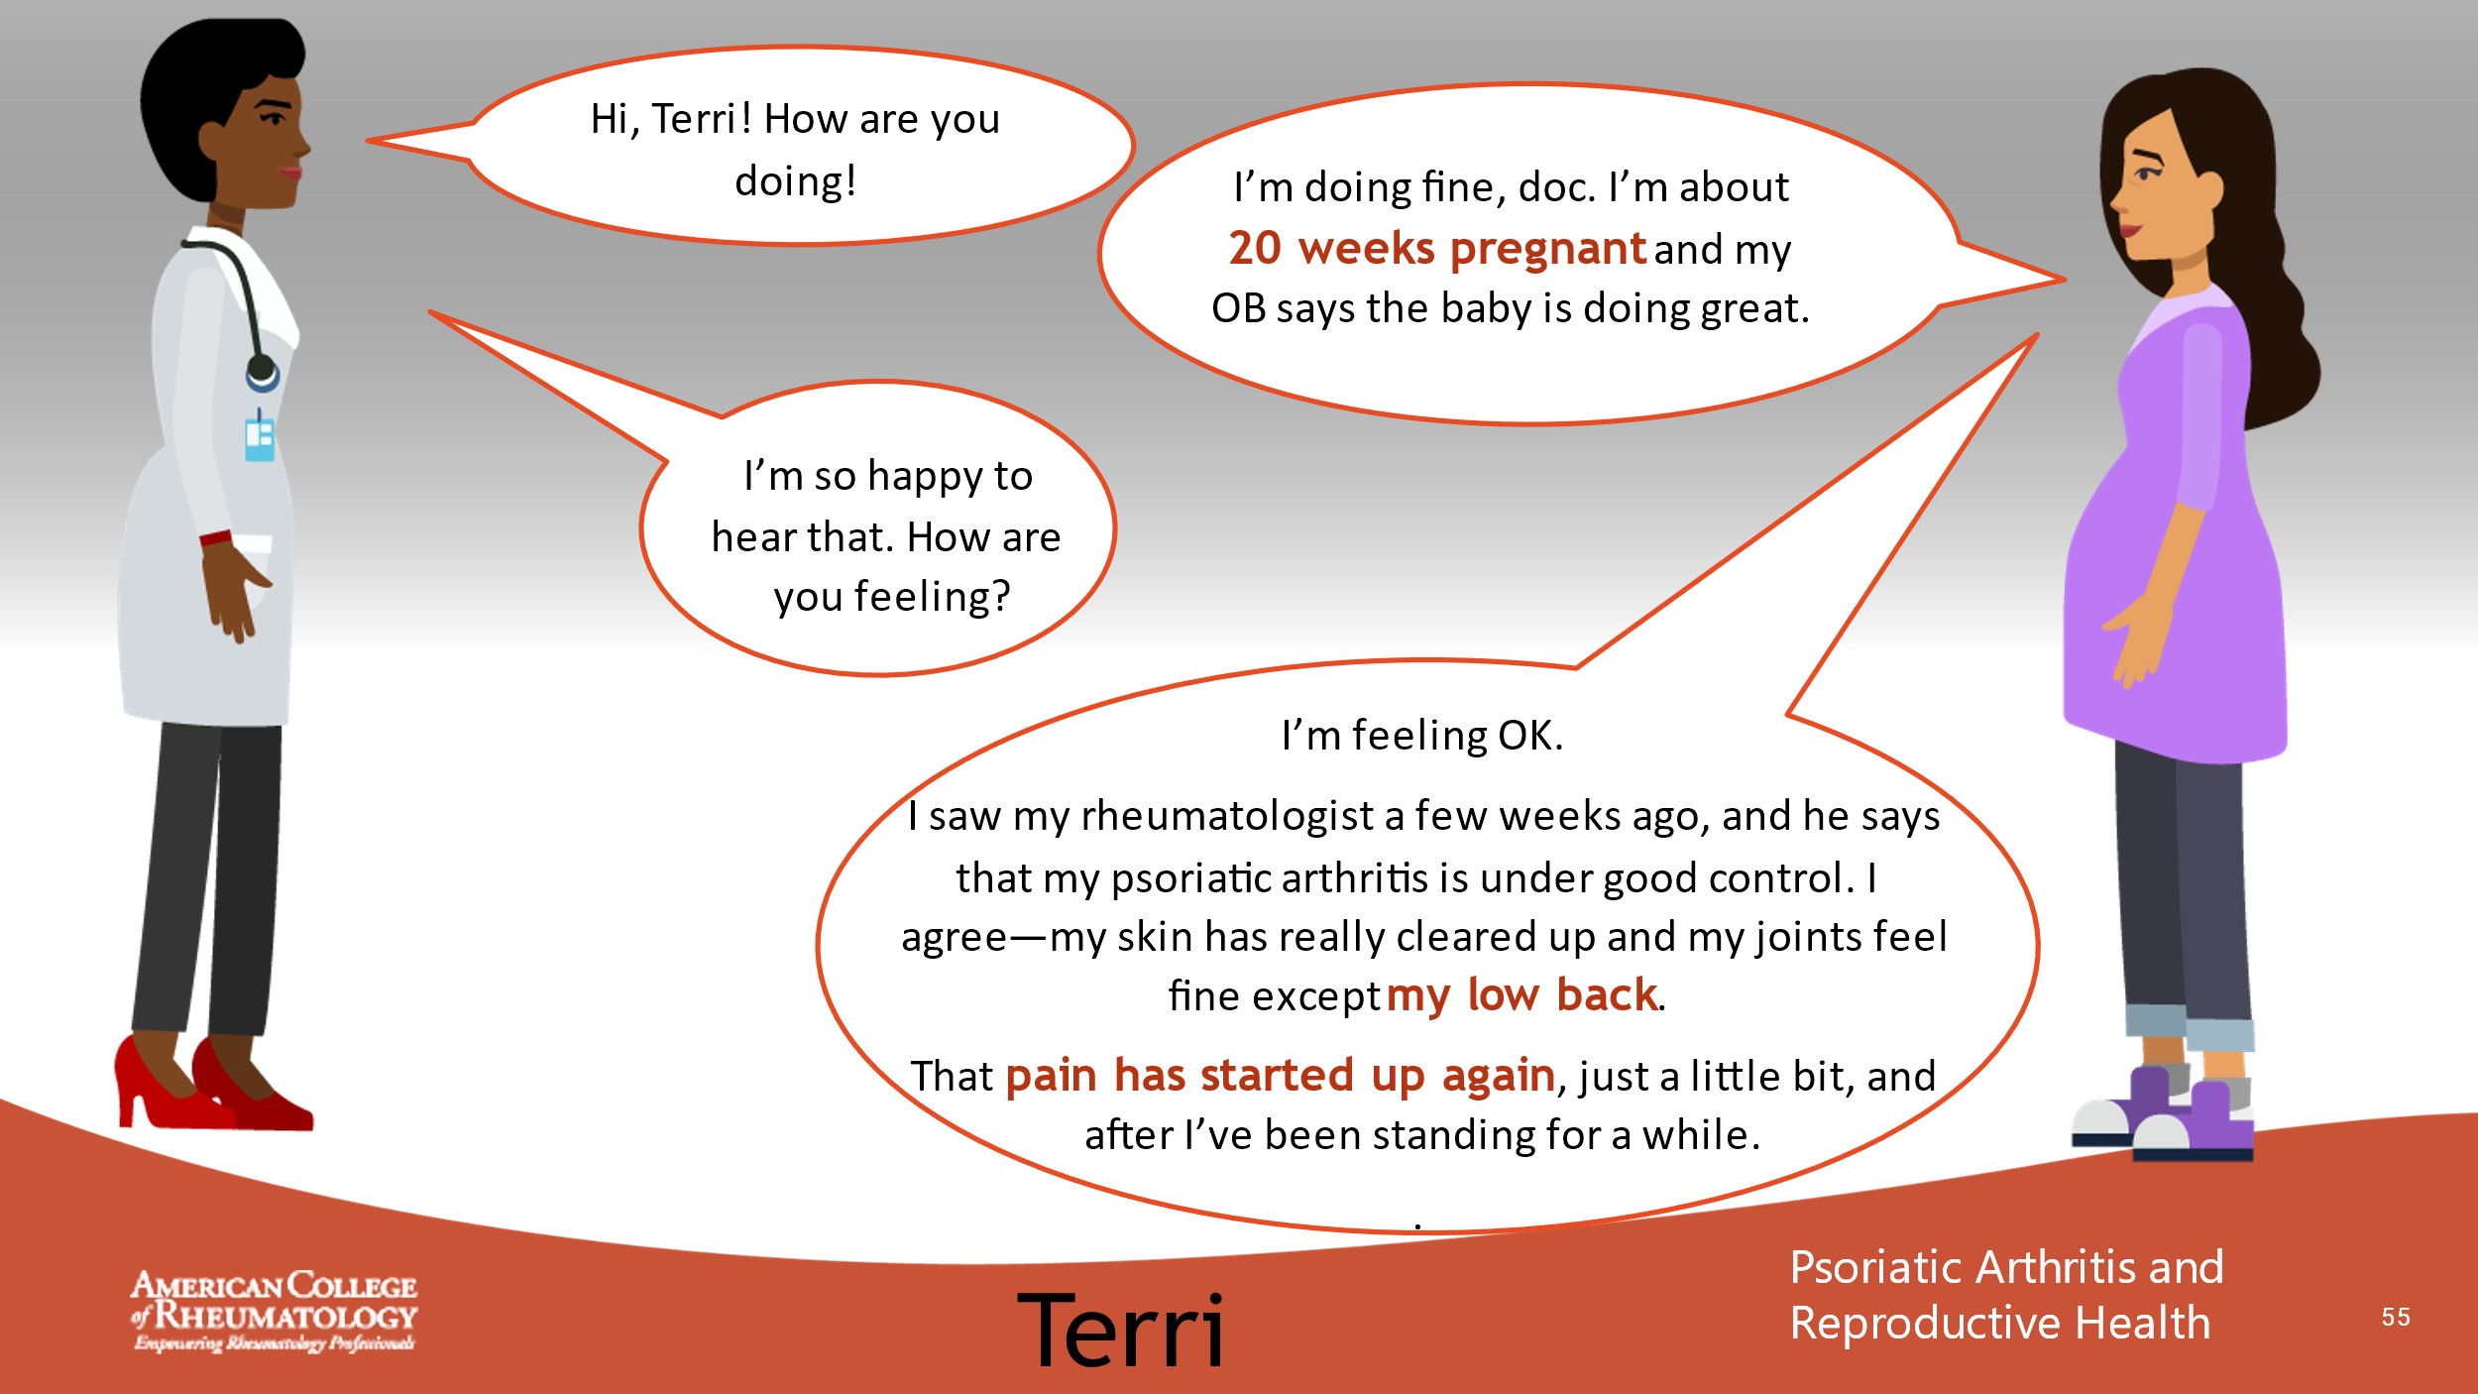

- _______________________________________________________
- _______________________________________________________
- _______________________________________________________
- _______________________________________________________
- _______________________________________________________
- _______________________________________________________
- _______________________________________________________
- _______________________________________________________

Slide 56: CONVERSATION
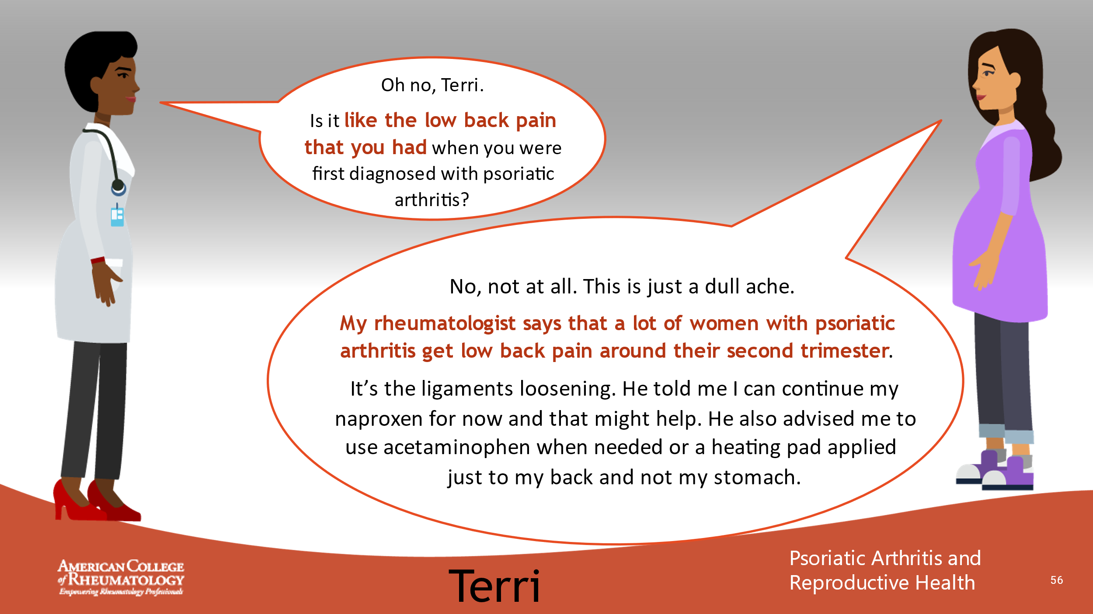

- _______________________________________________________
- _______________________________________________________
- _______________________________________________________
- _______________________________________________________
- _______________________________________________________
- _______________________________________________________
- _______________________________________________________
- _______________________________________________________

Slide 57: CONVERSATION
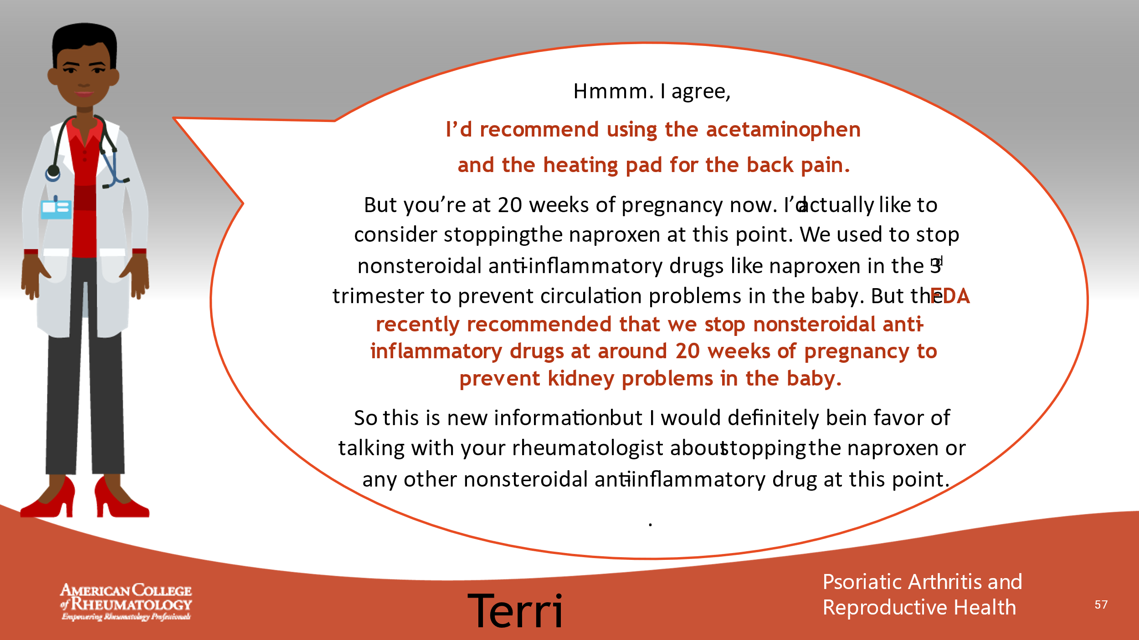

- _______________________________________________________
- _______________________________________________________
- _______________________________________________________
- _______________________________________________________
- _______________________________________________________
- _______________________________________________________
- _______________________________________________________
- _______________________________________________________

Slide 58: CONVERSATION
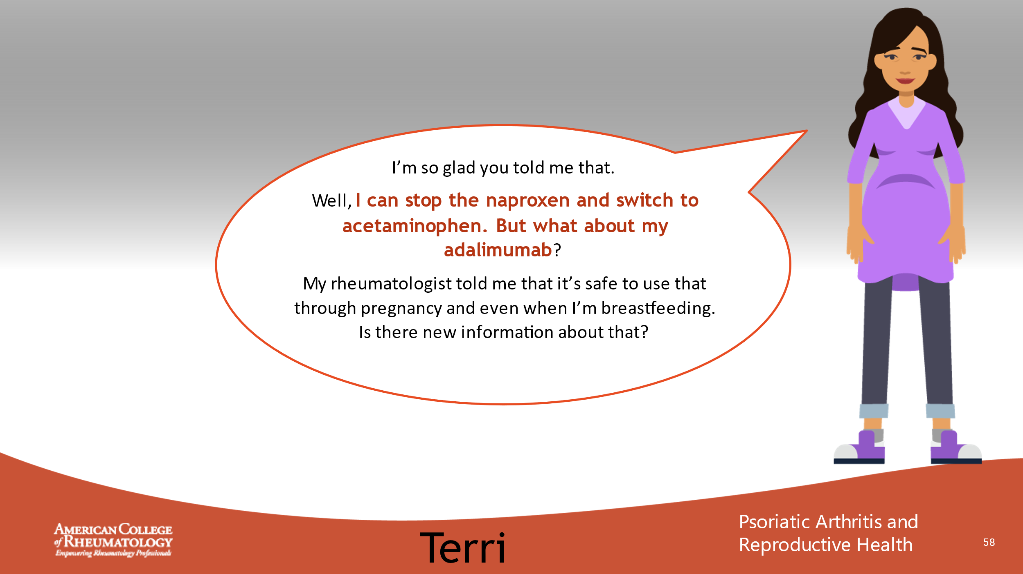

- _______________________________________________________
- _______________________________________________________
- _______________________________________________________
- _______________________________________________________
- _______________________________________________________
- _______________________________________________________
- _______________________________________________________
- _______________________________________________________

Slide 59: CONVERSATION
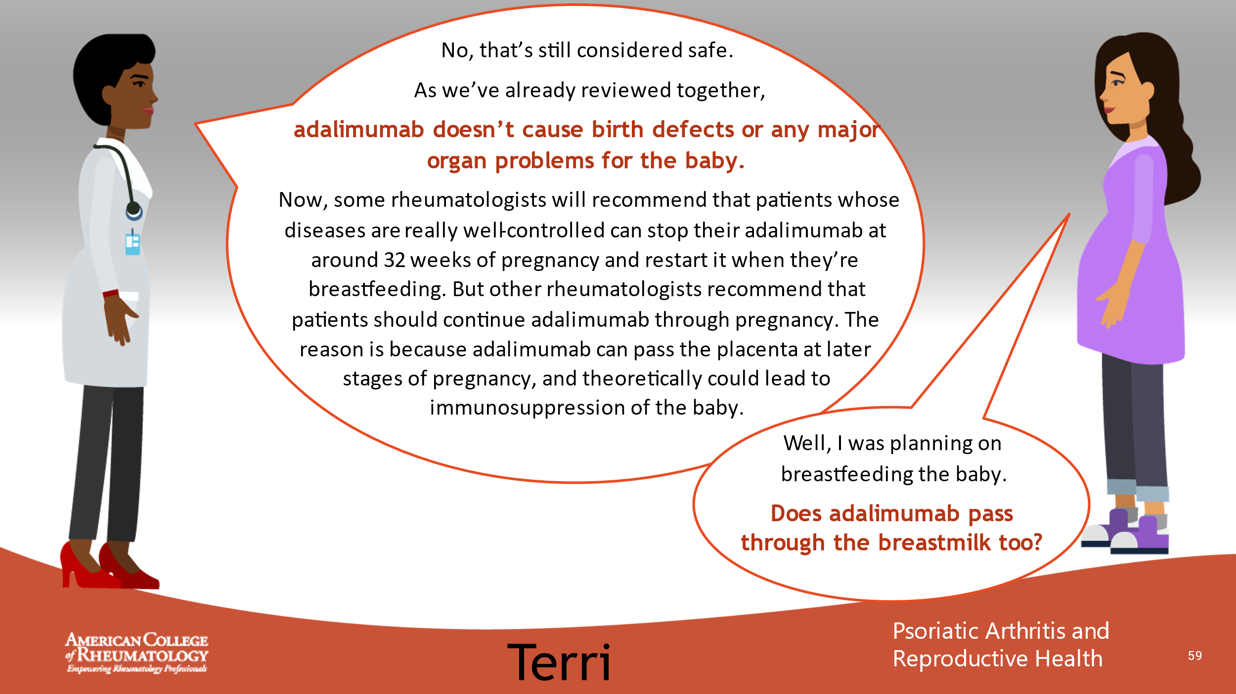

- _______________________________________________________
- _______________________________________________________
- _______________________________________________________
- _______________________________________________________
- _______________________________________________________
- _______________________________________________________
- _______________________________________________________
- _______________________________________________________

Slide 60: CONVERSATION
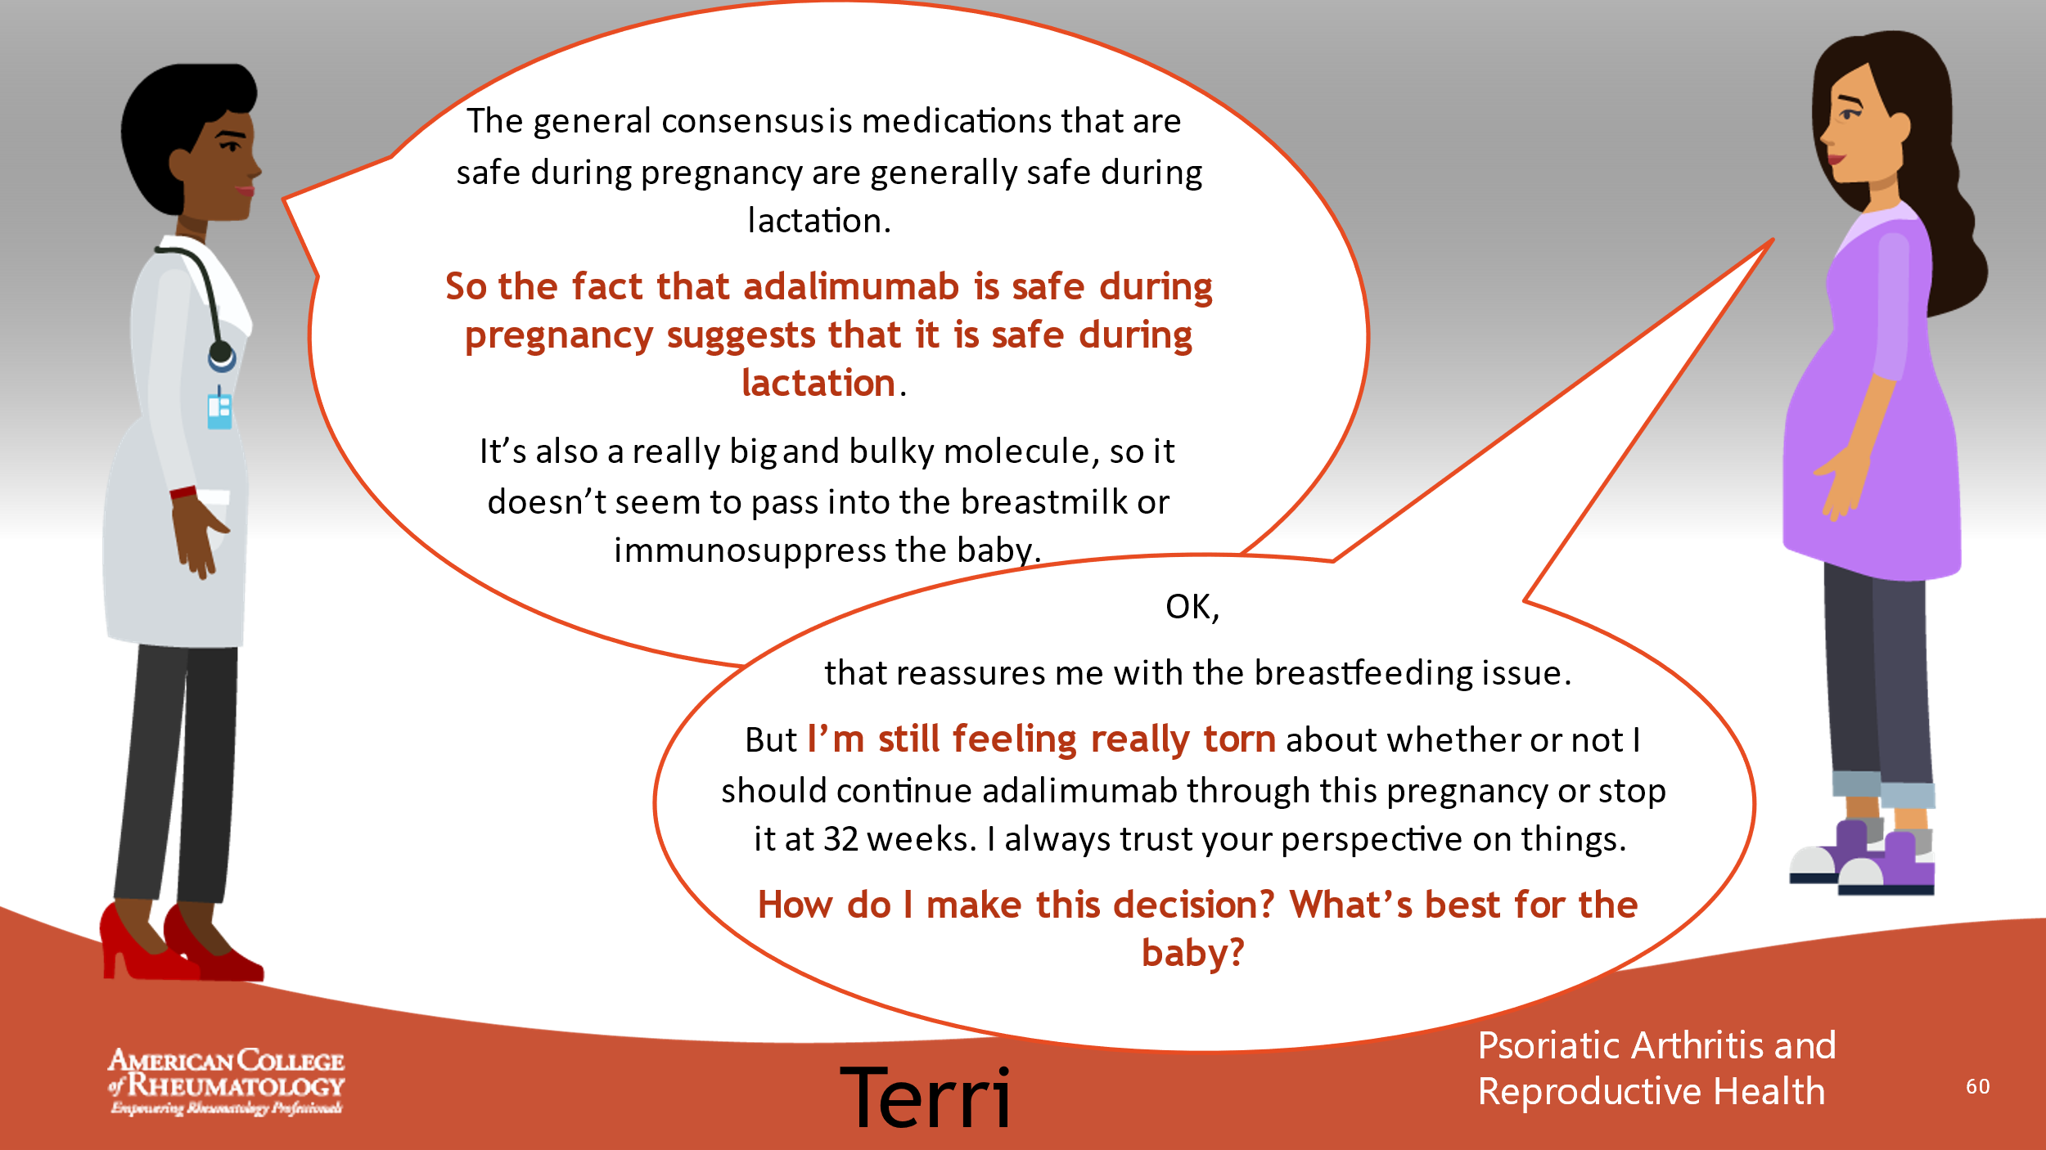

- _______________________________________________________
- _______________________________________________________
- _______________________________________________________
- _______________________________________________________
- _______________________________________________________
- _______________________________________________________
- _______________________________________________________
- _______________________________________________________

Slide 61: CONVERSATION
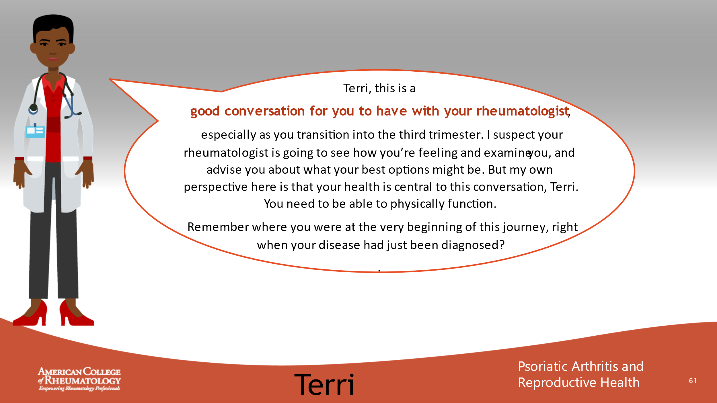

- _______________________________________________________
- _______________________________________________________
- _______________________________________________________
- _______________________________________________________
- _______________________________________________________
- _______________________________________________________
- _______________________________________________________
- _______________________________________________________

Slide 62: CONVERSATION
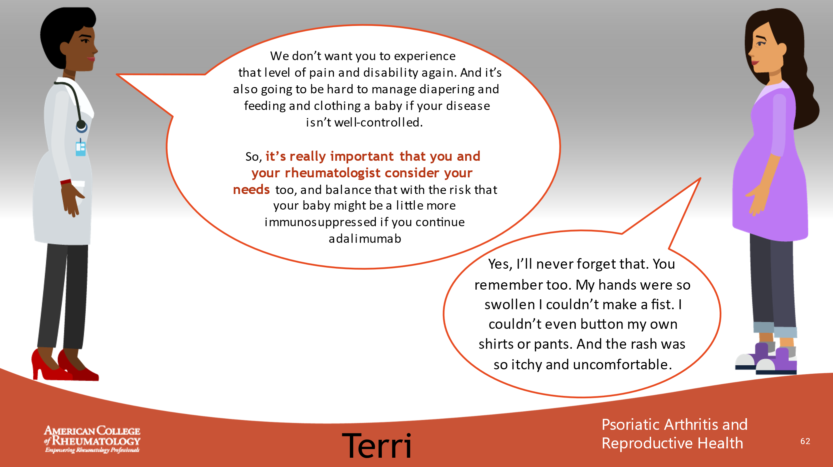

- _______________________________________________________
- _______________________________________________________
- _______________________________________________________
- _______________________________________________________
- _______________________________________________________
- _______________________________________________________
- _______________________________________________________
- _______________________________________________________

Slide 63: CASE 4 LEARNING POINTS
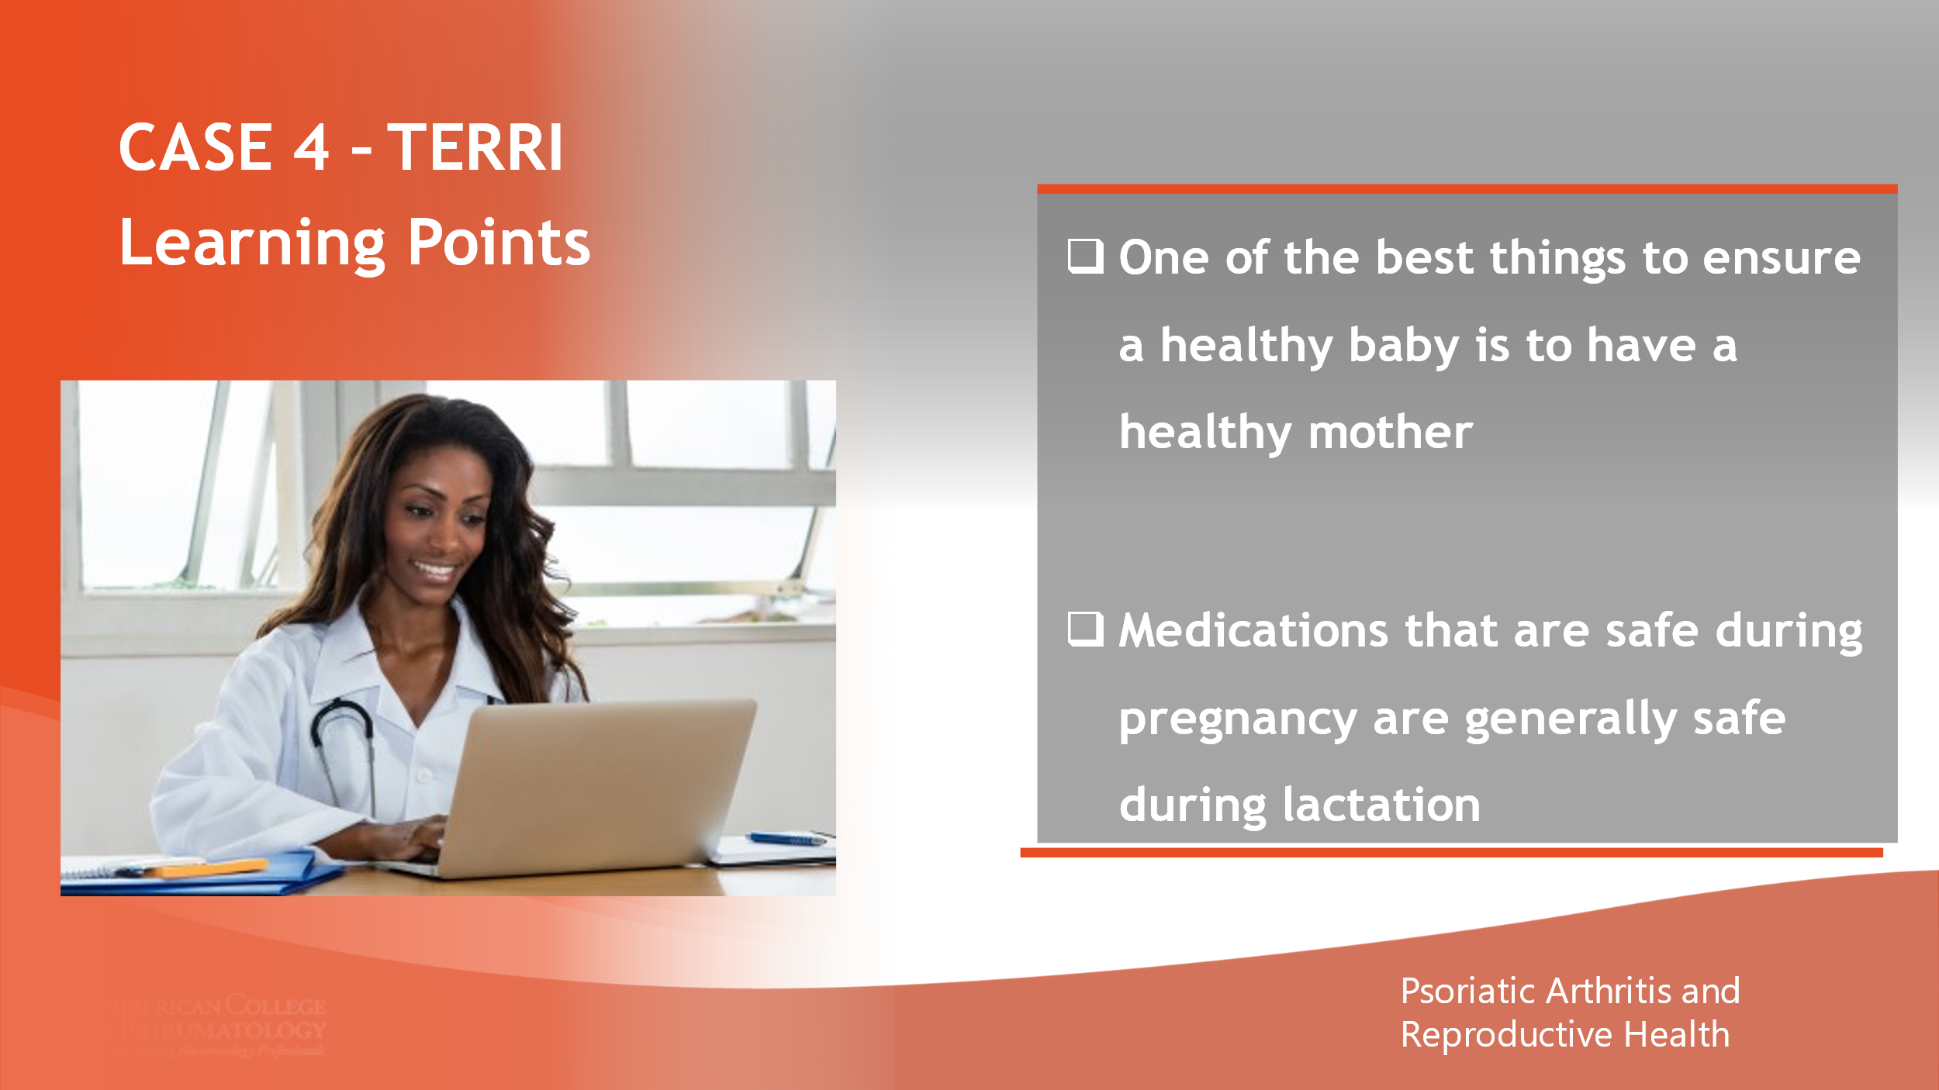

- _______________________________________________________
- _______________________________________________________
- _______________________________________________________
- _______________________________________________________
- _______________________________________________________
- _______________________________________________________
- _______________________________________________________
- _______________________________________________________

Slide 64: KEY MESSAGES
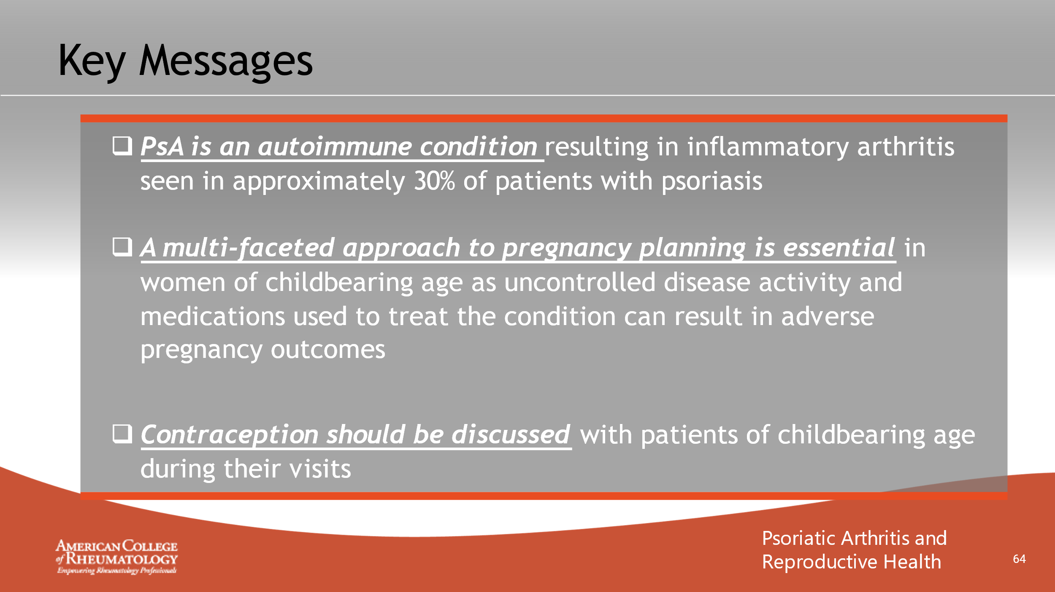

- _______________________________________________________
- _______________________________________________________
- _______________________________________________________
- _______________________________________________________
- _______________________________________________________
- _______________________________________________________
- _______________________________________________________
- _______________________________________________________

Slide 65: KEY MESSAGES
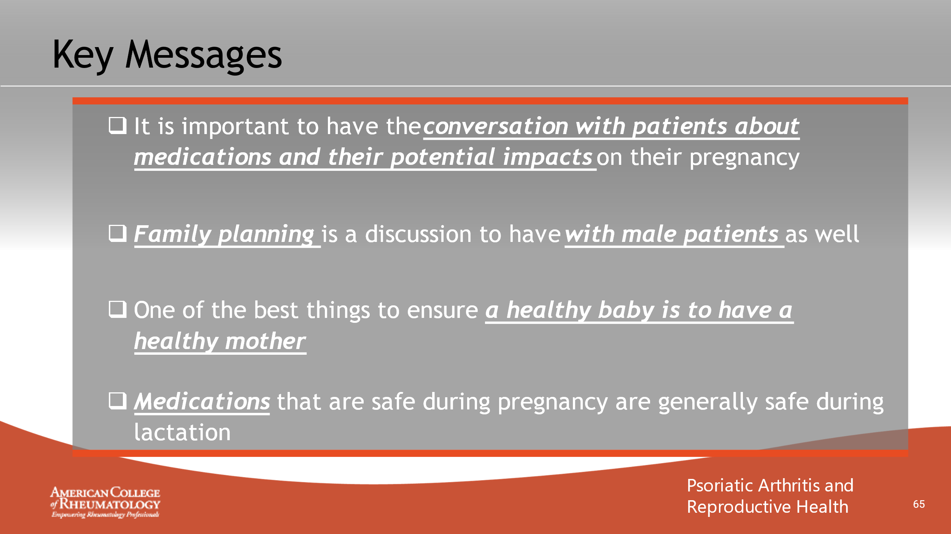

- _______________________________________________________
- _______________________________________________________
- _______________________________________________________
- _______________________________________________________
- _______________________________________________________
- _______________________________________________________
- _______________________________________________________
- _______________________________________________________

Slide 66: REFERENCES
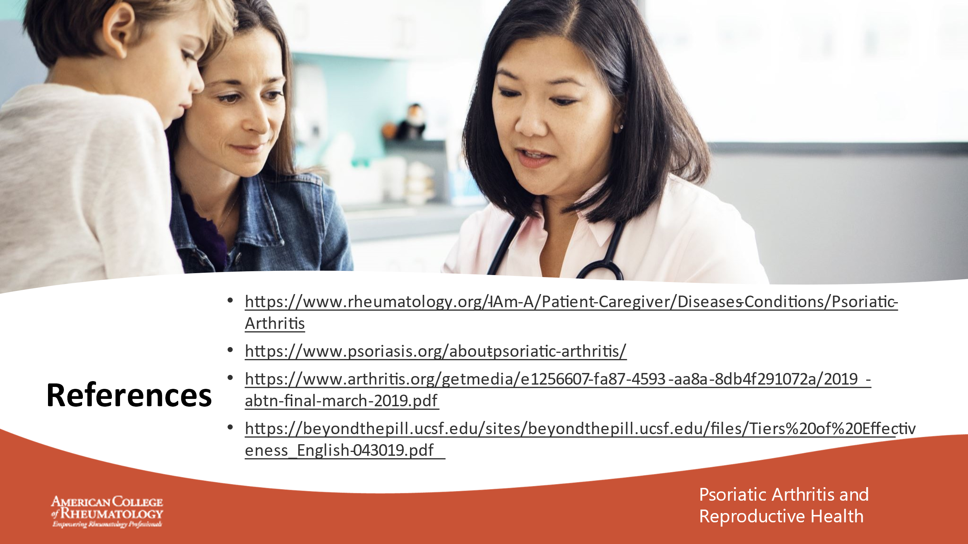

- _______________________________________________________
- _______________________________________________________
- _______________________________________________________
- _______________________________________________________
- _______________________________________________________
- _______________________________________________________
- _______________________________________________________
- _______________________________________________________

Slide 67: Q & A

- _______________________________________________________
- _______________________________________________________
- _______________________________________________________
- _______________________________________________________
- _______________________________________________________
- _______________________________________________________
- _______________________________________________________
- _______________________________________________________

Slide 68: CONTACT INFO

- _______________________________________________________
- _______________________________________________________
- _______________________________________________________
- _______________________________________________________
- _______________________________________________________
- _______________________________________________________
- _______________________________________________________
- _______________________________________________________

CONCLUSIONS
Facilitator Notes:
- Thank participants for attending Exploring PsA and Reproductive Health, Case by Case

- Remind participants about the importance of their feedback and emphasize that they take the post-test assessment. Allow 10 minutes for the post-test to be completed.

- If you are comfortable, consider offering your contact information to participants in case they have questions after today’s session.

