Facilitator’s Guide for Navigating Reproductive Health in Patients with Systemic Lupus Erythematosus (SLE)

ACKNOWLEDGEMENTS

These educational materials were supported by a medical education grant from GlaxoSmithKline to address Systemic Lupus Erythematosus (SLE) and Reproductive Health education to support patient, educators, and clinical teams.
Its contents are solely the responsibility of the authors and do not necessarily reflect the official views of GlaxoSmithKline.
© 2021 American College of Rheumatology. All rights reserved.

AUTHORS
Bonnie Bermas, MD
Brittany Bettendorf, MD
Cuoghi Edens, MD
Amanda Eudy, PhD
Sara Wasserman, MD
Michael Weisman, MD
021 American College of Rheumatology. All rights reserved.

Notes:
Getting Started
Navigating Reproductive Health in Patients with Systemic Lupus Erythematosus (SLE) is a program designed to educate prescribing providers and their healthcare teams on how to manage and treat SLE in patients of reproductive age. Utilizing the 2020 American College of Rheumatology (ACR) Guidelines for Reproductive Health in Rheumatic Disease as the foundation, this program will explore the importance of pre-conception counseling, medications compatible with pregnancy and lactation, as well as how to educate patients on how to prepare for the best pregnancy outcomes given their disease status. Using case studies, this program will walk providers through charts in the guidelines and discuss the appropriate considerations, lab tests, and conversations that non-rheumatology and rheumatology providers should be aware of in order to best care for their patients and their growing families.
Objectives of This Presentation:
At the end of this presentation, learners will be able to:
- Appreciate the impact of pregnancy on SLE disease activity and the risk of adverse pregnancy outcomes in women with SLE
- Recognize the importance of pre-conception counseling
- Identify disease specific management for pregnant SLE patients including the safety of common SLE meds in pregnancy and lactation
Length of the Activity:
The presentation and discussion should last between 60-75 minutes.
What You Need:
- Computer and audio/visual equipment for projection of the PowerPoint presentation to the audience
- Guide for Navigating Reproductive Health in Patients with Systemic Lupus Erythematosus (SLE) PowerPoint presentation
- Facilitator’s Guide/Presentation script
- SLE Handouts (2)

Importance of Evaluation: the Pre & Post Test
To continue to improve this education for others, it is important that we get feedback on:
- What are the participants learning from this session?
- How can this session be improved?
- What additional information would be helpful?
Please be sure to encourage your learners to take the pre-test prior to the session, and the post-test at the completion of the session. If you have questions, please speak with your organization’s point of contact.
Slide 4: Learning Objectives
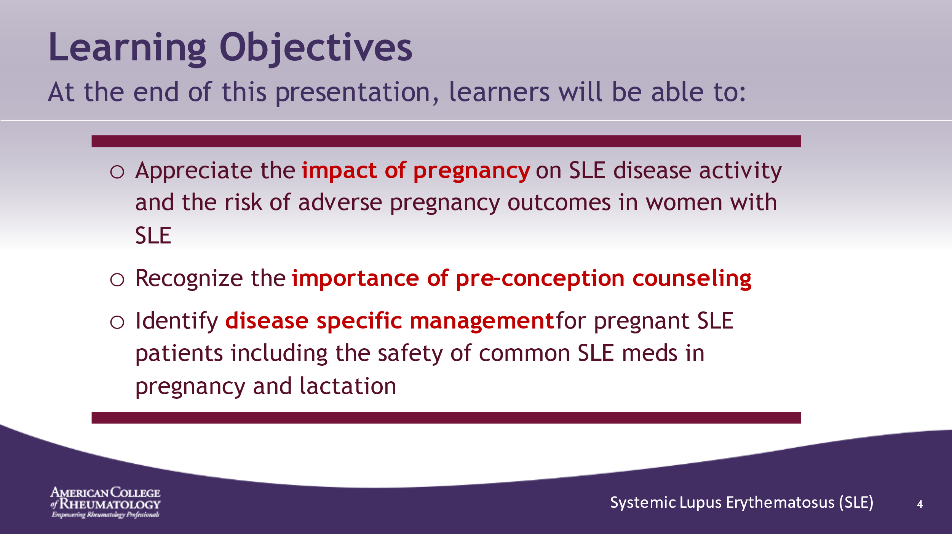

- ______________________________________________________
- ______________________________________________________
- ______________________________________________________
- ______________________________________________________
- ______________________________________________________
- ______________________________________________________
- ______________________________________________________
- ______________________________________________________

Slide 5: Disease Overview
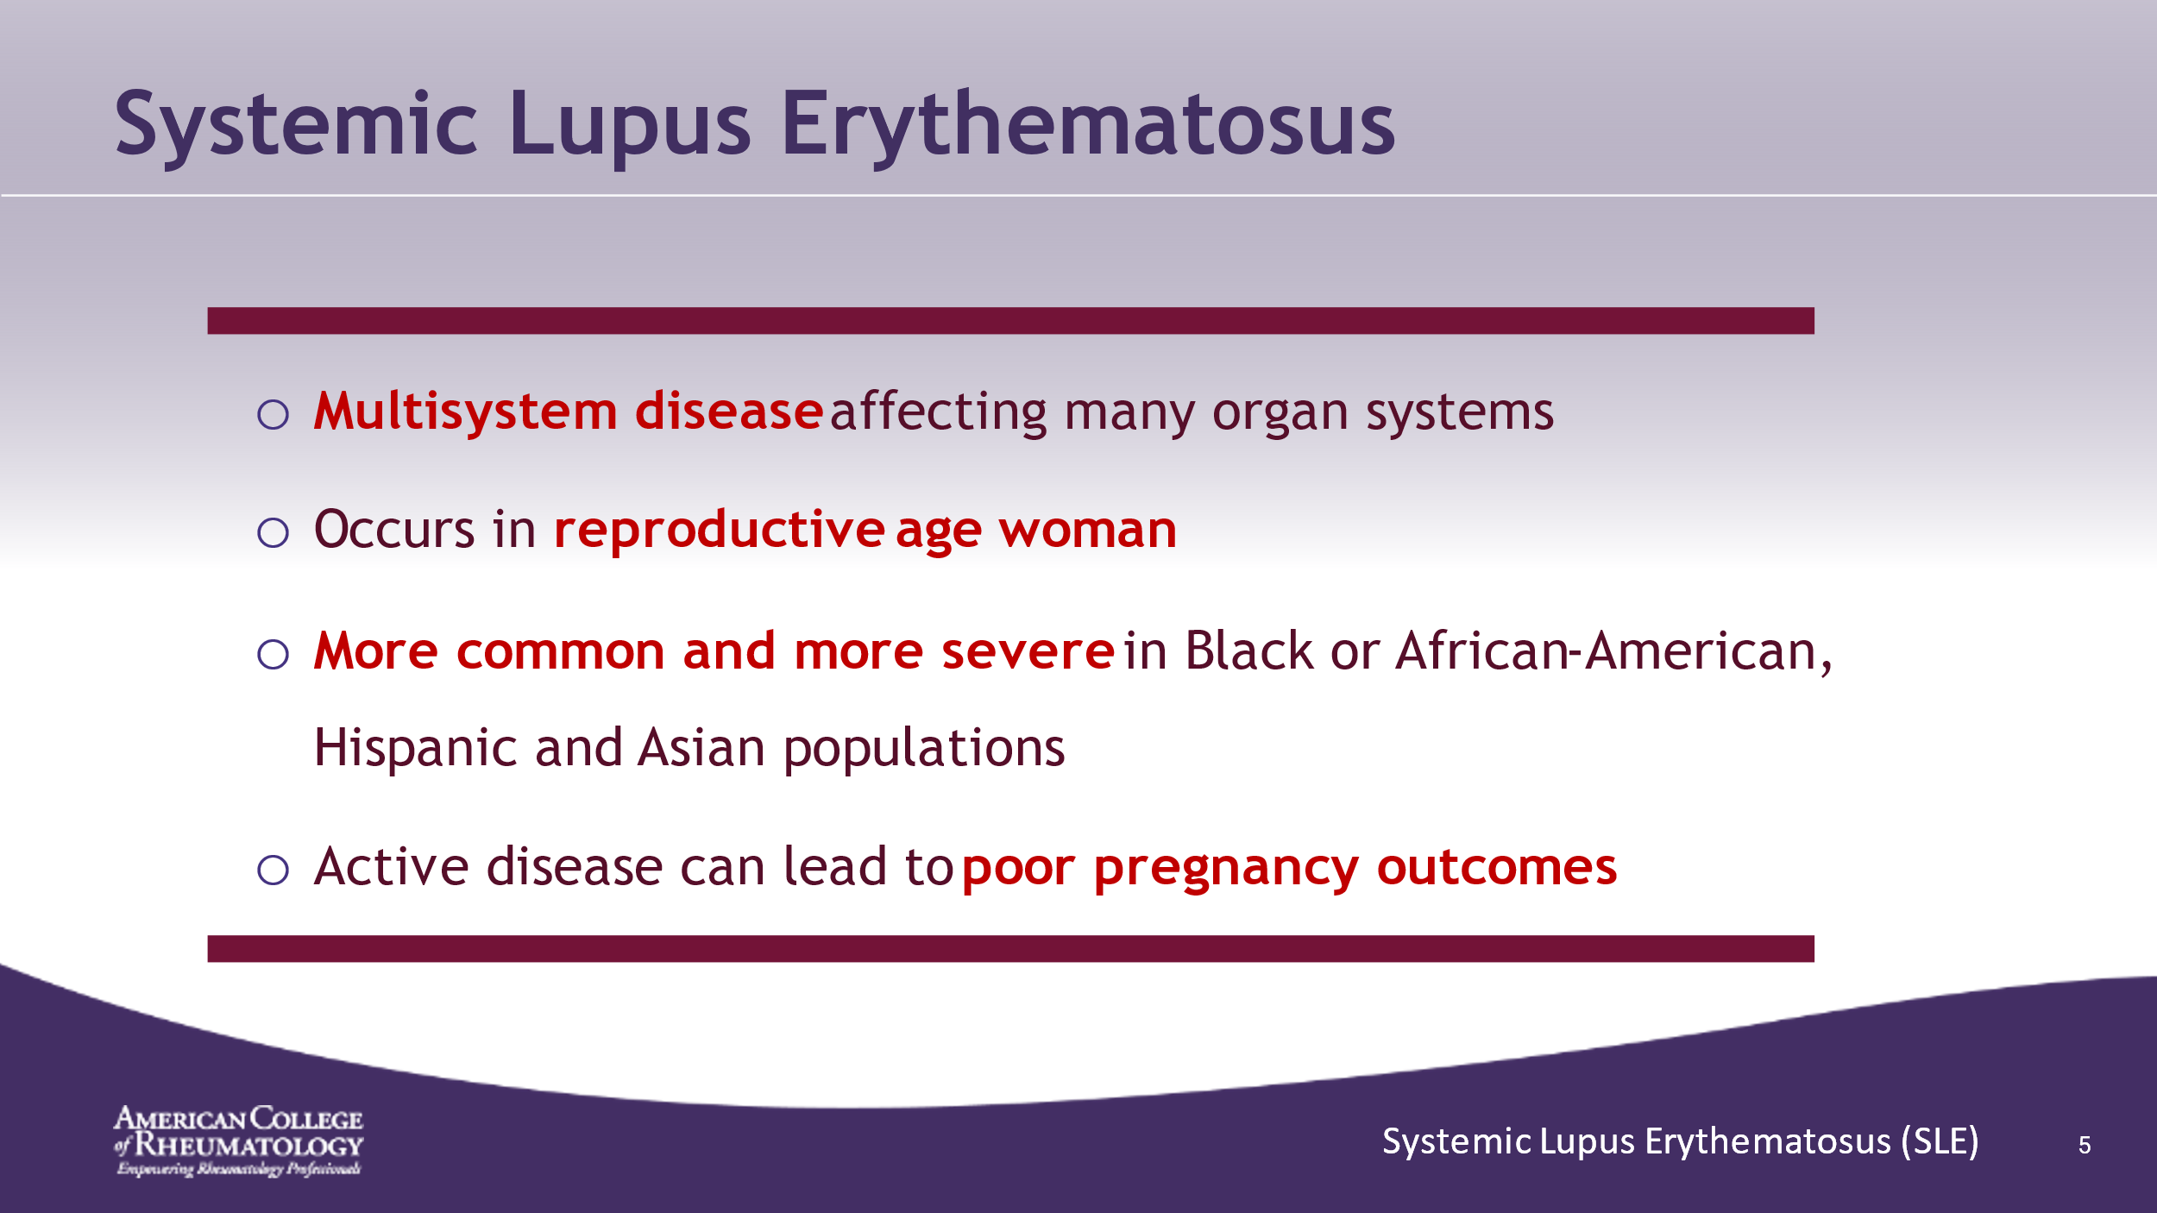

- ______________________________________________________
- ______________________________________________________
- ______________________________________________________
- ______________________________________________________
- ______________________________________________________
- ______________________________________________________
- ______________________________________________________
- ______________________________________________________

Slide 6: Basic Premises
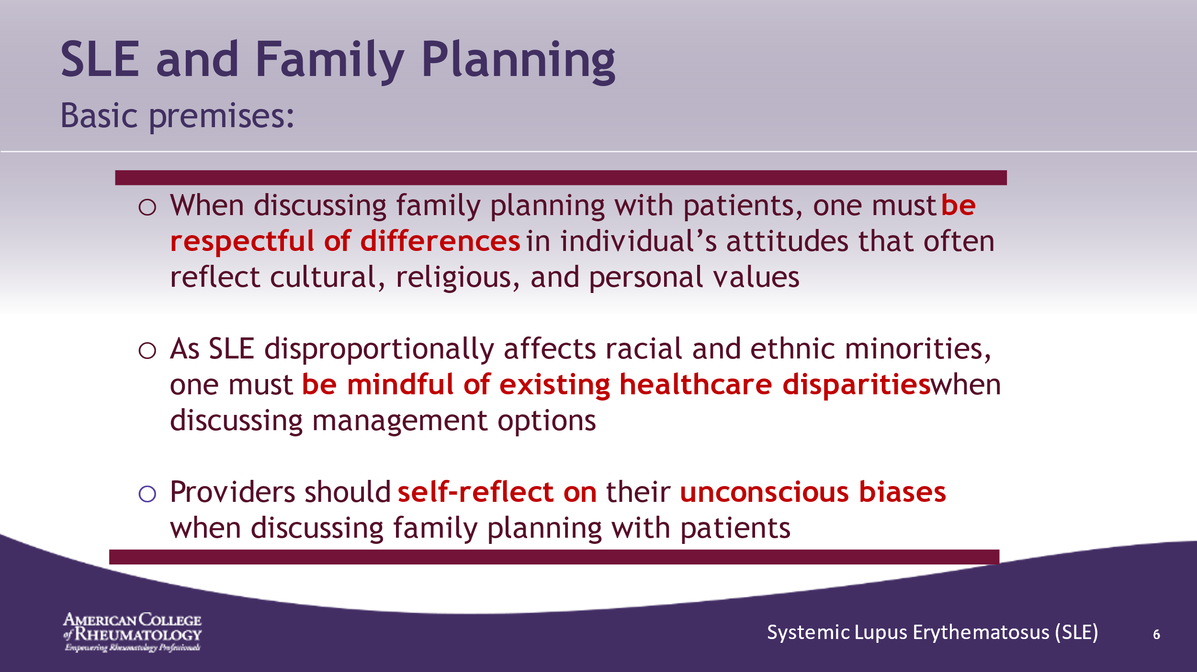

- ______________________________________________________
- ______________________________________________________
- ______________________________________________________
- ______________________________________________________
- ______________________________________________________
- ______________________________________________________
- ______________________________________________________
- ______________________________________________________

Slide 7: Lupus in Pregnancy Case
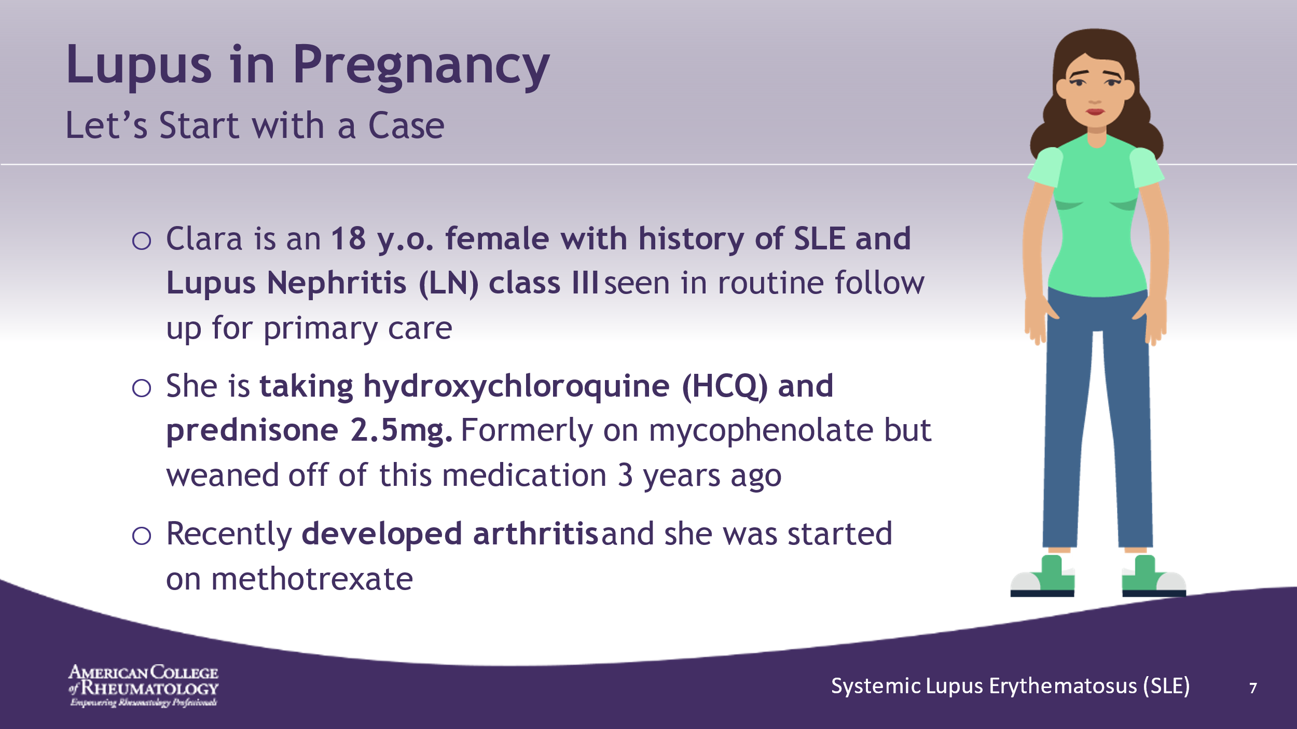

- ______________________________________________________
- ______________________________________________________
- ______________________________________________________
- ______________________________________________________
- ______________________________________________________
- ______________________________________________________
- ______________________________________________________
- ______________________________________________________

Slide 8: CONVERSATION
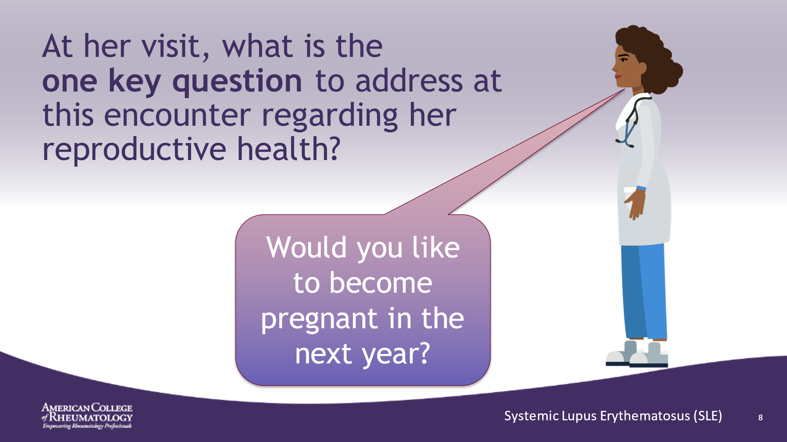

- ______________________________________________________
- ______________________________________________________
- ______________________________________________________
- ______________________________________________________
- ______________________________________________________
- ______________________________________________________
- ______________________________________________________
- ______________________________________________________

Slide 9: CONVERSATION
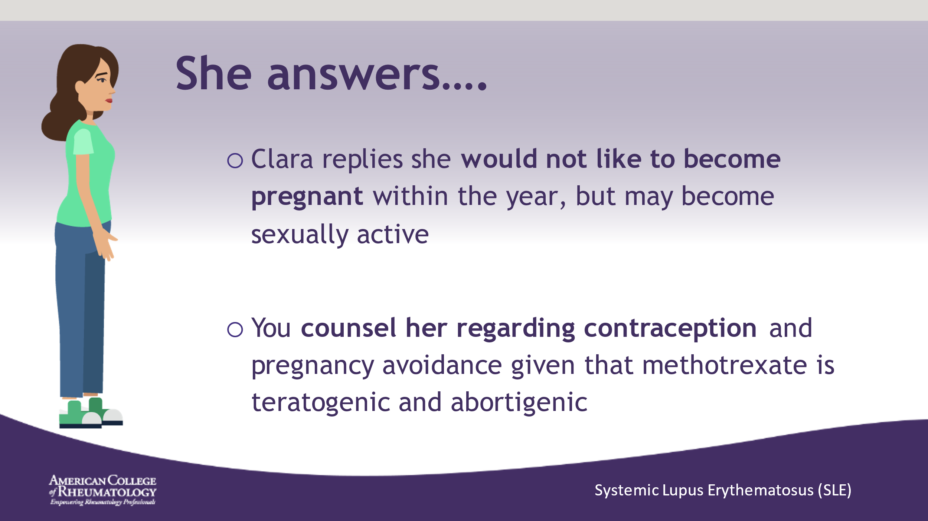

- ______________________________________________________
- ______________________________________________________
- ______________________________________________________
- ______________________________________________________
- ______________________________________________________
- ______________________________________________________
- ______________________________________________________
- ______________________________________________________

Slide 10: CONVERSATION
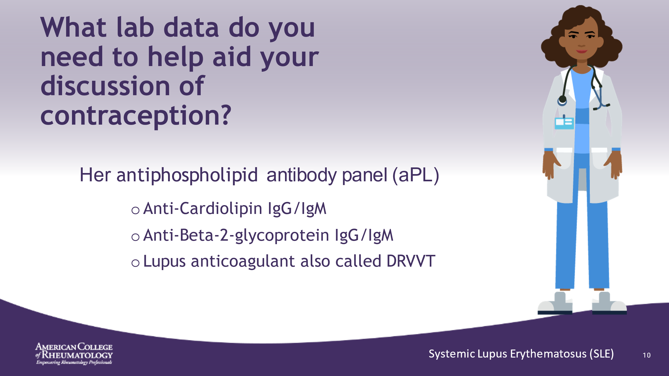

- ______________________________________________________
- ______________________________________________________
- ______________________________________________________
- ______________________________________________________
- ______________________________________________________
- ______________________________________________________
- ______________________________________________________
- ______________________________________________________

Slide 11: ASSESSING aPL STATUS
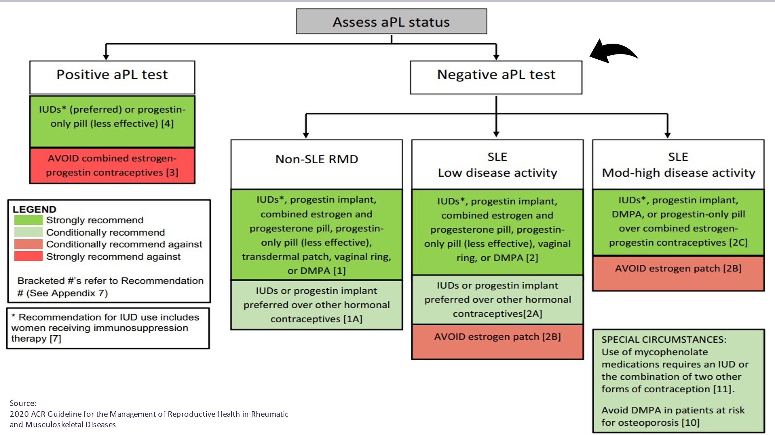

- RMD: Rheumatic and Musculoskeletal Disease
- ______________________________________________________
- ______________________________________________________
- ______________________________________________________
- ______________________________________________________
- ______________________________________________________
- ______________________________________________________
- ______________________________________________________

Slide 12: IF THE aPLs ARE NEGATIVE
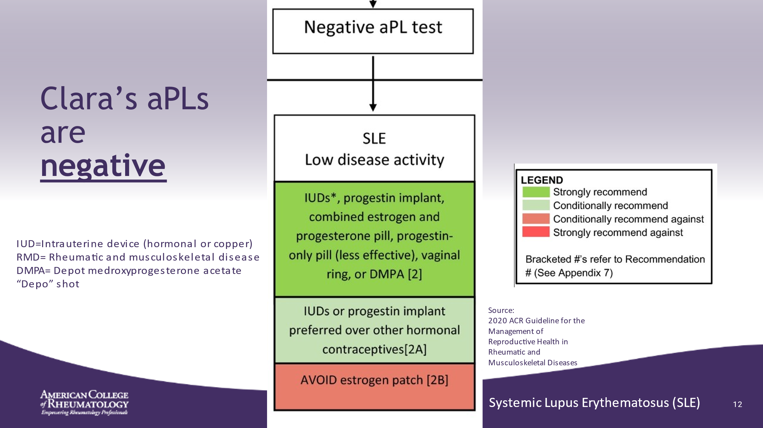

- Clara has many options available to her since aPL’s are negative.
- Estrogen patch has higher levels of estrogen than COC’s and thus should be avoided in patients with SLE
- ______________________________________________________
- ______________________________________________________
- ______________________________________________________
- ______________________________________________________
- ______________________________________________________
- ______________________________________________________

Slide 13: IF THE aPLs ARE POSITIVE
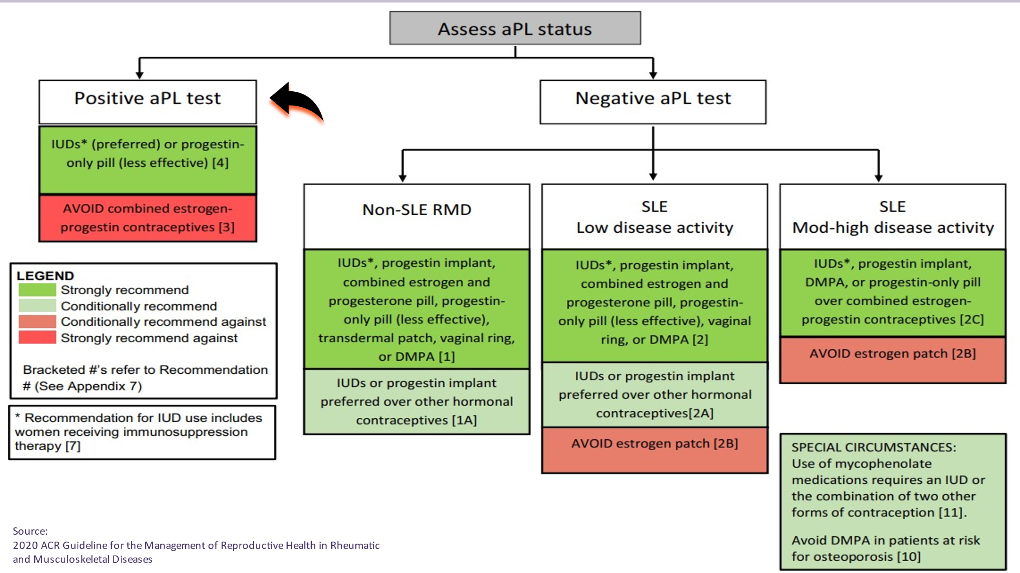

- ______________________________________________________
- ______________________________________________________
- ______________________________________________________
- ______________________________________________________
- ______________________________________________________
- ______________________________________________________
- ______________________________________________________
- ______________________________________________________

Slide 14: IF THE aPLs ARE POSITIVE
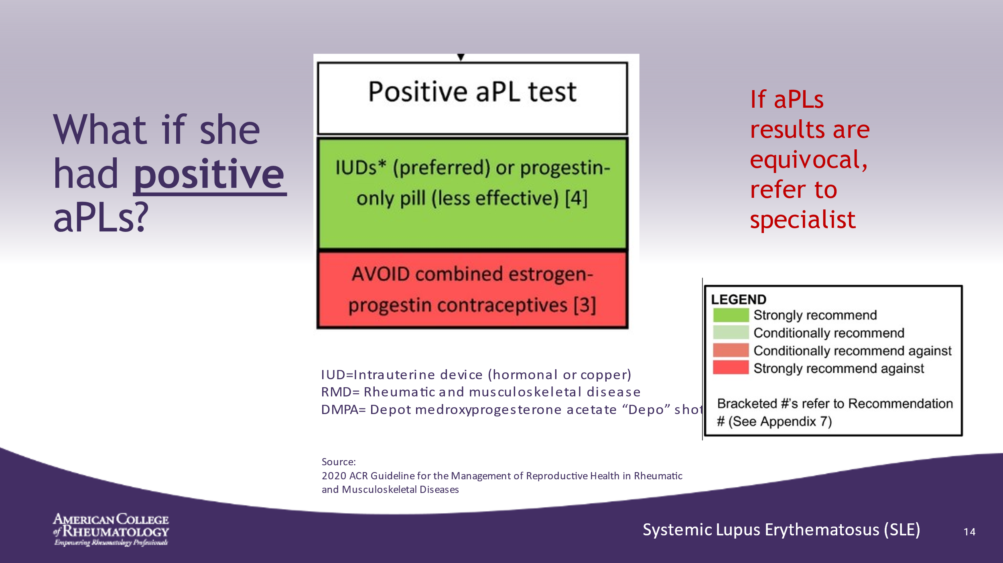

- The guidelines do not comment on new progestin implant in patients with positive aPL due to lack of data
- Avoid estrogen-containing contraception in these patients as estrogen increases risk of thromboembolism
- ______________________________________________________
- ______________________________________________________
- ______________________________________________________
- ______________________________________________________
- ______________________________________________________
- ______________________________________________________

Slide 15: NEXT STEPS….
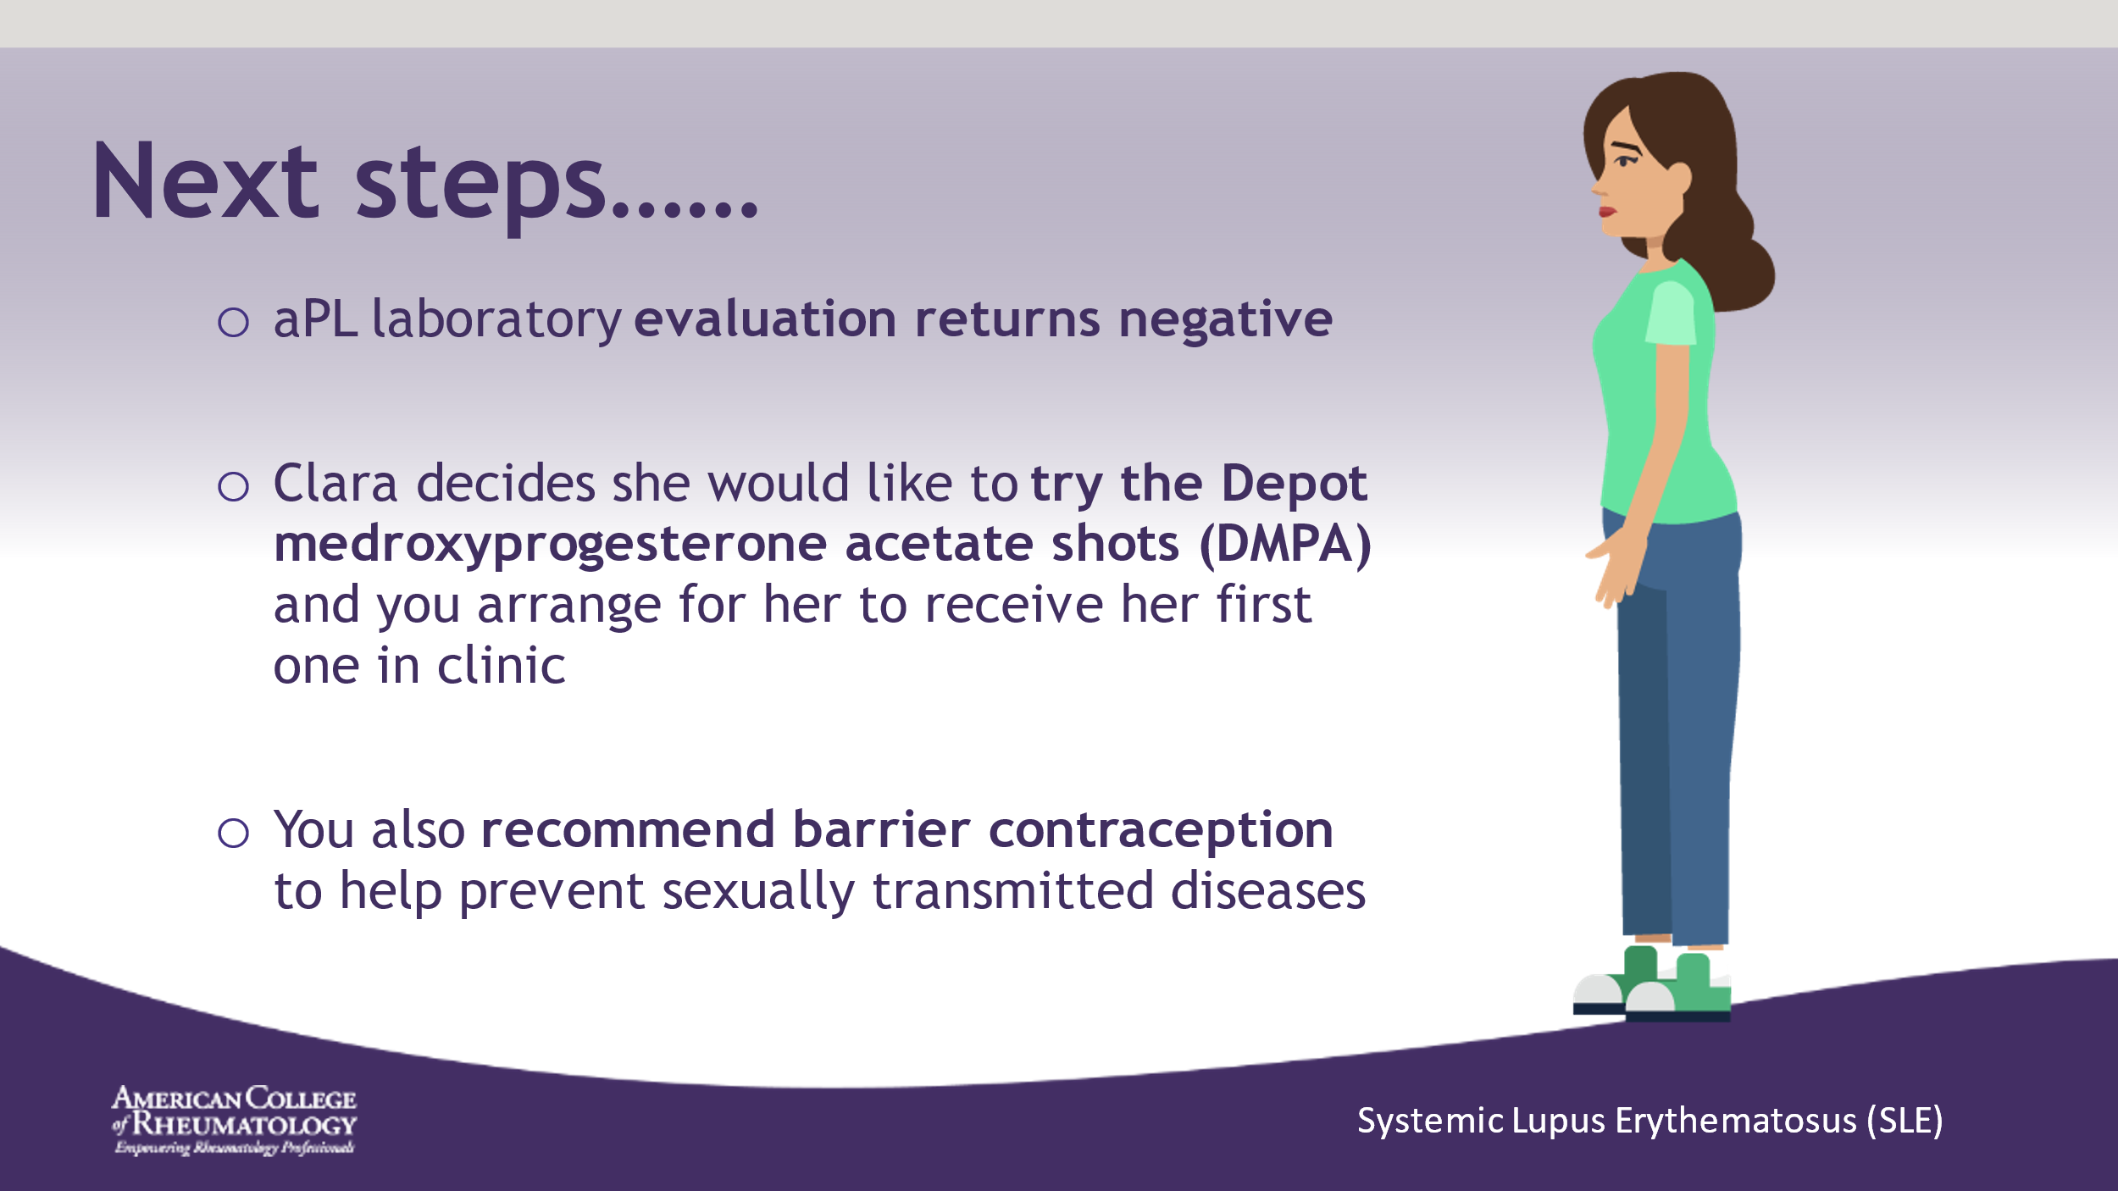

- ______________________________________________________
- ______________________________________________________
- ______________________________________________________
- ______________________________________________________
- ______________________________________________________
- ______________________________________________________
- ______________________________________________________
- ______________________________________________________

Slide 16: TWO YEARS LATER
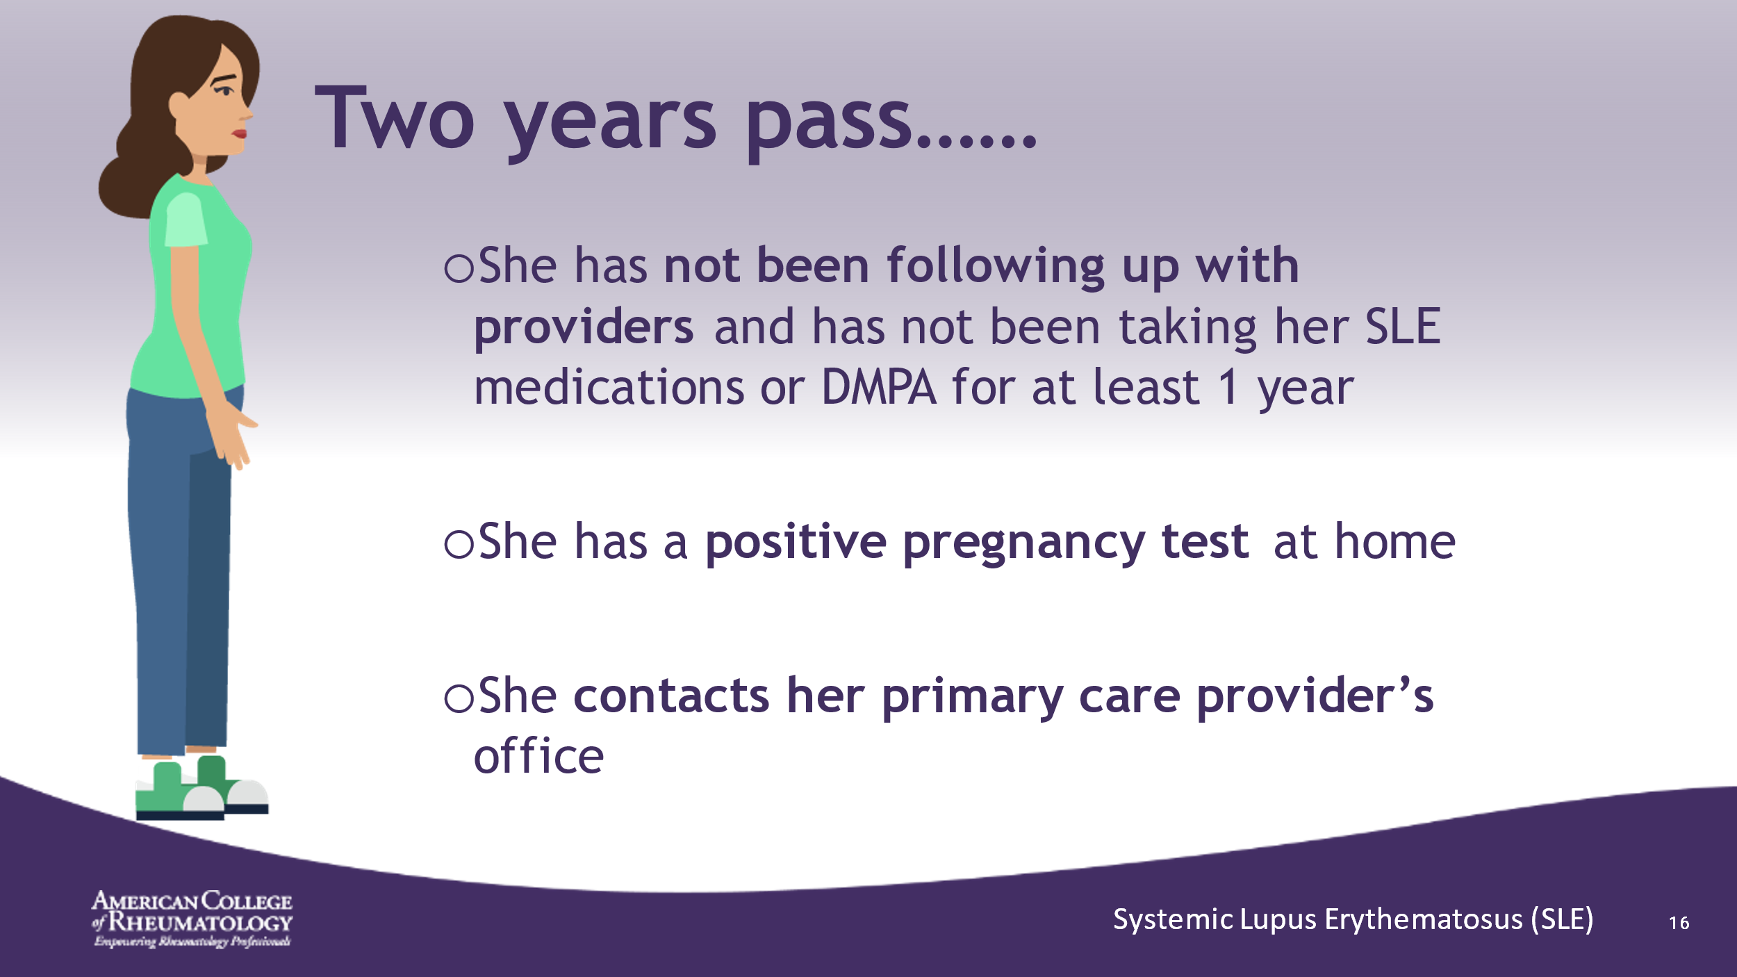

- DMPA: is the contraceptive injection, also known as “the shot”
- ______________________________________________________
- ______________________________________________________
- ______________________________________________________
- ______________________________________________________
- ______________________________________________________
- ______________________________________________________
- ______________________________________________________

Slide 17: PLANNNG LUPUS PREGNANCIES
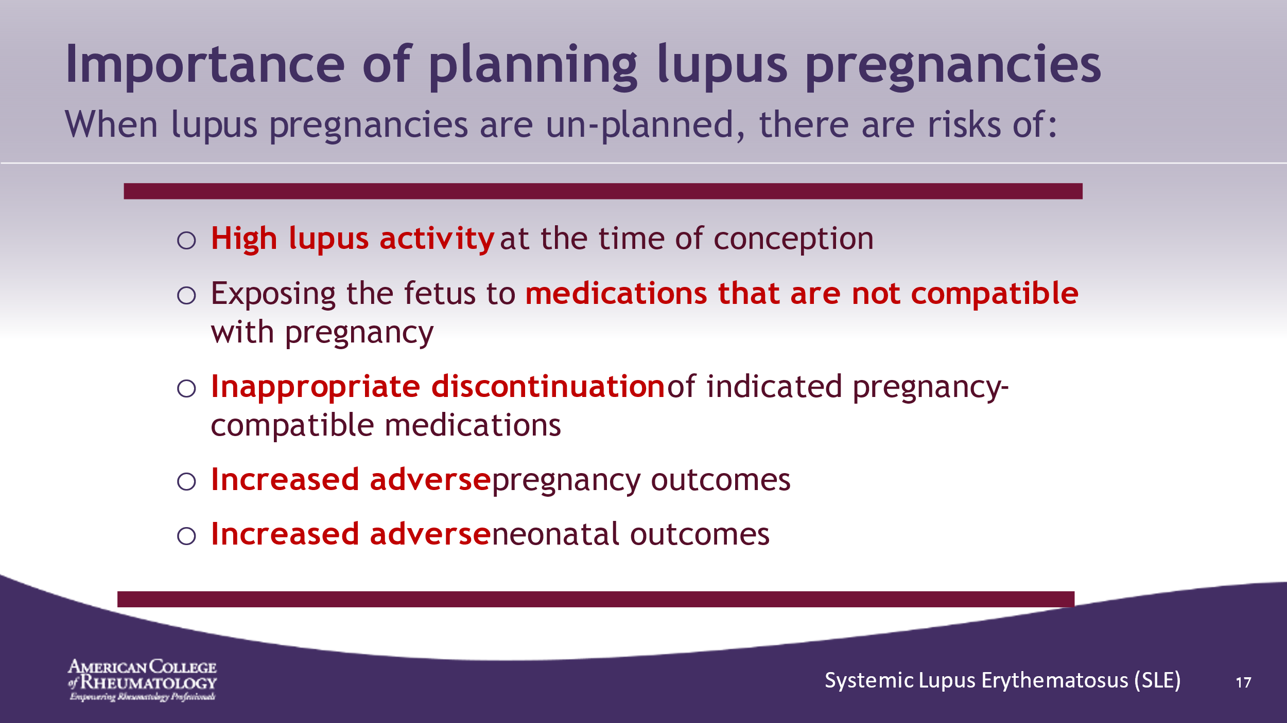

- ______________________________________________________
- ______________________________________________________
- ______________________________________________________
- ______________________________________________________
- ______________________________________________________
- ______________________________________________________
- ______________________________________________________
- ______________________________________________________

Slide 18: TAKING METHOTREXATE BEFORE PREGNANCY
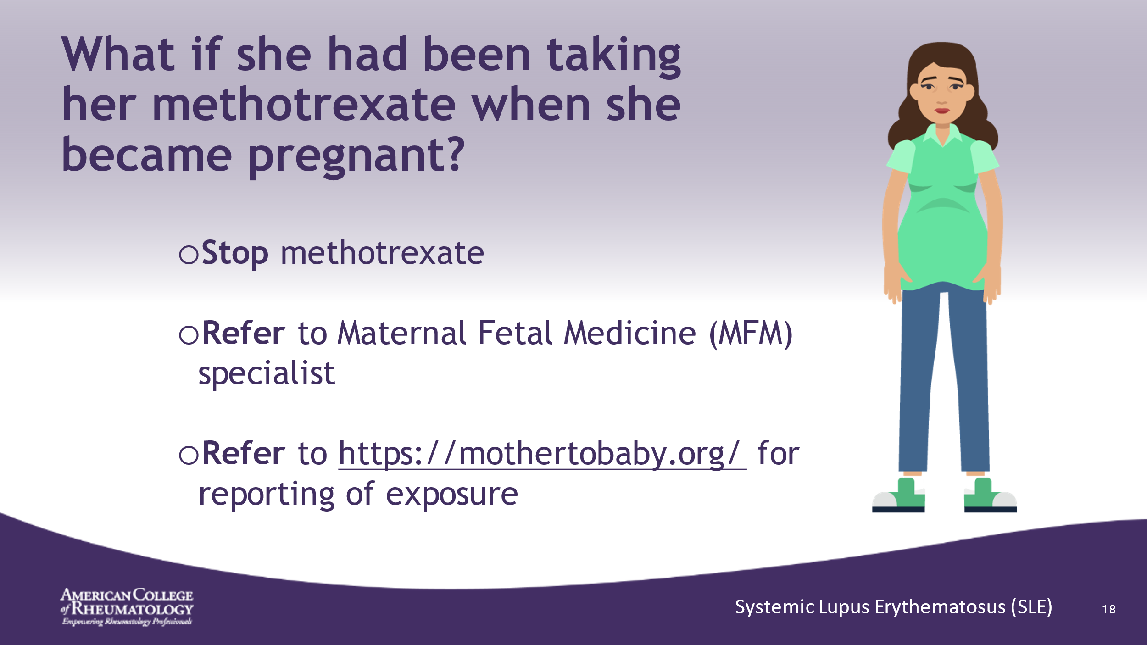

- Mothertobaby.org has resources for counseling her on the exposure and also tracks exposures and outcomes to collect data on medication exposures in pregnant patients
- ______________________________________________________
- ______________________________________________________
- ______________________________________________________
- ______________________________________________________
- ______________________________________________________
- ______________________________________________________
- ______________________________________________________

Slide 19: DRUG SAFETY OVERVIEW
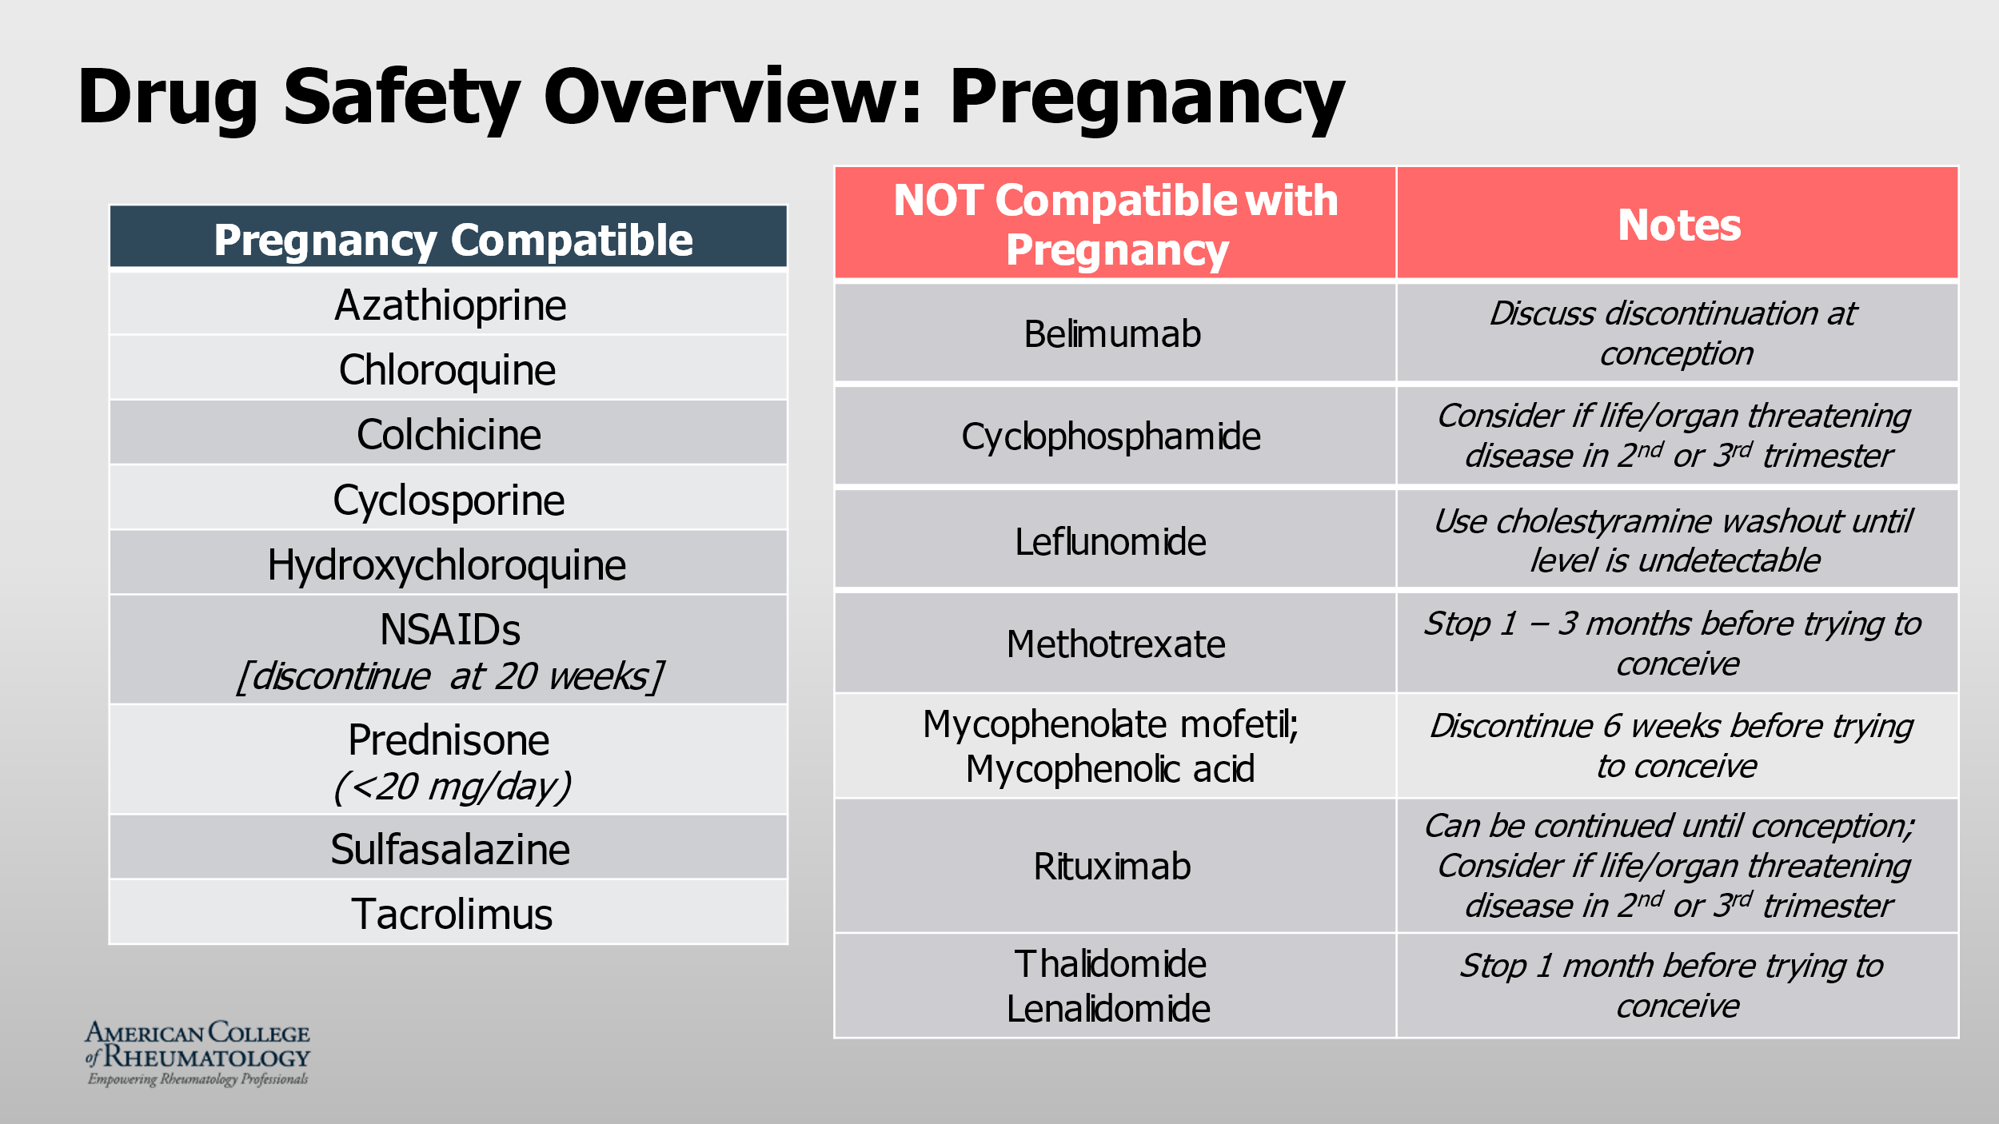

- ______________________________________________________
- ______________________________________________________
- ______________________________________________________
- ______________________________________________________
- ______________________________________________________
- ______________________________________________________
- ______________________________________________________
- ______________________________________________________

Slide 20: NEXT STEPS…..
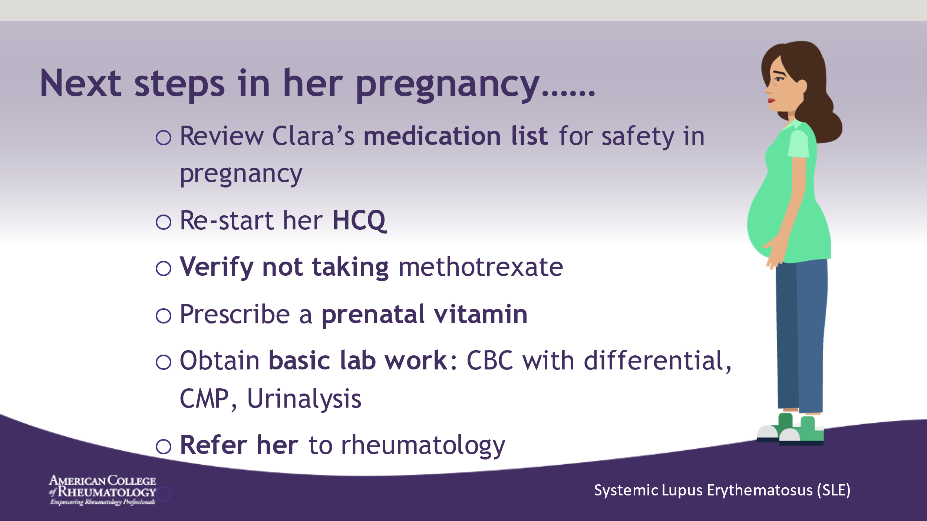

- ______________________________________________________
- ______________________________________________________
- ______________________________________________________
- ______________________________________________________
- ______________________________________________________
- ______________________________________________________
- ______________________________________________________
- ______________________________________________________

Slide 21: PREGNANCY COURSE
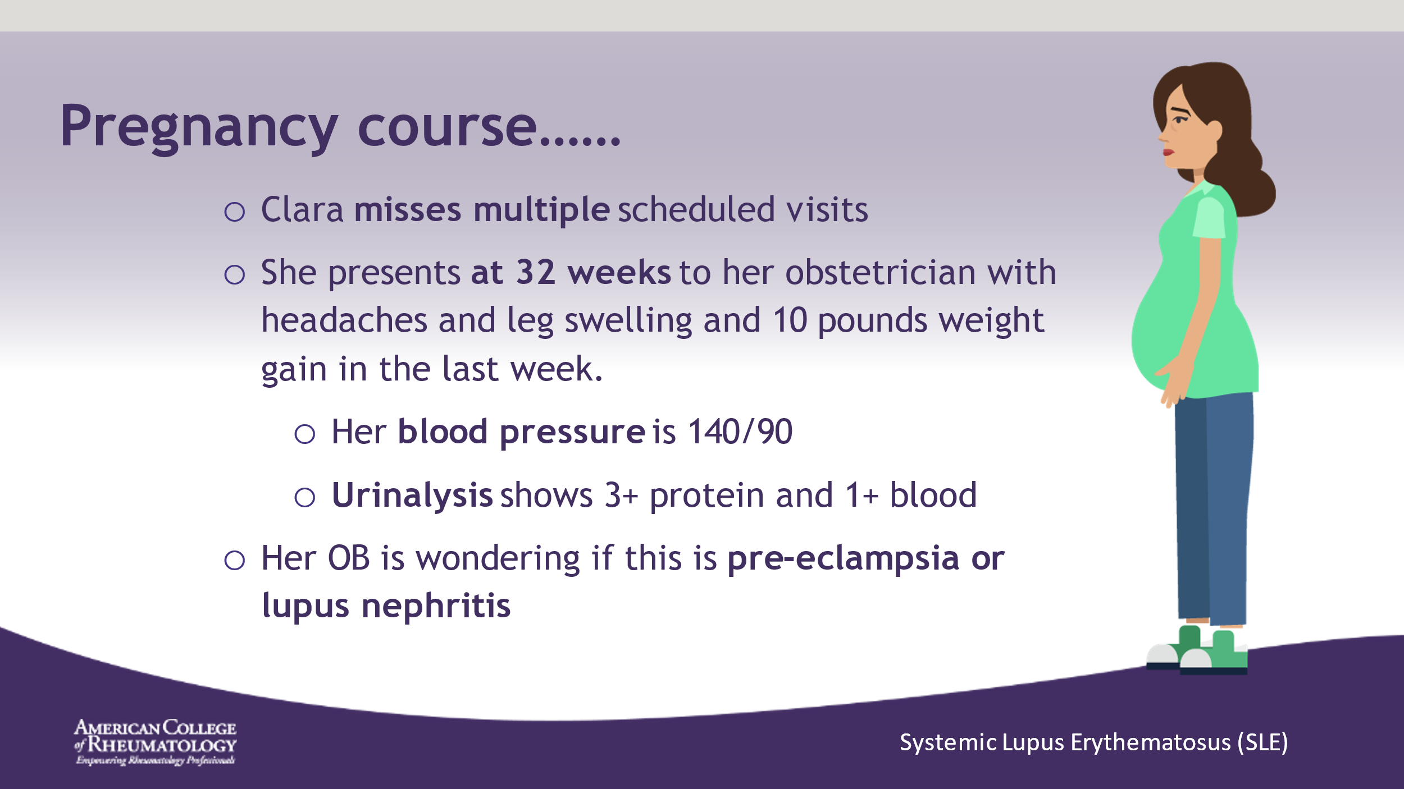

- ______________________________________________________
- ______________________________________________________
- ______________________________________________________
- ______________________________________________________
- ______________________________________________________
- ______________________________________________________
- ______________________________________________________
- ______________________________________________________

Slide 22: LUPUS NEPHRITIS OR PRE-ECLAMPSIA
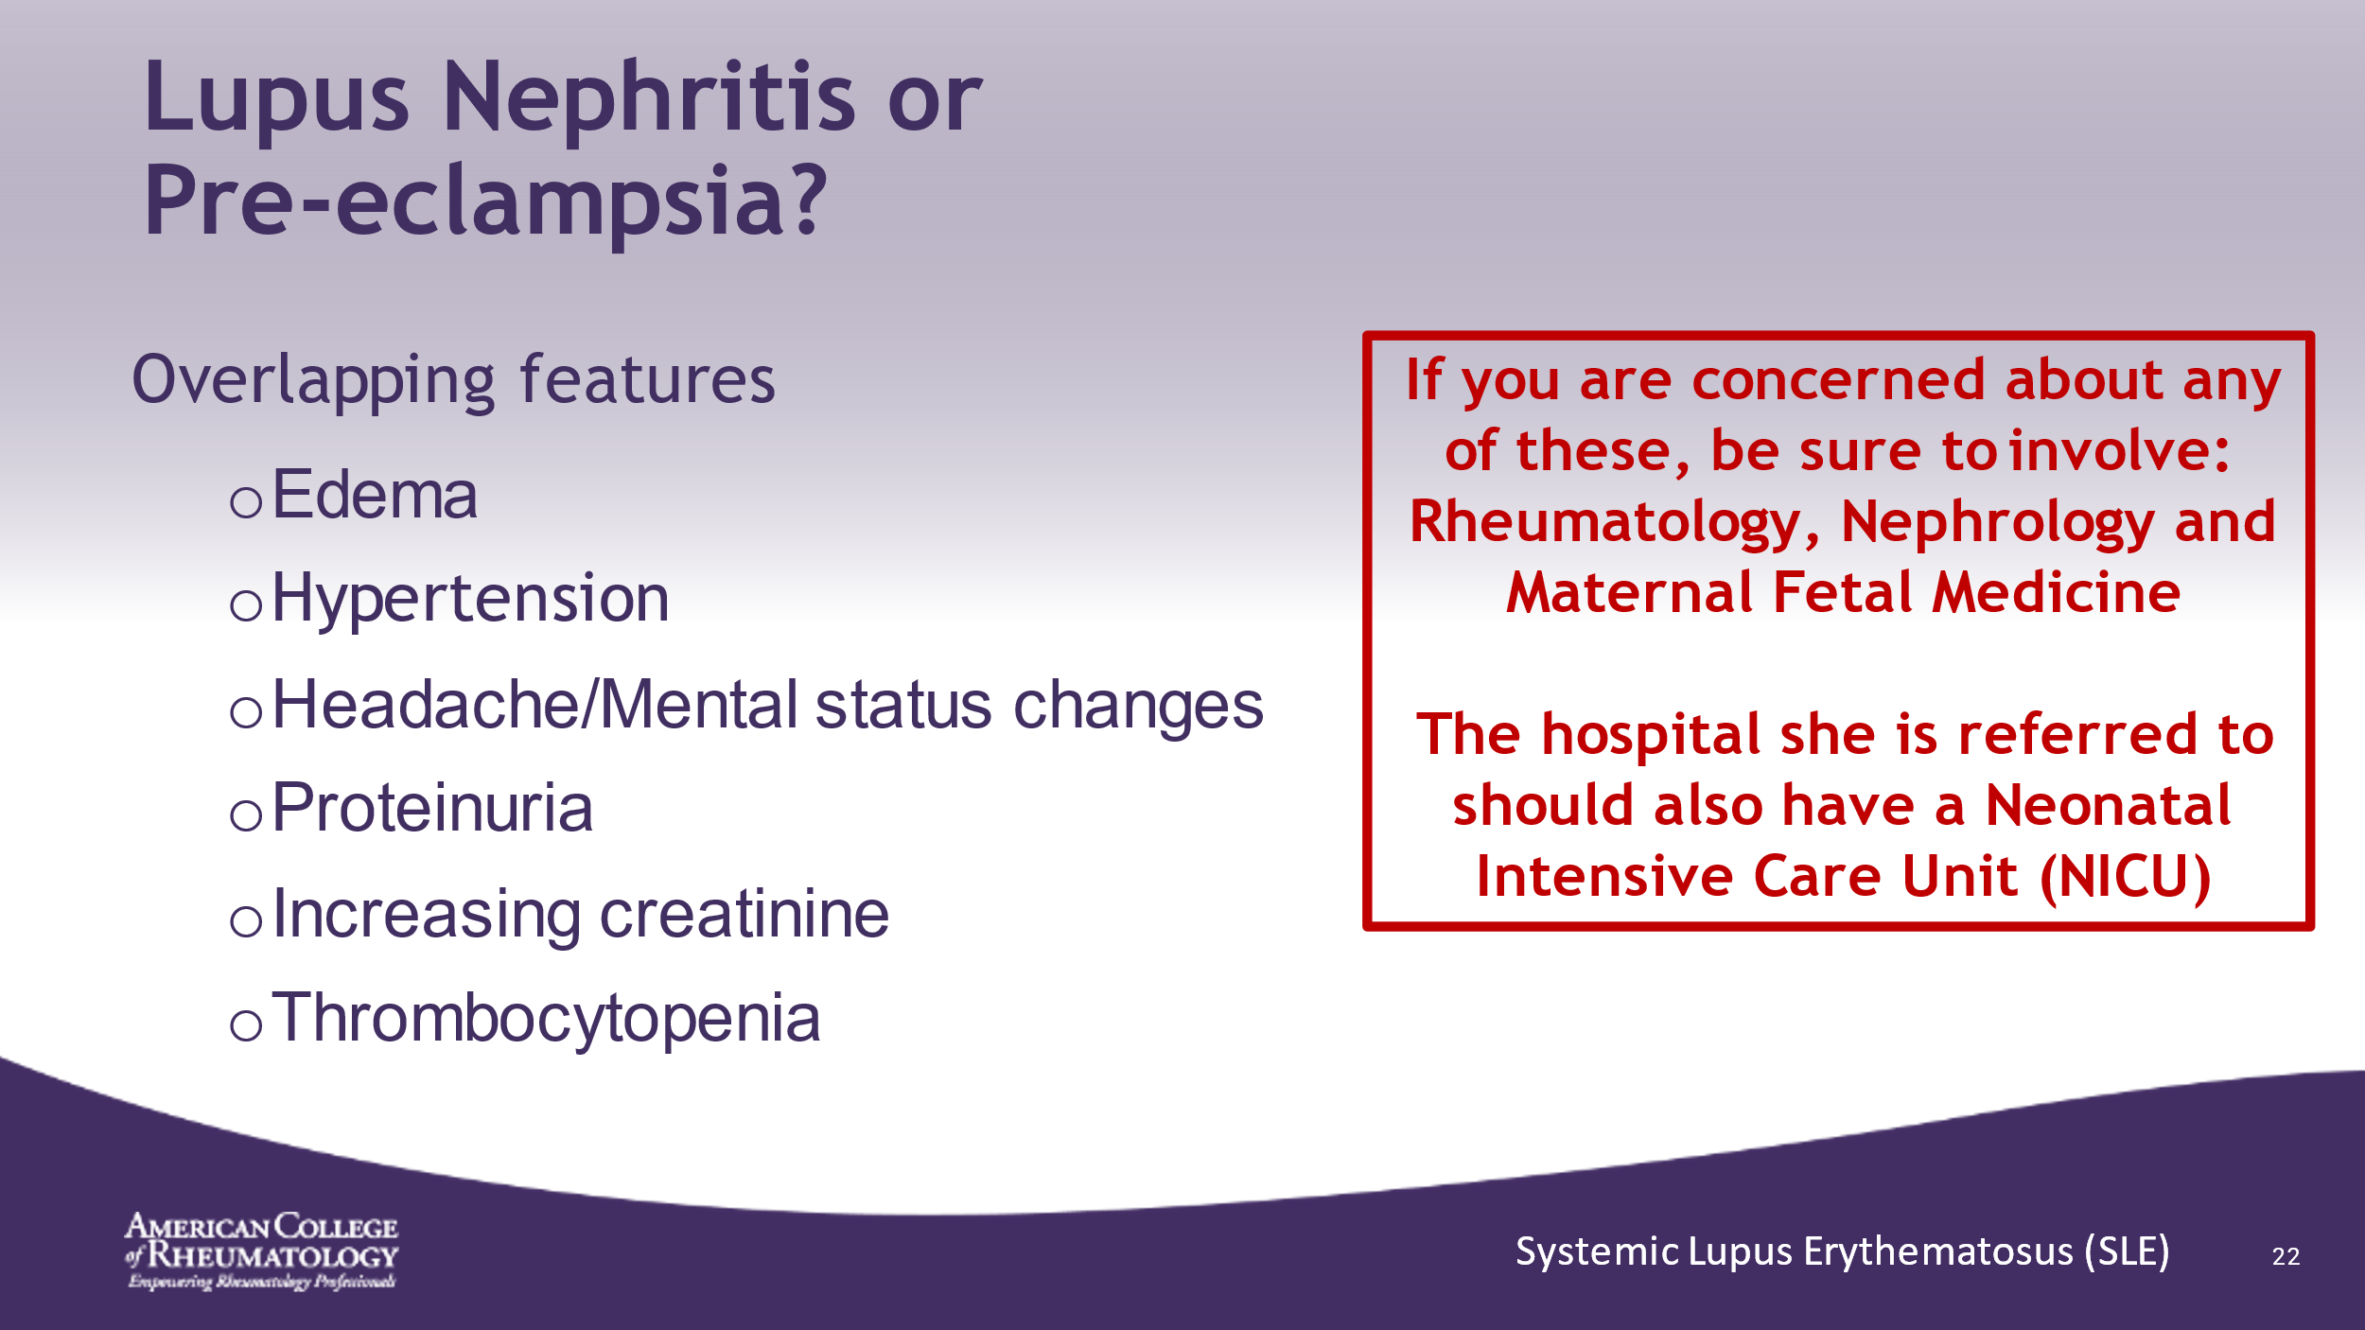

- ______________________________________________________
- ______________________________________________________
- ______________________________________________________
- ______________________________________________________
- ______________________________________________________
- ______________________________________________________
- ______________________________________________________
- ______________________________________________________

Slide 23: HOSPITAL COURSE
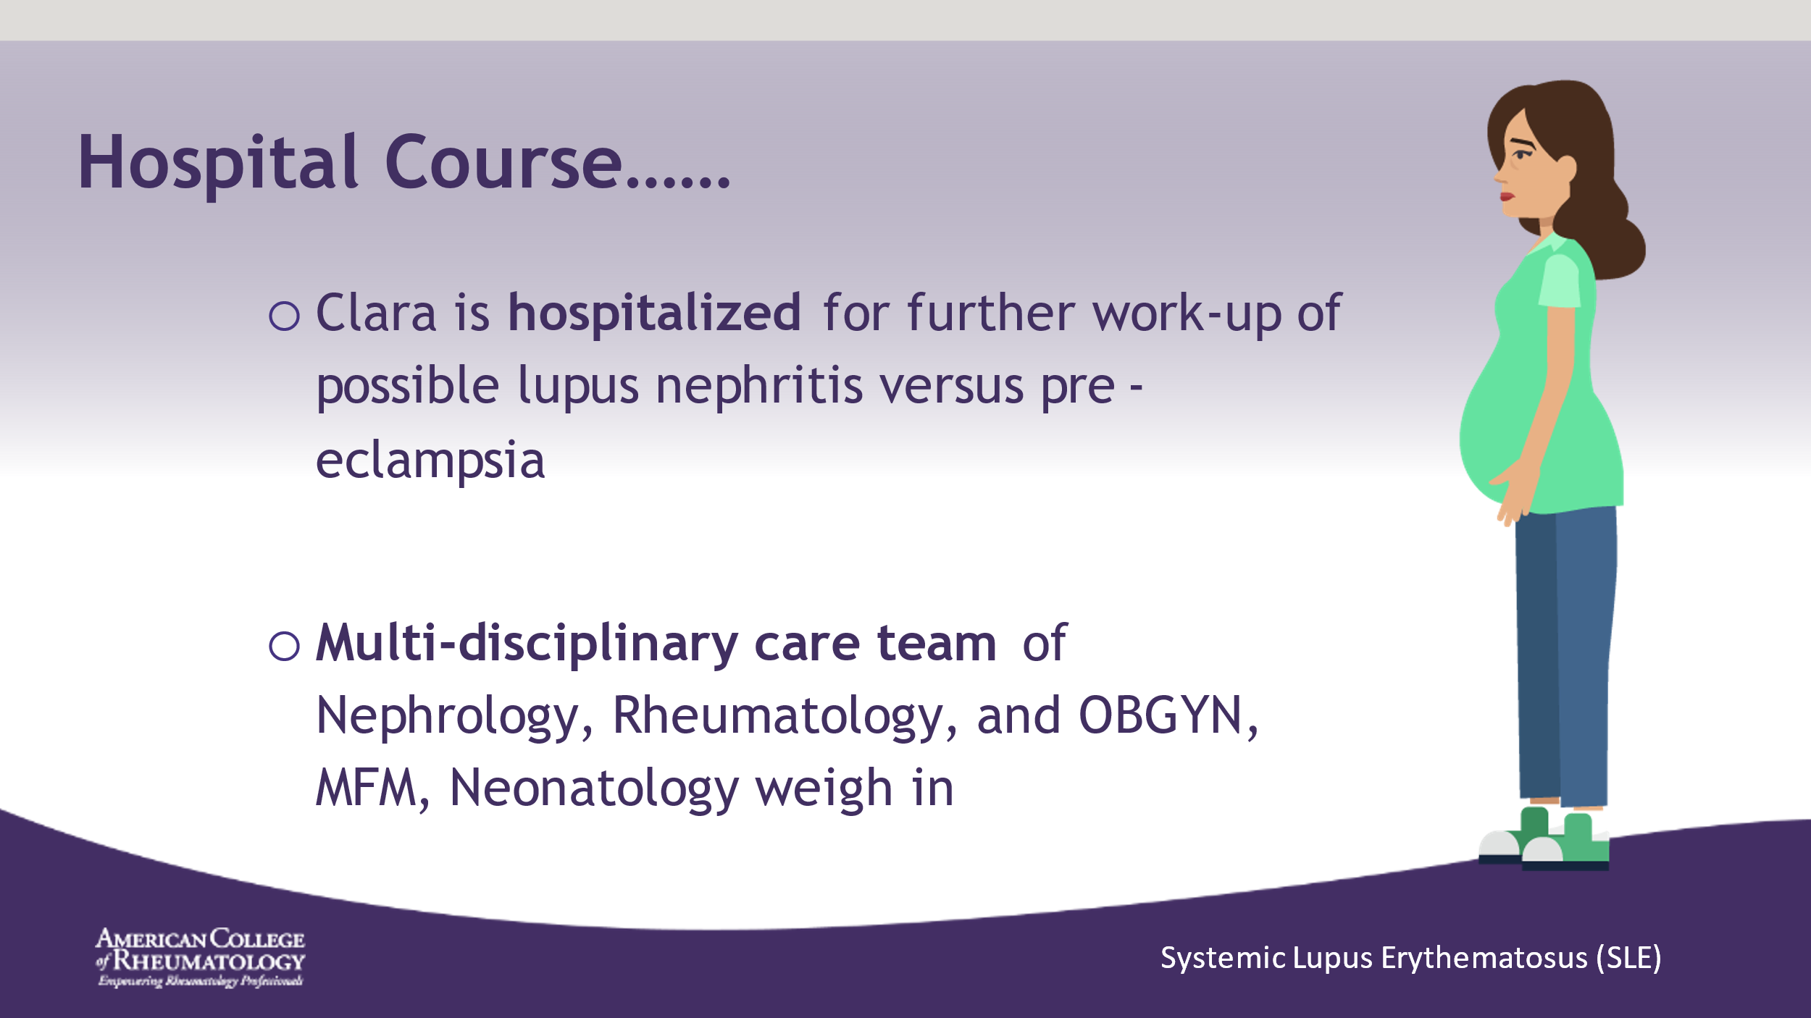

- ______________________________________________________
- ______________________________________________________
- ______________________________________________________
- ______________________________________________________
- ______________________________________________________
- ______________________________________________________
- ______________________________________________________
- ______________________________________________________

Slide 24: HOSPITAL COURSE
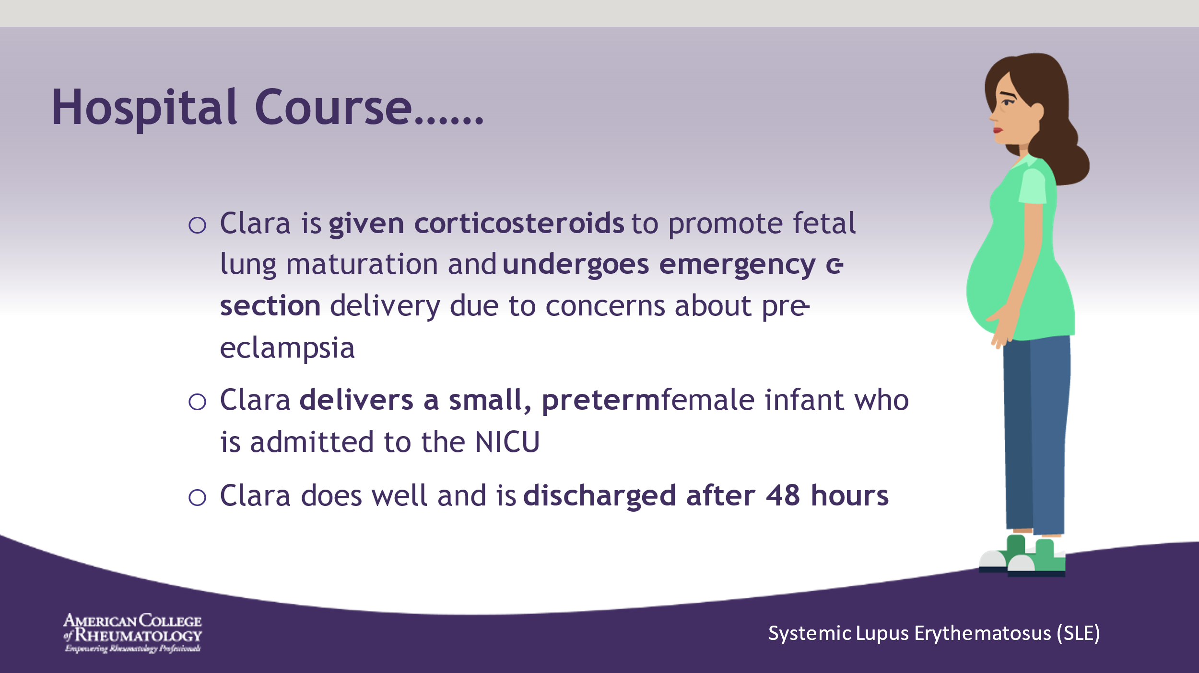

- ______________________________________________________
- ______________________________________________________
- ______________________________________________________
- ______________________________________________________
- ______________________________________________________
- ______________________________________________________
- ______________________________________________________
- ______________________________________________________

Slide 25: MEANWHILE THE BABY…
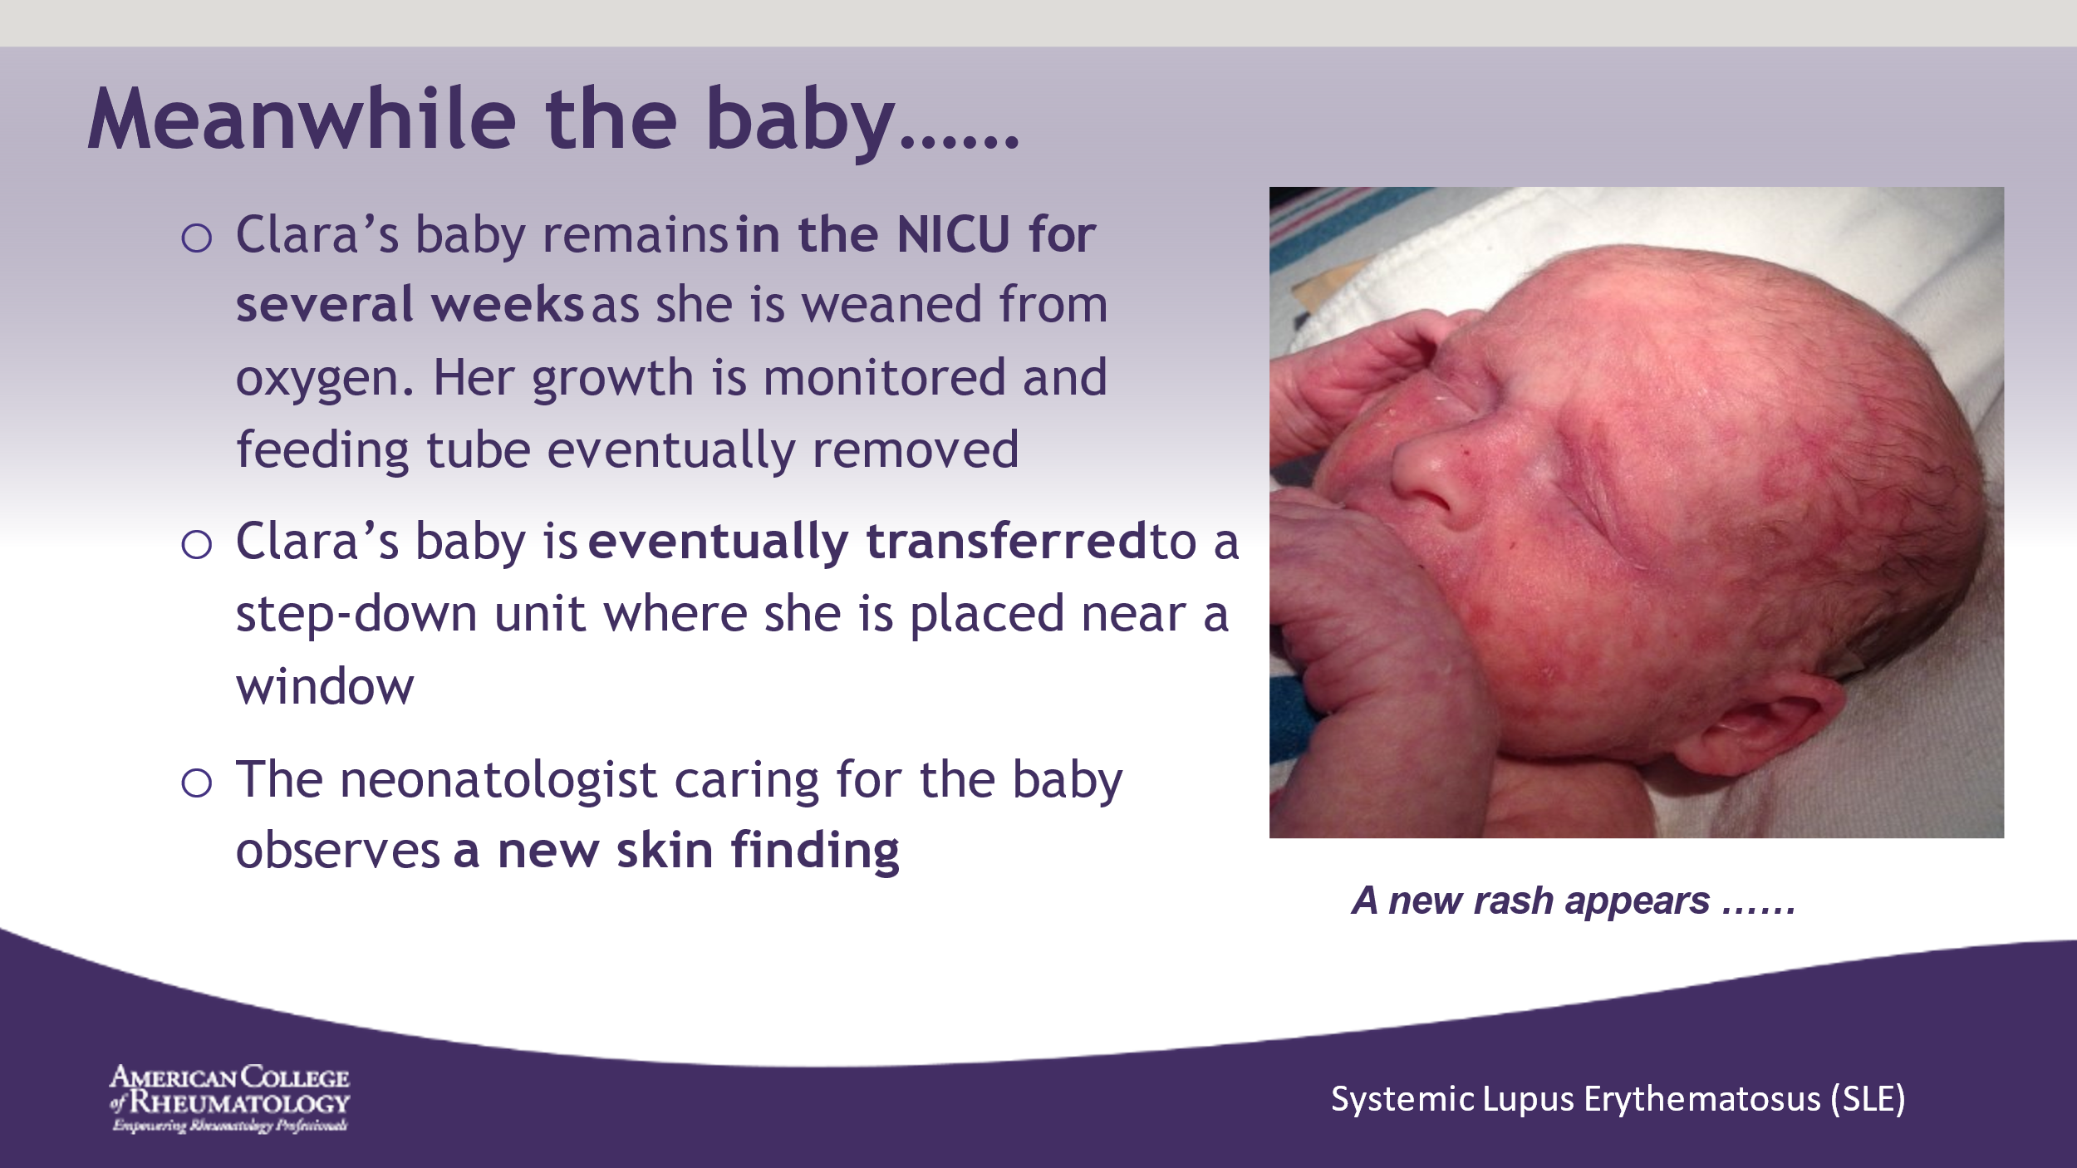

- This skin rash is classic for neonatal lupus
- _____________________________________________________
- ______________________________________________________
- ______________________________________________________
- ______________________________________________________
- ______________________________________________________
- ______________________________________________________
- ______________________________________________________
- ______________________________________________________

Slide 26: IMPORTANCE OF SCREENING
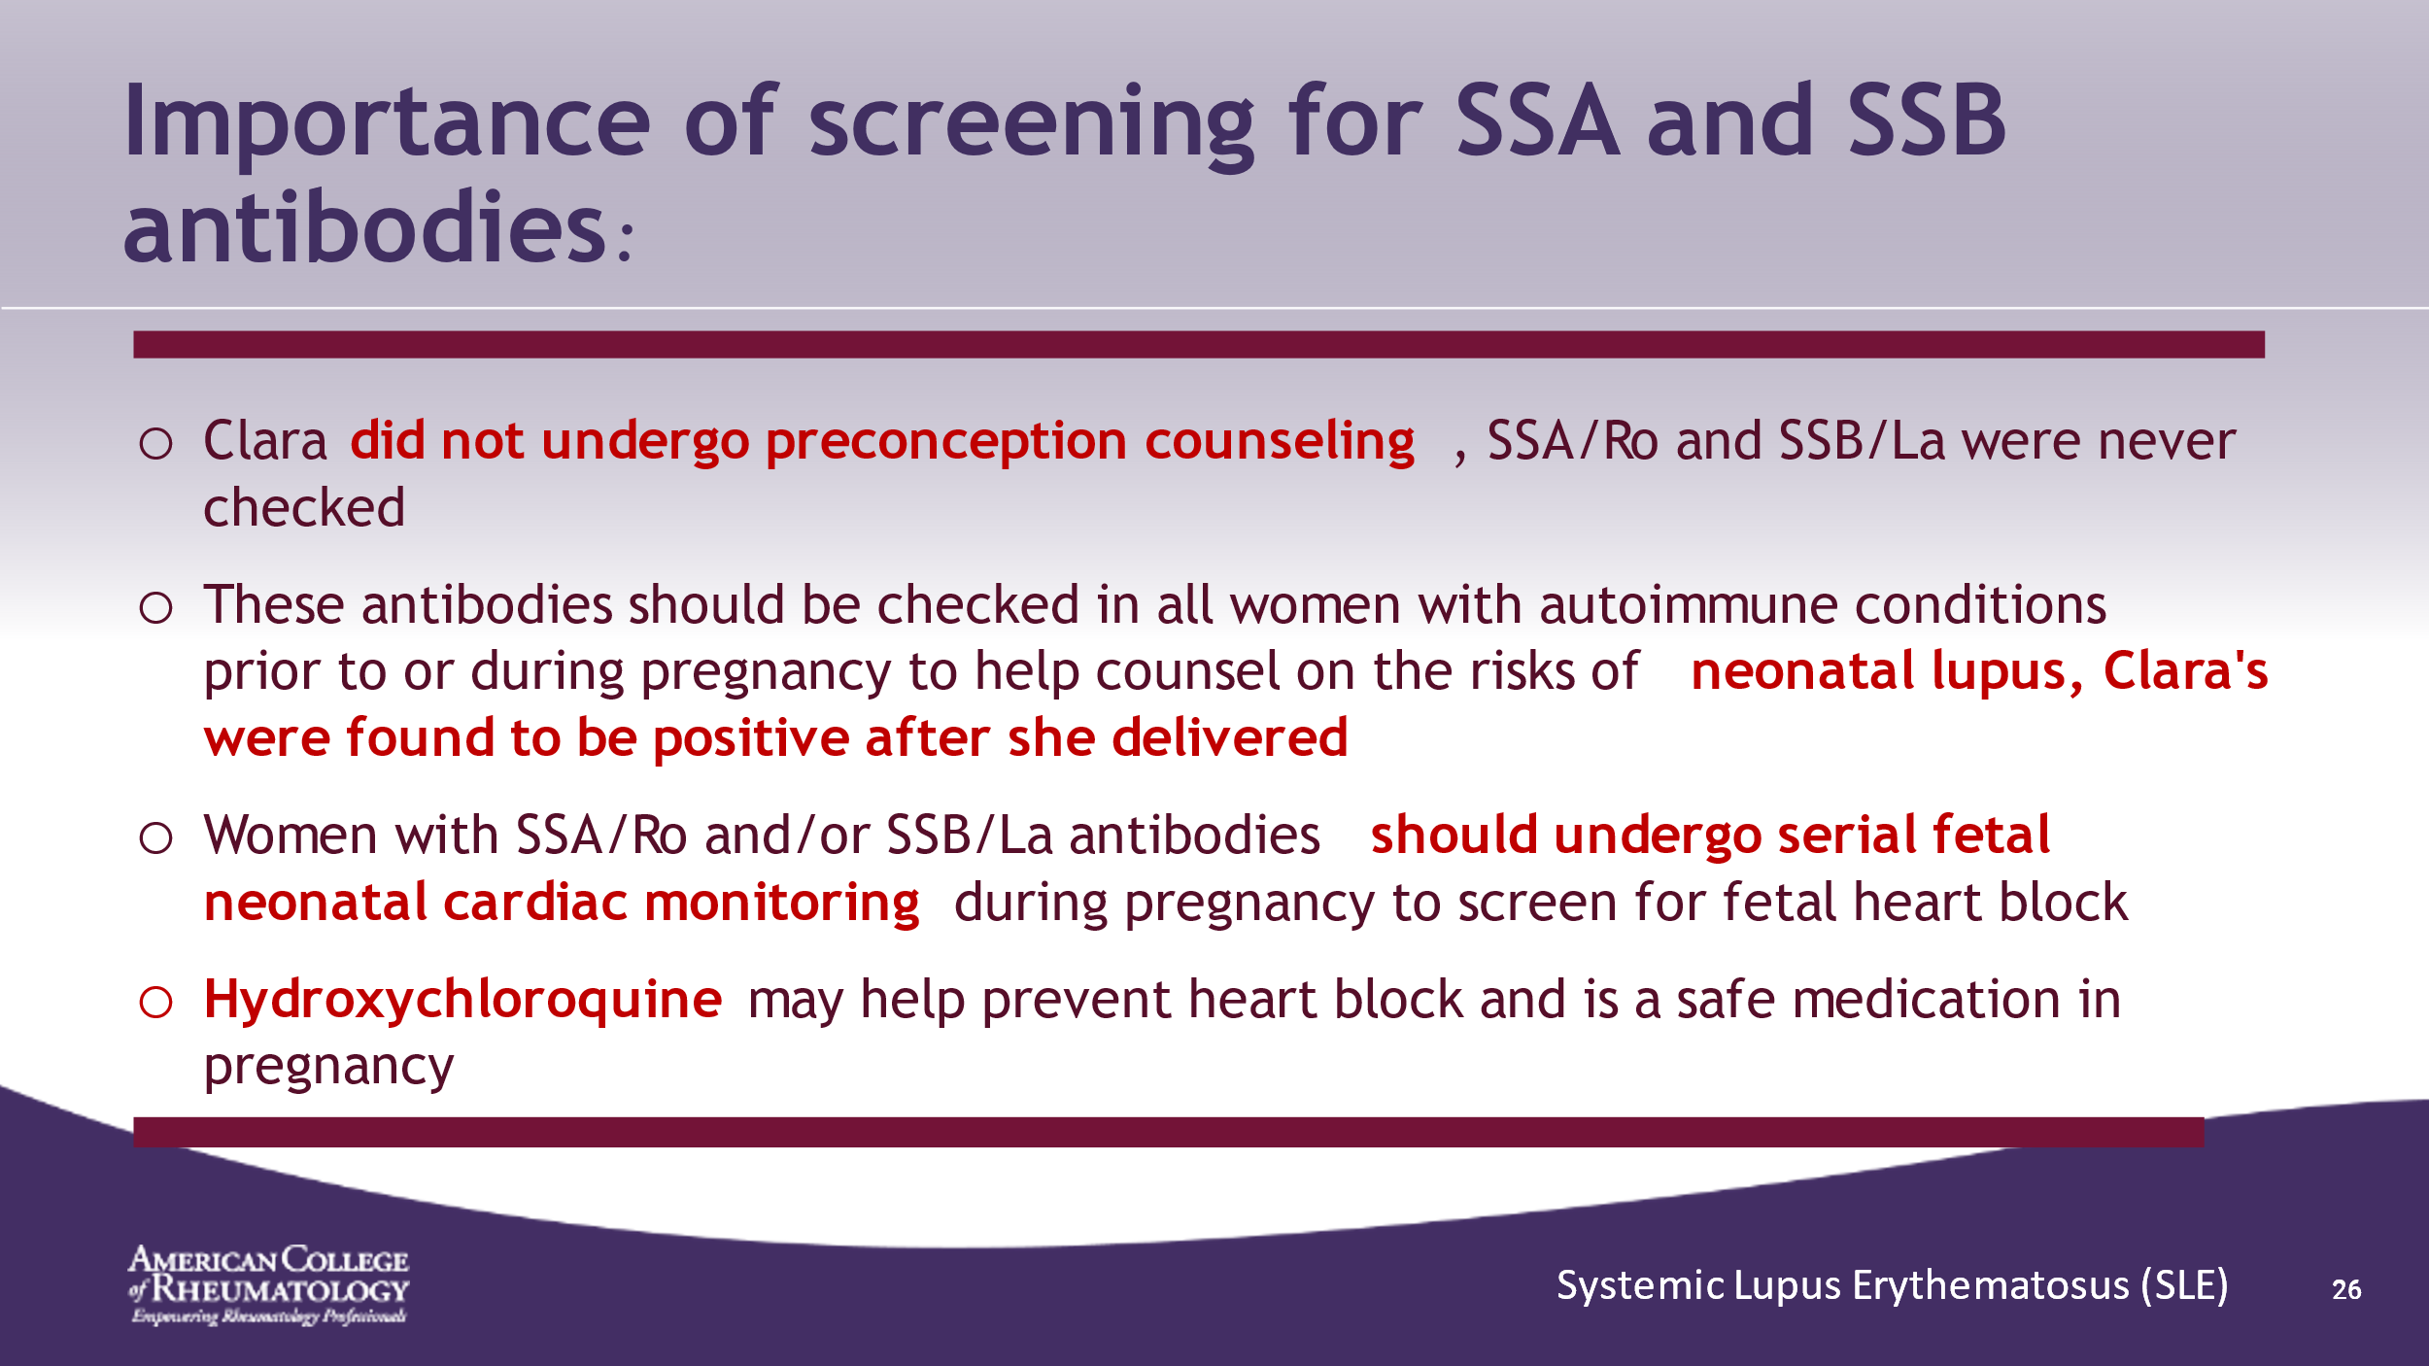

- ______________________________________________________
- ______________________________________________________
- ______________________________________________________
- ______________________________________________________
- ______________________________________________________
- ______________________________________________________
- ______________________________________________________
- ______________________________________________________

Slide 27: POST-PARTUM COURSE
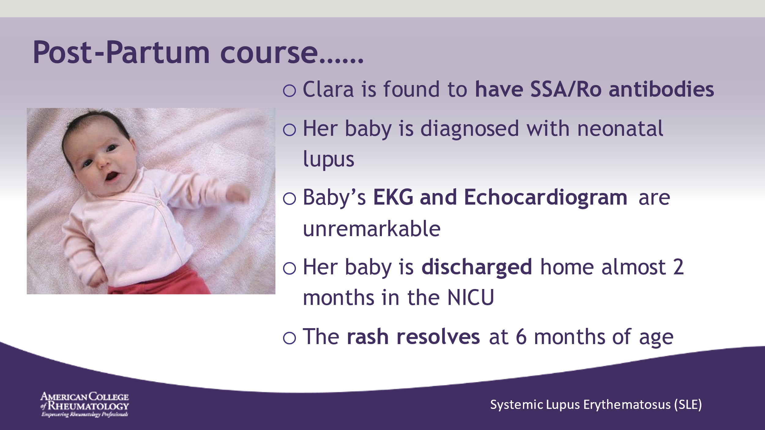

- ______________________________________________________
- ______________________________________________________
- ______________________________________________________
- ______________________________________________________
- ______________________________________________________
- ______________________________________________________
- ______________________________________________________
- ______________________________________________________

Slide 28: POST-PARTUM COURSE
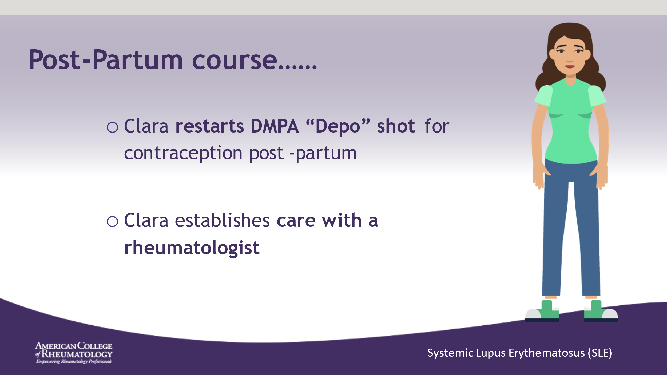

- ______________________________________________________
- ______________________________________________________
- ______________________________________________________
- ______________________________________________________
- ______________________________________________________
- ______________________________________________________
- ______________________________________________________
- ______________________________________________________

Slide 29: SEVERAL YEARS LATER
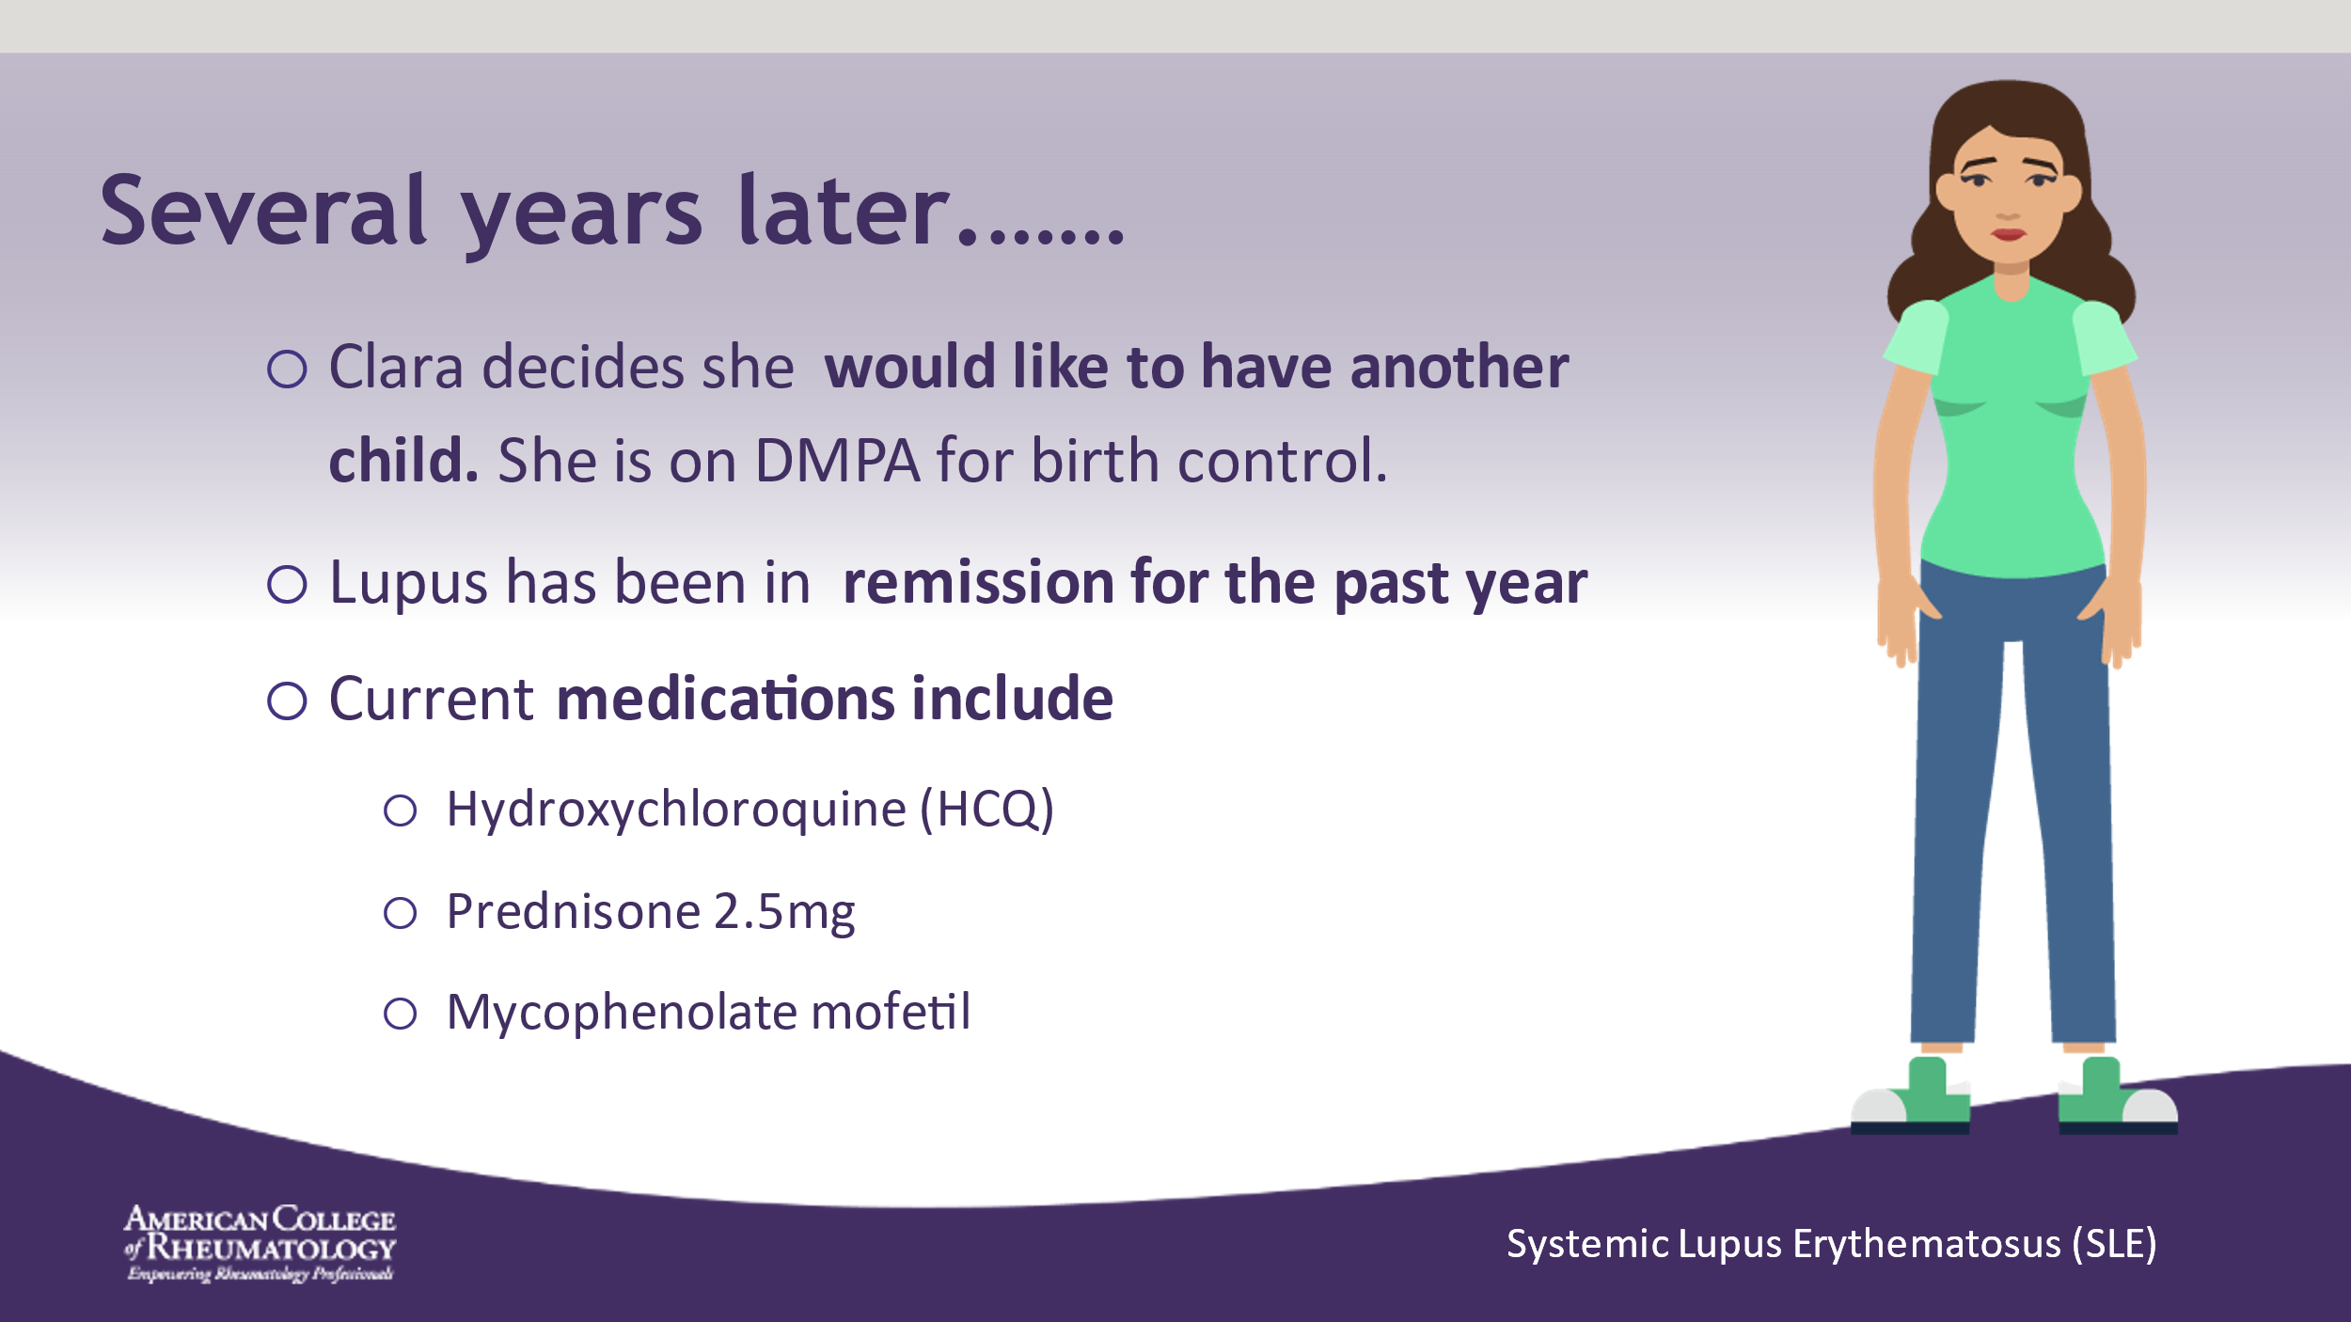

- ______________________________________________________
- ______________________________________________________
- ______________________________________________________
- ______________________________________________________
- ______________________________________________________
- ______________________________________________________
- ______________________________________________________
- ______________________________________________________

Slide 30: TOPICS TO ADDRESS
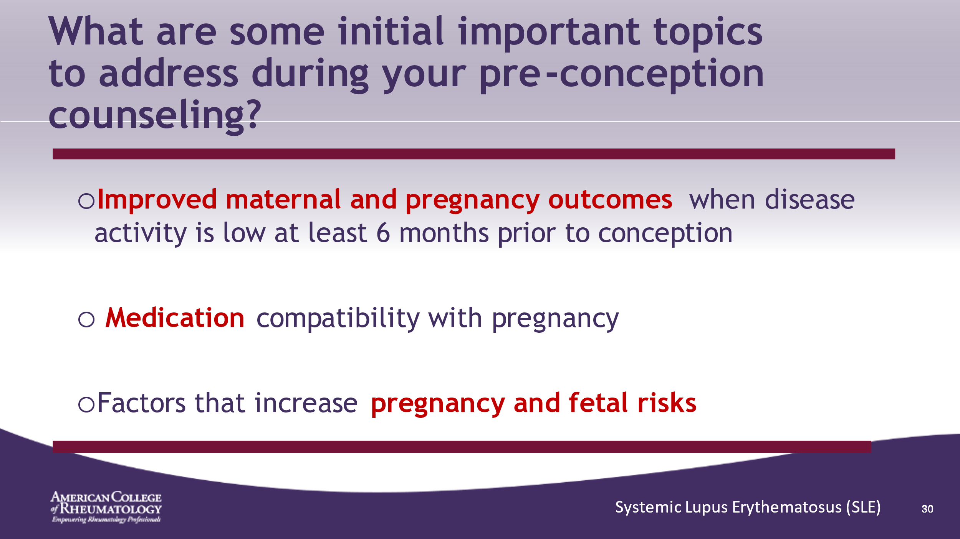

- ______________________________________________________
- ______________________________________________________
- ______________________________________________________
- ______________________________________________________
- ______________________________________________________
- ______________________________________________________
- ______________________________________________________
- ______________________________________________________

Slide 31: COUNSELING RHEUMATIC DISEASE
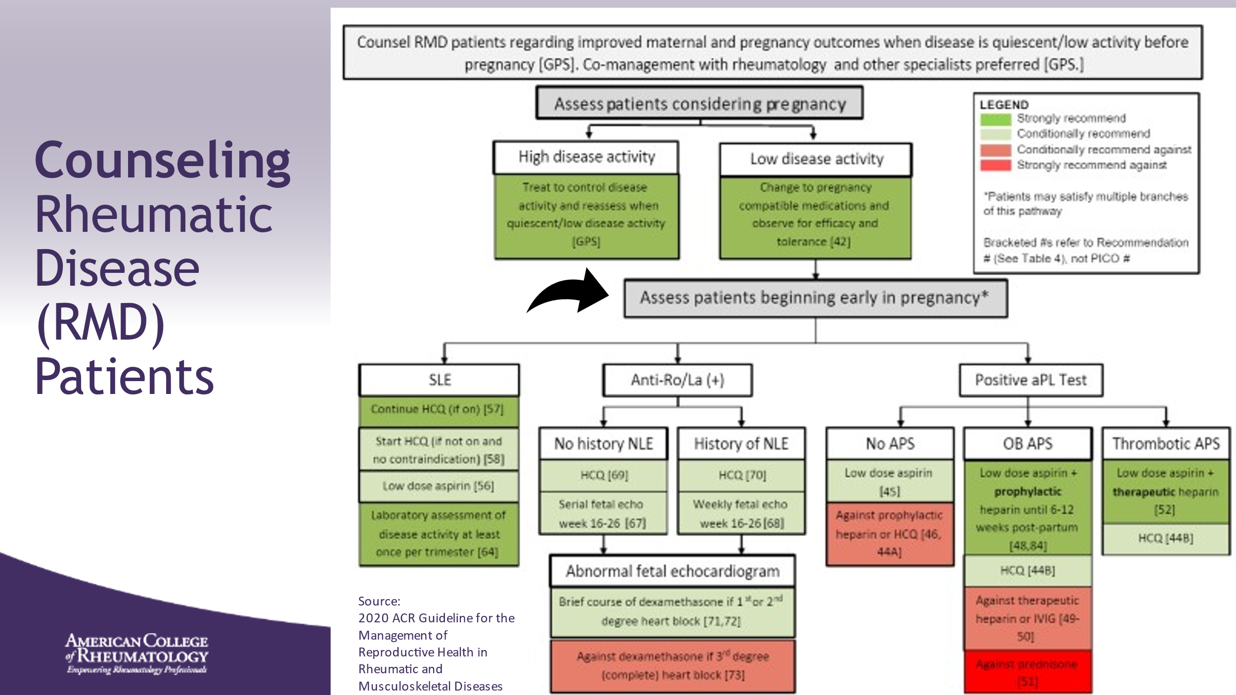

- ______________________________________________________
- ______________________________________________________
- ______________________________________________________
- ______________________________________________________
- ______________________________________________________
- ______________________________________________________
- ______________________________________________________
- ______________________________________________________

Slide 32: COUNSELING RMD PATIENTS
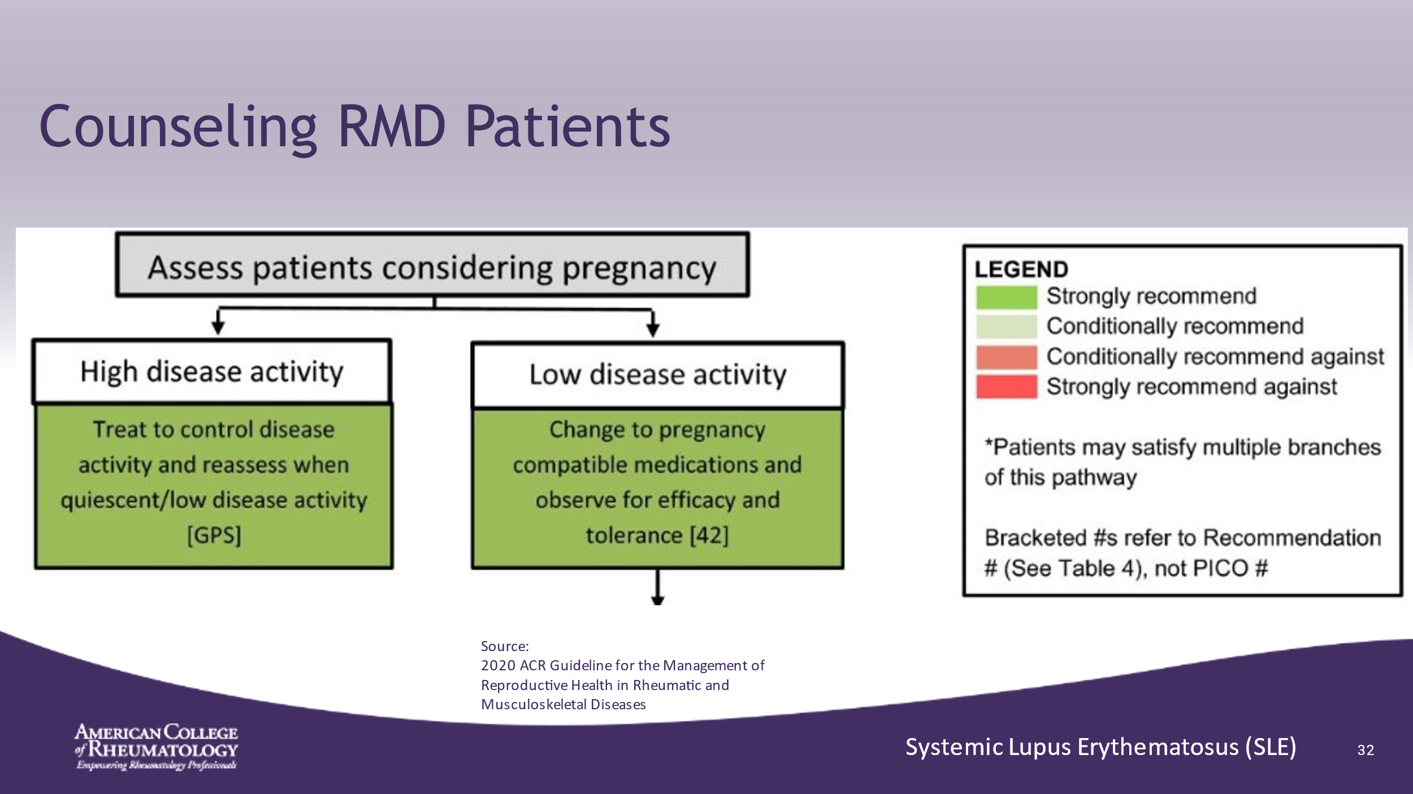

- RMD: Rheumatic and Musculoskeletal Disease
- ____________________________________________________
- ______________________________________________________
- ______________________________________________________
- ______________________________________________________
- ______________________________________________________
- ______________________________________________________
- ______________________________________________________
- ______________________________________________________

Slide 33: NEXT STEP IN COUNSELING
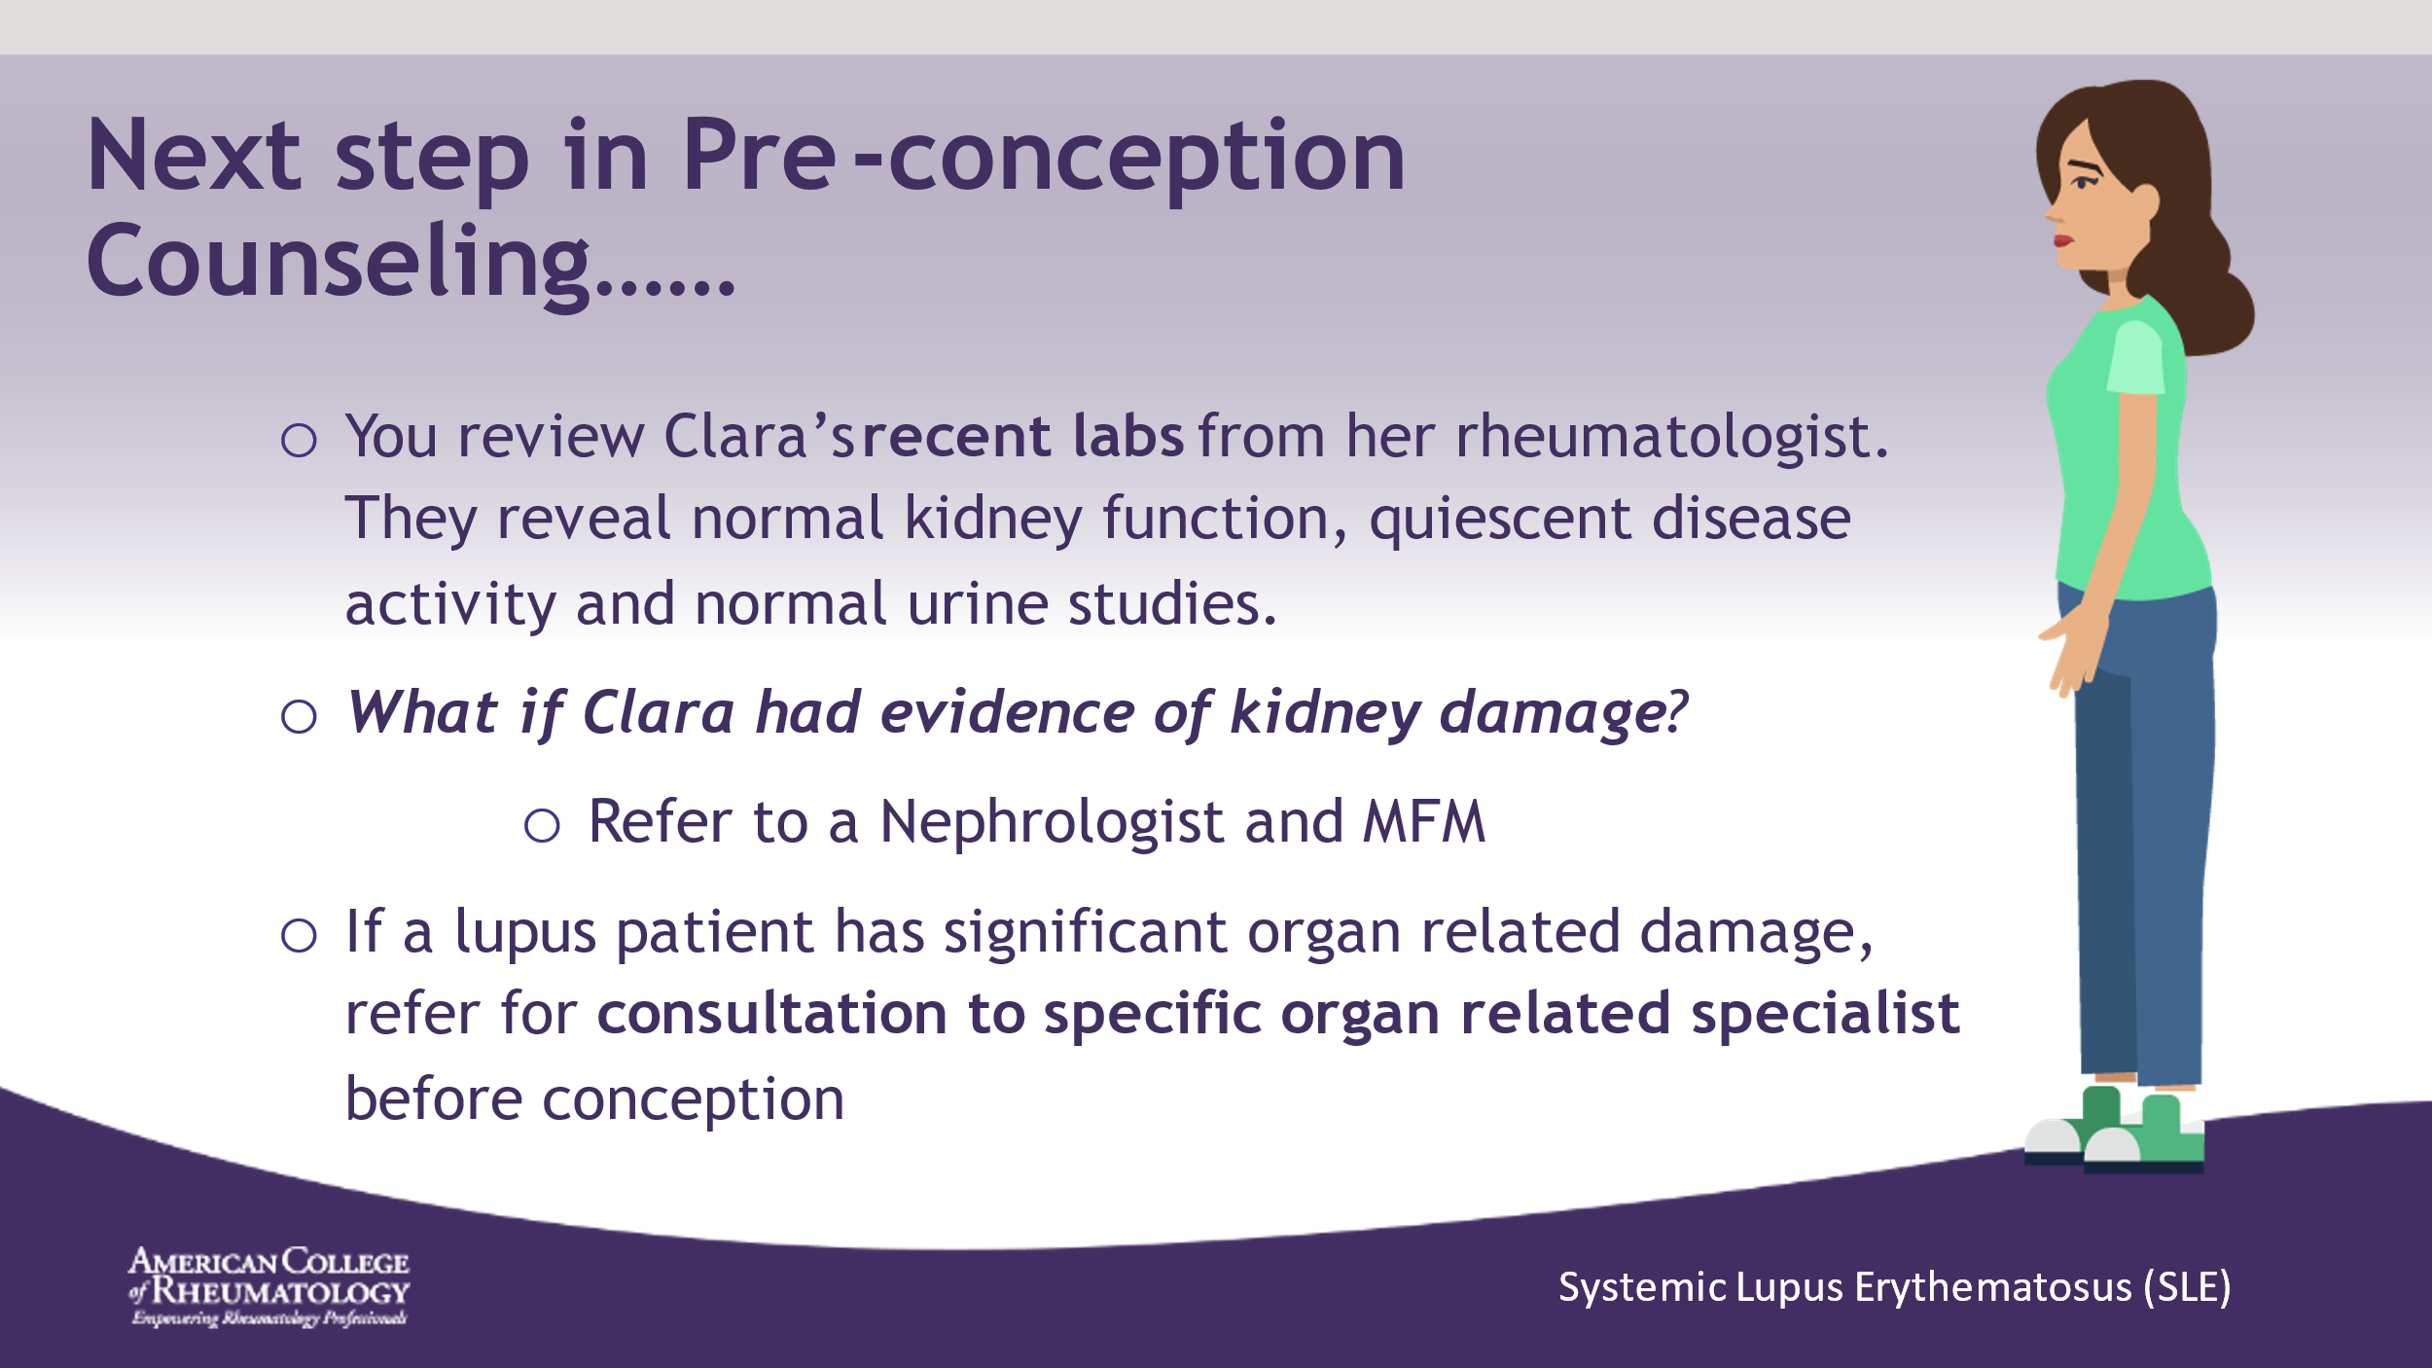

- ______________________________________________________
- ______________________________________________________
- ______________________________________________________
- ______________________________________________________
- ______________________________________________________
- ______________________________________________________
- ______________________________________________________
- ______________________________________________________

Slide 34: PRE-CONCEPTION MEDICAL MANAGEMENT
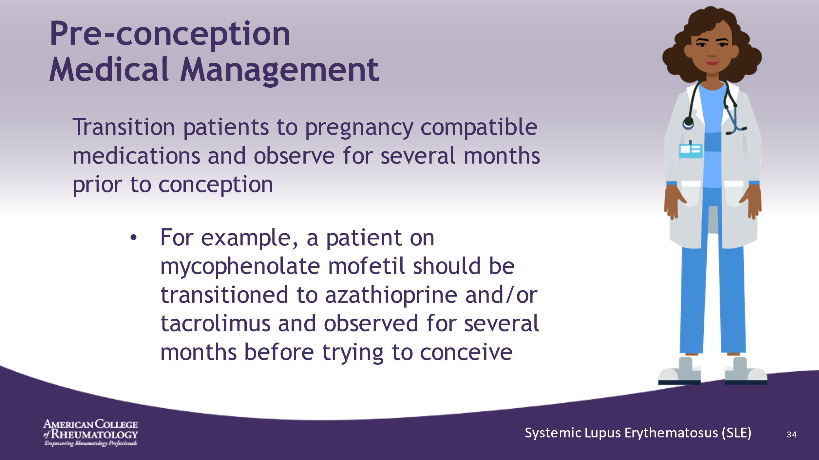

- ______________________________________________________
- ______________________________________________________
- ______________________________________________________
- ______________________________________________________
- ______________________________________________________
- ______________________________________________________
- ______________________________________________________
- ______________________________________________________

Slide 35: COUNSELING RMD PATIENTS
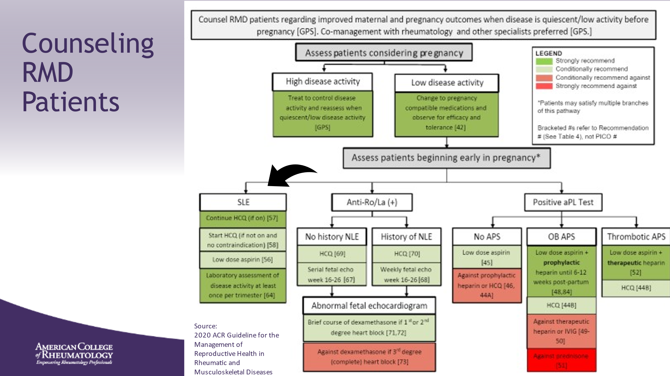

- RMD: Rheumatic and Musculoskeletal Disease
- ______________________________________________________
- ______________________________________________________
- ______________________________________________________
- ______________________________________________________
- ______________________________________________________
- ______________________________________________________
- ______________________________________________________
Slide 36: COUNSELING RMD PATIENTS
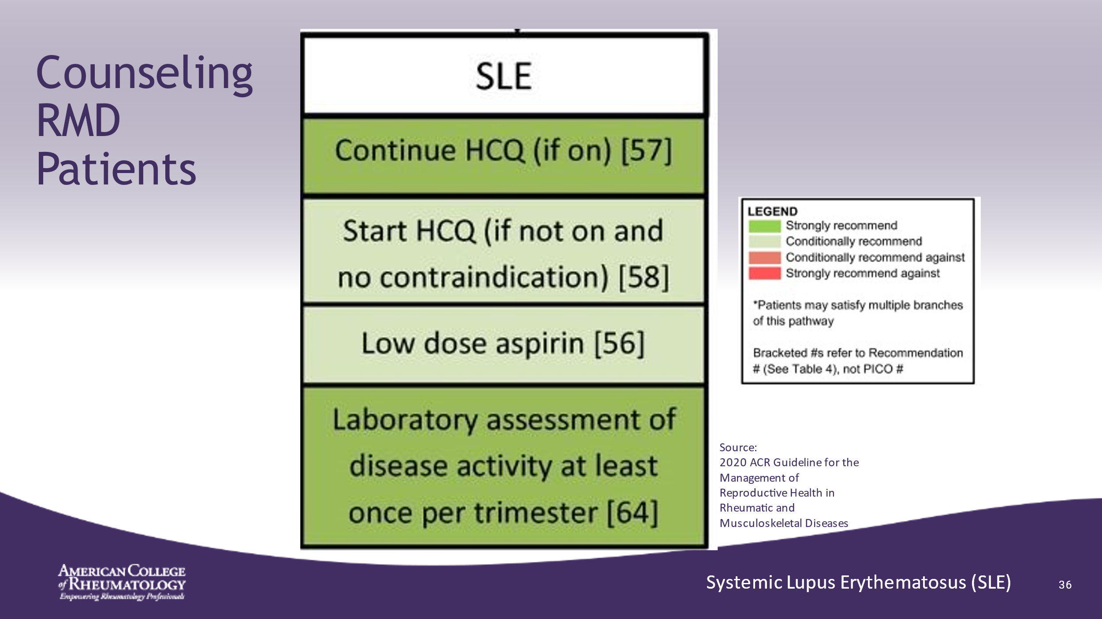

- ______________________________________________________
- ______________________________________________________
- ______________________________________________________
- ______________________________________________________
- ______________________________________________________
- ______________________________________________________
- ______________________________________________________
- ______________________________________________________

Slide 37: HYDROXYCHLOROQUINE (HCQ)
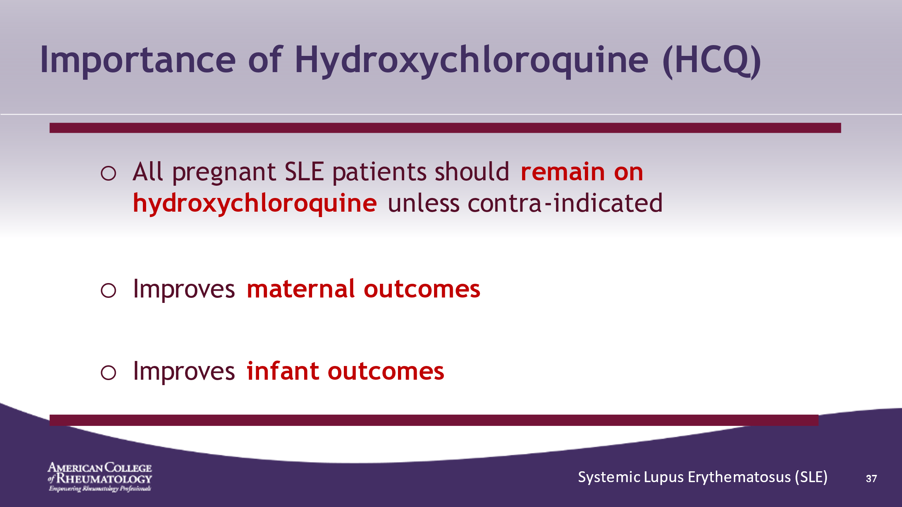

- This is a key learning point of this presentation
- ______________________________________________________
- ______________________________________________________
- ______________________________________________________
- ______________________________________________________
- ______________________________________________________
- ______________________________________________________
- ______________________________________________________
- ______________________________________________________

Slide 38: LOW DOSE ASPIRIN (81 OR 100 MG)
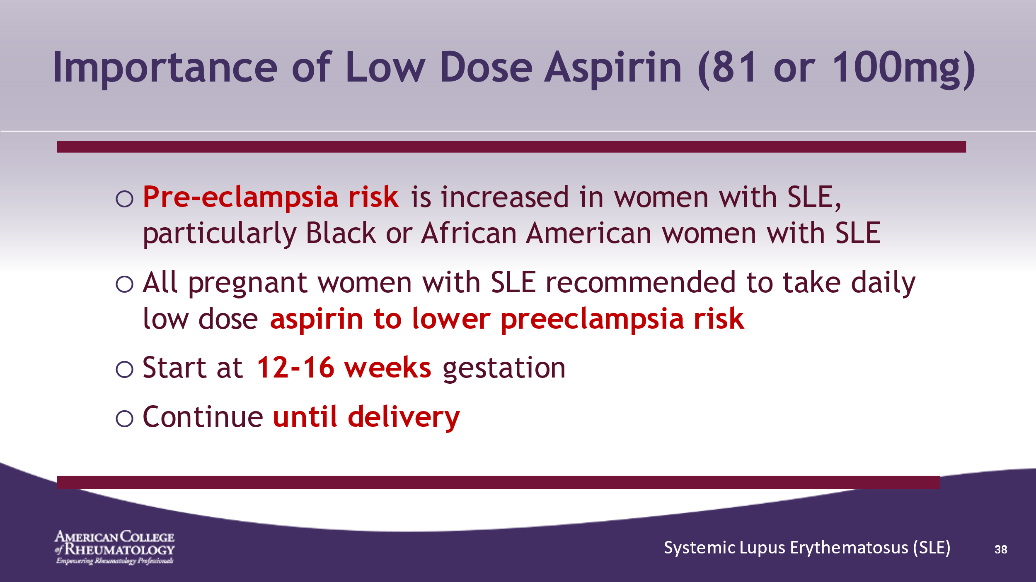

- ______________________________________________________
- ______________________________________________________
- ______________________________________________________
- ______________________________________________________
- ______________________________________________________
- ______________________________________________________
- ______________________________________________________
- ______________________________________________________

Slide 39: NEXT STEP IN COUNSELING
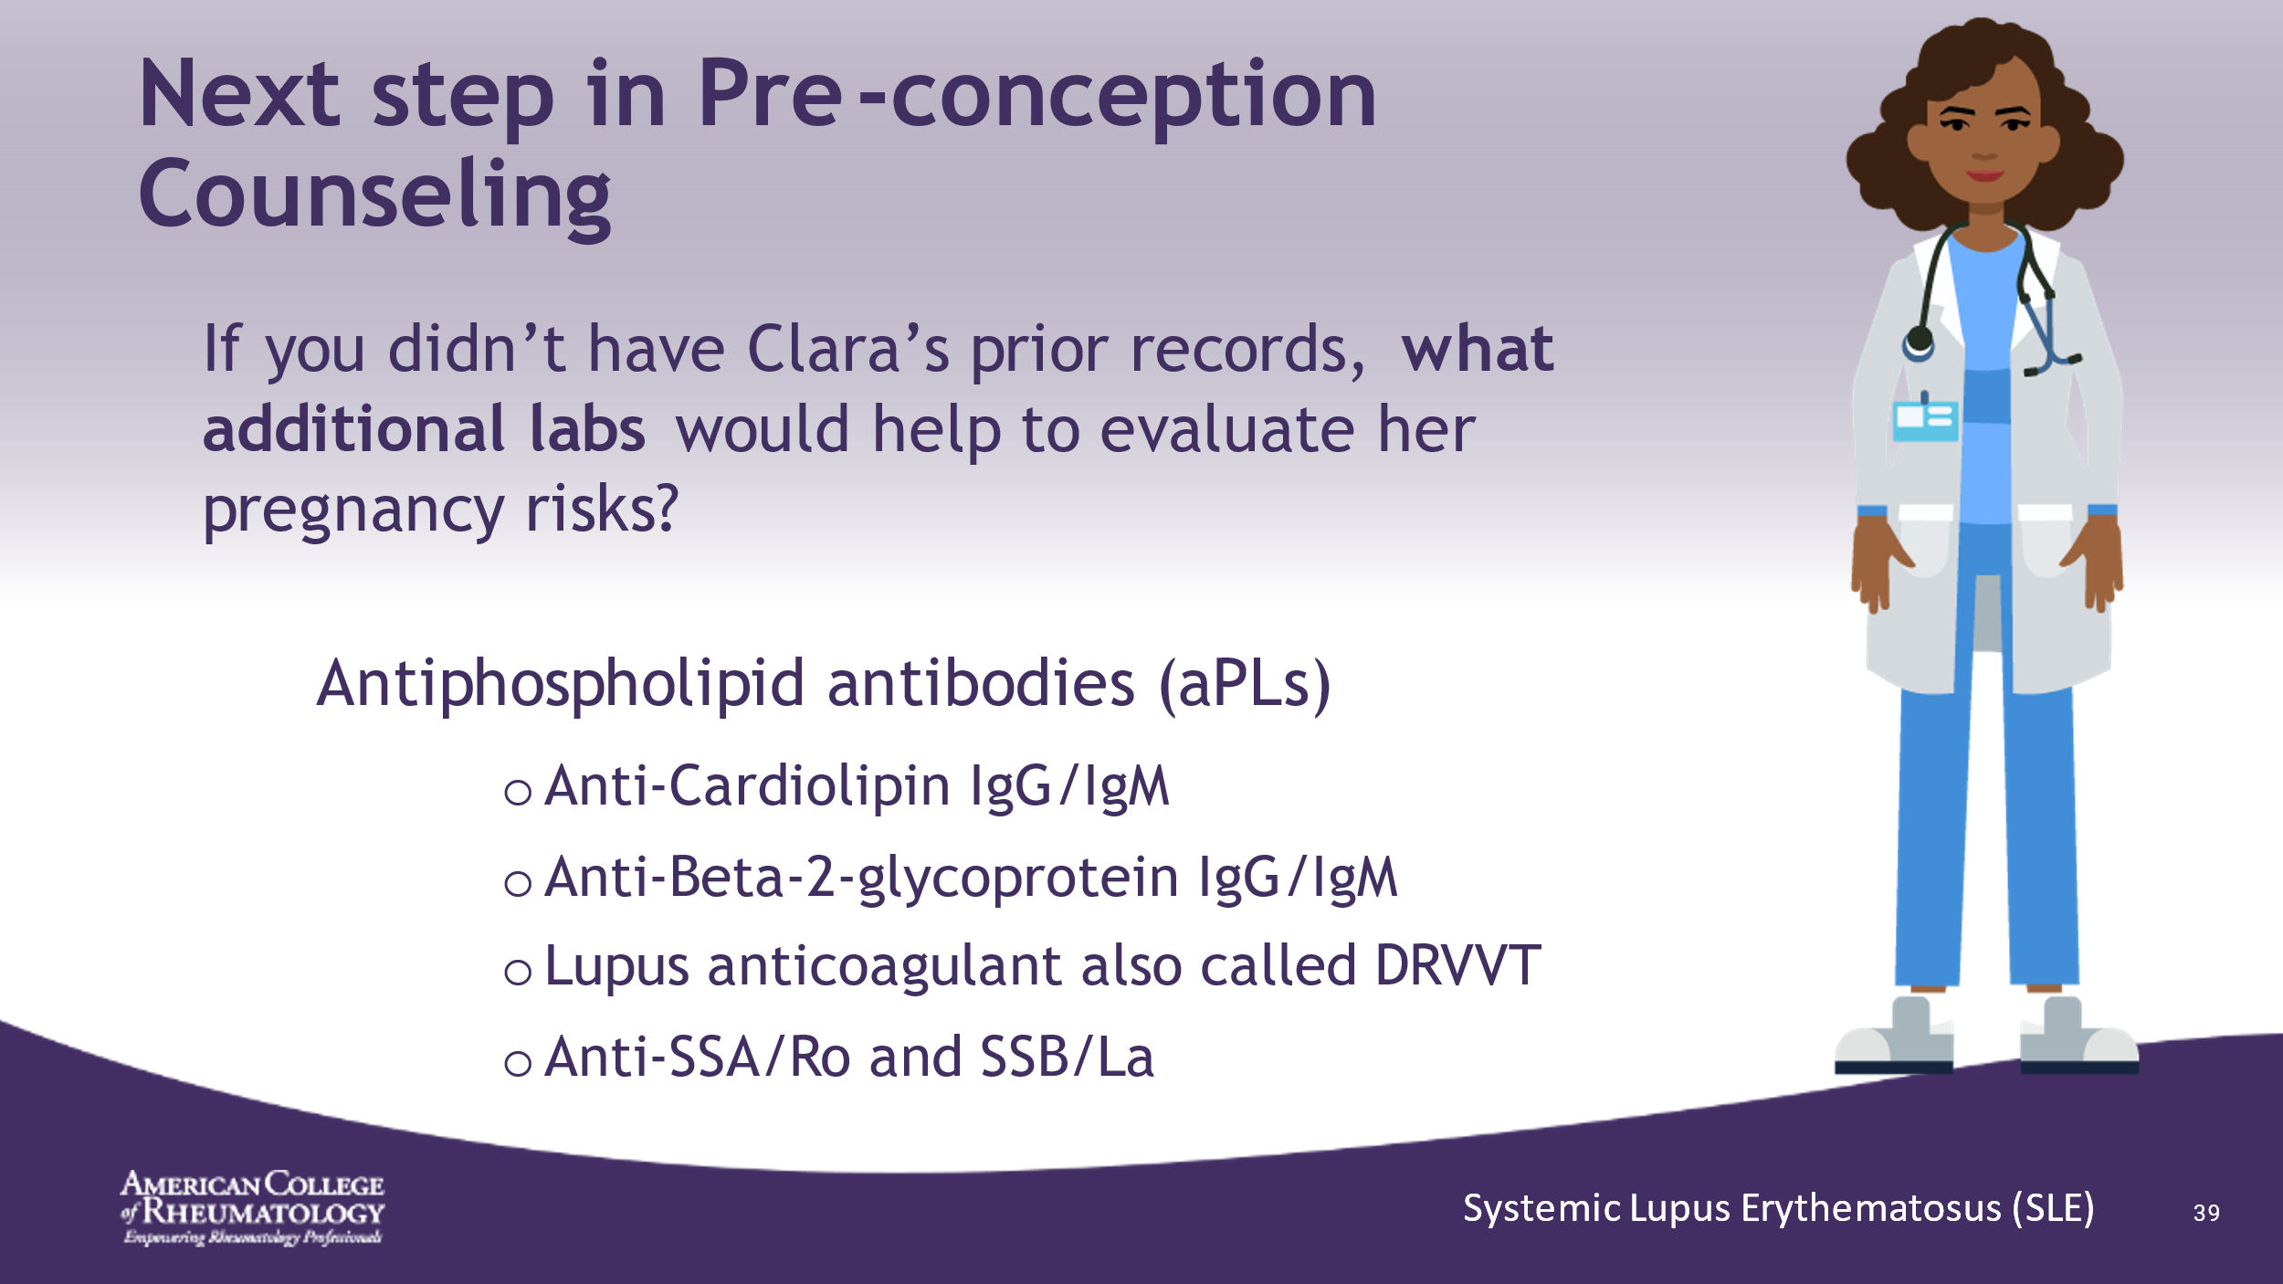

- ______________________________________________________
- ______________________________________________________
- ______________________________________________________
- ______________________________________________________
- ______________________________________________________
- ______________________________________________________
- ______________________________________________________
- ______________________________________________________

Slide 40: COUNSELING RMD PATIENTS
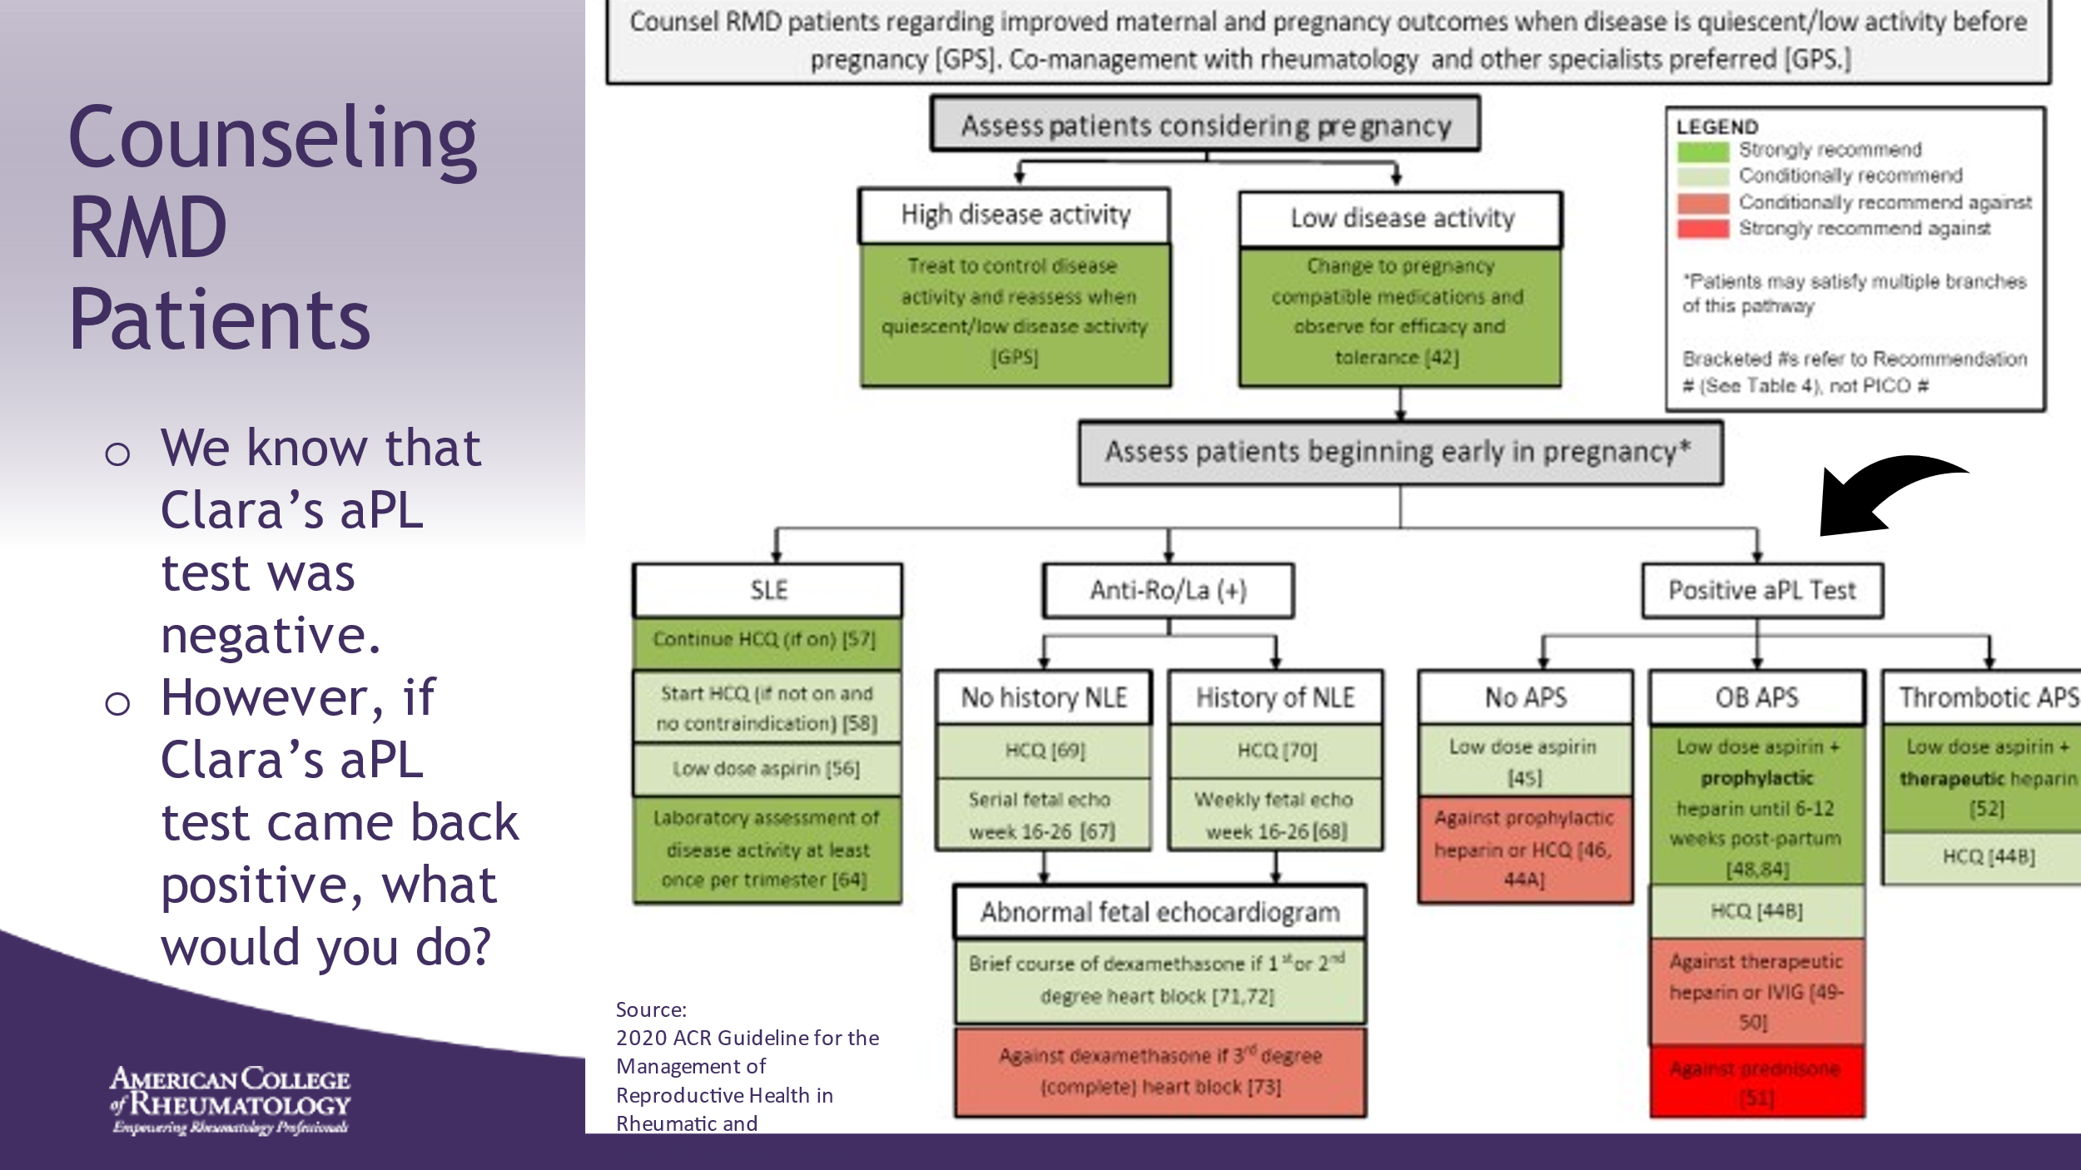

- ______________________________________________________
- ______________________________________________________
- ______________________________________________________
- ______________________________________________________
- ______________________________________________________
- ______________________________________________________
- ______________________________________________________
- ______________________________________________________

Slide 41: COUNSELING RMD PATIENTS
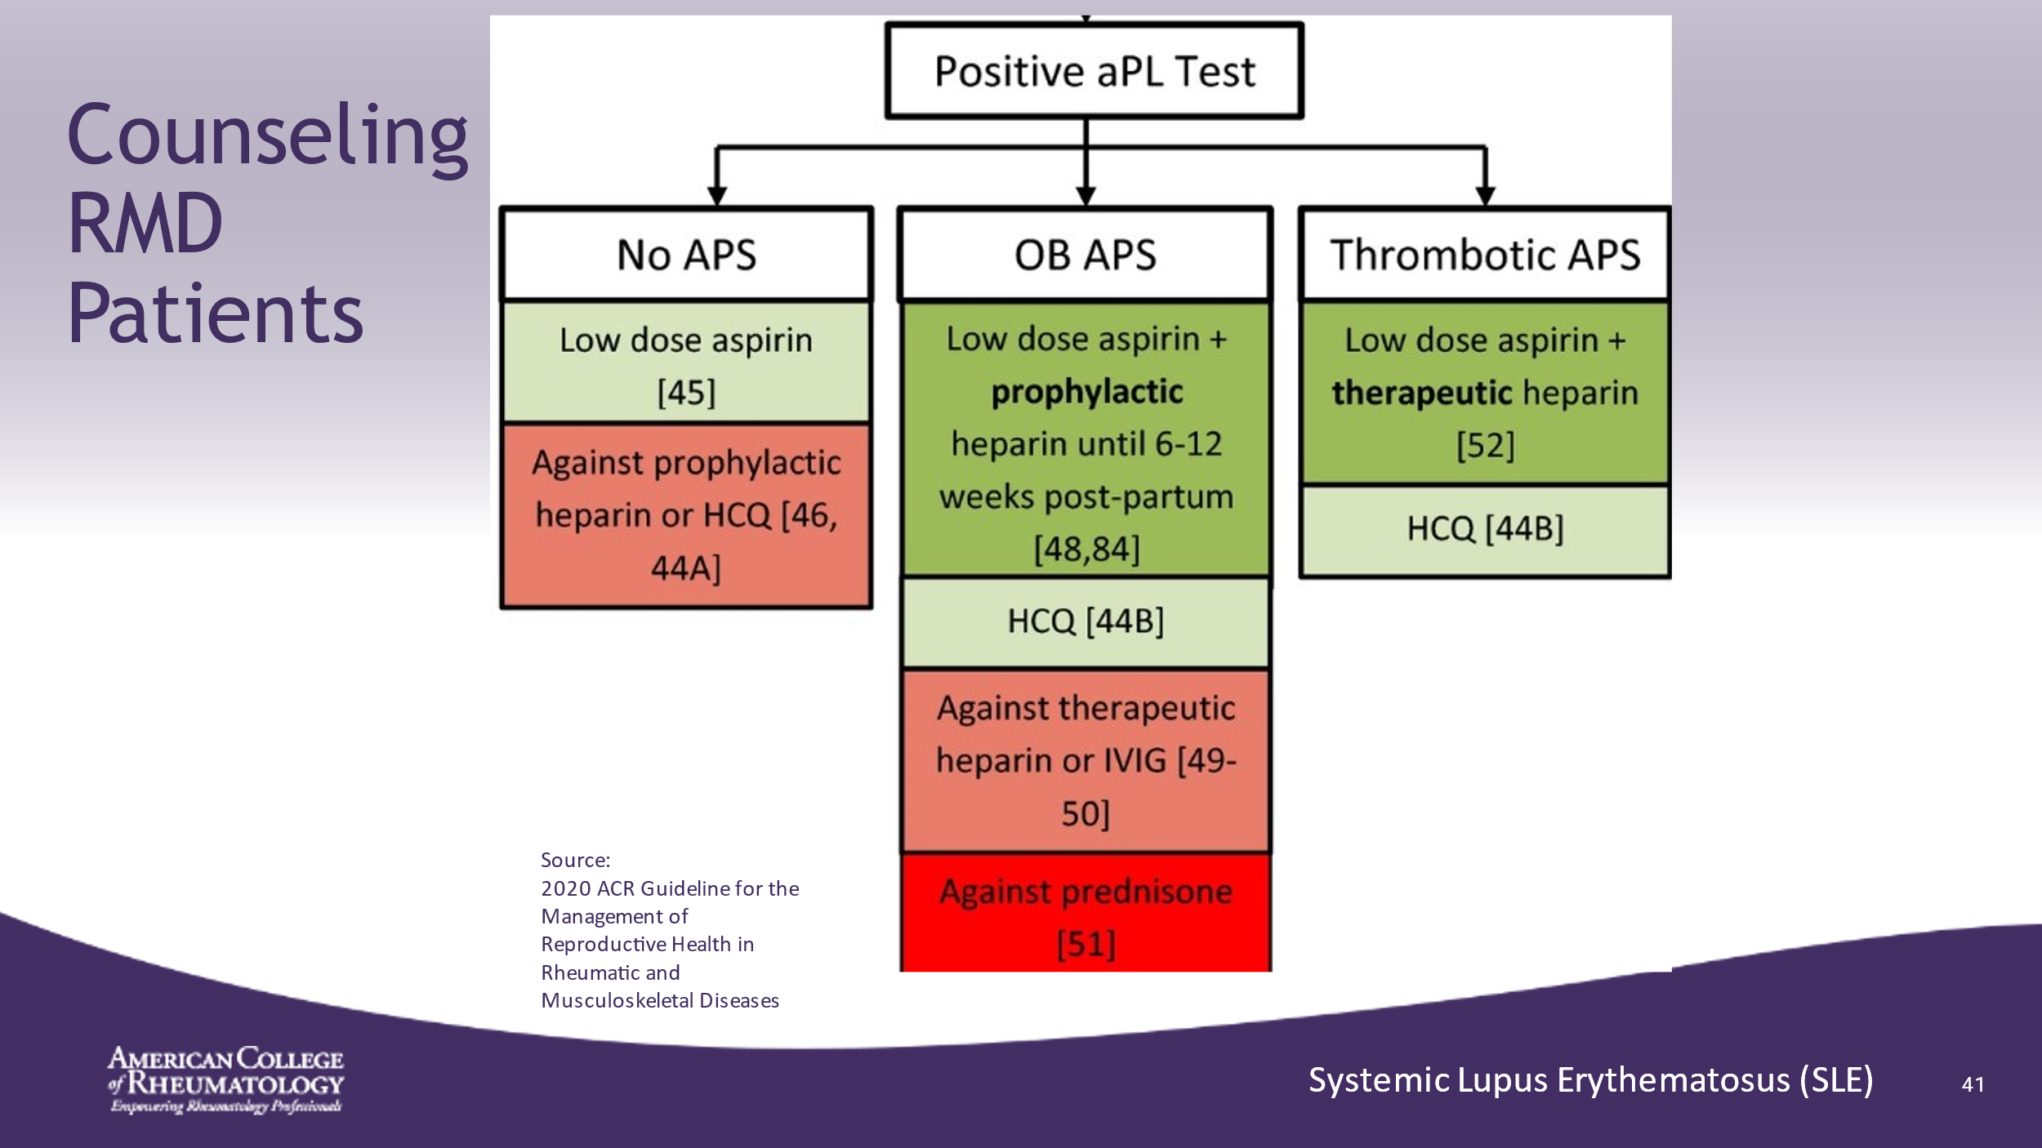

- If any antiphospholipid antibody test is positive, refer to a specialist with expertise in this area.
- Note: This discussion is beyond the scope of this presentation.
- ______________________________________________________
- ______________________________________________________
- ______________________________________________________
- ______________________________________________________
- ______________________________________________________
- ______________________________________________________
- ______________________________________________________

Slide 42: COUNSELING RMD PATIENTS
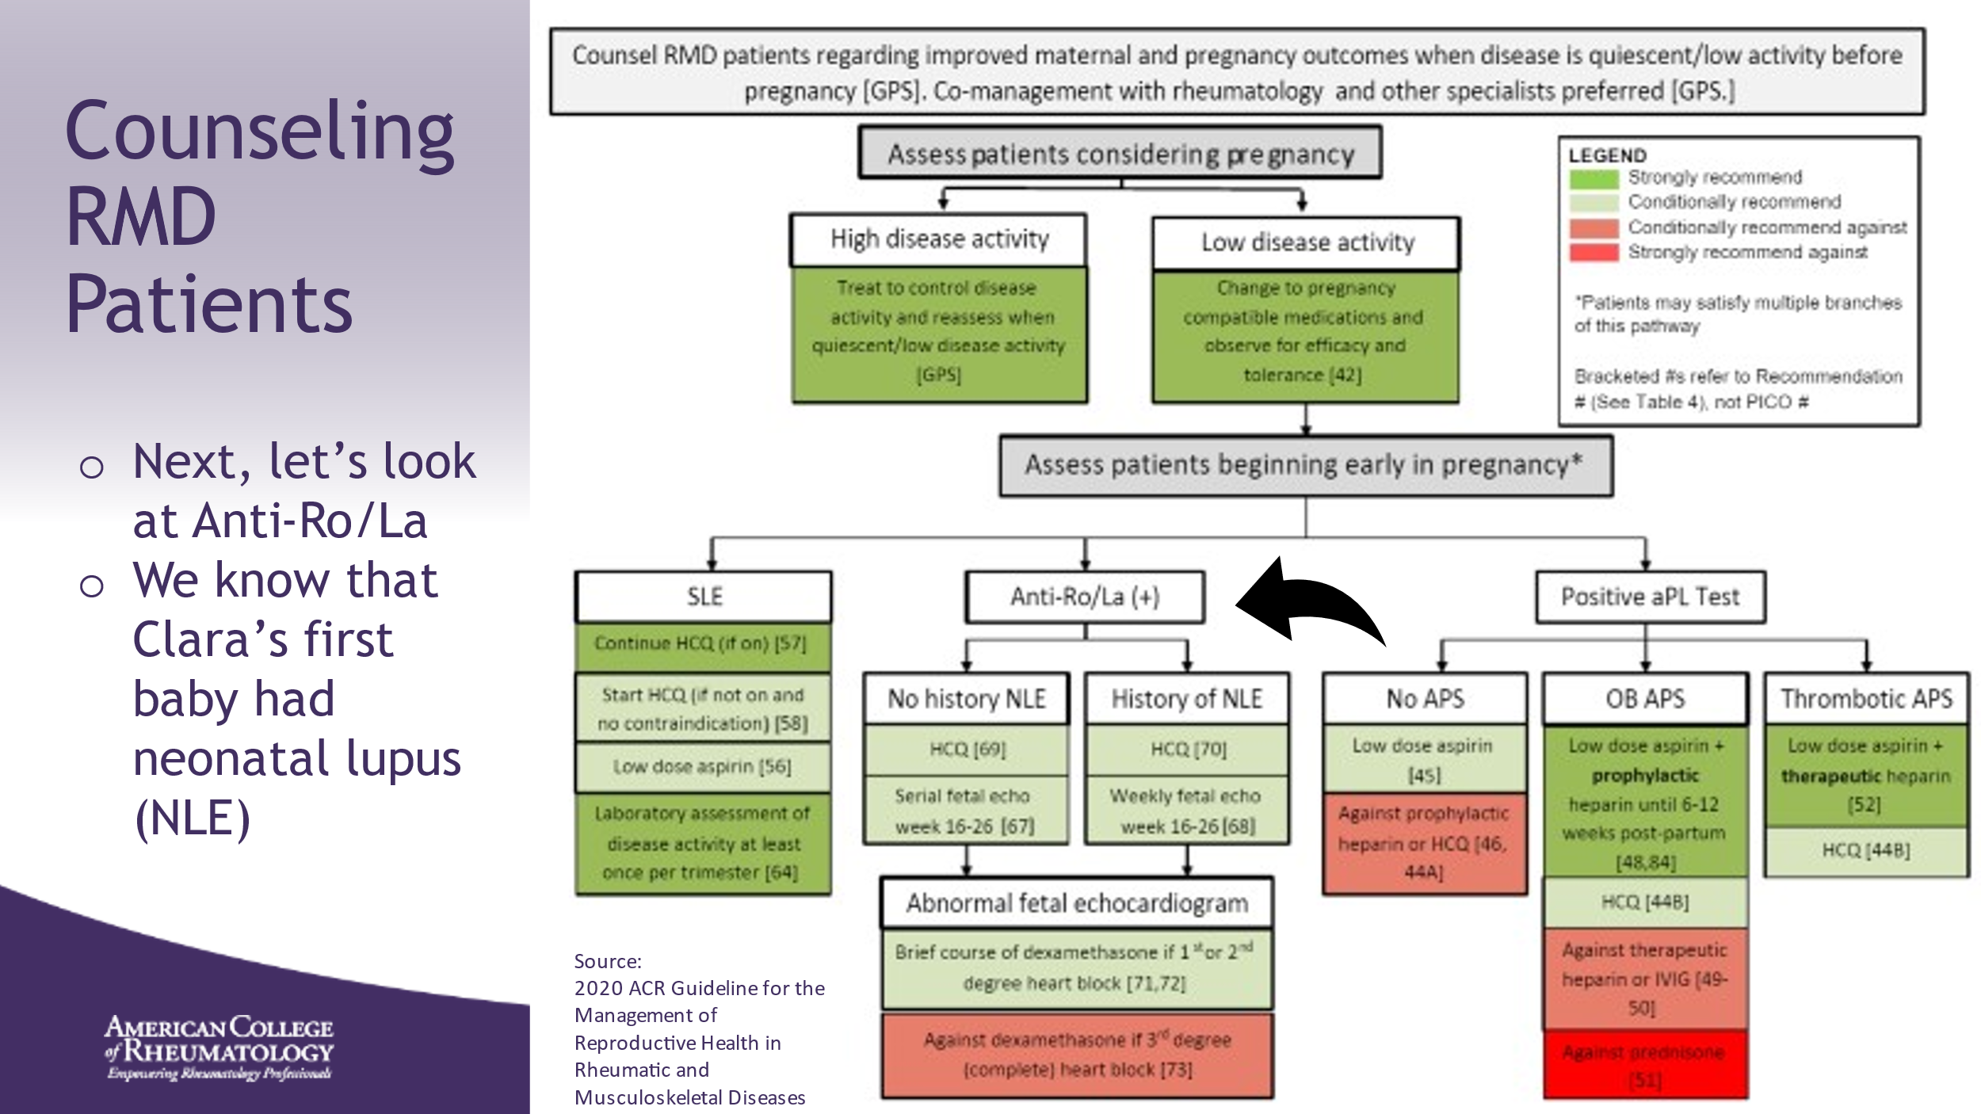

- ______________________________________________________
- ______________________________________________________
- ______________________________________________________
- ______________________________________________________
- ______________________________________________________
- ______________________________________________________
- ______________________________________________________
- ______________________________________________________

Slide 43: COUNSELING RMD PATIENTS
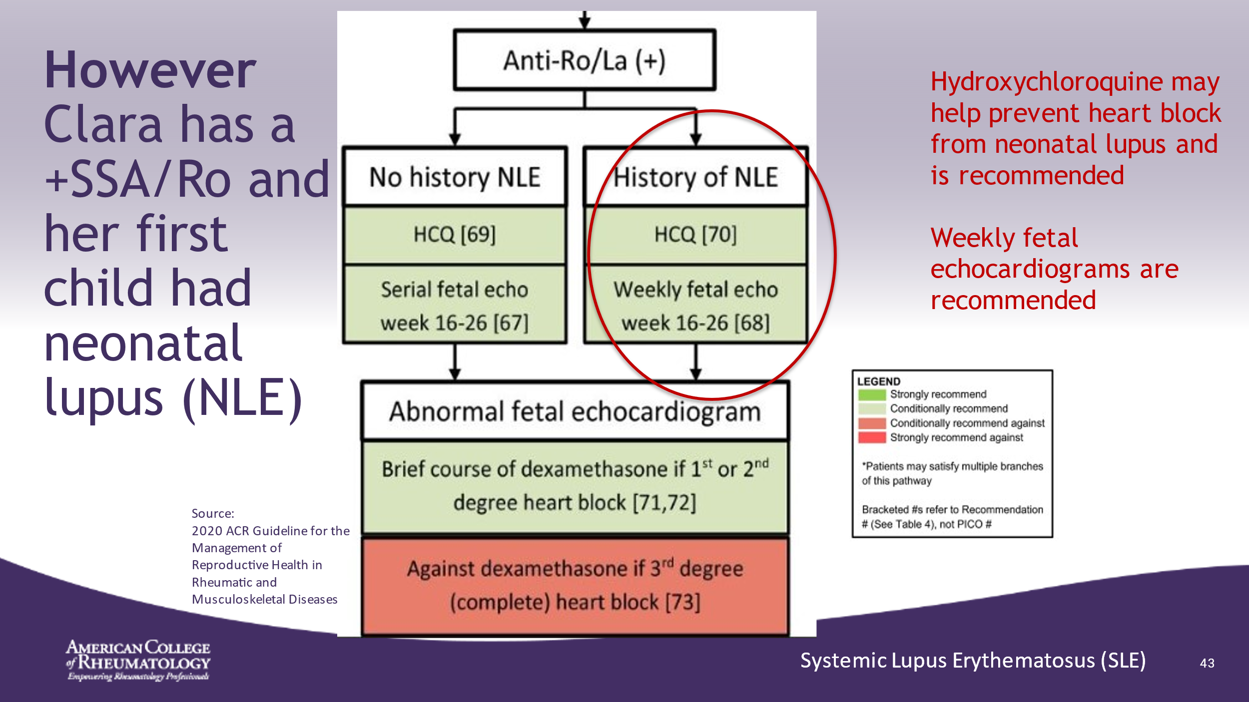

- Weekly cardiac monitoring recommended
- ______________________________________________________
- ______________________________________________________
- ______________________________________________________
- ______________________________________________________
- ______________________________________________________
- ______________________________________________________
- ______________________________________________________
- ______________________________________________________

Slide 44: PRE-CONCEPTION RECOMMENDATIONS
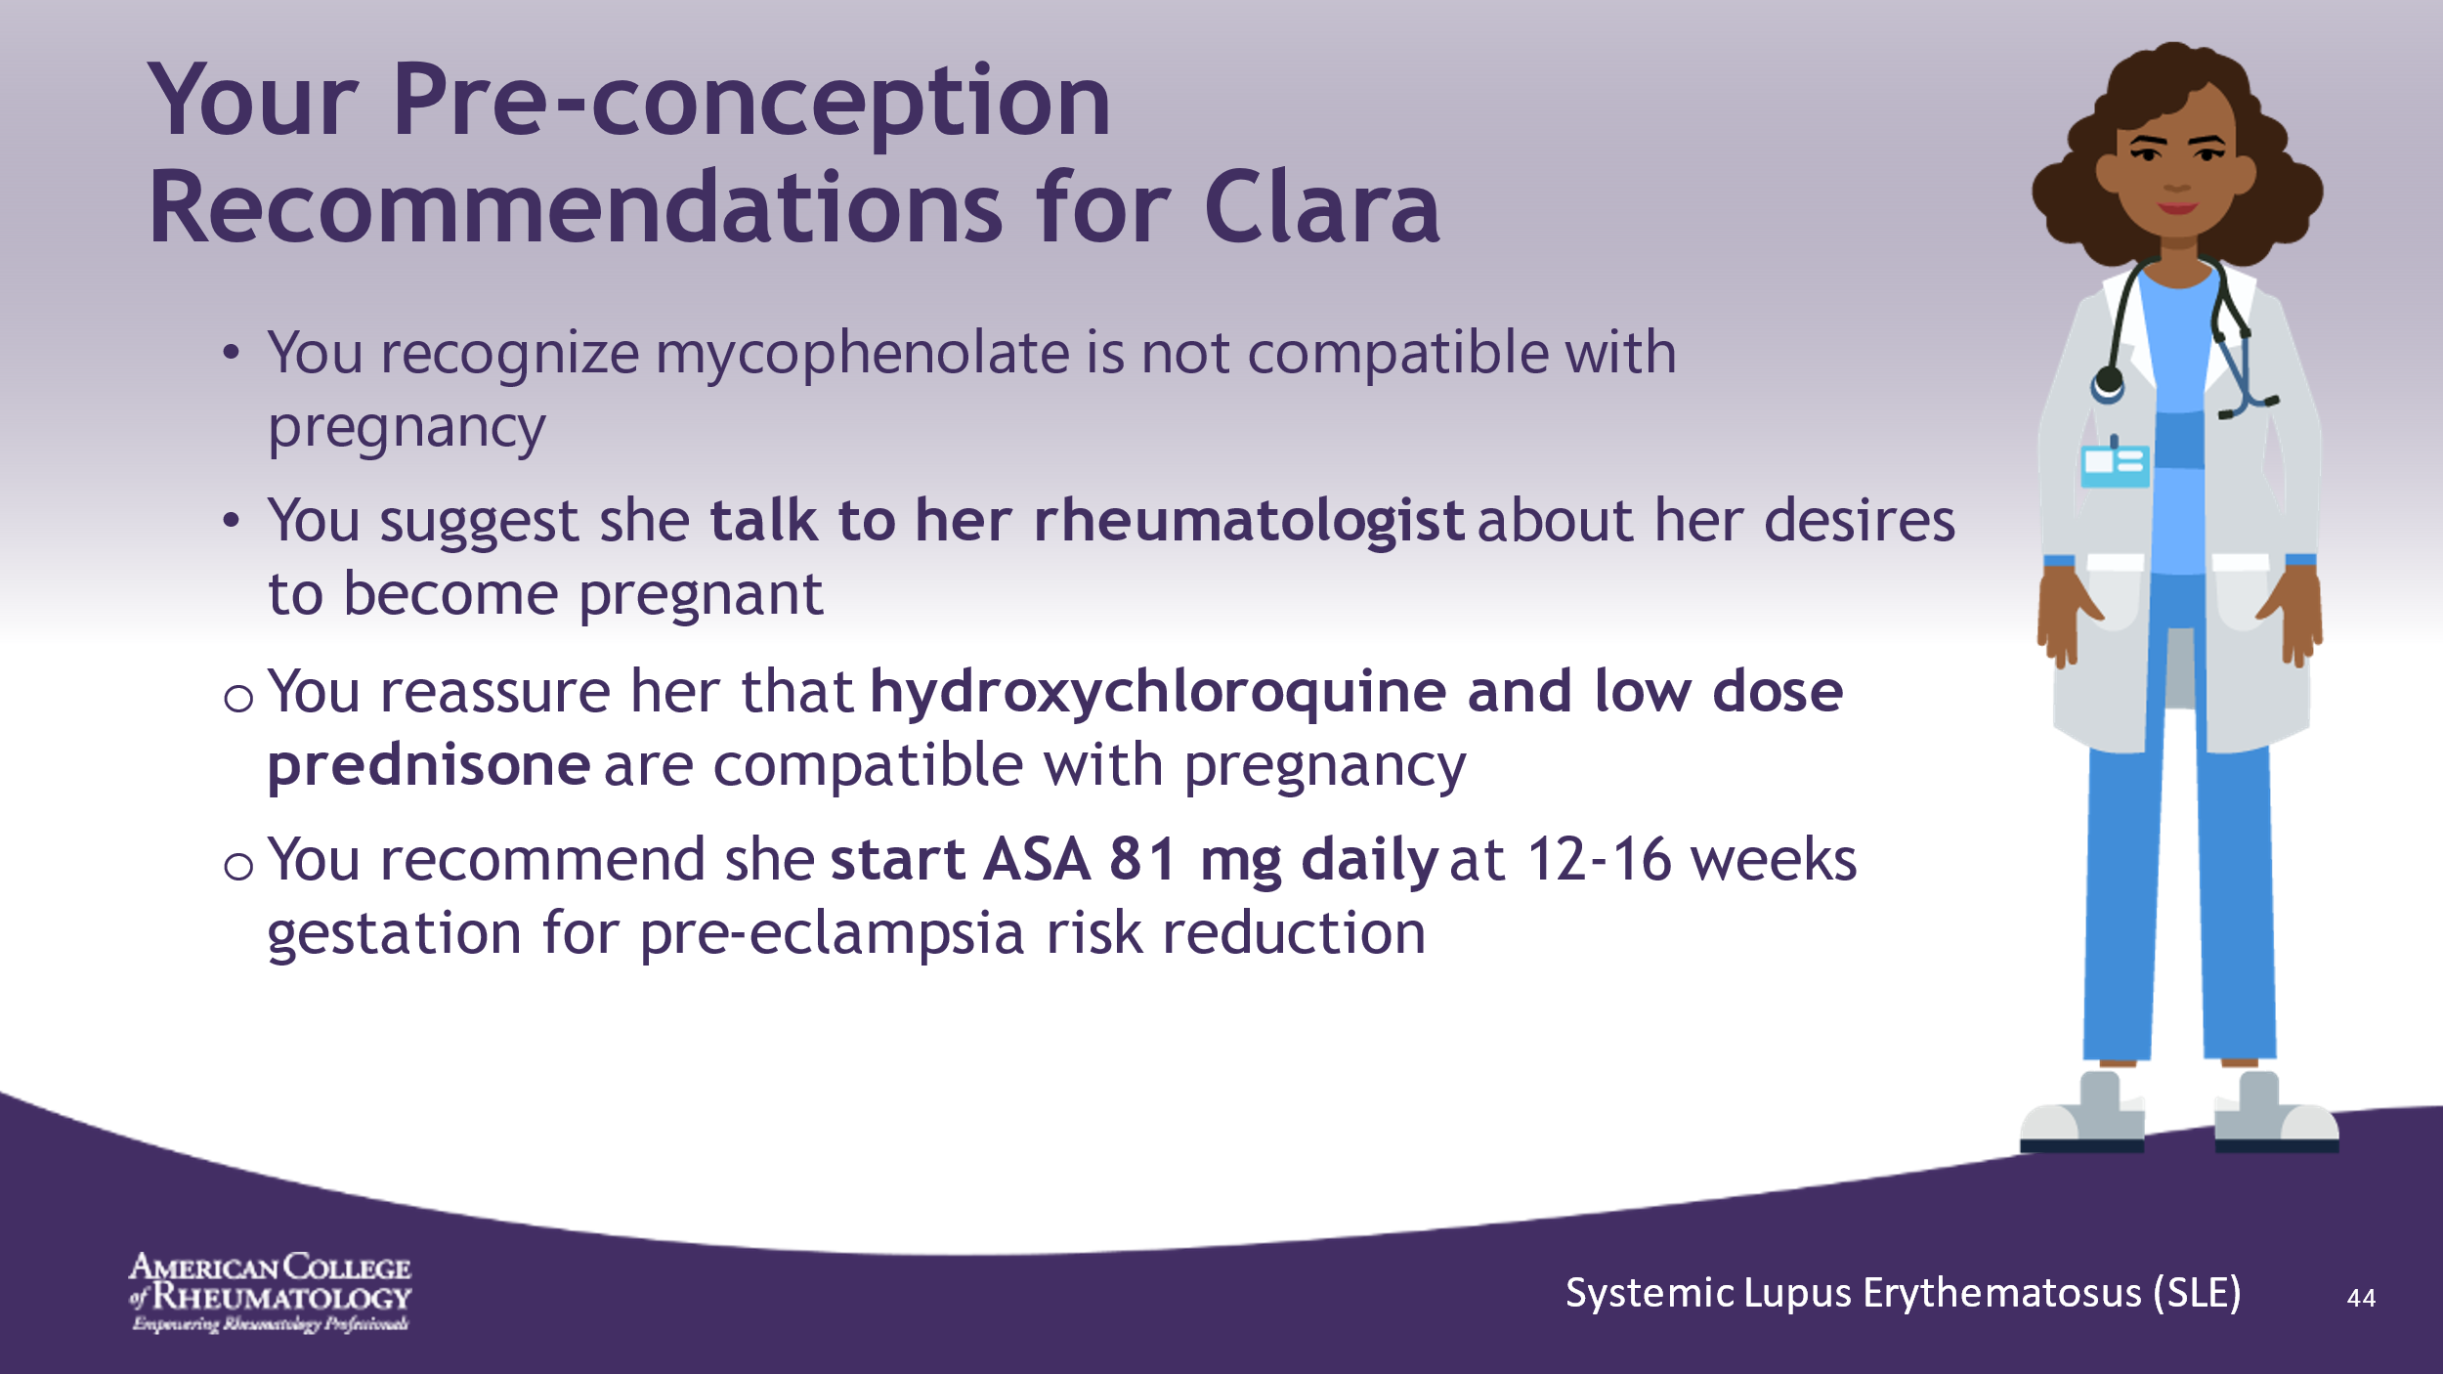

- ______________________________________________________
- ______________________________________________________
- ______________________________________________________
- ______________________________________________________
- ______________________________________________________
- ______________________________________________________
- ______________________________________________________
- ______________________________________________________

Slide 45: RHEUMATOLOGIST MEETING
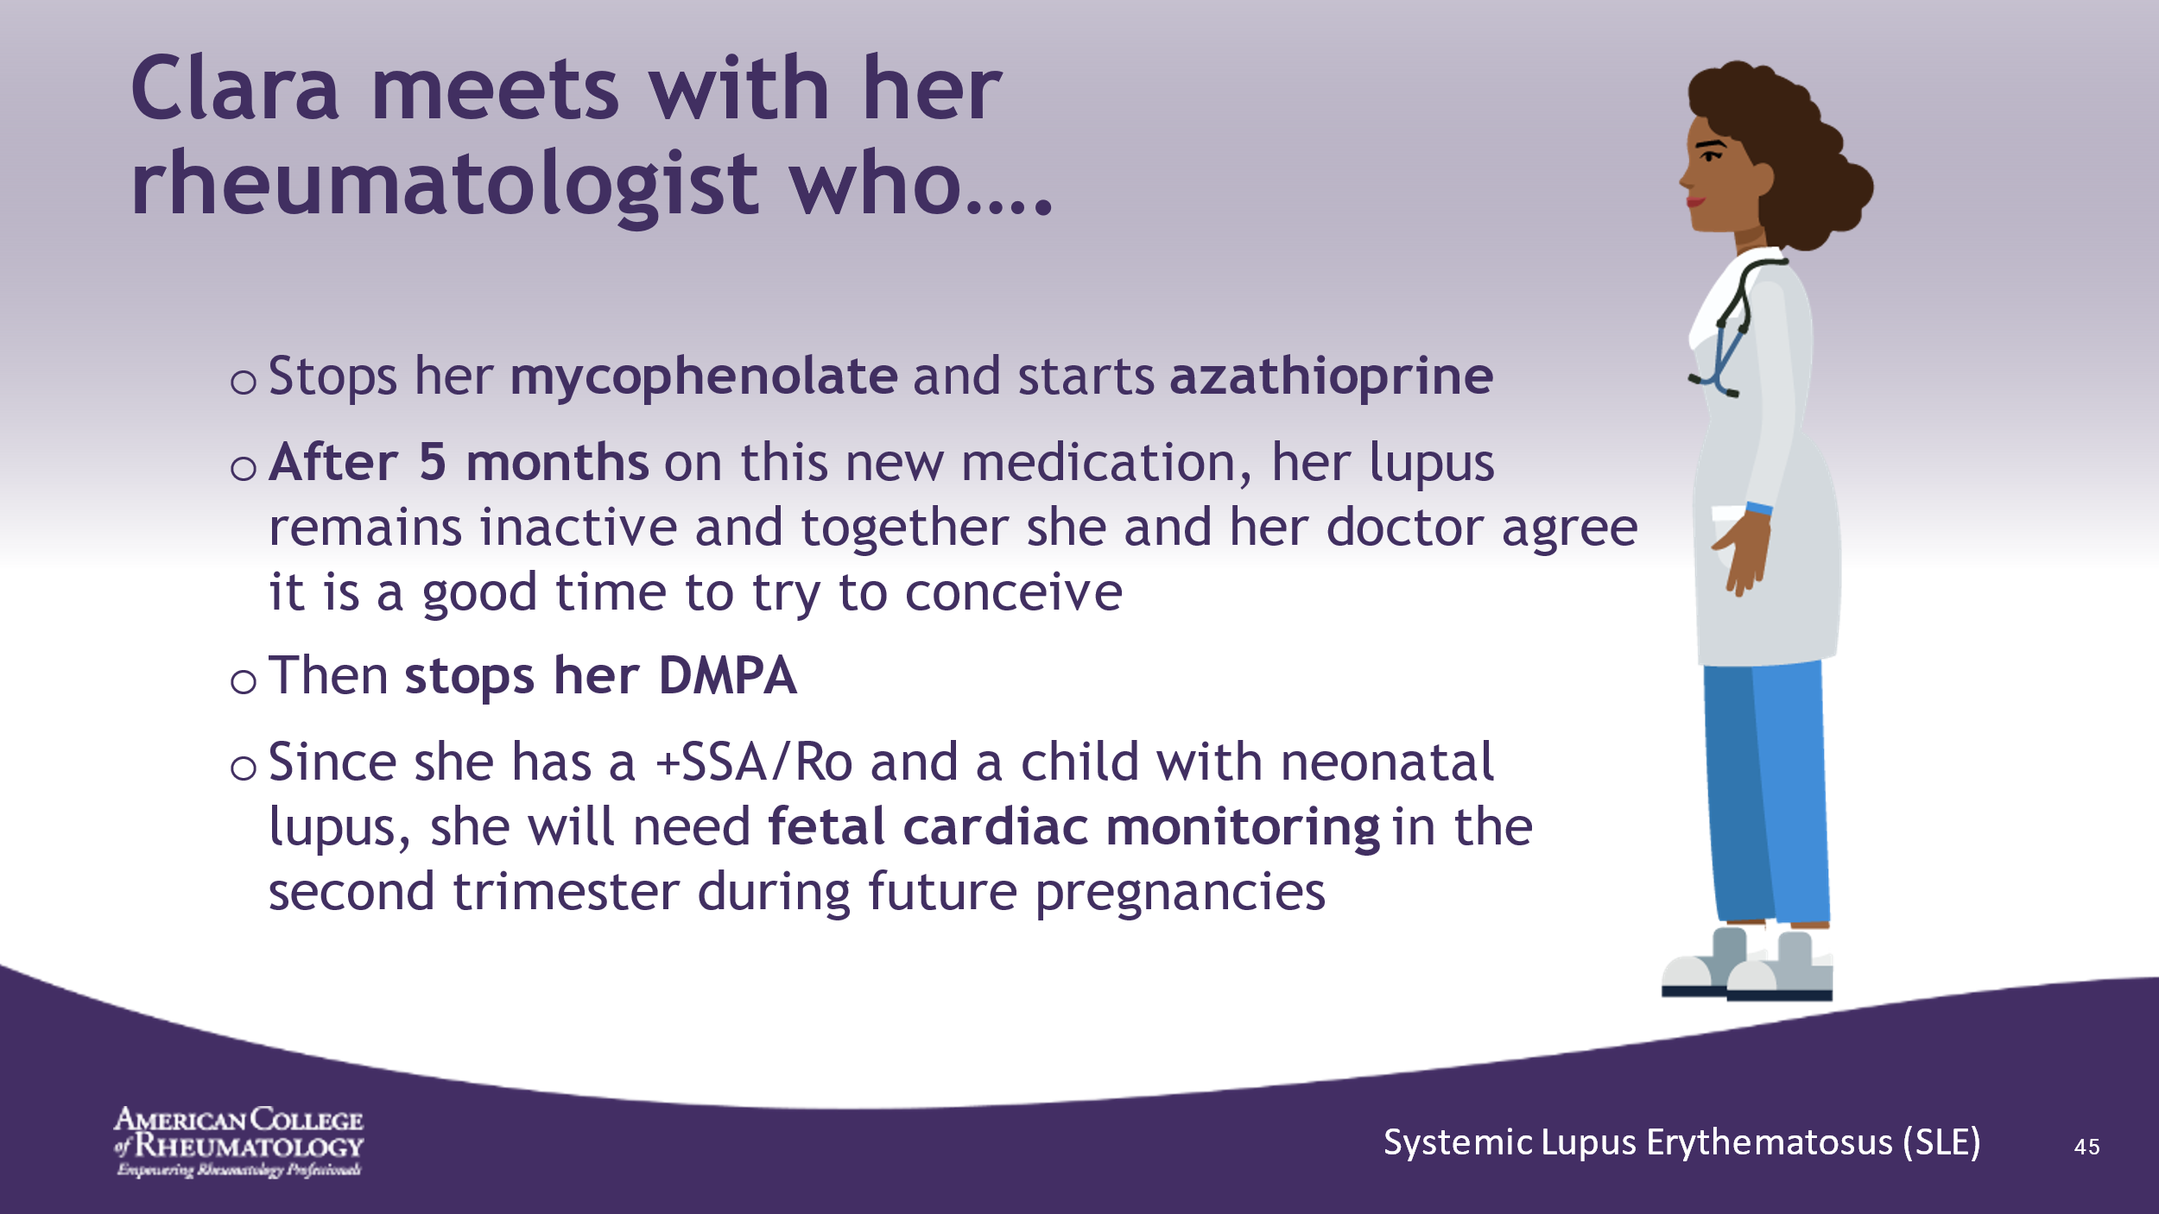

- ______________________________________________________
- ______________________________________________________
- ______________________________________________________
- ______________________________________________________
- ______________________________________________________
- ______________________________________________________
- ______________________________________________________
- ______________________________________________________

Slide 46: SECOND PREGNANCY
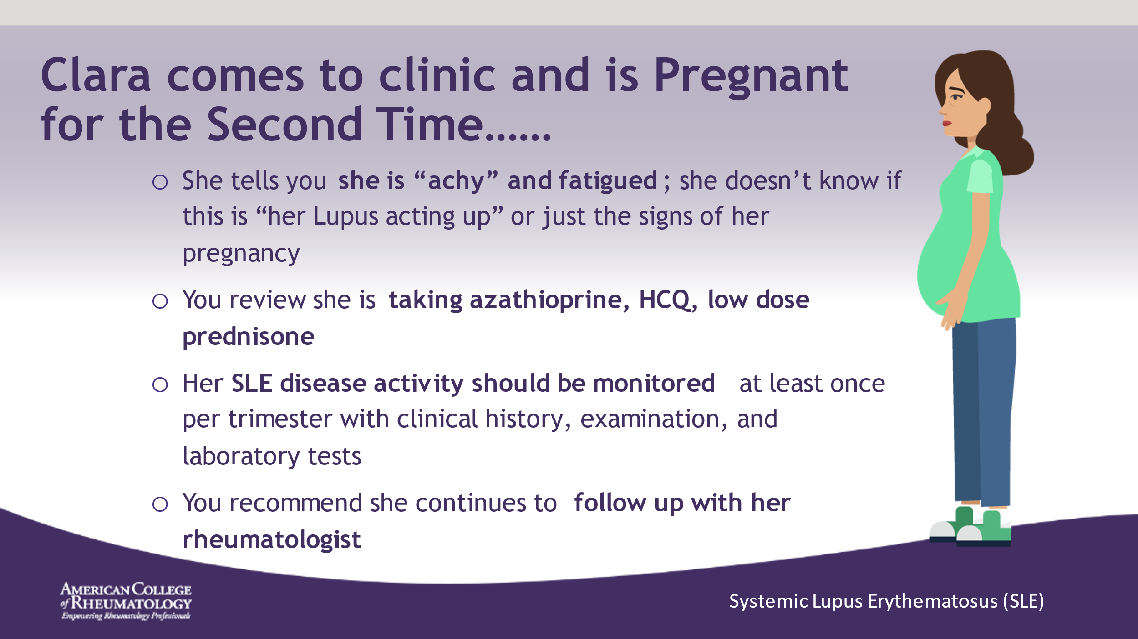

- ______________________________________________________
- ______________________________________________________
- ______________________________________________________
- ______________________________________________________
- ______________________________________________________
- ______________________________________________________
- ______________________________________________________
- ______________________________________________________

Slide 47: VACCINES
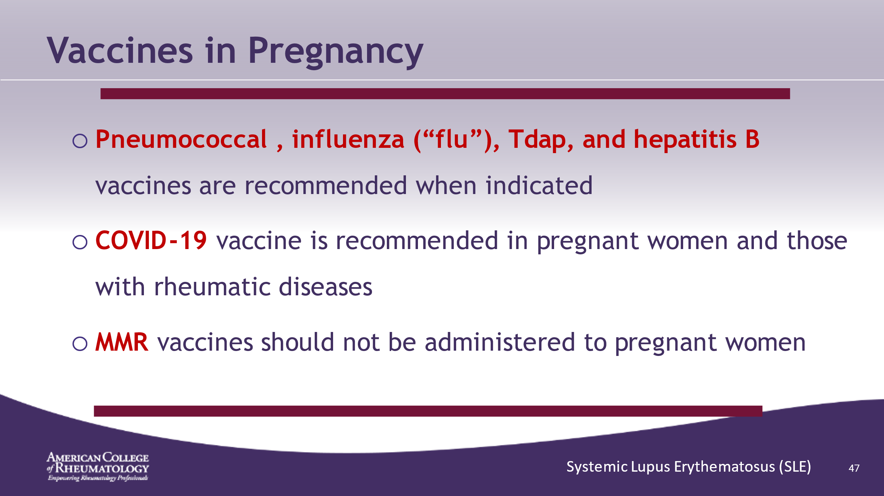

- ______________________________________________________
- ______________________________________________________
- ______________________________________________________
- ______________________________________________________
- ______________________________________________________
- ______________________________________________________
- ______________________________________________________
- ______________________________________________________

Slide 48: SECOND TRIMESTER
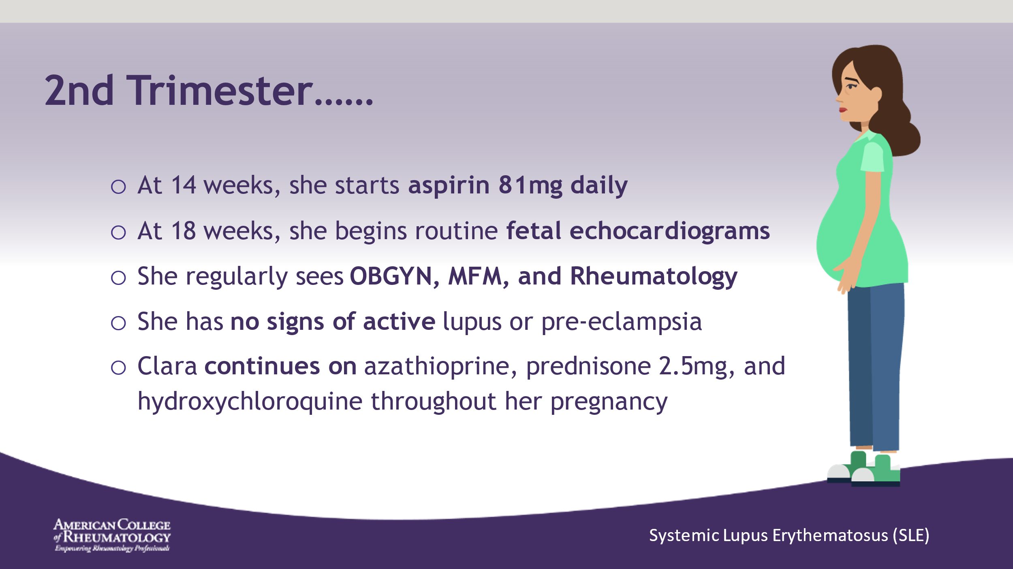

- ______________________________________________________
- ______________________________________________________
- ______________________________________________________
- ______________________________________________________
- ______________________________________________________
- ______________________________________________________
- ______________________________________________________
- ______________________________________________________

Slide 49: BREASTFEEDING
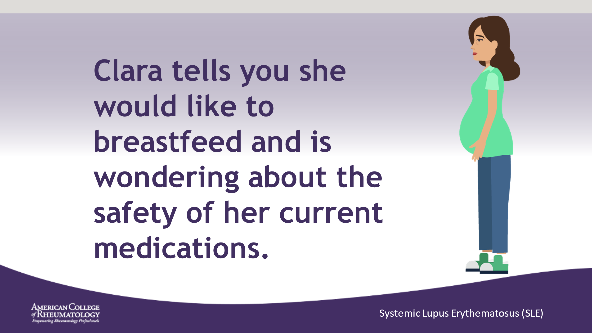

- ______________________________________________________
- ______________________________________________________
- ______________________________________________________
- ______________________________________________________
- ______________________________________________________
- ______________________________________________________
- ______________________________________________________
- ______________________________________________________

Slide 50: DRUG SAFETY BREASTFEEDING
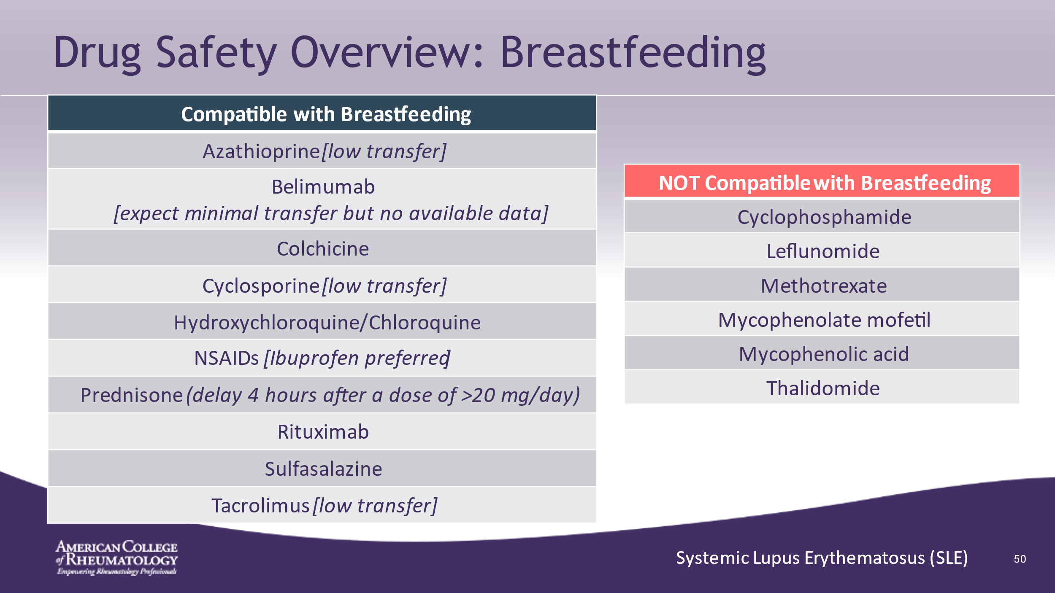

- ______________________________________________________
- ______________________________________________________
- ______________________________________________________
- ______________________________________________________
- ______________________________________________________
- ______________________________________________________
- ______________________________________________________
- ______________________________________________________

Slide 51: SECOND DELIVERY
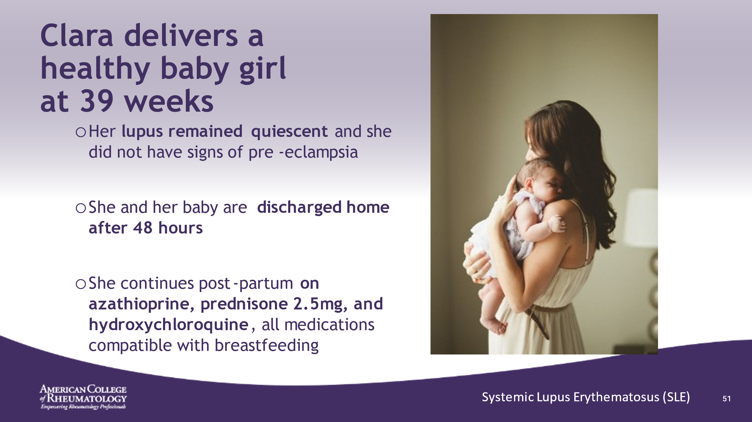

- ______________________________________________________
- ______________________________________________________
- ______________________________________________________
- ______________________________________________________
- ______________________________________________________
- ______________________________________________________
- ______________________________________________________
- ______________________________________________________

Slide 52: LEARNING POINTS
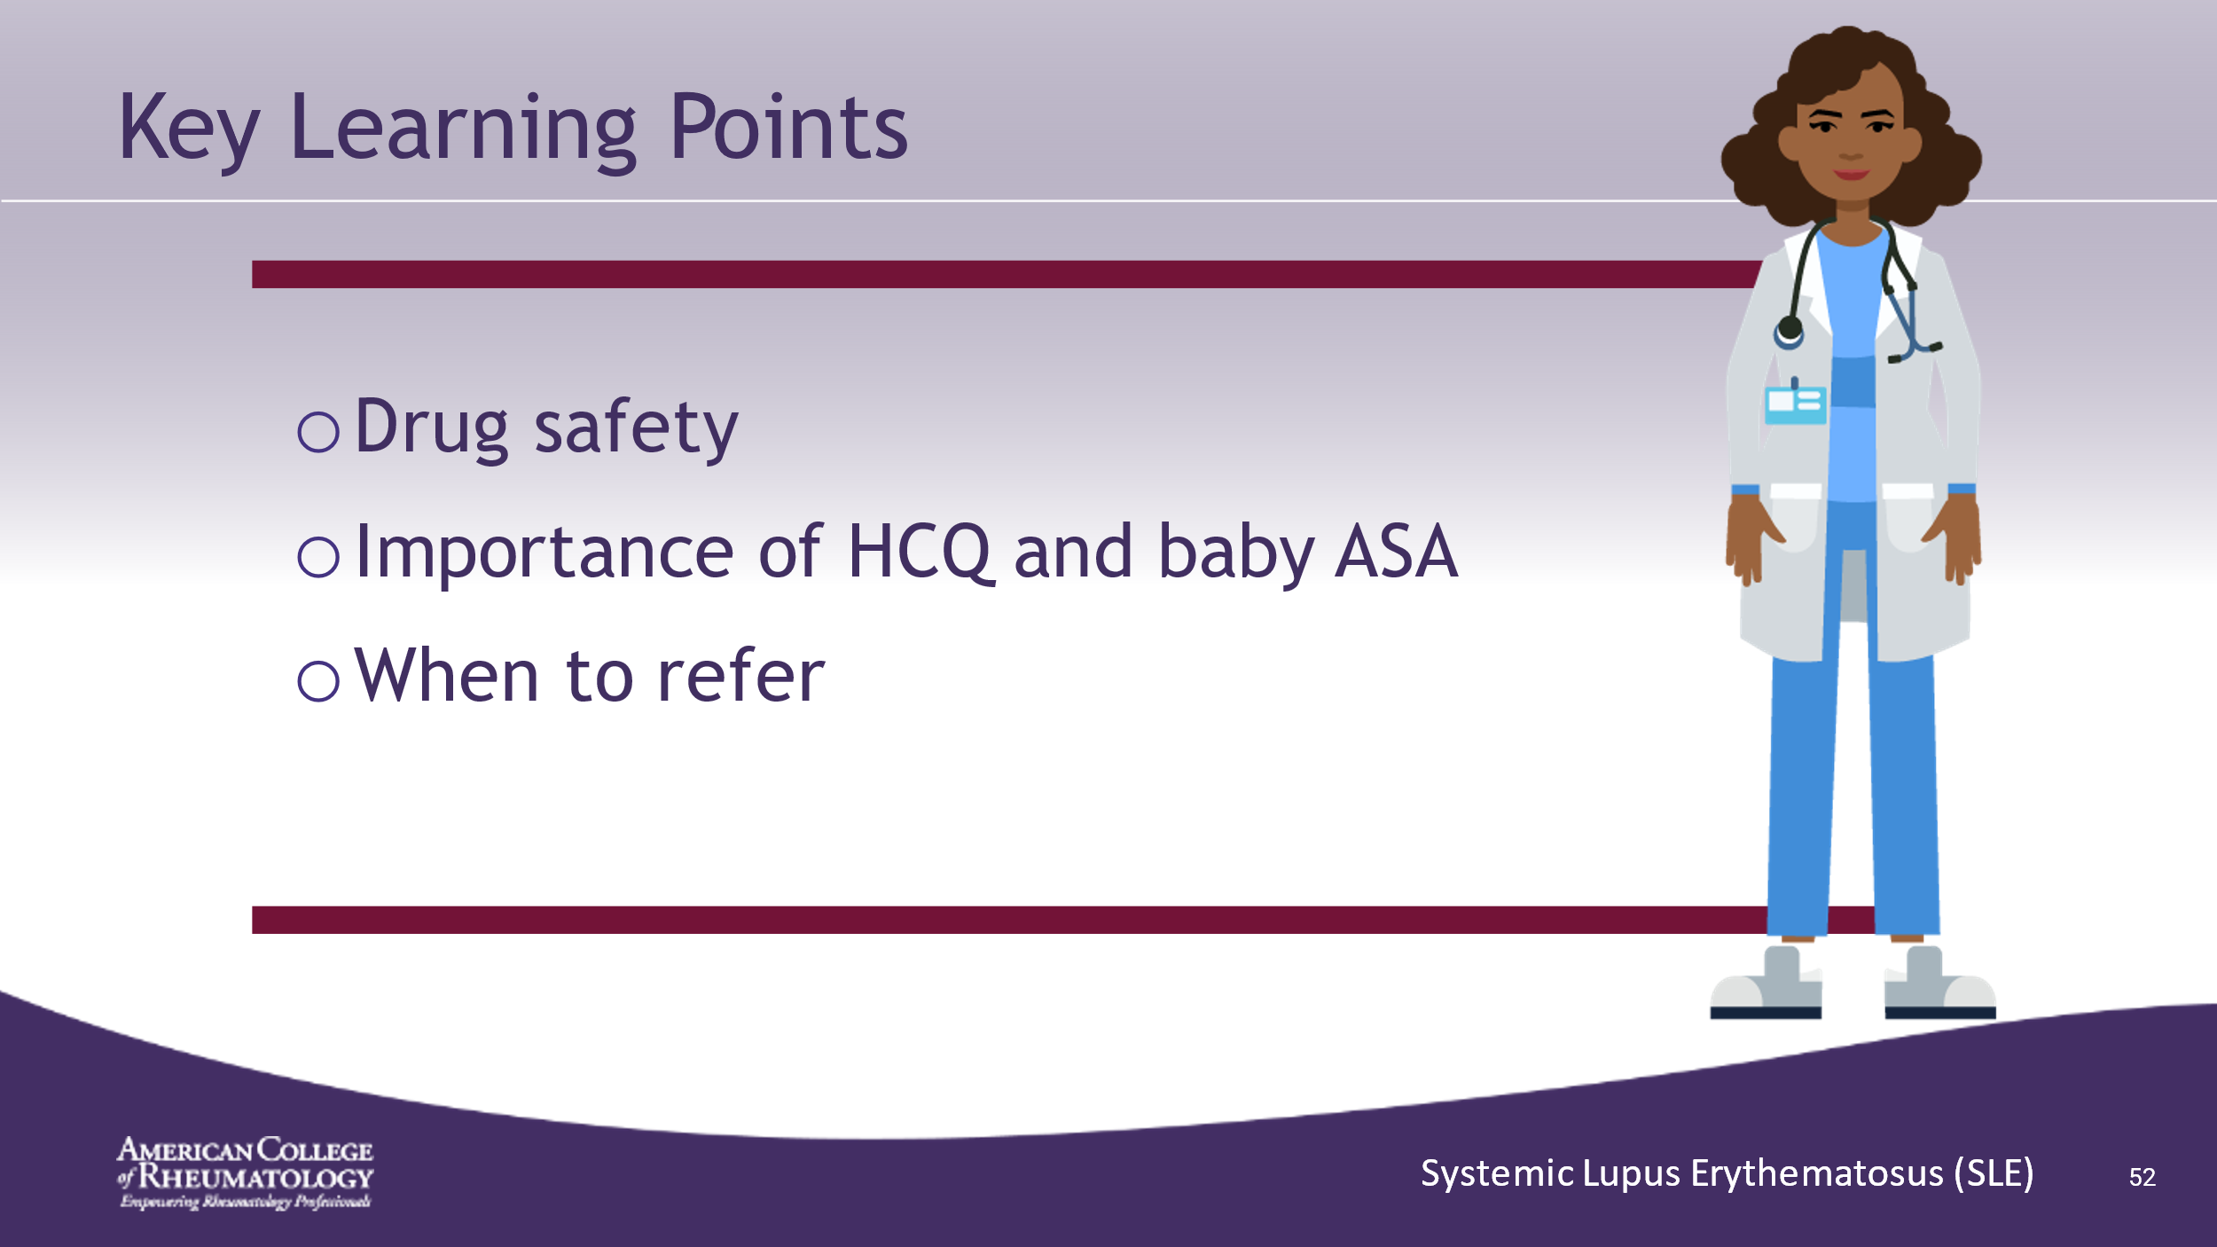

- ______________________________________________________
- ______________________________________________________
- ______________________________________________________
- ______________________________________________________
- ______________________________________________________
- ______________________________________________________
- ______________________________________________________
- ______________________________________________________

Slide 53: REFERENCES
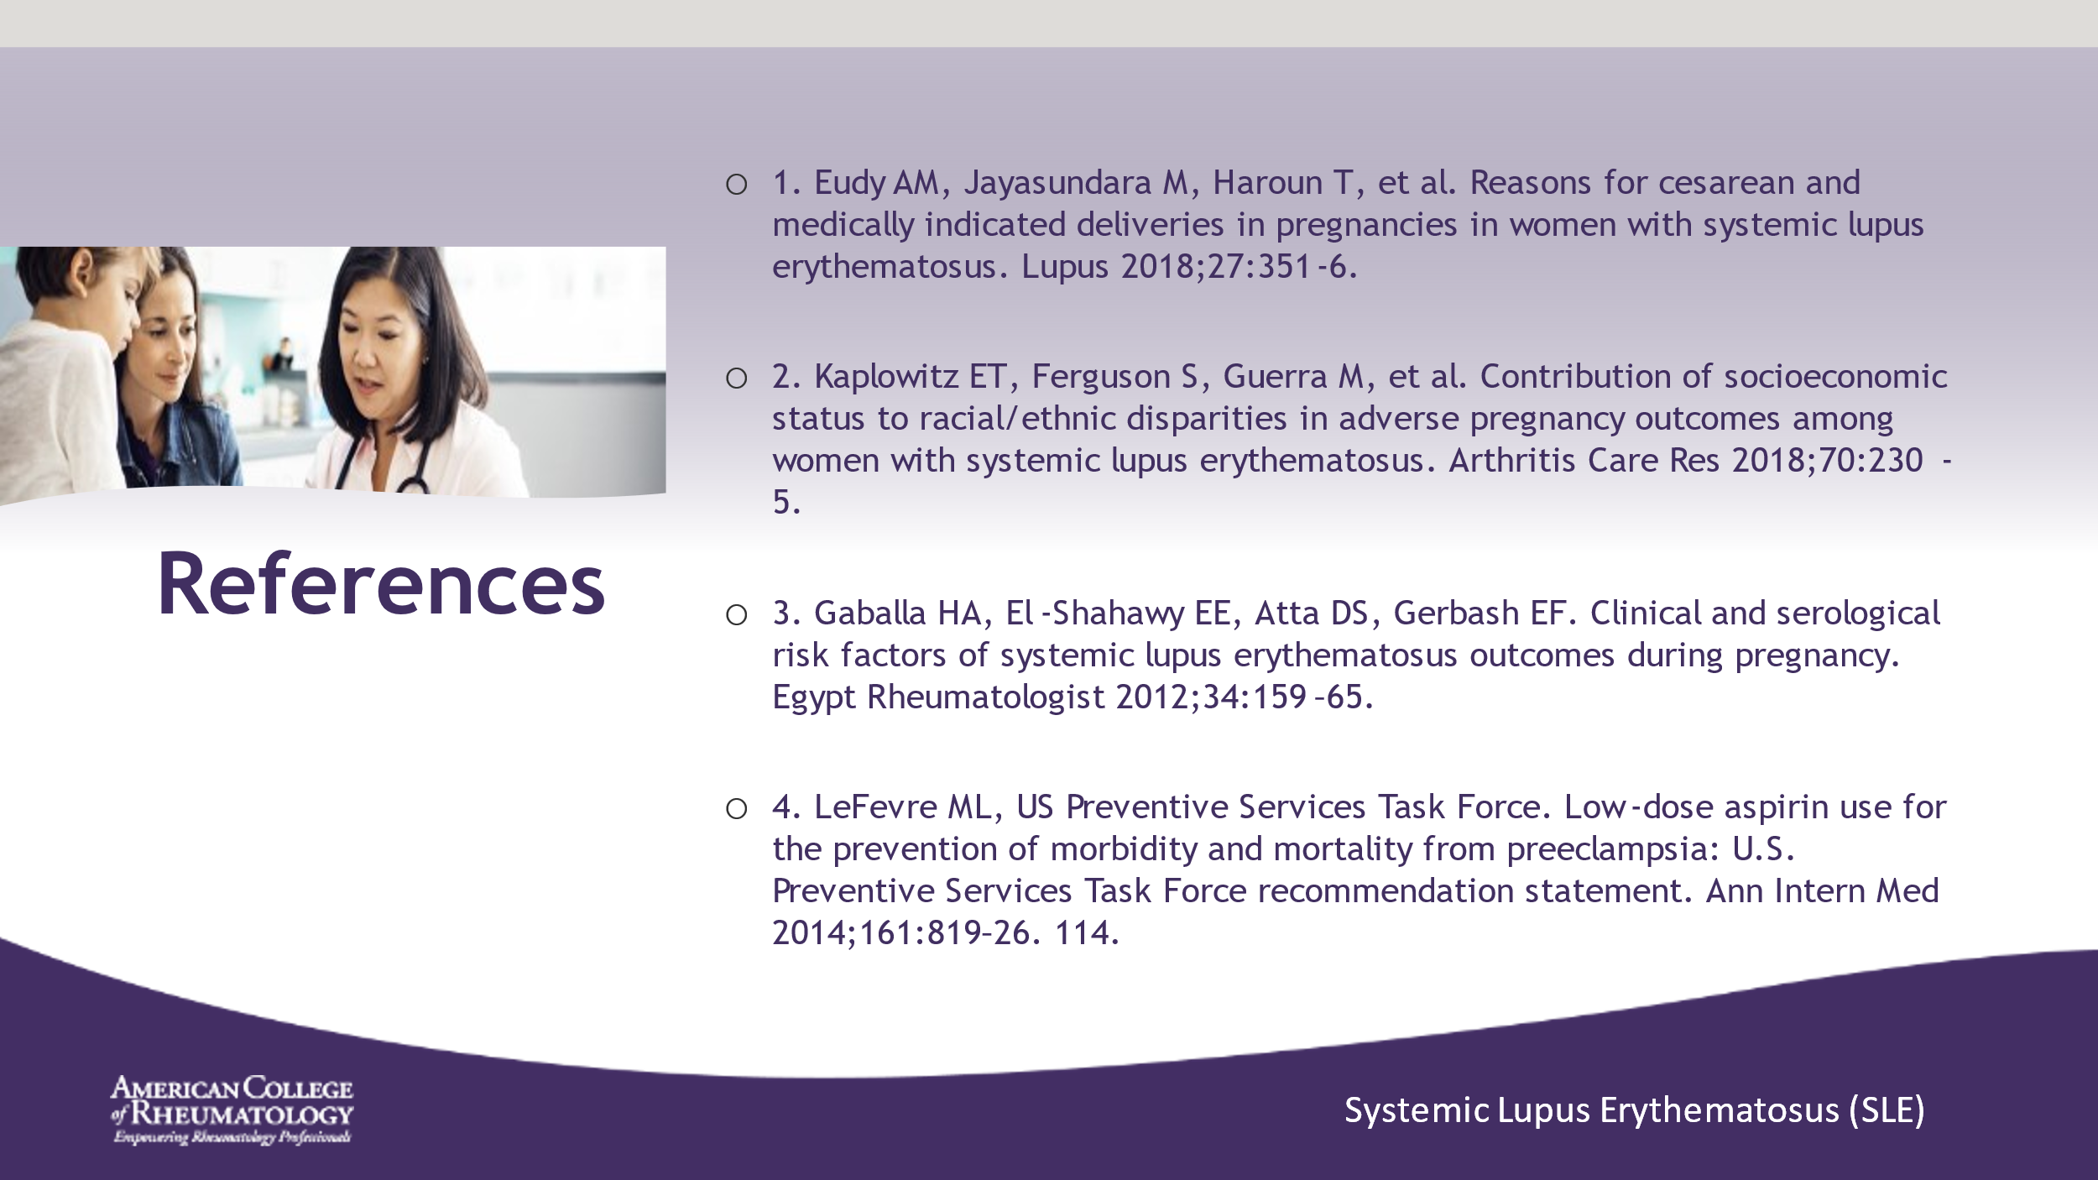

- ______________________________________________________
- ______________________________________________________
- ______________________________________________________
- ______________________________________________________
- ______________________________________________________
- ______________________________________________________
- ______________________________________________________
- ______________________________________________________

Slide 54: REFERENCES
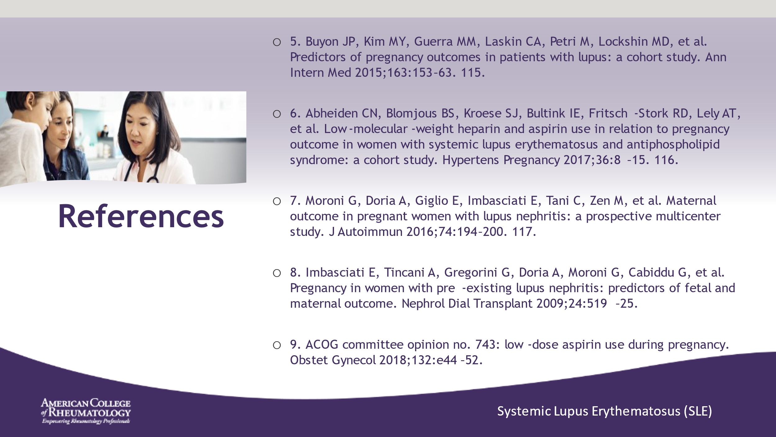

- ______________________________________________________
- ______________________________________________________
- ______________________________________________________
- ______________________________________________________
- ______________________________________________________
- ______________________________________________________
- ______________________________________________________
- ______________________________________________________

Slide 55: Q & A

- ______________________________________________________
- ______________________________________________________
- ______________________________________________________
- ______________________________________________________
- ______________________________________________________
- ______________________________________________________
- ______________________________________________________
- ______________________________________________________

Slide 56: CONTACT INFORMATION

- ______________________________________________________
- ______________________________________________________
- ______________________________________________________
- ______________________________________________________
- ______________________________________________________
- ______________________________________________________
- ______________________________________________________
- ______________________________________________________

CONCLUSIONS
Facilitator Notes:
- Thank participants for attending Navigating Reproductive Health in Patients with SLE

- Remind participants about the importance of their feedback and emphasize that they take the post-test assessment. Allow 10 minutes for the post-test to be completed.

- If you are comfortable, consider offering your contact information to participants in case they have questions after today’s session.

